Authorised and published by the Victorian Government, 1 Treasury Place, Melbourne
Report Card 2022-23

Port Phillip, Western Port and Gippsland Lakes
  - May 2024
  - Science Division
Authorised and published by the Victorian Government, 1 Treasury Place, Melbourne

Summary
The annual Report Card summarises the latest environmental water quality in Port Phillip Bay, Western Port and the Gippsland Lakes and their catchments (Figure 1). Environment Protection Authority Victoria (EPA), Melbourne Water and the Department of Energy, Environment, and Climate Action (DEECA) monitor the water quality in these regions. The results are described in this report.
The Report Card uses key indicators of environmental water quality to calculate an overall annual score. The score generates a rating of ‘Very Poor’, ‘Poor’, ‘Fair’, ‘Good’ or ‘Very Good’. This Report Card includes results from July 2022 to June 2023.
In 2022–23, water quality in the bays, lakes and waterways had changed from previous years, with improvements in Gippsland Lakes and Western Port and a decline in the Port Phillip Bay catchment waterways.
Water quality was mostly Very Good or Good for rivers in the elevated areas where most rivers originate. Water quality generally declined to Poor or Very Poor as the rivers moved through rural, agricultural, and urbanised areas in the foothills and coastal plains of the lowlands. In the bays and lakes, water quality was mostly Very Good or Good for areas that are able to mix with the open ocean.
Data from the Bureau of Meteorology for the reporting period, shows that rainfall in central Victoria was well above average, and average in the Gippsland region (Figure 2). Significant rainfalls in some of the Port Phillip catchments during spring 2022 resulted in localised flooding, increasing sediment and nutrient loads to Port Phillip Bay, resulting in Fair water quality scores for four of the six bay sites.
The annual Report Card has been available on EPA’s website since 2019. Prior to that, results were published on the Yarra and Bay website.
Figure 1: Location of Port Phillip Bay, Western Port, Gippsland Lakes (dark shading) and their
catchments (light shading).

Contents
Summary 2
Contents 2
What is the Report Card? 3
How are the scores calculated? 3
Climate in 2022–23 3
Port Phillip Bay and catchment 4
Western Port and catchment 7
Gippsland Lakes and catchment 10
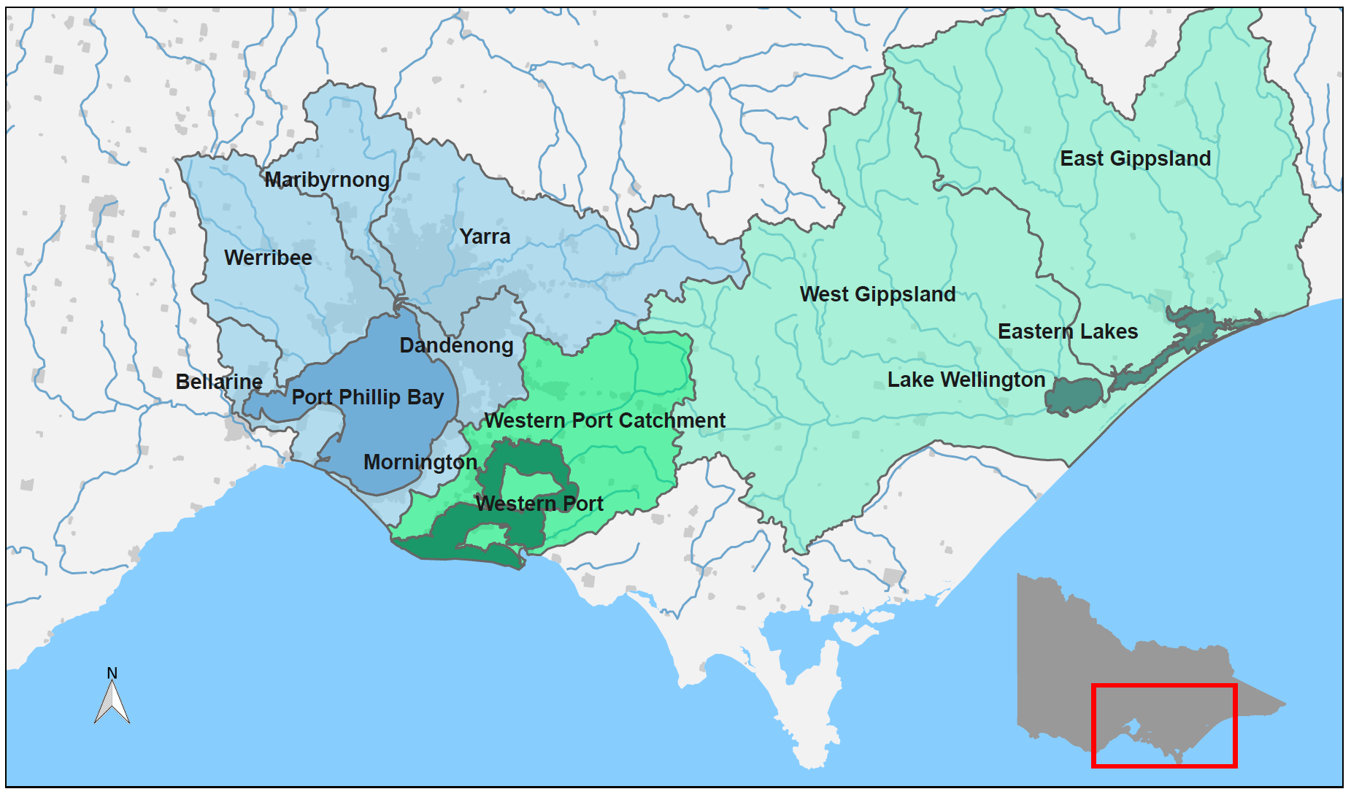
Further information 12

Figure 1: Location of Port Phillip Bay, Western Port, Gippsland Lakes (dark shading) and their catchments (light shading) within the state of Victoria.

What is the Report Card?
This Report Card provides a snapshot of water quality in Port Phillip Bay, Western Port, Gippsland Lakes, and the waterways in their catchments for 2022–23. These bays and lakes are the largest coastal waterbodies in Victoria. The waterways are a complex network of rivers, wetlands, and estuaries. They are of immense cultural, economic, and environmental value.
During summer, EPA forecasts recreational water quality based on microbiological indicators which are not reported here. For more information, see the Yarra Watch and Beach Report programs.

How are the scores calculated?
Key indicators of water quality are assessed against Victorian Environment Reference Standards (2021). These are combined to calculate an overall water quality index score (WQI) out of 10, corresponding to a rating of Very Poor to Very Good (Table 1). For this Report Card,WQI scores are for the period from July 2022 to June 2023.
Table 1: Water quality index (WQI) scoring categories for Report Card.
Water quality index score | Rating | Description
8–10 | Very Good | High quality waterways generally not impacted by pollution
6–8 | Good | Meets Victorian water quality objectives
4–6 | Fair | Some evidence of stress
2–4 | Poor | Under considerable stress
0–2 | Very Poor | Under severe stress

The water quality indicators used for catchment waterway sites are:
- dissolved oxygen
- metals
- nutrients (total nitrogen and total phosphorous)
- pH
- salinity (not at estuarine sites)
- water clarity.
The indicators used for bay and lake sites are:
- algae (chlorophyll-a)
- dissolved oxygen
- metals (where data is available)
- nutrients (total nitrogen – Port Phillip Bay and Western Port; total phosphorous – Gippsland Lakes)
- salinity (not at the estuarine Eastern Lakes)
- water clarity.
Key indicators gauge risks to aquatic ecosystems from key stressors, such as nutrient inputs, increased sediment, and algal blooms. The scores are summarised at the catchment and bay scale. The scores are calculated by considering the area of the sub-catchments and marine zones that each site represents, and calculating area-weighted average scores. Only sites that have a minimum of six samples that span the 12-month period are included so that the Report Card more accurately reflects the conditions throughout the year.

Climate in 2022–23
In 2022–23, rainfall was above average across Victoria, and much higher in central and western Victoria, compared with the long-term average (Figure 2). Mean air and coastal sea temperatures were up by 0.5 to 1.0°C throughout the period.
For Victoria overall, it was the highest spring rainfall since records began in 1900. This caused extensive flooding in many catchments across the Port Phillip region, but particularly so for the Maribyrnong catchment where water levels represented a 1 in 100 year flood. The following summer months from December 2023 to March 2024, were notably drier with below average rainfalls that continued through to autumn.
Climatic variation in rainfall and air temperature are known to influence water quality in inland, estuarine, and coastal waterways. Long periods of dry weather can reduce river flows, decrease pollution run-off into waterways, increase salinity, and cause more frequent or prolonged algal blooms. Conversely, wet conditions can increase the transport of pollutants, (such as nutrients and sediment), via stormwater/runoff from the catchment into waterways and bays.
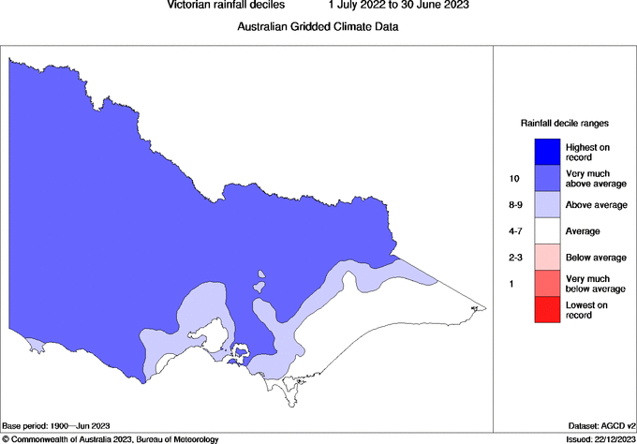
Figure 2: Victorian rainfall decile ranges from 1 July 2022 to 30 June 2023.
(Source: © Commonwealth of Australia 2023, Bureau of Meteorology.)

Port Phillip Bay and catchment
Port Phillip Bay is a large, shallow embayment. It is surrounded by catchments that are mostly rural, but has large urban areas around its shoreline, including Victoria’s two largest cities: Melbourne and Geelong. The Yarra, Maribyrnong, and Werribee Rivers are major river systems that originate in the forested hills and mountains, then flow through rural properties, townships, and urban areas to the bay. The bay is connected to Bass Strait by a narrow entrance. Waters in the south of the bay mix well with ocean waters, while riverine inputs highly influence the waters in the north and west of the Bay. The bay is a popular location for boating, fishing, and swimming, and supports Victoria’s largest recreational fisheries.
The Report Card for Port Phillip Bay and catchment is calculated using data sourced from Melbourne Water and EPA. In this Report Card, 88 freshwater and 6 marine sites in the Port Phillip region were used to calculate the WQI scores (Figures 3 and 7).
Figure 3: Location and WQI scores of Melbourne Water’s monitoring sites in the Port Phillip catchment. Colour indicates WQI score for each site in 2022–23.
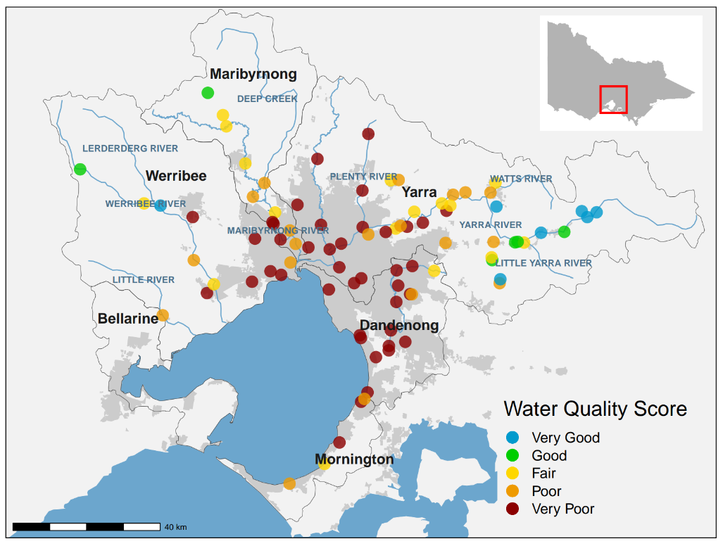
In 2022–23, water quality in Port Phillip Bay and its catchment varied from Very Good in southern areas of the bay and upper reaches of the Yarra catchment, to Very Poor in highly urbanised waterways. This was similar to previous years (Figures 4 and 6).
Catchment Report Card
Port Phillip Bay comprises six catchments: Yarra, Werribee, Maribyrnong, Dandenong, Mornington, and Bellarine (Figure 3).

Maribyrnong catchment
The Maribyrnong catchment includes rivers and creeks such as Deep Creek and Jacksons Creek. These all drain into the lower Yarra Estuary and then into Port Phillip Bay (Figure 3). Overall, water quality in the Maribyrnong catchment was Poor in 2022–23, a drop from Fair in 2021-22, continuing an overall general decline in water quality since 2017 that matches well with increasing river flow. (Figure 4). Water quality was Good to Fair in the upper reaches of the catchment in forested areas but declined to Poor and Very Poor as waterways flowed through the catchment’s agricultural and urban areas.

Yarra, Werribee, Dandenong and Mornington catchments
Water quality was Good in the forested upper Yarra and Werribee catchments but declined to Very Poor in urban areas. The middle Yarra showed some improvement with many sites shifting from Very Poor, to Poor or Fair in 2022-23, compared to the previous year. The highly urbanised areas of the relatively small Dandenong and Mornington catchments scored the lowest WQI scores for the Port Phillip region, with Very Poor water quality (Figure 3), which is consistent with previous years.

Bellarine catchment
The Bellarine catchment is outside Melbourne Water’s service area. Waterwatch data is available for the Bellarine. However, it is collected in a different way therefore, a WQI score cannot be calculated for Bellarine catchment.

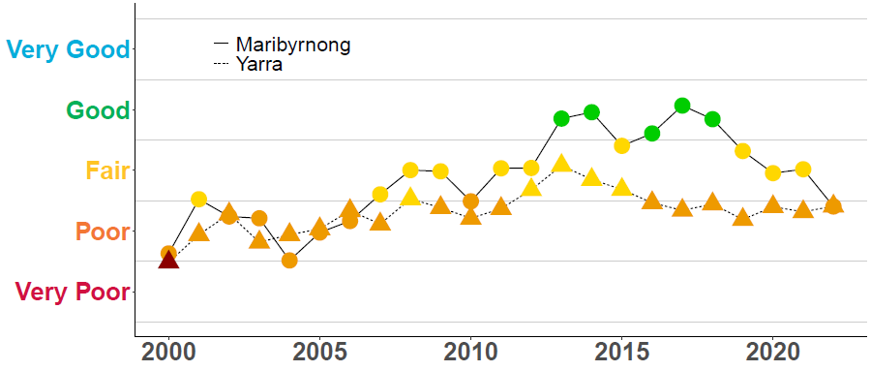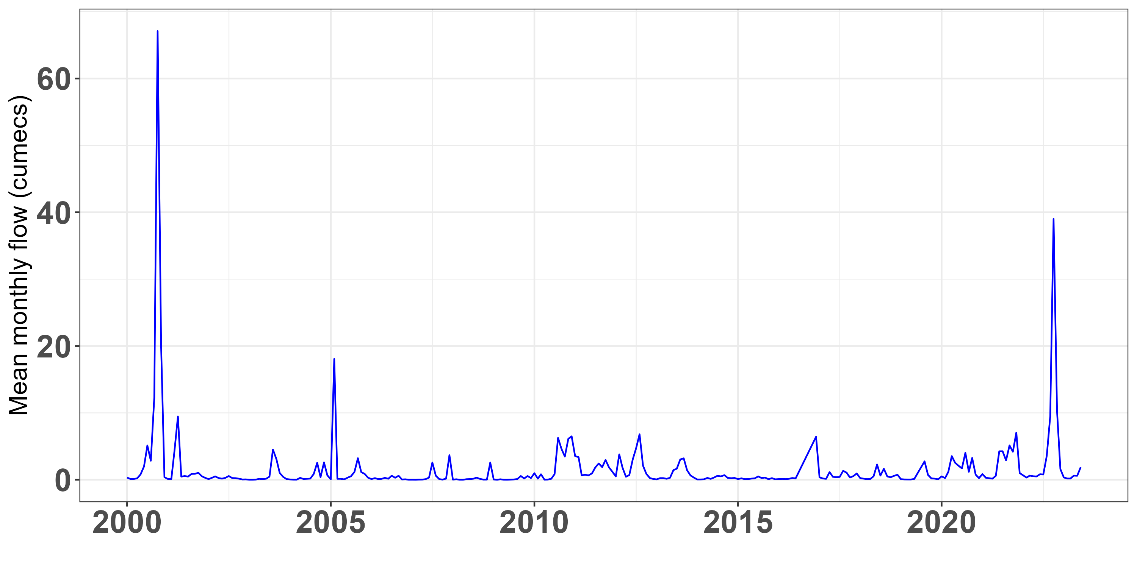

Figure 4: Historical WQI scores for the overall Maribyrnong and Yarra catchments. Colour indicates WQI score for each year. The mean monthly flow from Maribyrnong River, measured at Keilor, is provided for comparison to the WQI. (source sample site 230105A Melbourne Water).

Bay Report Card
Overall, water quality in Port Phillip Bay was Good in 2022–23, but all four coastal sites closest to urbanised catchment inputs were rated as Fair. This was driven by Poor Water clarity, and Fair Salinity and Nutrient indicator ratings (Figure 5) that had reduced from the previous year. Rainfall data from the Bureau of Meteorology showed the 2022–23 period had above average rainfall in areas of the Port Phillip catchment (Figure 2), and the highest spring rains on record. This rainfall affects the volume of surface and stormwater run-off, which can carry pollutants such as nutrients and sediment.
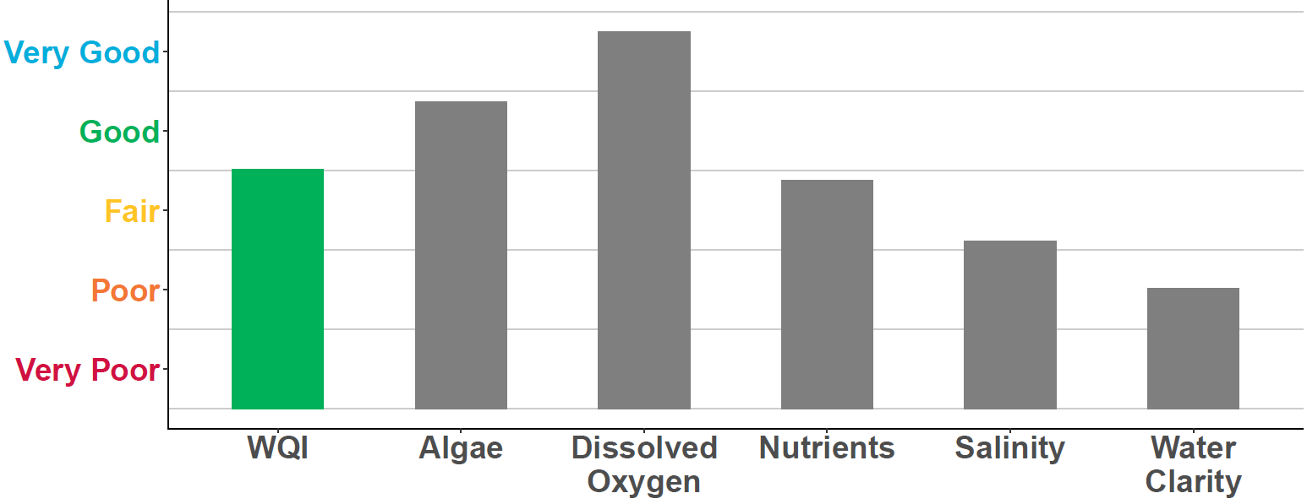
Figure 5: WQI scores for Port Phillip Bay in 2022–23. Coloured bar indicates the overall WQI score. Grey bars are the individual indicators used to calculate the overall WQI score.
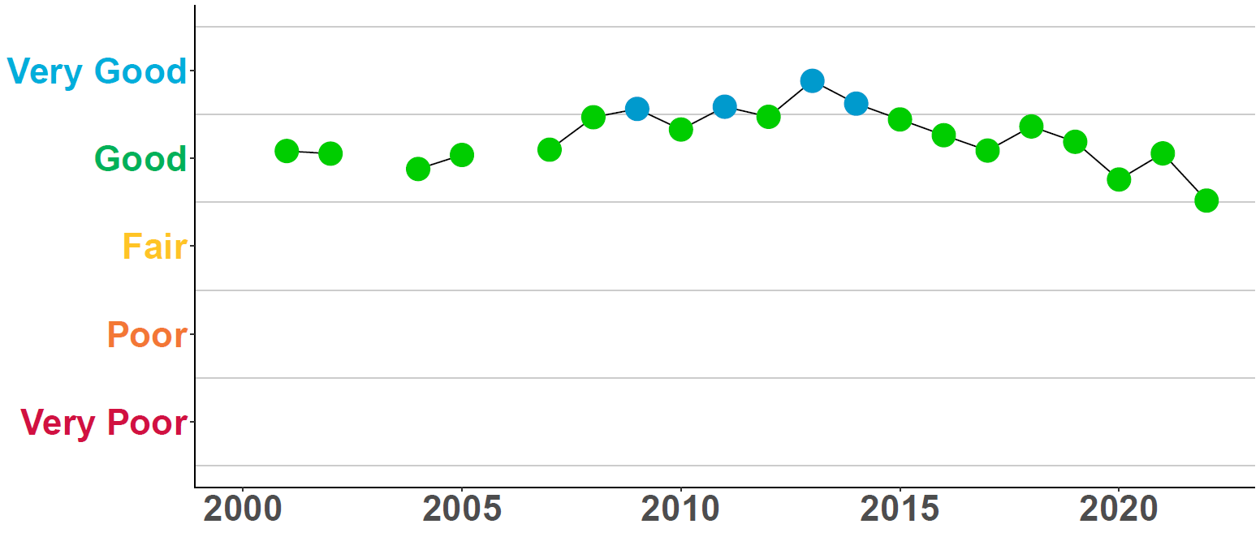
Figure 6: Historical WQI scores for Port Phillip Bay.
EPA has six monitoring locations in Port Phillip Bay (Figure 7). Conditions in Port Phillip Bay have remained relatively consistent since 2002, with overall water quality fluctuating between Good to Very Good (Figure 6). For 2022-23, the Bay has an overall ‘ Good” WQI rating, but shows a decline on previous years, driven by fair ratings at four coastal sites affected by the record Spring rains.
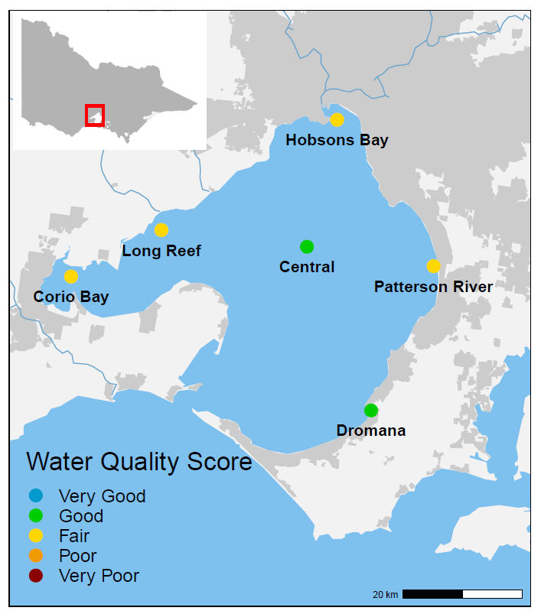
Figure 7: Locations and WQI scores of EPA long-term marine monitoring sites in Port Phillip Bay.

Dromana and Central Bay
Dromana and Central Bay had Good water quality. This is because the southern area of Port Phillip Bay is well flushed with water from Bass Strait due to regular tidal exchange, and the Central Bay site has minimal impacts from river inflows and urban run-off inputs.

Patterson River, Corio Bay, Long Reef and Hobsons Bay
Corio Bay, Long Reef, Hobsons Bay and Patterson River all had Fair water quality, due to the direct influence of higher river inflows, run-off, and stormwater that carry pollutants, such as nutrients, sediments, and heavy metals.

Western Port and catchment
Western Port is a well-flushed, semi-enclosed bay, with two large islands (Phillip Island and French Island) that constrain water flow. The catchment is largely rural (70 per cent), with state reserves (20 per cent) in the upper catchment, and a fast-growing urban growth corridor.
Waterways in the catchment flow through areas that have been highly modified to support rural and urban land use. The catchment also contains the Bunyip State Park and Strzelecki Ranges, highly vegetated areas that support significant environmental values. The northern and eastern areas of the bay are mostly intertidal mudflats dominated by catchment inflows from the Bunyip, Lang Lang, and Bass Rivers. Tidal exchange with Bass Strait highly influences the western and southern areas of the Bay.
The Report Card for Western Port and its catchment is calculated using data from Melbourne Water and EPA. In 2022–23, water quality varied from Good in areas of
the upper catchment and the bay, to Very Poor in highly urbanised or intensive
agricultural areas.

Catchment Report Card
Overall, the water quality in the Western Port catchment waterways was Poor for 2022–23. Poor ratings occur for five of the six water quality indicators (Figure 8). Scores for the Western Port catchment have remained relatively consistent over time and have mostly shown Poor water quality (Figure 9).
Melbourne Water routinely collects water samples across waterways of the Western Port catchment to assess how water quality is changing over time. In this Report Card, 23 sites in the Western Port catchment were used to calculate the WQI score (Figure 10).

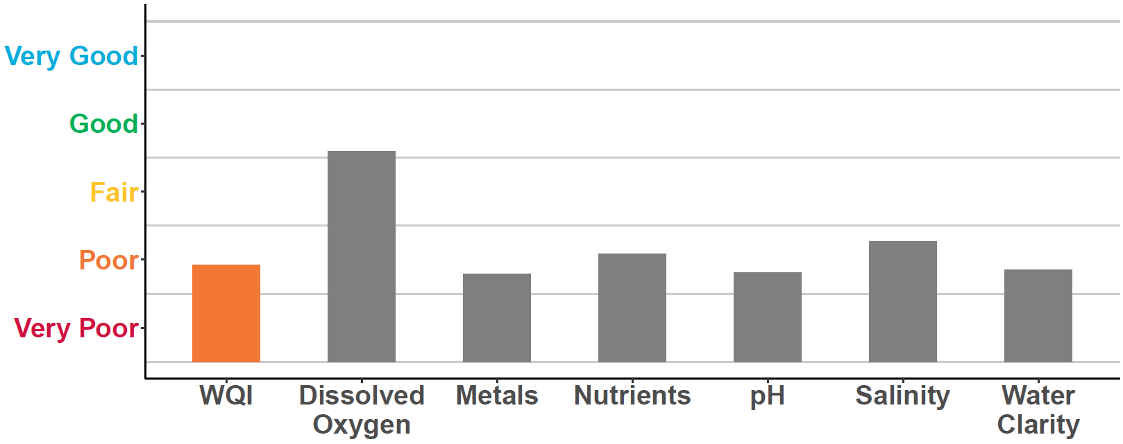
Figure 8: WQI scores for the overall Western Port catchment in 2022-23. Coloured bar indicates the overall WQI score. Grey bars are the individual indicators used to calculate the overall WQI score.

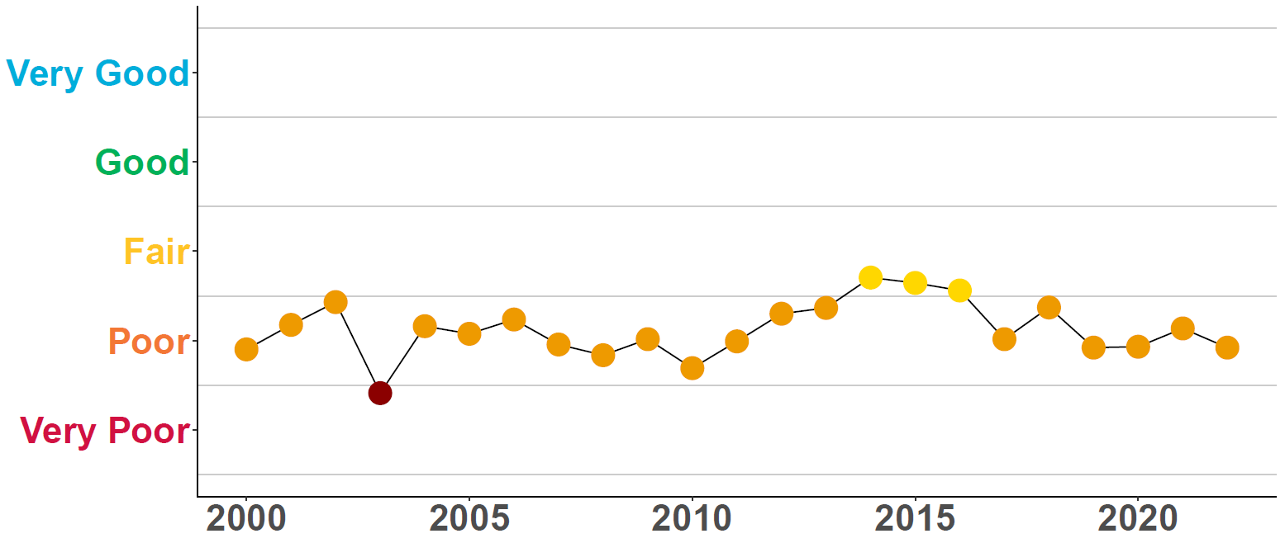
Figure 9: Historical WQI scores for the overall Western Port catchment.

Water quality was consistently Good in the upper catchment of the Bunyip River, and Fair in the upper catchment Lang Lang, which is an improvement on the 2020-21 score. Water quality declined to Poor or Very Poor in waterways in the mid and lower catchment where the land use changes into rural, agricultural, and urbanised areas.
Vegetation clearing, historical draining of the Koo Wee Rup swamp, the progressive growth of agriculture, and recent urban expansion has altered the Western Port catchment significantly over time. The altered drainage regimes and intensive land uses present significant challenges for maintaining water quality in these rivers and streams.
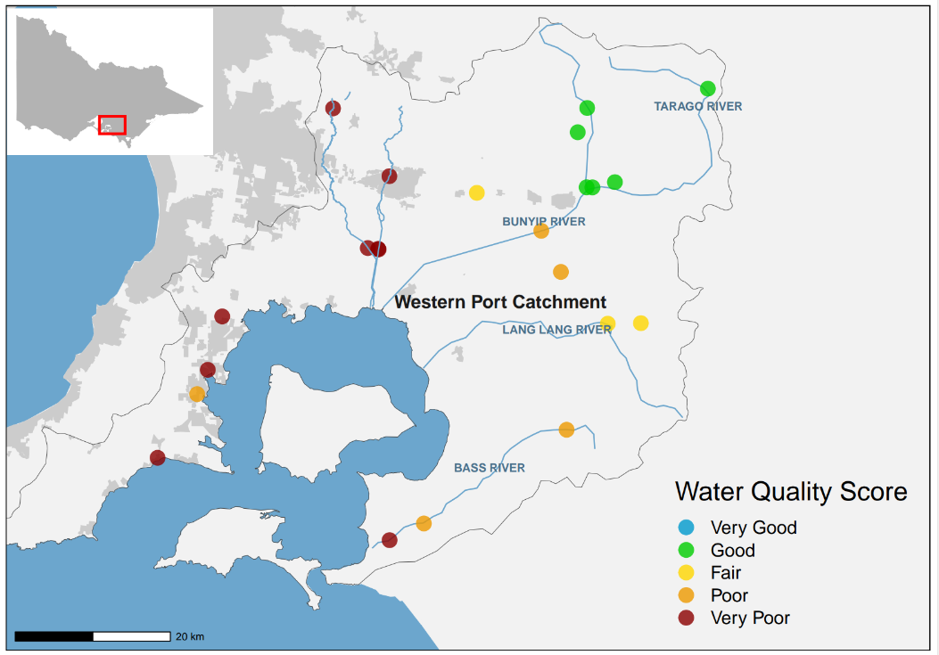
Figure 10: Location and WQI scores of Melbourne Water’s monitoring sites in the Western Port catchment.

Western Port Bay Report Card
Overall, water quality was Good in Western Port for 2022–23. High nutrient and reduced water clarity levels resulted in Fair and Poor ratings respectively for these parameters (Figure 11). this is consistent with previous years.
Rainfall data from the Bureau of Meteorology showed the Western Port catchment had above average rainfall in the 2022–23 period (Figure 2). This rainfall affects the volume of surface and stormwater run-off. River inputs are a source of nutrients and sediment from the northern and eastern catchments.
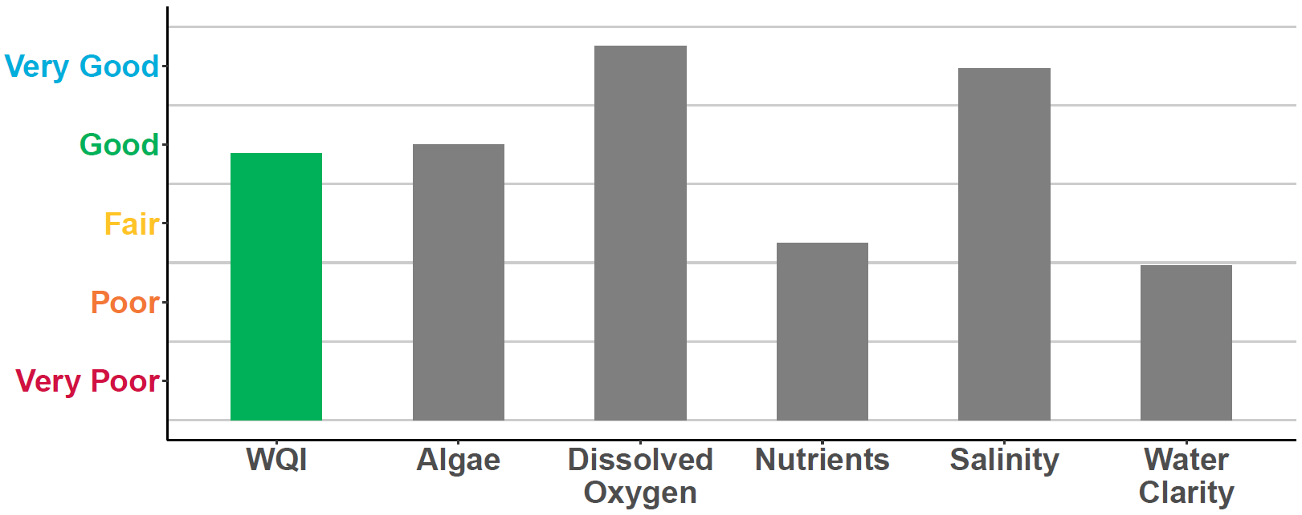

Figure 11: WQI scores for Western Port overall in 2022–23. Grey bars are the individual indicators used to calculate the overall WQI score.

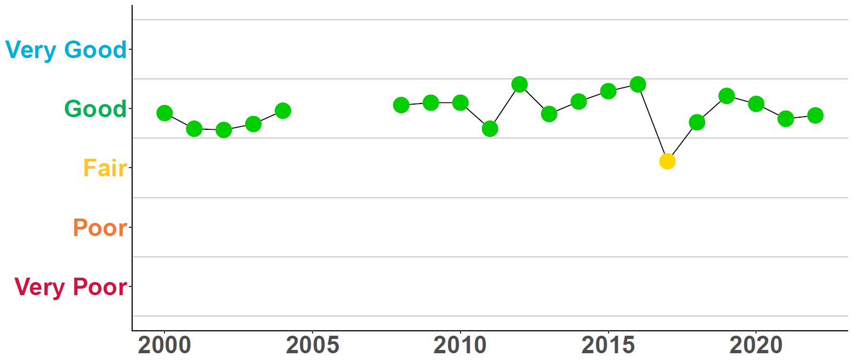

Figure 12: Historical WQI scores for Western Port. Due to limited monitoring, no scores were calculated from 2005–08.

While rainfall can temporarily decrease water quality, the WQI scores in Western Port have generally remained consistent since 2000 (Figure 12). The small catchment inflow volumes and mixing with Bass Strait helps to maintain good water quality in Western Port. EPA has two monitoring locations in Western Port (Figure 13).

Hastings
The Hastings monitoring site had Good water quality, which was the same as the previous year. This area is regularly flushed and mixed with oceanic waters from Bass Strait.

Corinella
The Corinella monitoring site had Good water quality, which has improved from a Fair rating in previous years. . Average rainfall in the east during 2022-23 compared to previous years, with easterly winds reducing the risk of coastal erosion, are the likely causes for improvements at this site.

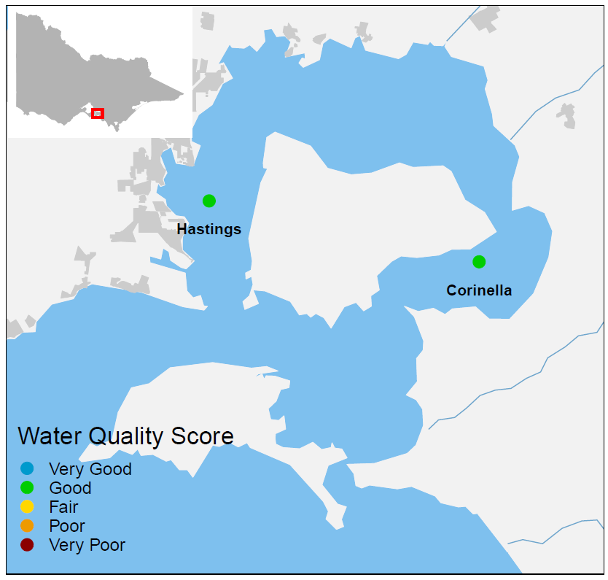
Figure 13: Locations and WQI scores of long-term EPA marine monitoring sites in Western Port.

Gippsland Lakes and catchment
The Gippsland Lakes are a 70 km-long series of large, shallow coastal lagoons. A narrow, artificially maintained channel at Lakes Entrance connects the lakes to Bass Strait. The catchment consists of mostly state reserves, forests, and national parks (60 per cent), and rural land (39 per cent). Five major river systems drain directly into the lakes: the Mitchell, Nicholson, and Tambo flow into Lake King, while the Latrobe and Avon Rivers flow into Lake Wellington.
The Report Card for Gippsland Lakes and its catchment is calculated using monitoring data from DEECA (26 sites) and EPA (five sites). Scores are only calculated for rivers and streams in the catchment that drain into the Gippsland Lakes. The Gippsland region continued to experience above average rainfall associated with the La Nina climatic pattern that has affected eastern Australia. In 2022–23 there was above average spring rainfall (Figure 2), which was reflected in water quality varying from Very Good and Good in the majority of the catchments (Figure 14). 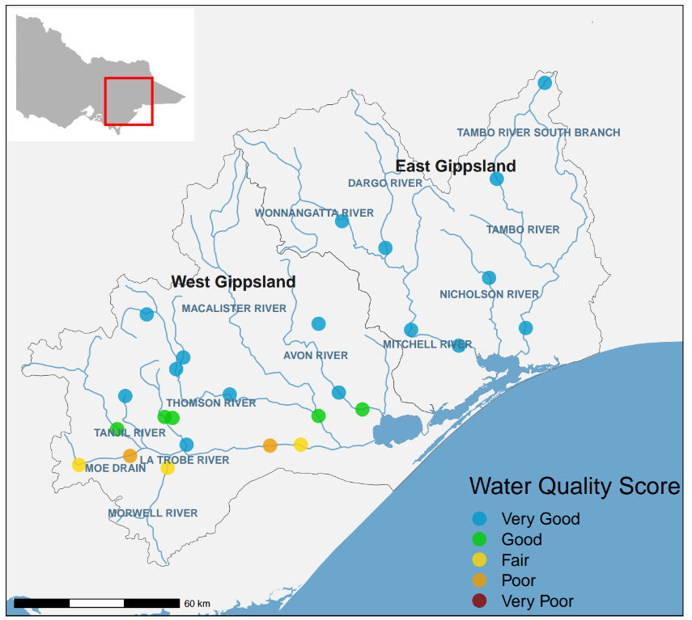
Figure 14: Location and WQI scores of DEECA’s monitoring sites in the Gippsland Lakes catchment.

Catchment Report Card
In West Gippsland, water quality was Good, similar to previous years (Figure 16). The forested areas on the slopes of the Great Dividing Range maintained Very Good water quality. Water quality declined to Fair or Poor along the mid and lower reaches of the Latrobe River, where cleared land and urbanisation have impacted water quality.
In the East Gippsland catchment, Very Good water quality was sustained from previous years (Figure 15).
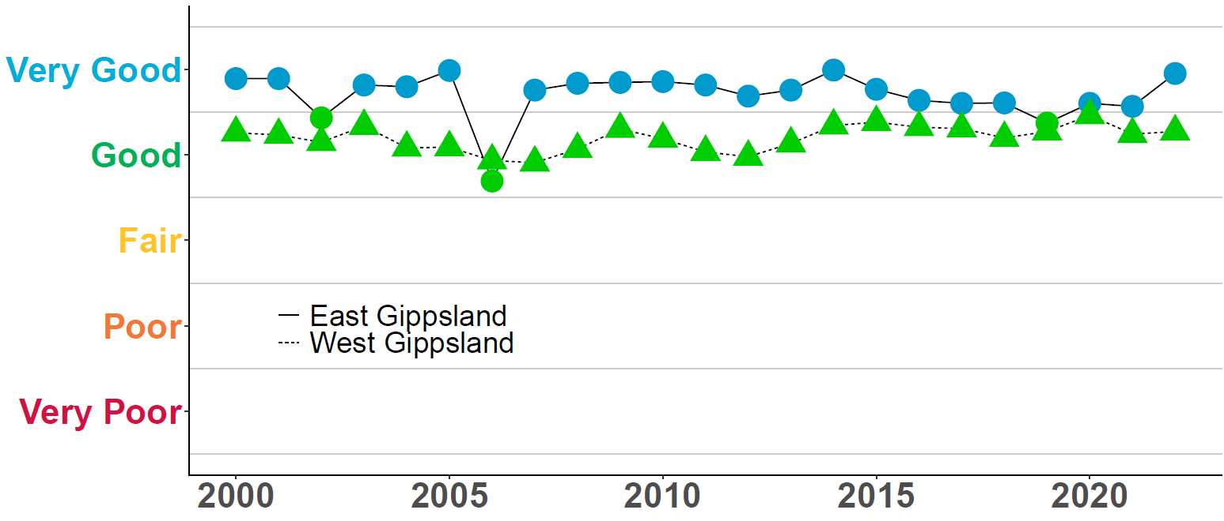
Figure 15: Historical WQI scores for the Gippsland catchments.

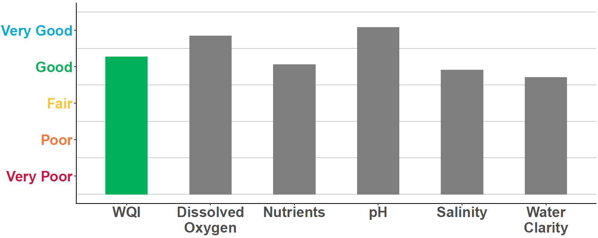
Figure 16: WQI scores for West Gippsland catchment in 2022–23. Grey bars are the individual indicators used to calculate the overall WQI score.

Gippsland Lakes Report Card
EPA has five monitoring locations in the Gippsland Lakes (Figure 17). Monitoring locations closer to the entrance to Bass Strait (Shaving Point, Lake King) typically have better water quality due to greater tidal exchange than those sites located further away from the entrance. (Lake Wellington and Lake Victoria).
Lake Wellington
Lake Wellington is a sink for sediments, nutrients, and contaminants. Wind and waves within the shallow waters of the lake can re-suspend sediments and nutrients. Algal blooms often develop because of the high availability of nutrients. During drier periods with less river inflow, the Lake can also be affected by rising salinity from ingress of marine water, and increased evaporation. Historically, water quality in Lake Wellington has been rated as Poor or Very Poor (Figure 18). The Fair rating, sustained from 2020-21, related to higher river flows maintaining lower salinity within Lake Wellington.
Eastern Lakes
The region experienced average to below average rainfall/run-off during spring/summer 2022-23 which delivered significantly less nutrient loads to the Lakes than recorded in 2021-22. This was reflected in an improved WQI to Good in 2022-23, driven by improvements in the Algae and Nutrient indicator scores (Figure 19). This was a significant improvement from the Poor rating in the previous 2021-22 Report Card, that was caused high rainfall and an extensive blue-green algal bloom in the Eastern Lakes.

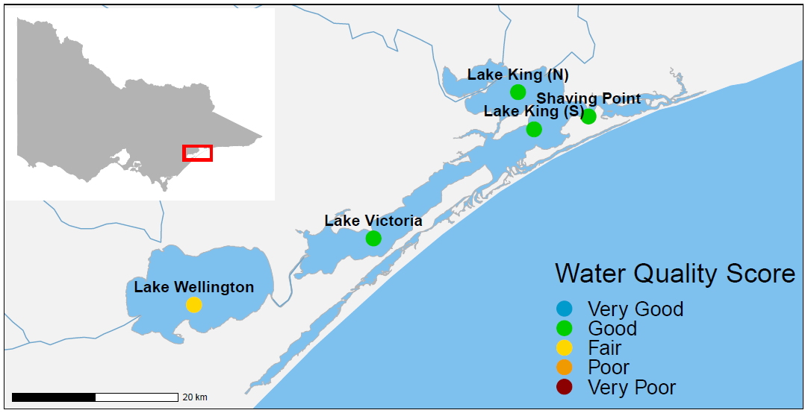Figure 17: Locations and WQI scores of EPA’s long-term marine monitoring sites in
Gippsland Lakes.

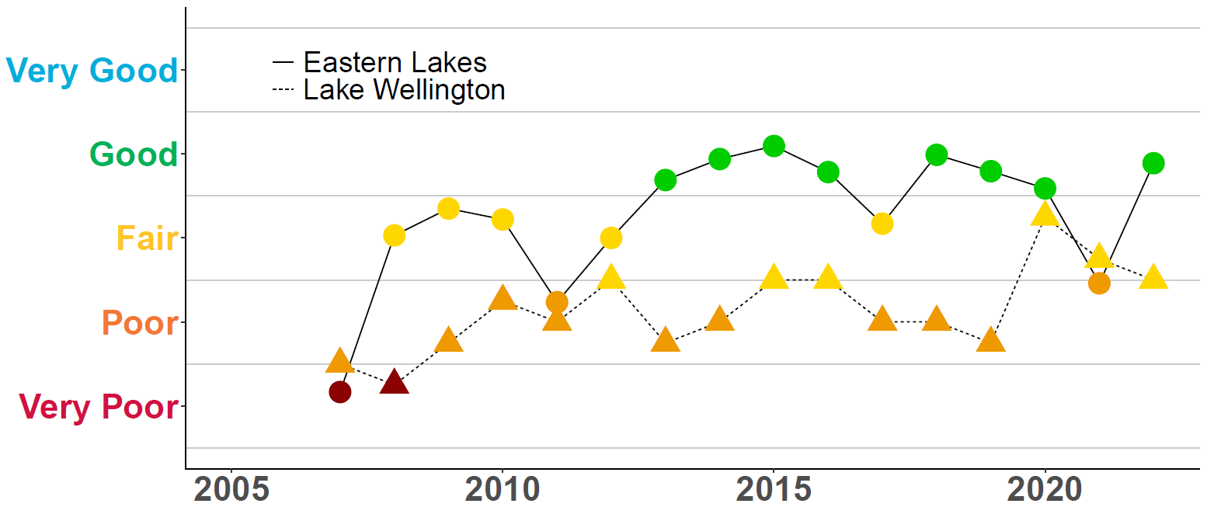
Figure 18: Historical WQI scores for Eastern lakes and Lake Wellington. Due to limited monitoring, no scores were calculated for some years between 2001 and 2006.
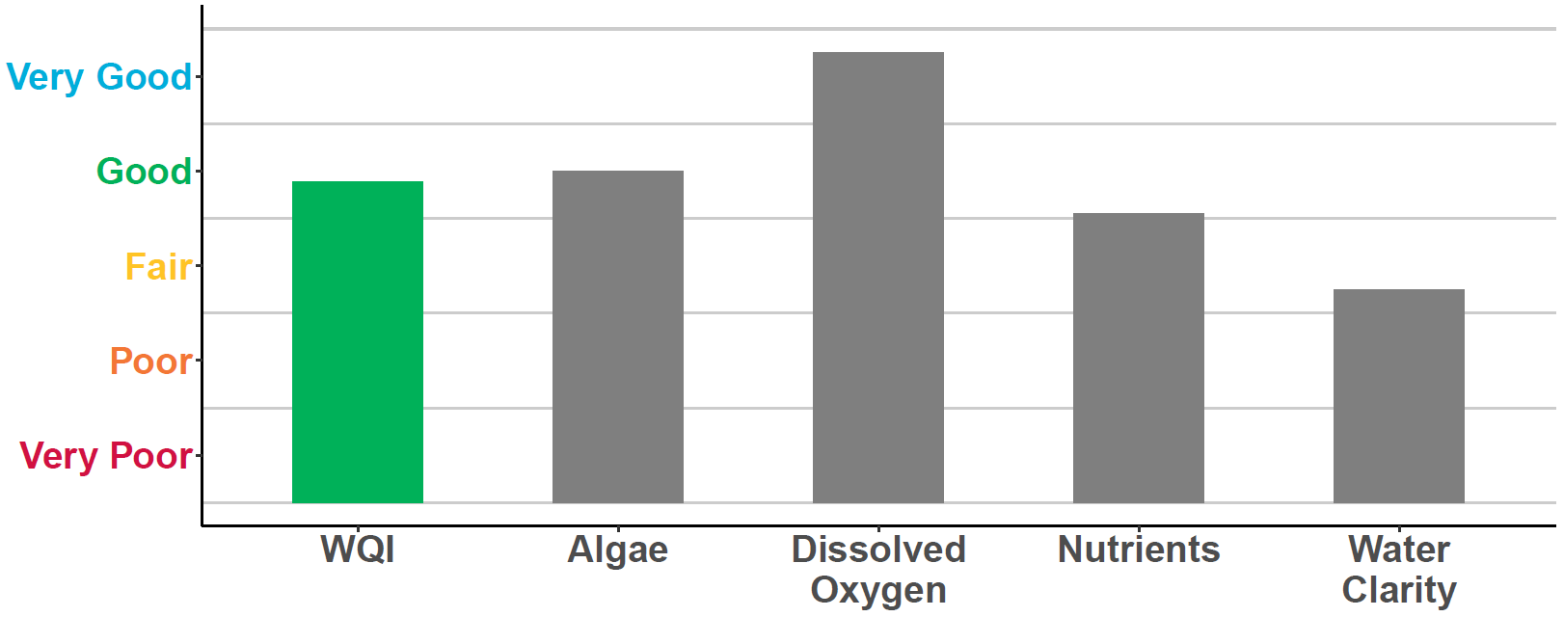Figure 19: Overall WQI scores for the Eastern lakes in 2022–23. Grey bars are the individual indicators used to calculate the overall WQI score.

Further information
Water Quality Data
Find data from the catchments at the Victorian government’s Water Measurement Information System (https://data.water.vic.gov.au/).
Find data for the bays and lakes at the Victorian governments open data website Data Vic (https://www.discover.data.vic.gov.au/)
Find information on how DEECA, EPA Victoria and Melbourne Water work to improve water quality across Victoria at EPA’s Report Card web page (https://www.epa.vic.gov.au/for-community/monitoring-your-environment/monitoring-victorias-water-quality/report-card).
Key References
Find out more about the Environment Reference Standard (2021) for Victoria at EPA’s website (https://www.epa.vic.gov.au/about-epa/laws/epa-tools-and-powers/environment-reference-standard).

This publication is for general guidance only. You should obtain professional advice if you have any specific concern. EPA Victoria has made every reasonable effort to ensure accuracy at the time of publication.

This work is licensed under a Creative Commons Attribution 4.0 licence.

EPA acknowledges Victoria’s First Nations peoples as the Traditional Owners of the land and water on which we live and work. We pay our respect to their Elders past and present.

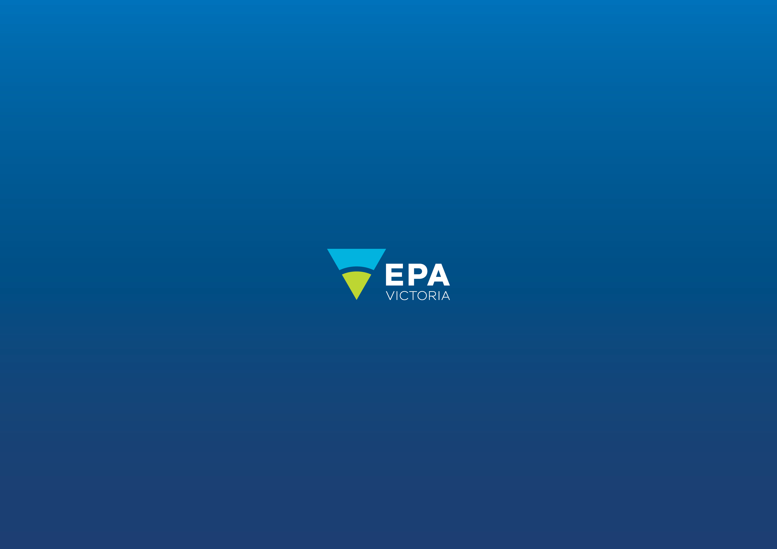
Authorised and published by the Victorian Government, 1 Treasury Place, Melbourne
epa.vic.gov.u
Environment Protection Authority Victoria
GPO BOX 4395 Melbourne VIC 3001
1300 372 842

