  - Publication 702.2

Soil sampling for
waste soils

Authorised and published by the Victorian Government, 1 Treasury Place, Melbourne
epa.vic.gov.au
Environment Protection Authority Victoria
GPO BOX 4395 Melbourne VIC 3001
1300 372 84
EPA acknowledges Aboriginal people as the first peoples and Traditional custodians of the land and water on which we live, work and depend. We pay respect to Aboriginal Elders past and present and recognise the continuing connection to, and aspirations for Country.

Acknowledgements
EPA gratefully acknowledges the industry groups, local councils and government agencies that contributed to the development of this guide through various workshops and information sessions.
We thank everyone for their contribution and commitment to keeping Victoria prosperous and liveable by preventing and reducing harm from pollution and waste.

Disclaimer
EPA guidance does not impose compliance obligations. Guidance is designed to help duty holders understand their obligations under the Environment Protection Act 2017 and subordinate instruments, including by providing examples of approaches to compliance. In doing so, guidance may refer to, restate, or clarify EPA’s approach to statutory obligations in general terms. It does not constitute legal or other professional advice and should not be relied on as a statement of the law. Because it has broad application, it may contain generalisations that are not applicable to you or your particular circumstances. You should obtain professional advice or contact EPA if you have specific concerns. EPA has made every reasonable effort to provide current and accurate information, but does not make any guarantees regarding the accuracy, currency or completeness of the information.
Except where noted at epa.vic.gov.au/copyright, all content in this work* is licensed under the Creative Commons Attribution 4.0 Licence. To view a copy of this licence, visit creativecommons.org.

Contents
Acknowledgements 2
Disclaimer 2
1. Introduction 5
1.1. Scope 5
1.2. Further information 5
2. Legislative Requirements 7
2.1. Environment Protection Act 2017 7
2.2. Environment Protection Regulations 2021 7
2.3. Overview of the waste framework 7
2.4. Classifying waste soil. 8
2.5. EPA Permissions 9
2.6. Compliance and enforcement of waste obligations 9
3. How sampling supports classification of waste soils 10
4. How to classify waste soils 12
4.1. Overview 12
4.2. Data Quality Objectives 12
4.3. Integrate DQO into your sampling plan 12
5. Initial assessment 14
6. Design 15
6.1. Defining the classification domain – Step 4 15
6.2. Confirmatory sampling 16
6.3. Sampling for waste soils potentially containing concentrations above fill material thresholds 16
6.3.1. Overview 16
6.3.2. Classification domain-based sampling design 17
6.3.3. Stockpile sampling design 18
6.3.4. Sampling Depth 19
6.4. Number of samples needed – Step 5 21
6.4.1. How many samples do I need? 21
6.4.2. Recommended number of sampling results for soil volumes over 5,000m³ 21
6.4.3. The combined risk value method 22
6.4.4. Other approaches 23
6.5. Considerations for obtaining a representative sample 23
6.6. What to test for – Step 6 24
6.7. Statistical analysis of results 24
6.7.1. Use of the maximum concentration 24
6.7.2. Calculation of 95% UCL average 24
6.7.3. Dealing with non-detects 25
6.7.4. Identifying and dealing with statistical outliers 25
6.7.5. Defining a new classification domain when a statistical outlier is identified 26
6.8. Leachability testing and the 20 times rule 27
6.9. Quality assurance and quality control considerations 28
6.9.1. Quality control samples 28
7. Assigning a waste category and classifying waste – Step 7 30
8. Using accredited consigner or environmental auditors 30
8.1. How an accredited consigner may assist 30
8.2. How an environmental auditor may assist 30
9. Glossary and definitions 31
10. Further information 32
Appendix 1: Soil characterisation considerations 33
Appendix 2: Worked example of 95% UCL average (normal distribution) 36
Appendix 3: Worked example of 95% UCL average for lognormal data 38
Appendix 4: Values of student’s T AT α = 0.05 (this gives 95% UCL) 41
Appendix 5: Values of h1-α = h0.95 for computing a one-sided upper 95% confidence limit on a lognormal mean 42

Introduction
Waste soils may contain contaminants including heavy metals, asbestos and industrial chemicals. If waste soils are not properly managed, they may expose people and the environment to contaminants, resulting in potential risk of harm. You have a legal duty under the Environment Protection Act 2017 (the Act) and the Environment Protection Regulations 2021 (the Regulations) to classify and manage your industrial waste soils (see Section 2).
This guidance provides information to help you identify suitable approaches for sampling and analysing soil so you can interpret the results to classify industrial waste soil before it is reused or contained onsite, or moved offsite for reuse, treatment or disposal.
How you use this guidance will depend on the nature of your project, including the volume of soil and the complexity of its contamination profile. The guidance will help you understand the priority waste category of your waste soil, which informs appropriate management options once the soil is classified in line with the Act.
This guidance is for environmental professionals and duty holders with a reasonable level of knowledge of environmental assessment and waste soils.

1.1 Scope
This guidance explains:
- legislative requirements for waste soils
- when waste soils need to be characterised to inform classification
- how to characterise waste soils, including sampling strategies, analysis requirements, statistical treatments as well as quality assurance and quality control considerations.
This guidance is intended to support duty holders who are in control or management of waste soil that is industrial waste.
Industrial waste is:
- waste arising from commercial, industrial or trade activities or from laboratories.
- waste from any source received at a place or premises which stores or handles waste generated at another site for the purpose of resource recovery or off-site transfer or disposal.
- waste transported for a fee or reward other than the collection of kerbside waste.
For more information on classifying industrial waste see Guide to classifying industrial waste (EPA Publication 1968.1).
This guidance does not provide information on soil sampling for contaminated land assessment or solid wastes other than soil.

1.2 Further information
To help manage risks from your industrial waste and comply with environment protection legislation, you should consider the following publications and resources in conjunction with this guidance:
- Industrial Waste Resource Guideline (IWRG701) Sampling and analysis of waters, wastewaters, soils and wastes details protocols required for soil sample collection, handling and storage.
- Waste disposal categories – characteristics and thresholds (EPA Publication 1828) details how to categorise waste soils to determine the appropriate management option. Waste soil must be assigned a hazard category of A, B, C, D or fill prior to offsite reuse, onsite containment, disposal or treatment.
- How to classify industrial wastes (EPA Publication 1968) details the process for classifying waste under the Act and Regulations.
- Potentially contaminated land – a guide for businesses (EPA Publication 2010) provides support for those who uncover or otherwise become aware of contamination of the land they manage or control.
- Australian Standard 4439.2:2019 Wastes, sediments and contaminated soils Part 2: Preparation of leachates – Zero headspace procedure (AS 4439.2:2019) details how to conduct leachability analysis and testing.
- National Environment Protection (Assessment of Site Contamination) Measure (ASC NEPM) Schedule B2 – Site Characterisation provides further information on sampling approaches and design.
- Potentially Contaminated Land – Planning Practice Note 30, July 2021 (published by the Department of Environment, Energy and Climate Action) details how to identify if land is potentially contaminated and the interaction between contaminated land regulation and land use planning.
If you require an environmental professional, you can identify a suitable one through an appropriate industry body or EPA’s appointed/accredited roles. See Section 8 for further information.

Legislative Requirements
This section explains how Victoria regulates waste soils under the Act and Regulations.

2.1 Environment Protection Act 2017
The Act takes a preventative approach to managing risks to human health and the environment from pollution and waste in Victoria. This approach focuses on preventing impacts from waste and pollution rather than managing those impacts after they have occurred. For more information see What the Environment Protection Act 2017 means for Victorian businesses.
The cornerstone of the Act is the general environmental duty (GED) supporting a preventative approach to protecting Victoria’s environment. It requires all Victorians to understand and minimise the risks of harm to human health and the environment from their pollution and waste. For more information see Industry guidance: supporting you to comply with the general environmental duty (EPA Publication 1741).
Part 6.4 of the Act sets out duties relating to industrial waste. If you are a business generating or dealing with waste, you have waste duties. You need to manage your risks onsite and when you dispose of or hand on your waste.

Environment Protection Regulations 2021
The Regulations support the objectives of the legislation to prevent or minimise risks of harm to human health and the environment from pollution or waste. The Regulations give effect to the Act by imposing obligations in relation to environmental protection, pollution incidents, contaminated land and waste. The Regulations also prescribe activities requiring an EPA permission under the Act.
The Act sets out the definition of industrial waste and establishes waste duties. The Regulations set up the process for classifying industrial waste and prescribe additional situations where waste is considered industrial waste. Part 4.2 of the Regulations sets out the requirements for managing industrial waste in line with the Act.

2.3 Overview of the waste framework
The objectives of the waste framework include:
- encouraging application of the waste management hierarchy
- promoting waste reduction
- resource recovery and resource efficiency
- minimising the impact on human health and the environment from waste generation and waste disposal.
The Regulations set out processes and requirements to help you in fulfil your duties under the Act. This includes the process you must use to classify waste and the permissions required to lawfully transport and receive certain waste types. The Regulations convert the duties outlined in the Act into actions to follow, forming the waste framework. Figure 1 provides an overview of the waste framework.
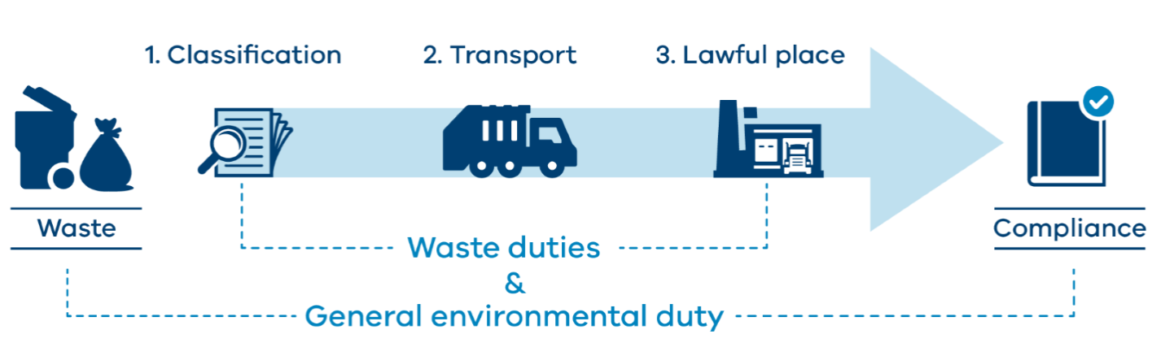
Figure 1 depicts the general overview of the waste framework.
The 3 key steps to managing industrial waste under the waste framework are:
- Classification: what is the waste?
Industrial waste must be properly identified and classified. This makes the duties that apply to the management of the waste clear. Some industrial wastes are classified as priority wastes or reportable priority wastes. These are subject to additional requirements.
- Transportation: how should the waste be transported safely?
Waste must be safely contained during transportation. Some waste types have specific containment and isolation requirements. Transport duties will depend on the classification of your waste.
- Lawful place: where must the waste go?
Industrial waste must go to somewhere authorised to receive it, such as a place with an EPA permission or where a determination allows reuse.

2.4 Classifying waste soil
Soils that is industrial waste must be classified. Changes introduced in 2021 have made it easier to classify industrial waste by:
- listing waste codes and waste types in the Regulations. Waste soil can be classified as:
  - fill material (waste code N122)
  - contaminated soil (waste code N120)
  - waste acid sulfate soil (waste code N123)
- publishing waste category limits for a large number of common contaminants found in waste in Waste Disposal Categories – Characteristics and Thresholds (EPA Publication 1828).
The list of contaminants in EPA Publication 1828 is not exhaustive. If there are contaminants not included in this list that you need guidance about, contact EPA.
If the soil meets the definition of industrial waste and is contaminated soil, reportable priority waste duties will apply. This includes transport requirements, such as the use of Waste Tracker, and for the waste to be transported in a permissioned vehicle. Along with your reportable priority waste duties, there are additional requirements under your priority waste duties, such as investigating alternatives to waste disposal and ensuring sufficient information about the waste is provided to the next person in the supply chain so they can meet their duties.
EPA Publication 1828.2 sets out contaminant thresholds for various potential contaminants of concern in waste soils. Assigning a waste disposal category to your waste soil will inform which permissioned sites can receive the waste. It will also indicate if you require a permission (for instance, to contain the soil on a project site) or if you need to treat your soil. You can find out more about how to classify waste soil in How to classify industrial waste (EPA Publication 1968.1).
Waste soil may be tested to identify the appropriate waste disposal category. Soil sampling analysis and results are compared against thresholds set out in EPA Publication 1828 to determine the appropriate category of waste soil.

2.5 EPA Permissions
EPA permissions work alongside the GED to ensure performance standards are met. You may require more than one permission, depending on your operations and the type of waste you have. There are 3 tiers of permissions based on the level of risk to human health and the environment:
- licences for high-risk activities
- permits for medium-risk activities
- registrations for low-risk activities.
The activities that require an EPA permission are set out in Schedule 1 of the Regulations. Schedule 1 also sets out what type of permission is required for each prescribed activity.
Examples of permissions relevant to managing waste soil include:
- A01 licence: for storing, treating, reprocessing, containing or disposing of reportable priority waste generated at another site.
- A13 licence, permit or registration: for receiving, storing or processing non-reportable priority waste generated at another site for resource recovery or offsite transfer or disposal, depending on the size and extent of the activity.
- A17 permit: for the containment of Category D waste soil within a project site.
- L08 registration: for receiving Actual Acid Sulfate Soil or Potential Acid Sulfate Soil for treatment.
- L09 permit: for disposing of tunnel boring machine spoil generated at another site, unless already authorised under an EPA licence.

Further permissions may be needed from EPA prior to onsite or offsite reuse or disposal of waste soil. For general information on permissions, refer to EPA’s Permissions scheme policy.
If you wish to trial, research or develop a new process or product or demonstrate an innovative technology or technique, a pilot project licence may be appropriate.
If you are not sure what type of permission you might need, check if you need a permission by submitting a Permission proposal pathway form or contact EPA on permissions@epa.vic.gov.au to discuss your activity and potential permission requirements.

2.6 Compliance and enforcement of waste obligations
The Act provides EPA with various powers to hold duty holders accountable for their responsibilities and other obligations. EPA will use these powers to monitor and enforce compliance in line with our Compliance and enforcement policy (EPA Publication 1798.2).
This may include requiring parties to remedy noncompliance, remedy or restore any harm caused and, where appropriate, pursue a penalty or punishment.

3 How sampling supports classification of waste soils
To accurately classify your waste, and to provide assurance to the receiving site that they are legally allowed to receive the waste soil, EPA recommends sampling if you are generating waste soil that potentially contains contaminants. Figure 2 provides an overview of the recommended steps to manage waste soils.
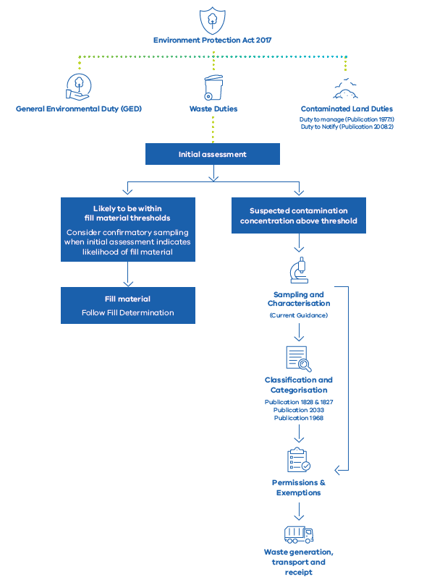
Figure 2: Identifies where soil sampling falls within the management of waste soil and the overarching duties.

When classifying industrial waste that is soil, EPA recommends assessment of the soil including an understanding of site history. EPA recommends an initial site assessment to determine the likely contaminants in your waste soil and to meet your waste duties. Your initial assessment will inform any further steps appropriate to classifying the waste (see Section 5).
If your initial assessment indicates potential contamination, you should characterise your waste by soil sampling and testing for contaminants that are known or that you should reasonably expect to be present. This includes contaminants from previous site uses and history, local geology and lithologies, known contaminated land and contaminating events.
Soils should be sampled if they:
- arise from potentially contaminated land
- arise from known contaminated land as per Regulation 62 – classifying soil sourced onsite from contaminated land
- have been mixed with any waste
- consist of, or partially consist of, soil of unknown origin brought onto a site
- arise from sites where former uses include industrial, commercial, mining or agricultural activities
- have had manufactured chemicals applied.
Where there is limited or no information (for example, stockpile of unknown origin) consider conducting soil sampling using the full suite of contaminants listed in Table 3 of EPA Publication 1828.2.
Where the likelihood of contaminants is low or likely to fall within fill material thresholds, consider confirmatory sampling to establish multiple lines of evidence to classify your soil as fill material (see Section 6.2)

4 How to classify waste soils

4.1 Overview
There are many components to classify waste soils. This section outlines how to choose:
- an appropriate sampling density
- where to sample
- what to test for
- how to analyse and interpret results to assign a waste category.
You may adopt a different combination of approaches to create a suitable regime for your circumstances.

4.2 Data Quality Objectives
The data quality objectives are a useful framework to guide and optimise your sampling plan to achieve high quality data for decision making. The DQO process can be adapted for all projects types. For further information on the DQO process, refer to ASC NEPM and references therein such as the US EPA Guidance on Systematic Planning Using Data Quality Objectives Process (2006), for greater detail.

4.3 Integrate DQO into your sampling plan
The following section outlines the steps EPA recommends to develop a sampling plan while considering the DQOs:
Initial Assessment
- Step 1 state the problem: Identify soils that are waste or will become waste (see Section 2.4 about when a soil is waste and needs to be classified).
- Step 2 identify the goal of the study: The objective is to assign an appropriate waste category to soils to classify them as waste.
- Step 3 identify the information inputs: An initial assessment establishes what to test for and where to collect preliminary samples to classify your waste soil.

Design
- Step 4 define the classification domain(s): Identify the spatial location, dimensions and volume of waste soil that will be produced and, if required, split the soil into multiple classification domains. See Section 6.1 for defining a classification domain.
- Step 5 determine where to sample, what to sample for and how many samples are needed: Develop a sampling plan that shows where the samples will be collected, what the samples will be analysed for and how many samples will be collected and analysed. This is outlined in sections 6.3 and 6.4 respectively.
- Step 6: specify performance or acceptance criteria:
- ensure laboratory detection limits are suitably lower than waste category thresholds
- use the highest concentration or the 95% UCL to categorise the domain
- test for and investigate statistical outliers
- test for total concentration (TC) and Australian Standard Leaching Procedure (ASLP), as required
- assess data quality in terms of repeatability and accuracy (See Section 6.8 and 6.9 for further advice on leachability testing and quality assurance or quality control assessment)

Execute sampling
The physical collection of samples should be done in accordance with ASC NEPM

Analysis of results
Step 7 laboratory analysis of results and complete statistical analysis: Determine the waste category to be assigned. The results of sampling are compared against waste categorisation thresholds in EPA Publication 1828.
Appendix 1 sets out a checklist of considerations when characterising waste soils. EPA recommends waste classification reports include this information.
EPA recommends a visual depiction of the information gathered and used to classify waste soil. As an example, this could include a site map with key soil sampling features, including locations and number of samples, and planned project features, such as permissioned activities (for example, containment of Category D soils)

5 Initial assessment
Steps 1 to 3 can be summarised in an initial assessment. Once you have identified soils that are waste or will become waste and the objective of classifying your waste appropriately, the first step in classifying your waste soils to determine their waste category is to undertake an initial assessment.
The initial assessment should be used to identify:
- the spatial location and approximate dimensions, including the estimated volume of the waste soil (that is, the classification domain, see Section 6.1 for further information).
- any activities (on or nearby the waste soil) that may have resulted in contaminant concentrations above fill material thresholds.
- contaminants that may be above fill material thresholds.
Where an initial assessment identifies waste soils generated from the site have the potential to be contaminated, EPA recommends sampling and analysis of the waste soil. Information gathered during an initial assessment (such as areas where activities with potential to contaminate have occurred) as well as practical considerations (such as the extent to which materials can be separated during excavation) can be used to design future sampling approaches.
Activities on or near waste soils that may have resulted in contaminant concentrations above fill material thresholds may include (but are not limited to):
- abattoirs
- airports
- brickworks
- cement manufacturing
- chemical manufacturing, storage or blending
- fill sites
- gasworks
- landfills or waste depots
- service stations or fuel storage sites
- mining or extractive industries
- dry cleaning
- agriculture and animal production where commercial pesticides have been applied
- farm waste disposal
- stockpiles of anthropogenic fill soils that have an unknown origin.
For further information about the elements to consider when conducting an initial assessment, please refer to Schedule B2 of the ASC NEPM guidance on how to conduct an initial assessment in line with preliminary site assessment (PSI). Please note that the following elements of a PSI are not relevant when characterising waste soils:
- identification of potential human and ecological receptors
Identification of potentially affected media (other than soil or media that may act as a source of contaminants to that soil, for example, contaminated groundwater in contact with the waste soil in question). If in the process of classifying waste soil you come to believe you have contaminated land, consult the following resources:
- Planning Note PPN30: Potentially Contaminated Land
- Guide to the duty to manage contaminated land (EPA Publication 1977.1)
- Guide to the duty to notify of contaminated land (EPA Publication 2008)

6 Design

6.1 Defining the classification domain – Step 4
Classification domain refers to the volume of waste soil being characterised to identify the appropriate waste category. When determining the classification domain:
- identify the spatial extent of the waste soil, including the volume and dimensions. This should also be presented in a diagram that shows the location of the classification domain at the source site
- explain the basis of the spatial extent of the domain, which may include:
- site knowledge, including different contaminant risk areas or historical data
- practical considerations, including construction techniques (such as the use of a tunnel boring machine)
- different stratigraphic layers or soil horizons.
The classification domain of your soil may evolve as more information becomes available during characterisation. For example, an initial assessment may identify the likelihood of 2 classification domains or, if a statistical outlier is identified, a further classification domain may be stratified. Following sampling and statistical analysis of the results, the domains can both be categorised as Category C. For practicality, the waste soils can be treated as the same classification domain.
Another scenario may be that an initial assessment identified a single classification domain but when the results are received, they identify the presence of a statistical outlier. Further investigation and delineation will result in a separate classification domain. (See Section 6.7.4 on statistical outliers.)
The stratification of waste soils into multiple classification domains may also be suitable when dealing with waste soils derived from large or complex sites, such as industrial facilities or linear infrastructure projects.
There are several ways to stratify waste soils from a site into multiple classification domains (see Figure 3). Classification domains may be chosen based on pre-existing knowledge (for example, site history and soil type). The main advantages of this design are:
- potential to achieve greater precision in estimates of the mean and variance
- calculation of reliable estimates for each classification domain.
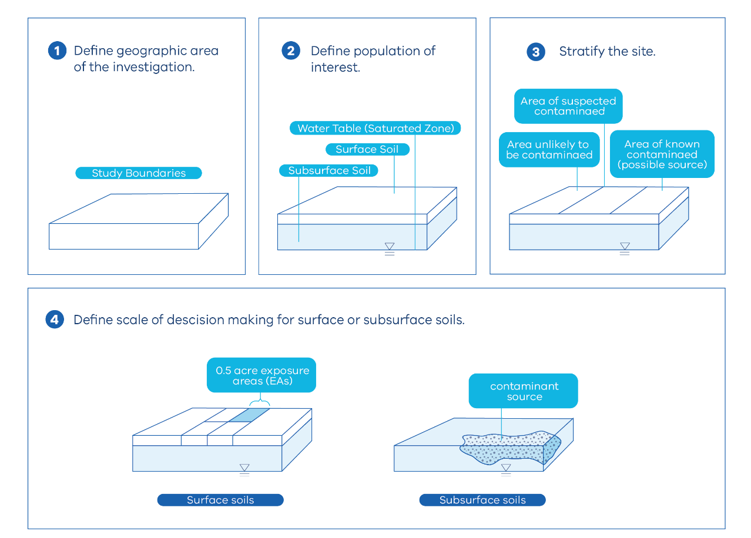

Figure 3 is adapted from US EPA. It shows the US EPA recommended process for stratifying a site into multiple classification domains when investigating potential contamination.

6.2 Confirmatory sampling
When an initial assessment indicates a classification domain is unlikely to contain contaminant concentrations above fill material thresholds, sampling can be conducted to confirm this assumption. This sampling may also be used to check that concentrations of naturally occurring chemical substances or concentrations from diffuse inputs do not exceed fill material criteria.
Consider collecting a minimum of 3 samples for classification domain volumes <1,500 m³.
For classification domain volumes >1,500 m³ consider a minimum of 10 samples when using 95% UCL up to 5,000 m³, then one additional sample for every 500 m³ above 5,000 m³. For example, a volume of 6,000 m³ requires 12 samples.
Where any of the analytical results received from confirmatory sampling exceed fill material thresholds, the waste soil should be sampled following the process set out in the following sections.
If all the analytical results received from the confirmatory sampling are below fill material thresholds, the waste soil is fill material.

6.3 Sampling for waste soils potentially containing concentrations above fill material thresholds

6.3.1 Overview
When an initial assessment indicates a classification domain is likely to contain contaminant concentrations above fill material thresholds or results of confirmatory sampling exceed fill material thresholds, undertake more detailed sampling as described below.
Soil categorisation may be done in combination with in-situ and ex-situ sampling. Where limited sampling is done using in-situ sampling, ex-situ sampling can confirm findings.

6.3.2 Classification domain-based sampling design
Once classification domains have been established, a sampling strategy can be chosen. The strategy should be chosen with the aim of:
- collecting samples representative of the classification domain
- identifying the spatial (lateral and vertical) extent of contaminants throughout the domain
- capturing variability in contaminant profile spatially (laterally and vertically)
- enabling reliable statistical analysis of results, for example, the calculation of 95% UCL average.
For in-situ soils EPA recommends 3-dimensional systematic grid sampling pattern as a simple approach that minimises potential bias, while enabling population-based statistics to be determined (mean and 95% UCL, for example). It involves applying a regular or offset grid or herringbone pattern of samples across a classification domain. See Figure 4 for an example of a systematic grid sampling approach.
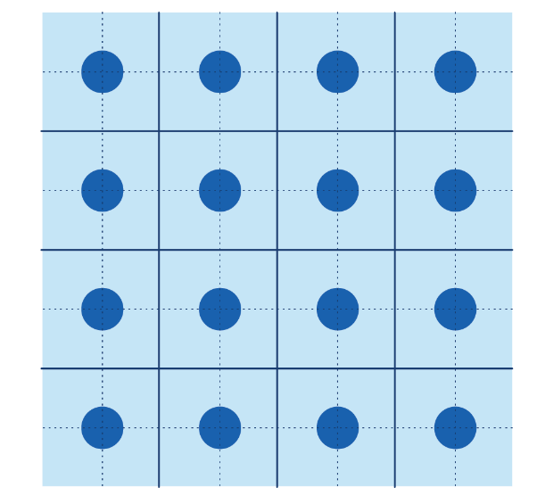

Figure 4. Example of sampling that takes place at regular intervals in a gridded configuration
Other approaches such as judgemental sampling may be used where justified.
Judgemental sampling may be appropriate for known point source contamination. This technique skews the sampling pattern to target areas with expected contamination or soil likely to have contaminants above fill material thresholds.
In Figure 5 the judgemental approach would result in the top right being defined as its own classification domain and the surrounding area would be another classification domain.
It is important to note that judgemental sampling can invalidate some statistical approaches due to its deliberately biased sampling nature, see section 6.7.2 for further detail.
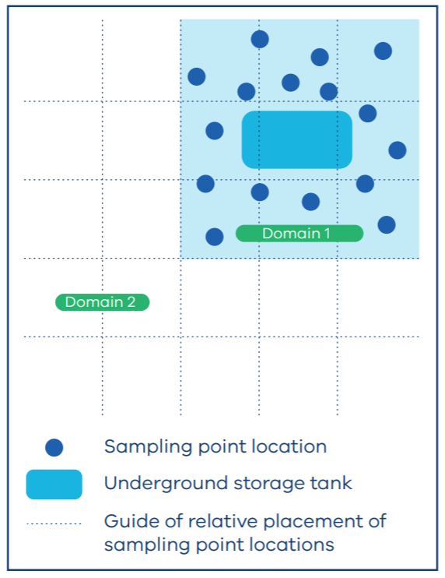

Figure 5. Highlights judgemental sampling around a known source of contamination.

6.3.3 Stockpile sampling design
A 3-dimensional systematic grid sampling design should also be used for stockpiles to account for spatial variability. Surface sampling from the stockpile will not be sufficient to categorise its contents and is not appropriate where volatile and leachable contaminants are present. Sampling should be uniformly distributed throughout the stockpile, including sampling at depth. Figure 6 illustrates a
3-dimensional system suitable for stockpiles.

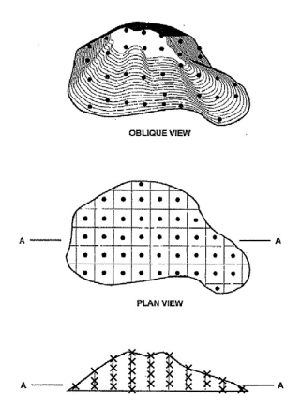

Figure 6 Demonstrates how to approach stockpile sampling. It is reprinted, with permission from D 6009-96(2006) Standard Guide for Sampling Waste Piles, copyright ASTM International, 100 Barr Harbor Drive, West Conshohocken, PA 19428. The complete standard may be purchased from ASTM International, www.astm.org).

6.3.4 Sampling Depth
As described above, a 3-dimensional systematic grid approach should be used for sampling, including the collection of subsurface samples. Collecting subsurface samples determines if and by how much contaminant concentrations change with depth across the classification domain. This will maximise the representativeness of the samples.
When determining the depth at which samples should be collected:
- apply the initial assessment and classification domain vertically
- ensure the sample depth reflects the depth of the waste soil to be removed (refer to section 6.4 further information on the number of samples needed).
Consider sampling and analysing horizons in the soil/rock profile where contaminant concentrations are expected to vary or accumulate, or both, such as:
- at surface (0.0–0.1 metres below ground level)
- at half a metre (0.4–0.5 metres below ground level)
- at one metre below ground level
- at actual or possible locations of contaminant sources (for example, vicinity of current or former underground storage tanks)
- at any depth where there are visual or olfactory signs of contamination at the site
- either side of a significant lithological change, or other geological features where contaminants may accumulate (for example, in the capillary fringe)
- at the base of the classification domain (that is, the deepest point).
One potential approach includes taking one sample for every metre below ground level. Where there are site-specific requirements, consider obtaining a representative classification of your waste soils at depth. The recommended points are illustrated in Figure 7.
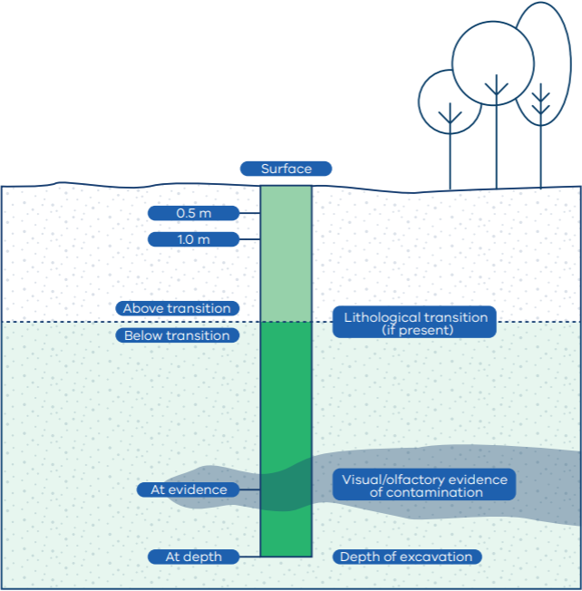

Figure 7 provides an example of recommended sampling points

6.4 Number of samples needed – Step 5

6.4.1 How many samples do I need?
This section outlines the recommended sampling frequency and approaches to calculating appropriate frequencies for large volumes of waste soils sourced from complex sites (for example, many sources or land parcels).
The number of samples to take will be informed by the initial assessment, the volume of soil to be excavated, and statistical approaches used.
When sampling in situ, a 1.33 bulking factor should be used in conjunction with the number of samples in Figure 8.
Figure 8 outlines the minimum sampling rate for waste soils, based on classification domain volume. Where other lines of evidence show additional investigation requirements (for example, from the initial assessment), a greater sampling density may be required.
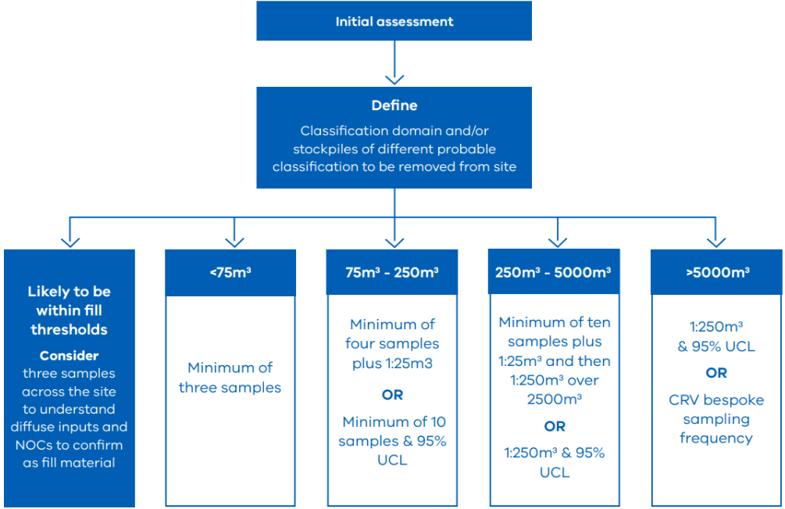
Figure 8 Flowchart to determine the minimum sampling rates and options. Volumes are based on the volume of classification domain. A 1.33 bulking factor should be included for all in-situ sampling.

6.4.2 Recommended number of sampling results for soil volumes over 5,000m³
For volumes greater than 5,000 m³, the following options may be used to determine the appropriate number of sampling results required to assign a waste category.
Option 1: One sample per 250 m³, using the 95% UCL average to compare against waste disposal category thresholds.
Option 2: Undertake the combined risk value (CRV) method as set out below. EPA recommends verification of classifications using this option by EPA appointed environmental auditors (see Section 8.2).

6.4.3 The combined risk value method
The CRV method is a statistical technique to interpret samples collected using one of the probabilistic sampling approaches (that is, collecting samples using a grid sampling approach). It is used to validate whether a sufficient number of samples have been collected based on concentration results in a given area.. This is assessed using 95% UCL average or other statistical methods, or both.
It is important to note the CRV method assumes a normal distribution. It is not suitable for datasets that are not normal or lognormal. A requirement of using the CRV method, therefore, is evidence that the data has normal or lognormal distribution. Normality tests, such as the Shapiro-Wilk test, and tools, such as ProUCL, can be used to examine the distributional model most appropriate for a given dataset.
When the CRV method indicates that a large number of samples are required, as well as a large value standard deviation (σ), further characterisation may be required to segregate the classification domain into multiple classification domains either across the landscape or by depth or if there is a hotspot. Effect size should also be considered. The CRV method can be used to design a sampling program based on either previously collected data or estimates to determine the mean and standard deviation retrospectively (NSW EPA).
You will need an initial range-finding sampling approach to determine estimated standard deviation if using the CRV method. A minimum of 3 samples is required to determine a standard deviation of the data set but you may require more samples to determine the standard deviation needed for your unique project requirements.

Equation 1
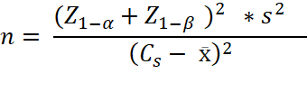

Where:

n = number of samples needed
z = standard normal distribution (z curve)
Z_{1- α} = Z value for α risk
Z_{1- β} = Z value for β
C_{s} = criterion/action level
x̄ = sample mean
s = sample standard deviation
6.2 = factor derived from 0.05 α risk and 0.2 β risk
(Calculation adapted from NSW EPA – Sampling Design – Application Part 1).

6.4.4 Other approaches
CRV is the preferred approach. An alternative option is the maximum probably error (MPE) method set out in NSW EPA guidance. It is useful for estimating a classification domain’s arithmetic mean at a specified confidence level. MPE uses the margin of error (MoE), standard deviation(s) and the critical value at a 95% UCL or higher. MPE assumes the data will have an almost normal distribution. It is based on parametric methods and assumes unbiased sampling data (NSW EPA). The MPE method is unable to retrospectively demonstrate sufficient sampling but can provide a guide for an appropriate number of samples based on the data’s variability(s) and the precision of the data or MoE. It should be used in conjunction with other approaches.
For data that are not parametric (that is, not normal or lognormal), other approaches to determining an appropriate number of samples may be adopted, provided they have a robust statistical basis. Consider engaging with an accredited professional such as an environmental auditor for verification.

6.5 Considerations for obtaining a representative sample
Characterisation of a classification domain should be based on samples representative of the waste being produced. For in-situ sampling, EPA requires you to consider the construction techniques expected to be used in generating the waste.
Where an in-situ characterisation is conducted on waste soil that will be generated by a tunnel-boring machine (TBM), for example, ideally the sample should be subjected to conditions that mimic the action of the TBM, including churning and mixing of the material. Considering additives that may be used to help the construction process may also be necessary. Ideally, samples should be collected across the horizon the TBM is anticipated to intercept.
There are a wide range of sampling techniques that may be used to collect a representative sample. These are outlined in the National Environment Protection (Assessment of Site Contamination) Measure (ASC NEPM) Schedule B2.
Contact EPA for other sampling approaches

6.6 What to test for – Step 6
To support accurate and representative soil classification, it is recommended that you:
- test for contaminants reasonably expected from the initial assessment. If your initial assessment indicates soil may contain contaminants not listed in EPA Pub 1828, contact EPA for further guidance
- consider testing 20% of all samples against the full suite of analytes set out in EPA Publication 1828.2 Table 3 – Fill material contamination total concentration upper limit.
Testing and analysis should be conducted by a laboratory accredited by the National Association of Testing Authorities, Australia (NATA).
Where total concentrations reported are within 20 times of the ASLP category thresholds, ASLP testing may be required. See Section 6.8 for further information.

6.7 Statistical analysis of results

6.7.1 Use of the maximum concentration
In circumstances where the number of samples is not adequate to calculate a 95% UCL or where the 95% UCL is not appropriate for a given dataset (as determined by the assessor), use the highest individual concentration result to determine the appropriate waste disposal category.

6.7.2 Calculation of 95% UCL average
The 95% UCL average demonstrates with 95% confidence that the average contaminant concentration of the soil represented by the data set is at or below the concentration stated.
The 95% UCL average can be calculated manually (see Appendix 2 for examples) though several tools can also be used, including but not limited to ProUCL, Microsoft Excel and ‘R’ program. It is important to note that these tools use different methods (for example Chebyshev, Student’s t, Gamma, Kaplan-Meier) to recommend a 95% UCL average, based on underlying assumptions about data distribution.
Where the 95% UCL average is used as the basis for determining the waste category of a classification domain, it should be clearly identified and justified.
There are several things to consider when calculating the 95% UCL to determine the appropriate waste category of a classification domain, including:
- The accuracy and reliability of using tools to determine the 95% UCL average depends on the quality of input data. If the data used for analysis is incomplete, contains errors or has missing values, it can lead to inaccurate results. Users should carefully review and clean their data before calculating the 95% UCL.
- The different 95% UCL approaches make different assumptions during analysis. If these assumptions are not met, the results may be invalid or misleading. Users should have a good understanding of the underlying statistical principles and assumptions to interpret results correctly.
- When using tools such as ProUCL, users should be aware of changes or updates to underlying methods that occur from time to time. For example, there was a major change in ProUCL between versions 4.0 and 5.2, whereby the Chebyshev model was not considered in the updated version. But the Chebyshev model may be an appropriate for your circumstance and is still available for assessors to adopt.
- Using the 95% UCL may mean the classification domain cannot be physically split up when excavated (that is, the waste soil must all go to the same receival site) to avoid undermining the statistical basis of the category assigned. This is particularly the case where waste soil is fill material and is being reused in an environment where human and ecological receptors may be exposed.
Environmental data often requires complicated statistical analysis and methods. Consider if there are other statistical treatments and programs for your specific purposes.

6.7.3 Dealing with non-detects
Options for dealing with non-detects in a dataset include substitution with half the detection limit, substitution with the detection limit or substituting with random values between zero and the detection limit. The appropriate method depends on the individual dataset and should be determined by the assessor.
Where detection limits are close to the categorisation threshold, assuming a value of half the detection limit may not be appropriate. For more information on handling non-detect values refer to the ProUCL User’s Guide, which includes worked examples for using ProUCL to calculate 95% UCL average with non-detects.

6.7.4 Identifying and dealing with statistical outliers
Outliers are common in environmental data sets, including those used to categorise waste soils. Decisions about how to handle them may have a consequential effect for the waste category assigned to a classification domain. Outliers are commonly referred to as hotspots. For waste classification, a hotspot is a sample that may contain waste soil that has a different waste disposal category. This may require further investigation.
An outlier can be defined as an observation in a set of data that appears to be inconsistent with the remainder of that data set (Barnett and Lewis, 1984). When interpreting sampling results of a classification domain, outliers can be identified using one or more of the following methods, depending on the number of results as well as the distribution of the data:
For parametric data:
- Dixon’s test can be used when the sample size is less than or equal to 25, where the data are normally distributed.
- Rosner’s test can be used to identify up to 10 outliers when the sample size is equal to or greater than 25, where the data are normally distributed.
For non-parametric data:
- Any result that is greater than the third quartile (Q3) plus 1.5 multiplied by the interquartile range (IQR), where the IQR equals the Q3 minus the first quartile (Q1) (Q3+1.5 x IQR). This approach is suitable for non-normally distributed data.
Modified z score greater than 3.5 measures how much a particular result differs from typical results in the dataset. The modified z score can be used for non-normal distributions as it approximates the difference of a result from the median value. It can be calculated using:
Equation 2
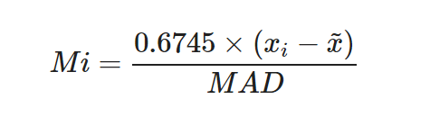

Where:
Mi = the modified z score,
MAD = median absolute deviation, and
x̅ = median, x_{i} = any single result in the dataset.
MAD = median |x−x̅| and can be calculated in ProUCL and other statistical tools.
These methods are available in tools such as ProUCL, Excel and ‘R’ program or can be calculated manually. Further information about Dixon’s and Rosner’s tests can be found in the ProUCL user guide.
You may also use other available tests.
Users should be aware of the assumptions underlying outlier identification tests and consider justifying the method selected in documentation. Graphical tools may also be useful for choosing an appropriate distributional fit for the data, as well as for identifying and investigating outliers. These tools include Q-Q plots, cumulative probability plots, and box and whisker plots.
When a statistical outlier has been identified, it should be screened against waste category thresholds to assess if it could make a difference to the category assigned to the classification domain.
If the answer is no, the classification domain can be assigned the calculated waste category. Note that this assumes the result is not on the periphery of a pocket of soil that contains even higher concentrations that have not been detected elsewhere.
If the answer is yes, the outliers are considered potentially consequential and further investigation is warranted. This involves assessing whether the outliers are:
- A data error – for example, a transcription mistake, or due to some error by the laboratory. Where an outlier can be explained as a data error, it may be necessary to re-test the sample or collect a new sample in the same vicinity. Once demonstrated to be a data error using multiple lines of evidence, it may be excluded from analysis. This decision-making process should be documented.
- Part of another classification domain – for example, a pocket of soil that may have a higher waste category should be split out and investigated separately. See Section 6.1.5 for further advice on creating a new classification domain.
If a consequential outlier cannot be explained, it may be a part of the distribution of the classification domain. In such a case, it may be necessary to assign a higher waste category to your soil.
Where such distributions are encountered and the material is being reused in the environment (for example, not going to landfill), it is necessary to ensure information is retained for future management and to consider potential implications of the high concentration results for receptors in the receiving environment. This aligns with your general environmental duty.

6.7.5 Defining a new classification domain when a statistical outlier is identified
When an assessor decides a statistical outlier may represent a different classification domain, the first step is to define the spatial boundary. One way to do this is using the ‘step-out’ approach, which involves taking samples at regular intervals in 4 directions away from the outlier sample to identify the point at which the new classification domain ends.
Assessors are encouraged to revisit the required sampling density for the new classification domain before assigning a waste category. Where it is not practical to collect additional samples to classify, the new classification domain should be presumed to extend to the next nearest sample location and depth where a lower category of contaminated soil is found. Additional ex-situ analysis of the material may be warranted to confirm the assumed waste category is appropriate.
The more samples taken, the more accurately the new classification domain can be defined and characterised, resulting in more informed waste management decisions.
Figure 9 shows the step-out delineation process when a statistical outlier is identified.
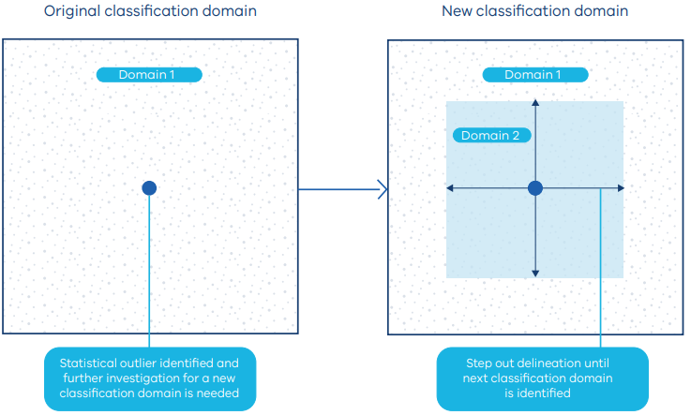
Figure 9 shows the step-out delineation process when a statistical outlier is identified. Each arrow represents a sample 7 metres away from the hotspot sample point to delineate out a hotspot statistical outlier. The light blue denotes the delineated hotspot which becomes its own classification domain.

6.8 Leachability testing and the 20 times rule
Leachability testing determines a contaminant’s ability to seep out from soil into the groundwater and surface water or landfill leachate (where soils are disposed of to landfill). Leachability thresholds following the Australian Standard Leaching Procedure (ASLP) are set out in EPA Publication 1828.2 for the different waste categories. ASLP analysis is recommended for all samples and contaminants where it is theoretically possible (based on the total contaminant concentration) for the ASLP threshold to be exceeded, which will result in a higher waste category. The 20 times rule accounts for the dilution inherent in the ASLP method, which uses soil to extractant ratio of 1:20.
ASLP can be conducted using extractants with different pH levels. The choice of extractant should be based on anticipated conditions in the receiving environment/landfill, as set out in Table 1.

Table 1 Leaching fluids for different landfill categories
Class | Landfill category | Leaching fluid (volatile contaminants) | Leaching fluid (non-volatile contaminants)
Class 1 | In situ – to be left undisturbed at the site | Reagent water | Reagent water
Class 2 | Mono-filled  2a Putrescible material  2b Non-putrescible material | Acetate buffer pH 5.0  Reagent water | Acetate buffer pH 5.0  Reagent water
Class 3 | Co-disposed with  3a Putrescible material  3b Non-putrescible material | Acetate buffer pH 5.0  Acetate buffer pH 5.0 and tetraborate buffer pH 9.2 (i.e. two leaches) | Acetate buffer pH 5.0 or pH 2.9  Acetate buffer pH 5.0 or pH 2.9 and tetraborate buffer pH 9.2 (i.e. two leaches)
Class 4 | Disposed of without confinement (including reuse in the environment in an unconfined manner) | Reagent water | Reagent water
Table 1. is adapted from AS 4439.2:2019 and AS 4439.3:2019.
For non-volatile contaminants there is a pre-treatment step. See AS4439.3 for further information on pre-treatment. For further information on leachability testing see AS 4439.1:2019, AS 4439.2:2019 and AS4439.3:2019.

6.9 Quality assurance and quality control considerations
Quality assurance (QA) and quality control (QC) are processes to ensure the accuracy, reliability and integrity of soil sampling data. Implementing QA and QC processes give confidence about the results and any decisions made based on them.

6.9.1 Quality control samples
The ASC NEPM provides appropriate guidance for taking, analysing and appraising QC samples, including blind replicates, split samples and rinsate blanks. Tolerable relative per cent differences for QC samples are listed in Table 2, as adopted from AS 4482.1:2005.

Table 2 Acceptance criteria for quality control samples
Quality control sample | Minimum number of samples | Typical RPD for quality control samples (see Notes 1 and 2)
Blind replicate sample | One for every 20 samples collected | 30–50% of mean concentration of analyte (see Note 3)
Split sample | One for every 20 samples collected | 30–50% of mean concentration of analyte determined by both laboratories (see Note 3)
Rinsate blank | One per matrix per piece of equipment per day | The significance of the rinsate blank analysis will be evaluated for the actual field samples
Notes:
- Relative Percent Difference RPD = $\frac{Result No. 1-Results No. 2}{Mean result}*100$.
- The significance of RPD of results should be evaluated based on the sampling technique, sample variability, absolute concentrations relative to criteria and laboratory performance.
- This variation can be expected to be higher for organic analysis than for inorganics and for low concentrations of analytes.
Note: blind replicate and split samples must be excluded from statistical analysis used to determine the appropriate waste category to assign, as this may be a form of pseudo-replication (i.e., double counting of a single result)

7 Assigning a waste category & classifying waste - Step 7
Following statistical analysis and evaluation of data quality, a waste category can be assigned to a classification domain. This will result in the waste soil being categorised as either:
- fill material,
- Category D,
- Category C,
- Category B or
- Category A.
The waste category assigned is used to inform the classification of that waste.
When reporting the category, it is important to ensure sufficient supporting information and documentation is also presented. Appendix 1 sets out EPA’s expectations when reporting the category of waste soils.

8 Using accredited consigner or environmental auditors

8.1 How an accredited consigner may assist
An EPA accredited consigner is an EPA-appointed professional who may help you meet your waste duties. They can help you with:
- classification and management of waste soils
- transport of waste soils to a lawful place
- creating records and tracking waste on Waste Tracker.
Further information on accredited consigners is available on EPA’s website.

8.2 How an environmental auditor may assist
EPA may require verification of sampling when classification domains with volumes greater than 5,000 m³ or when CRV approaches are used. This may be directed through an EPA notice, planning authority requirement or as directed by guidance.
An EPA-appointed environmental auditor may be engaged to verify classification reports and help manage waste soils.
EPA appoints environmental auditors under the Act. Auditors must meet all the appointment requirements, according to EPA’s assessment process. This includes being considered experts in their field.
Further information on environmental auditors is available on EPA’s website.

9 Glossary and definitions
Act | Environment Protection Act 2017 (Vic)
ASC NEPM | National Environment Protection (Assessment of Site Contamination) Measure
ASLP | Australian Standard Leaching Procedure
CRV | Combined risk value – a statistical method for determining sampling frequency.
Confirmatory sampling | A small number of samples to verify the hypothesis that soil has contaminant concentrations that do not exceed fill material after an initial assessment.
Consequential outlier | In sampling, a consequential outlier refers to an observation or data point that significantly deviates from the rest of the sampled data and has a substantial impact on the conclusions drawn from the sample.  A datapoint in a classification domain dataset, that, if excluded, would result in a different waste classification and management option.
Effect size | A value measuring the strength of the relationship between two variables in a population or a sample-based estimate of that quantity.
Ex situ | Outside or away from the original location. In this guidance, this refers to sampling stockpiles of soil.
GED | General environmental duty – see Section 25 of the Act
ha | Hectare
Hotspot | A localised contaminated area where the contaminant concentration is noticeably higher than in surrounding areas. A maximum of the sampling data that is 250% higher than the criteria level and where the standard deviation is more than 50% may indicate a hotspot.
In situ | In its natural or original place. In this guidance, this refers to sampling before any excavation has occurred.
IWRG | Industrial Waste Resource Guideline
MPE | Maximum probable error
NATA | National Association of Testing Authorities, Australia
ProUCL | A statistical software package for analysis of environmental data sets.
PSI | Preliminary site investigation
QA/QC | Quality assurance and quality control
Regulations | Environment Protection Regulations 2021 (Vic)
Statistical outlier | A data point that differs significantly from other observations

10 Further information
Cement Concrete & Aggregates Australia (August 2006) Guideline to SAMPLING for the Extractive Industry.
Environment Protection Authority, New South Wales (2022) Contaminated Sites — Sampling design part 1- application (PDF).
Environment Protection Authority, New South Wales (2022) Sampling design part 2- interpretation (PDF).
EPA Victoria (June 2009) IWRG701, Sampling and analysis of waters, wastewaters, soils and wastes.
Gilbert RO (1987) Statistical Methods for Environmental Pollution Monitoring, Chapter 13, page 170, Van Nostrand Reinhold.
National Environment Protection (Assessment of Site Contamination) Measure Schedule B2 – Site Characterisation ASTM International, D 6009-96 (2006) Standard Guide for Sampling Waste Piles, 2006.
Standards Australia, 2019 Australian Standard 4439.2:2019 Wastes, sediments and contaminated soils Part 2: Preparation of leachates – Zero headspace procedure for pH testing requirements.
Standards Australia, 1999, Australian Standard 4482.2-1999: Guide to the Sampling and Investigation of Potentially Contaminated Soil. Part 2: Volatile Substances.
Standards Australia (2005) Australian Standard 4482.1-2005: Guide to the Sampling and Investigation of Potentially Contaminated Soil. Part 1: Non-volatile and Semi-volatile compounds.
Standards Australia (2021) Australian Standard 1141.3.1 Methods for sampling and testing aggregates, Method 3.1: Sampling – Aggregates.
United States Environmental Protection Agency (June 2022), ProUCL Version 5.2 User Guide.

Appendix 1: Soil characterisation considerations
This checklist is for site operators and EPA officers to confirm the details in this guidance have been considered and controls implemented or found to be inapplicable. It is not an exhaustive list of everything that needs to be covered as there may be risks identifiable through a risk assessment that this document does not cover. Likewise, not all aspects of this appendix will be relevant to all projects.
Information should be clearly presented and coherent, with no gaps in logic or assumptions.
Stage | Step | Comments
Data quality objectives have been developed and followed. |  | ¨  ¨  ¨  ¨
Clear understanding of data/information in the context of broad background information | Initial assessment complete | ¨  ¨
 | Confirmatory sampling of unlikely to be contaminated land complete | ¨  ¨
 | Review of hydrological settings | ¨  ¨
 | Review of geological settings | ¨  ¨
 | Other | ¨  ¨
Lines of evidence process to classify the material to be generated while in situ (prior to being excavated). This should include: | Assessment of historical land uses in the area | ¨  ¨
 | Assessment of soil and groundwater quality in the vicinity of the alignment | ¨  ¨
 | Assessment of contamination sources based on the above-mentioned assessments | ¨  ¨
Rationale for sampling design | Rationale for sampling locations | ¨  ¨
 | Rationale for sample collection techniques (methods, depths etc.) | ¨  ¨
 | Rationale for contaminants analysed | ¨  ¨
 | Justification that the number of samples analysed is representative of the classification domain | ¨  ¨
Visual presentations of the results by incorporating sample locations and depth along the alignment with aerial and longitudinal (cross sectional) maps | Visual presentations should indicate the spatial distribution of sampling locations for analytes of concern | ¨  ¨
 | Analytes of concern may be grouped into contaminants of potential concern listed in EPA Publication 1828.2, PFAS and acid sulfate | ¨  ¨
 | Clear definition of categorisation classification domain and presentation of data relevant to each domain | ¨  ¨
Laboratory analysis and statical analysis of results | Identification and treatment of outliers (statistical or otherwise) | ¨  ¨
 | Are the statistical assumptions clearly identified? | ¨  ¨
 | Have uncertainties arising from any assumptions been assessed? | ¨  ¨
 | Are any uncertainties significant (if a different assumption was made, could this change the categorisation decision)? | ¨  ¨
 | Justification of all choices regarding statistical treatments (e.g. 95% UCL) where they are relied on in categorisation decisions. | ¨  ¨
What are the limitations of the soil sampling approach and are they expressly acknowledged? For example: | Have data gaps been identified that need to be addressed in the future or are there any circumstances that would render the results unreliable? | ¨  ¨
 | Is any further sampling required? | ¨  ¨
 | Are there any sites or areas that would require intrusive investigation and sampling but were unable to be accessed? How and when should this occur? | ¨  ¨
Are any consequential decisions expressly acknowledged and justified? | Are there any statistical assumptions or treatment of statistical outliers and uncensored data, the grouping of data into domains, or the inclusion/exclusion of samples based on physical characteristics? | ¨  ¨
Presentation and reporting | Classification for each classification domain is clearly identified | ¨  ¨
 | Graphical presentation of the vertical and lateral extents of the classification domains, including sample distribution provided | ¨  ¨
 | Have suitable quality control/quality assurance processes been performed and presented? | ¨  ¨
 | All primary data relied on, including bore logs, field records, analytical laboratory reports and statistical analysis (inputs, process, outputs), present  Have bulking factors been considered? | ¨  ¨

Appendix 2: Worked example of 95% UCL average (normal distribution)
Reference: Gilbert, R.O. (1987) Statistical Methods for Environmental Pollution Monitoring, Van Nostrand Reinhold, New York, NY.
A 250 m³ stockpile needs to be removed from the site and requires categorisation as fill material or contaminated soil (category A, B, C or D) according to EPA Publication 1828.2. The initial assessment demonstrates a contaminant of concern is arsenic.
Solution
1. A stockpile of 250 m³ requires:
- samples to be taken at one in 25 m³ (total of 10 samples) and for the soil to be categorised based on the highest concentration sample result, or
- the soils may be categorised using 95% UCL average, as demonstrated below.
The soil site history and visual inspection indicate the soil is well classified. The site assessor decides to categorise the soil using a 95% UCL average. A minimum of 10 samples needs to be taken and tested for total concentrations and the leachable concentration.
The arsenic concentrations in these 10 samples are 5, 10, 18, 20, 25, 28, 30, 40, 43, 45 mg/kg.
2. Calculate the coefficient of variation (CV)
Mean = 26.4 mg/kg, standard deviation (S) = 13.59 mg/kg
The CV = S/Mean = 0.515
CV <1.2, indicating that the data is normally distributed.
3. Determine the t value from the table in Appendix 4. For 10 samples, with 95% confidence, t (for n-1) = 1.833.
4. Determining the 95% UCL average concentration:

Equation 3
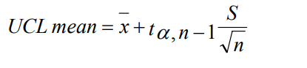

Where:
UCL mean = Upper confidence limit of the arithmetic mean concentration of the sampling area at the
1-α confidence level.
α = The probability that the ‘true’ mean concentration of the sampling area might exceed the UCL mean determined by the above equation.
n = Number of sample measurements.
x = Arithmetic mean of all sample measurements.
tα, n − 1 = A test statistic (Student’s t and an α level of significance and n-1 degrees of freedom).
S = Standard deviation of the sample measurements.
UCL mean = 26.4 + [(1.833)*((13.59/√10))] = 34.28
Based on the 95% UCL average concentration = 34.28 mg/kg, arsenic, this soil is not suitable for fill material.

- The leachability of the soils now needs to be determined. The leachable concentration for categorisation can be calculated using the same 95% UCL average methodology discussed above. Note: where the CV is >1.2, the leachate concentration may need to be calculated using the method outlined in Appendix 3. For this example, the 95% UCL average leachable concentration is 0.5 mg/L.
- According to EPA Publication 1828.2 the soil is categorised as Category C contaminated soil.

Appendix 3: Worked example of 95% UCL average for lognormal data
Reference: Gilbert, R.O. (1987) Statistical Methods for Environmental Pollution Monitoring, Van Nostrand Reinhold, New York, NY
A site has 5,000 m³ in-situ soil that needs to be removed and requires categorisation as fill material or contaminated soil (category A, B, C or D) according to EPA Publication 1828.2. Initial assessment indicates a contaminant of concern is copper.
Solution
- The site history and visual inspection indicate the soil is well classified. The site assessor determines that sampling at the minimum rate (one in 250 m³) should be sufficient to categorise the soil. In all, 20 soil samples are taken and analysed chemically for copper.
The copper concentrations in these 20 samples are 500, 510, 155, 150, 121, 100, 99, 95, 92, 90, 55, 50, 49, 47, 18, 15, 40, 38, 29, 25 mg/kg.
The results indicate the soil contamination is heterogeneous. Therefore, the site assessor should check the adequacy of the domains to ensure all possible measures, including additional sampling, have been taken to segregate areas of varied contamination.
- Calculate the CV (as detailed in Appendix 2). The CV = 1.229.
- The CV >1.2 indicates the distribution of the soil is lognormal and the 95% UCL average needs to be calculated using:
Equation 4
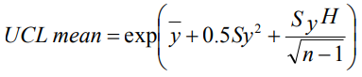
Where:
UCL mean = Upper confidence limit of the arithmetic mean concentration at the % confidence level.
y = Arithmetic mean of the log-transformed sample measurements.
Sy² = Variance of the log-transformed sample measurements.
n = Number of sample measurements.
H = A statistical constant. Its value is dependent on the values of Sy and n.
exp = Exponential function, i.e. 2.7,183 to the power of the value inside the brackets.
- Logarithmically transform the sample measurements. Let y_{i} = ln x, where x is the original sample measurement.
Sample result (x) | y_{i} = log of sample result (x)
500 | 6.214608
510 | 6.234411
155 | 5.043425
150 | 5.010635
121 | 4.795791
100 | 4.60517
99 | 4.59512
95 | 4.553877
92 | 4.521789
90 | 4.49981
55 | 4.007333
50 | 3.912023
49 | 3.89182
47 | 3.850148
18 | 2.890372
15 | 2.70805
40 | 3.688879
38 | 3.637586
29 | 3.367296
25 | 3.218876

- Determine the value of H from Appendix 5. For values of Sy and n that are not listed in the tables, use interpolation.
H = 2.545.
- Compute the % UCL mean from Equation 3 above.
95% UCL mean concentration = 193 mg/kg, Copper.
- The leachability of the soils now needs to be determined. The leachable concentration for categorisation can be calculated using the same 95% UCL average methodology discussed above. Note: where the CV is >1.2 the leachate concentration may need to be calculated using the lognormal method outlined above. For the purposes of this example the 95% UCL average leachable concentration = 100 mg/L.
- The soils are categorised as Category C contaminated soils based on the concentration (total) of 193 mg/kg and the leachable concentration of 100 mg/L.

Appendix 4: Values of student’s T AT α = 0.05 (this gives 95% UCL)
Reference: Gilbert RO (1987).
This table identifies the T values at 95% UCL.
α | 0.05 (95%) | α | 0.05 (95%)
Number of samples |  | Number of samples
1 | 6.314 | 19 | 1.729
2 | 2.920 | 20 | 1.725
3 | 2.353 | 21 | 1.721
4 | 2.132 | 22 | 1.717
5 | 2.015 | 23 | 1.714
6 | 1.943 | 24 | 1.711
7 | 1.895 | 25 | 1.708
8 | 1.860 | 26 | 1.706
9 | 1.833 | 27 | 1.703
10 | 1.812 | 28 | 1.701
11 | 1.796 | 29 | 1.699
12 | 1.782 | 30 | 1.697
13 | 1.771 | 40 | 1.684
14 | 1.741 | 60 | 1.671
15 | 1.753 | 120 | 1.658
16 | 1.746 | ∞ | 1.645
17 | 1.740
18 | 1.734

Appendix 5: Values of h1-α = h0.95 for computing a one-sided upper 95% confidence limit on a lognormal mean
Reference: Gilbert RO (1987).
Sy | Number of samples (n)
 |  | 5 | 7 | 10 | 12 | 15 | 21 | 31 | 51 | 101
0.10 |  | 2.035 | 1.886 | 1.802 | 1.775 | 1.749 | 1.722 | 1.701 | 1.684 | 1.670
0.20 |  | 2.198 | 1.992 | 1.881 | 1.843 | 1.809 | 1.771 | 1.742 | 1.718 | 1.697
0.30 |  | 2.402 | 2.125 | 1.977 | 1.927 | 1.882 | 1.833 | 1.793 | 1.761 | 1.733
0.40 |  | 2.651 | 2.282 | 2.089 | 2.026 | 1.968 | 1.905 | 1.856 | 1.813 | 1.777
0.50 |  | 2.947 | 2.465 | 2.220 | 2.141 | 2.068 | 1.989 | 1.928 | 1.876 | 1.830
0.60 |  | 3.287 | 2.673 | 2.368 | 2.271 | 2.181 | 2.085 | 2.010 | 1.946 | 1.891
0.70 |  | 3.662 | 2.904 | 2.532 | 2.414 | 2.306 | 2.191 | 2.102 | 2.025 | 1.960
0.80 |  | 4.062 | 3.155 | 2.710 | 2.570 | 2.443 | 2.307 | 2.202 | 2.112 | 2.035
0.90 |  | 4.478 | 3.420 | 2.902 | 2.738 | 2.589 | 2.432 | 2.310 | 2.206 | 2.117
1.00 |  | 4.905 | 3.698 | 3.103 | 2.915 | 2.744 | 2.564 | 2.423 | 2.306 | 2.205
1.25 |  | 6.001 | 4.426 | 3.639 | 3.389 | 3.163 | 2.923 | 2.737 | 2.580 | 2.447
1.50 |  | 7.120 | 5.184 | 4.207 | 3.896 | 3.612 | 3.311 | 3.077 | 2.881 | 2.713
1.75 |  | 8.250 | 5.960 | 4.795 | 4.422 | 4.081 | 3.719 | 3.437 | 3.200 | 2.997
2.00 |  | 9.387 | 6.747 | 5.396 | 4.962 | 4.564 | 4.141 | 3.812 | 3.533 | 3.295
2.50 |  | 11.67 | 8.339 | 6.621 | 6.067 | 5.557 | 5.013 | 4.588 | 4.228 | 3.920
3.00 |  | 13.97 | 9.945 | 7.864 | 7.191 | 6.570 | 5.907 | 5.388 | 4.947 | 4.569
3.50 |  | 16.27 | 11.56 | 9.118 | 8.326 | 7.596 | 6.815 | 6.201 | 5.681 | 5.233
4.00 |  | 18.58 | 13.18 | 10.38 | 9.469 | 8.630 | 7.731 | 7.024 | 6.424 | 5.908
4.50 |  | 20.88 | 14.80 | 11.64 | 10.62 | 9.669 | 8.652 | 7.854 | 7.174 | 6.590
5.00 |  | 23.19 | 16.43 | 12.91 | 11.77 | 10.71 | 9.579 | 8.688 | 7.929 | 7.277
6.00 |  | 27.81 | 19.68 | 15.45 | 14.08 | 12.81 | 11.44 | 10.36 | 9.449 | 8.661
7.00 |  | 32.43 | 22.94 | 18.00 | 16.39 | 14.90 | 13.31 | 12.05 | 10.98 | 10.05
8.00 |  | 37.06 | 26.20 | 20.55 | 18.71 | 17.01 | 15.18 | 13.74 | 12.51 | 11.45
9.00 |  | 41.68 | 29.46 | 23.10 | 21.03 | 19.11 | 17.05 | 15.43 | 14.05 | 12.85
10.00 |  | 46.31 | 32.73 | 25.66 | 23.35 | 21.22 | 18.93 | 17.13 | 15.59 | 14.26

Accessibility
Contact us if you need this information in an accessible format such as large print or audio.
Please telephone 1300 372 842 or email contact@epa.vic.gov.au
Interpreter assistance
If you need interpreter assistance or want this document translated, please call 131 450 and advise your preferred language. If you are deaf, or have a hearing or speech impairment, contact us through the National Relay Service.

epa.vic.gov.au
Environment Protection Authority Victoria
GPO BOX 4395 Melbourne VIC 3001
1300 372 842

Authorised and published by the Victorian Government, 1 Treasury Place, Melbourne

At the time of publication, the Australian standard has been withdrawn but this resource provides sound advice to ensure quality assurance and quality control in the field and laboratory
Normal distribution: is a data set that is normally distributed. To determine if the data is normal, the coefficient of variation (CV) needs to be < 1.2. If the CV is >1.2 it indicates that the data may be log normal and may need to be calculated using method outlined in Appendix 2.

