Air monitoring report 2021: Compliance with the National Environment Protection (Ambient Air Quality) Measure

Publication 2052 | December 2022
Air, Odour and Noise Sciences, Applied Sciences Division

epa.vic.gov.au
Environment Protection Authority Victoria
GPO BOX 4395 Melbourne VIC 3001
1300 372 842

This publication is for general guidance only. You should obtain professional advice if you
have any specific concern. EPA Victoria has made every reasonable effort to ensure accuracy
at the time of publication.

Give feedback about this publication online: epa.vic.gov.au/publication-feedback

EPA acknowledges Aboriginal people as the first peoples and Traditional custodians of the land
and water on which we live, work, and depend. We pay respect to Aboriginal Elders past and present
and recognise the continuing connection to, and aspirations for Country.

Contents
Contents
Contents 3
Executive summary 5
What is the Measure? 5
Compliance with the Measure 5
1 - Monitoring summary 5
1.1 - Monitoring stations 5
1.1.1 - Implementation of the monitoring plan 7
1.1.2 - Screening procedure 7
1.2 - Monitoring and reporting methods 7
1.2.1 - NATA status 8
2 - Assessment of compliance with standards and goals 9
2.1 - Particles (PM_{2.5}) 10
2.2 - Particles (PM₁₀) 10
2.3 - Carbon monoxide (CO) 11
2.4 - Nitrogen dioxide (NO₂) 12
2.5 - Ozone (O₃) 13
2.6 - Sulfur dioxide (SO₂) 14
2.2 - Particles (PM₁₀) 15
2.3 - Carbon monoxide (CO) 15
2.4 - Nitrogen dioxide (NO₂) 16
2.5 - Ozone (O₃) 17
2.6 - Sulfur dioxide (SO₂) 18
3 - Analysis of air quality monitoring 19
3.1 - Particles (PM_{2.5}) 19
3.2 - Particles (PM₁₀) 21
3.3 - Carbon monoxide (CO) 22
3.4 - Nitrogen dioxide (NO₂) 22
3.5 - Ozone (O₃) 22
3.6 - Sulfur dioxide (SO₂) 23
4 - Trend and distribution analysis 24
4.1 - Particles (PM_{2.5}) 24
4.2 - Population exposure (PM_{2.5}) 25
4.3 - Particles (PM₁₀) 27
4.4 - Carbon monoxide (CO) 29
4.5 - Nitrogen dioxide (NO₂) 30
4.6 - Ozone (O₃) 31
4.7 - Sulfur dioxide (SO₂) 33
Accessibility 2
Interpreter assistance 2

Executive summary
This report presents the results of air quality monitoring in Victoria for 2021 and assesses them against the requirements of the Ambient Air Quality National Environment Protection Measure (AAQ NEPM) (referred to as the Measure).
Based on the NEPM ambient air monitoring stations, Victoria’s air quality was generally considered to be good in 2021, although there were periods of poor air quality. Exceedances of the 24-hour PM_{2.5} standard occurred during the months of May and July and during September, October, and December for 24-hour PM₁₀. PM_{2.5} exceedance were associated with landscape fires and wood heaters, while PM₁₀ exceedances were associated with strong winds causing elevated levels of entrained particulate matter.
Environment Protection Authority Victoria (EPA) provides hourly data updates on air pollution levels and categories on its website. EPA’s historical air pollution data can be accessed via the Victorian Government DataVic website. EPA also collects data from stations at sites with specific air pollution issues, such as the Brooklyn Industrial Precinct and in the Latrobe Valley (excluding Traralgon air monitoring station). These data are not assessed against the Measure and therefore not included in this report.

What is the Measure?
This report presents the results of air quality monitoring in Victoria for 2021 and assesses them against the requirements of the Ambient Air Quality National Environment Protection Measure (AAQ NEPM) (Referred to as the Measure). On 15 April 2021, the National Environment Protection Council (NEPC) approved a variation to the Measure standards for ozone, nitrogen dioxide and sulfur dioxide. This report reflected the updated standards and recalculated the number of exceedances from previous years according to the updated standards.
Environment Protection Authority Victoria (EPA) provides hourly data updates on air pollution levels and categories on its website. EPA’s historical air pollution data can be accessed via the Victorian Government DataVic website.

Compliance with the Measure
EPA assesses air quality in Victoria against the standards and pollutant goals defined in the Measure. Compliance with the Measure requires that air quality standards are not exceeded more than the allowable number, as outlined in Schedule 2 of the Measure. Compliance with the Measure also requires that a minimum of 75 per cent of data are available for each quarter in the year. In addition to standard instrumentation for measuring compliance with the Measure, EPA also collects data from stations at sites with specific air pollution issues, such as the Brooklyn Industrial Precinct and in the Latrobe Valley (excluding Traralgon air monitoring station). This is known as ‘campaign monitoring.’ These data are not assessed against the Measure and therefore not included in this report. Results for these air monitoring stations are reported on EPA’s website and historical air pollution data can be accessed via the Victorian Government DataVic website.

1 - Monitoring summary
Victoria’s air monitoring plan for the assessment of air quality against the Measure was first approved in February 2001 by national, state and territory ministers on the National Environment Protection Council. Data presented in this report have been produced in accordance with the monitoring plan, with exceptions noted where required.

1.1 - Monitoring stations
The Measure requires EPA to monitor the pollutants: carbon monoxide (CO), nitrogen dioxide (NO₂), ozone (O₃), sulfur dioxide (SO₂), particles less than 10 micrometres in diameter (PM₁₀), and particles less than 2.5 micrometres in diameter (PM_{2.5}). EPA no longer monitors for lead (Pb), as ambient concentrations in Victoria have decreased significantly, due to the phase out of leaded petrol.
Eight regions are defined in Victoria’s air monitoring plan, including:
- Port Phillip and Latrobe Valley regions, which have Measure-compliant monitoring stations.
- Ballarat, Bendigo, Shepparton, Warrnambool and Mildura, where campaign monitoring was conducted previously.
- Wodonga, where data from monitoring at Albury, New South Wales was used.
EPA’s 2021 Measure-compliant monitoring stations are shown in Figure 1 and Figure 2. The monitoring stations, pollutants monitored, and site types are summarised in Table 1. Site types are defined in the Measure as ‘generally representative upper bound for community exposure’ and ‘population-average sites. EPA also has trend stations that provide data on the long-term trends in air pollution over many years. The types of communities covered by each monitoring station (known as the ‘exposed population’) is described in the ‘location category’ column in Table 1.
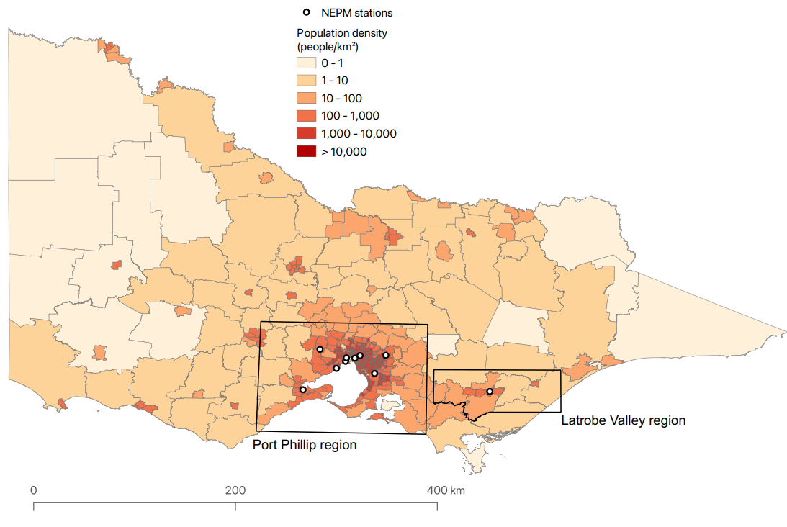
Figure 1: Defined regions and population density in Victoria
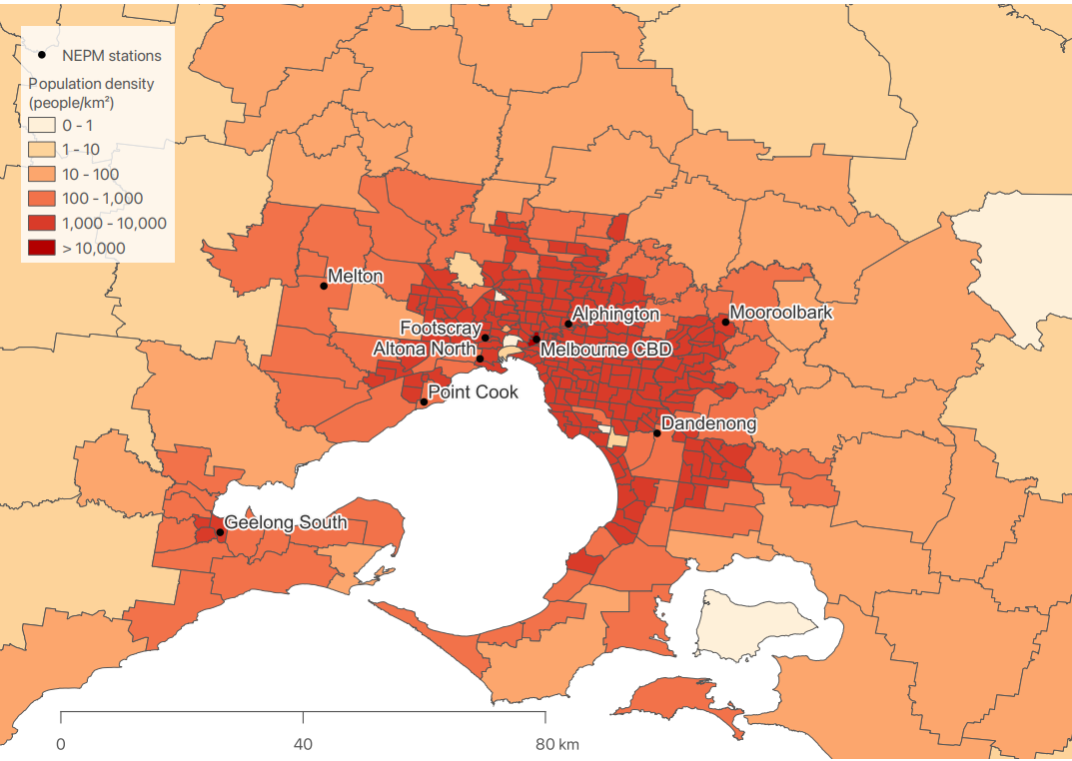
Figure 2: Defined regions and population density in Port Phillip region

Table 1: EPA NEPM monitoring stations and parameters
Monitoring Station | Region | Location Category | CO | NO₂ | O₃ | SO₂ | PM₁₀ | PM_{2.5}
Alphington | Melbourne East | Residential | G* | G* | Pop | Pop | G* | G*
Altona North | Melbourne West | Industrial / Residential |  |  |  | G*
Dandenong | Melbourne East | Industrial |  |  | Pop* |  | Pop
Footscray | Melbourne West | Residential |  | G* | G* |  | G* | G*
Geelong South | Geelong | Industrial / Residential | G* | G* | Pop* | G* | G* | G*
Melbourne CBD | Melbourne CBD | Commercial / Residential |  |  |  |  |  | G
Melton | Melbourne West | Residential |  |  | G
Mooroolbark | Melbourne East | Residential |  |  | Pop |  | Pop
Point Cook | Melbourne West | Residential |  | Pop* | G*
Traralgon | Latrobe Valley | Residential |  | G* | G* | G* | G* | G*
Note:
* Trend station (used to determine long term trends in air quality)
G - Generally representative upper bound
Pop – Population trend station

1.1.1 - Implementation of the monitoring plan
EPA continually evaluates Victoria’s air quality monitoring program to determine which sites and pollutants need to be monitored. Stations are located and set up according to the Australian Standards (Table 2). Generally, EPA’s air monitoring stations have remained stable over the years, although changes to the network are made as needed. Recent changes include:
- A PM_{2.5} monitoring station was established in the Melbourne CBD in 2017.
- A PM_{2.5} monitoring station was established in Bendigo in 2020. Data from this station are not included in this report as it is a campaign station. Data from this station are available on EPA’s AirWatch website.
- A PM_{2.5} monitoring station was established in Campbellfield in 2020 for a period of a year. Data from this station are not included in this report as it is a campaign station.
- In mid-2019, the Altona monitoring station was temporarily shut down pending relocation to another site, a new site was established at a nearby location in late 2020.
- In early 2021, the Footscray monitoring station was relocated to a new site due to a redevelopment of the old site.

1.1.2 - Screening procedure
Victoria’s air monitoring plan outlines how EPA may use screening procedures to demonstrate whether concentrations of pollutants are consistently below the standards in the Measure. If these screening procedures are satisfied, monitoring may not be required, or may be conducted at fewer locations. Screening procedures conducted in accordance with the Measure have been satisfied for Victorian regions. EPA did not monitor air quality at Ballarat, Shepparton, Warrnambool, Wodonga, and Mildura in 2021 as previous monitoring campaigns in these areas showed that pollutant levels were expected to be consistently below the relevant standards.

1.2 - Monitoring and reporting methods
Victorian monitoring is conducted in accordance with the Australian Standards as shown in Table 2 and Table 3. Data not meeting the requirements of these Standards and EPA’s quality assurance procedures were identified as invalid and not included in this report. Tapered Element Oscillating Microbalance (TEOM) PM₁₀ data included in this report have been adjusted according to the approved procedure outlined in Technical Paper No. 10 – Collection and Reporting of TEOM PM₁₀ Data 5, using the temperature dependent formula with a constant value of K equal to 0.04. The resulting adjustments vary from no change at daily average temperatures at or above 15°C, to an increase of 40 per cent at a temperature of 5°C. Particle concentration units of μg/m³ refer to volumes at 0°C and one atmosphere of pressure.

1.2.1 - NATA status
As of February 2016, EPA outsourced monitoring for PM₁₀ and PM_{2.5} using the Hivol and Partisol gravimetric methods to Golder Associates (NATA accreditation Number 1910). All other methods currently used by EPA for performance monitoring are covered by its National Association of Testing Authorities (NATA) accreditation (Number 15119) except for PM_{2.5} using Beta Attenuation Monitors (BAMs). EPA was reaccredited by NATA in 2020. EPA is working to incorporate monitoring for PM_{2.5} using BAMs as part of its NATA accreditation. The method is in use and all technical elements have been completed and is due to be assessed at an upcoming NATA audit. Table 2 shows compliance with AS/NZS 3580.1.1:2016 for the siting and operation of each air monitoring station.

Table 2: EPA NEPM monitoring stations siting compliance with AS/NZS 3580.1.1-2016
Monitoring Station | Height above ground | Minimum distance to support structure | Clear sky angle of 120° | Unrestricted airflow of >270° | 20m from trees | No nearby emission sources | Minimum distance from road or traffic
Alphington | Y | Y | Y | Y | N | Y | N
Altona North | Y | Y | Y | Y | Y | Y | N
Dandenong | Y | Y | Y | Y | N | Y | N
Footscray | Y | Y | Y | Y | N | Y | N
Geelong South | Y | Y | Y | Y | N | Y | N
Melbourne CBD | Y | Y | Y | Y | N | Y | N
Melton | Y | Y | Y | Y | N | Y | N
Mooroolbark | Y | Y | Y | Y | N | Y | N
Point Cook | Y | Y | Y | Y | N | Y | N
Traralgon | Y | Y | Y | Y | N | Y | N

Table 3: EPA NEPM monitoring methods
Pollutant |  | Australian Standard | Measurement technique
Carbon monoxide | CO | Australian Standard 3580.7.1 Ambient air - Determination of carbon monoxide, direct instrumental method | Gas filter correlation/infrared
Nitrogen dioxide | NO₂ | Australian Standard 3580.5.1 Ambient air — Determination of oxides of nitrogen — Direct reading instrument method | Gas phase chemiluminescence
Photochemical oxidant (ozone) | O₃ | Australia Standard 3580.6.1 Ambient air — Determination of ozone — Direct reading instrument method | Non-dispersive ultraviolet
Sulfur dioxide | SO₂ | Australian Standard 3580.4.1 Ambient air — Determination of sulfur dioxide — Direct reading instrument method | Pulsed fluorescence
Particles less than 10µm | PM₁₀ | Australian Standard 3580.9.8 Determination of suspended particulate matter — PM10 continuous direct mass method using a tapered element oscillating microbalance analyser | Tapered element oscillating microbalance (TEOM)
Particles less than 2.5µm | PM_{2.5} | Australian Standard 3580.9.12 Determination of suspended particulate matter PM2.5 beta attenuation monitors | Beta attenuation monitors (BAM)
 |  | Australian Standard 3580.9.10 Determination of suspended particulate matter – PM2.5 low volume sampler – Gravimetric method | Gravimetric reference method

2 - Assessment of compliance with standards and goals
Air quality is assessed against the standards defined in the Measure and the associated goals shown in Table 4. The goal of the Measure is to achieve the National Environment Protection Standards as assessed in accordance with the monitoring protocol to the extent specified in Schedule 2 of the Measure. The extent is expressed as a maximum allowable number of exceedances for each standard (shown in column four of Table 4).

Table 4: Air quality standards and goals in the Measure
Pollutant | Averaging period | Standard | Goal max allowable exceedances
Carbon monoxide | 8 hours | 9.0 ppm | 1 day a year
Nitrogen dioxide | 1 hour | 80 ppb | 1 day a year
 | 1 year | 15 ppb | None
Photochemical oxidant (ozone) | 8 hours | 65 ppb | None
Sulfur dioxide | 1 hour | 100 ppb | 1 day a year
 | 1 day | 20 ppb | 1 day a year
Particles less than 10µm | 1 day | 50 µg/m³ | None
 | 1 year | 25 µg/m³ | None
Particles less than 2.5µm | 1 day | 25 µg/m³ | None
 | 1 year | 8 µg/m³ | None
Lead | 1 year | 0.50 µg/m³ | None
Note: For PM_{2.5}, there is an additional goal to further reduce concentrations to below a daily concentration of 20 μg/m³ and an annual concentration of 7 μg/m³ by 2025.
The number of allowable exceedances associated with the standards has been set to account for unusual meteorological conditions. In the case of particles, allowable exceedances include exceptional events such as bushfires, hazard reduction burning (if authorised by state jurisdiction) or continental-scale windblown dust that cannot be controlled through normal air quality management strategies. Air quality monitoring data from each monitoring site are assessed against the Measure’s standards and the associated goals for each pollutant.
Compliance with the Measure requires that air quality standards are not exceeded more than the allowable number (as outlined in Schedule 2 of the Measure). Compliance with the Measure also requires that a minimum of 75 per cent of data are available for each quarter in the year. Regions are deemed to meet the Measure’s standards and goal if previous screening has shown that pollution levels are consistently below air quality standards and monitoring is therefore not required. In this way, lead is deemed to meet the Measure’s standards and goals, because lead was shown to be consistently below the Measure’s standards, due to the introduction of unleaded fuel in 1985. Consequently, EPA stopped monitoring for lead in 2004.
The Measure’s goals for carbon monoxide, nitrogen dioxide, ozone, sulfur dioxide, PM₁₀, PM_{2.5} and lead must be below the standards within the extent specified, such as taking into consideration exceptional events as described in the Measure. EPA uses a green, amber & red traffic light system to indicate compliance.
- Met– standard and goal achieved.
- Not Met (insufficient data) – standard and goal not achieved due to insufficient data capture.
- Not Met – standard and goal not achieved.

2.1 - Particles (PM_{2.5})
In Victoria, PM_{2.5} is assessed against a daily standard of 25 µg/m³, with a goal of zero exceedance days allowed per year, excluding exceptional events such as bushfires and authorised hazard reduction burning. PM_{2.5} is also assessed against an annual standard of 8 µg/m³ as shown in Table 5. Table 6 shows the highest recorded concentration for each monitoring station.
In 2021 there were several exceedances recorded on PM_{2.5} instruments across EPA’s network. As a result, the standards and goal for PM_{2.5} were not met. The exceedances are likely to be due to planned land burns in May and woodsmoke from domestic solid fuel heaters in July. Due to an instrument issue, insufficient data was collected at the Footscray monitoring station in quarter 3 (Q3), as a result the data capture during this period was below 75% so it is deemed that compliance with the standard was not demonstrated.

Table 5: PM_{2.5} compliance for 2021
Monitoring Station | Q1 data capture | Q2 data capture | Q3 data capture | Q4 data capture | Annual data capture | Exceedances 24hr | Annual Average (µg/m3) | Performance against standard and goals
Alphington | 97.05 | 93.75 | 95.97 | 93.68 | 95.15 | 3 | 6.65 | Not Met
Footscray | 65.03 | 99.31 | 70.1 | 98.95 | 83.54 | 0 | 5.15 | Not Met (insufficient data)
Geelong South | 95.04 | 97.78 | 98.58 | 99.86 | 97.85 | 0 | 5.75 | Met
Melbourne CBD | 96.86 | 89.17 | 99.63 | 98.08 | 95.98 | 3 | 6.28 | Not Met
Traralgon | 98.74 | 98.24 | 98.86 | 96.66 | 98.13 | 2 | 7.24 | Not Met

Table 6: 24hr PM_{2.5} highest and second highest concentrations (µg/m³) for 2021
Monitoring Station | Valid Days | Highest Value | Date | Next Highest Value | Date
Alphington | 344 | 34.34 | 2021-05-30 | 29.58 | 2021-07-10
Footscray | 302 | 21.51 | 2021-07-10 | 19.85 | 2021-05-01
Geelong South | 353 | 22.86 | 2021-07-09 | 19.82 | 2021-05-01
Melbourne CBD | 348 | 27.78 | 2021-05-30 | 27.69 | 2021-07-10
Traralgon | 353 | 31.81 | 2021-05-01 | 28.6 | 2021-05-02

2.2 - Particles (PM₁₀)
In Victoria, PM₁₀ is assessed against a daily standard of 50 µg/m³, with a goal of zero exceedance days allowed per year, excluding exceptional events such a continental scale dust storms. PM₁₀ is also assessed against an annual standard of 25 µg/m³ as shown in Table 7. Table 8 shows the highest recorded concentration for each monitoring station.
In 2021 there were exceedances recorded at two stations in the PM₁₀ network, as a result, the standards and goal were not met. An exceedance in October at Footscray was likely associated with local dust generated as a front travelled across the state. Similarly, strong wind gusts were likely associated with an exceedance at Geelong in September and hot dry conditions were likely to be responsible for an exceedance in December.

Table 7: PM₁₀ compliance for 2021
Monitoring Station | Q1 data capture | Q2 data capture | Q3 data capture | Q4 data capture | Annual data capture | Exceedances 24hr | Annual Average (µg/m3) | Performance against standard and goals
Alphington | 96.96 | 91.49 | 77.29 | 22.35 | 71.79 | 0 | 17.92 | Not Met (insufficient data)
Dandenong | 98.64 | 98.66 | 95.15 | 98.31 | 97.7 | 0 | 17.96 | Met
Footscray | 35.21 | 65.99 | 69.37 | 95.56 | 66.7 | 1 | 18.65 | Not Met (Insufficient data)
Geelong South | 92.98 | 95.7 | 95.42 | 96.52 | 95.2 | 2 | 20.11 | Not Met
Mooroolbark | 96.4 | 92.13 | 99.86 | 97.98 | 96.63 | 0 | 15.78 | Met
Traralgon | 98.88 | 78.02 | 98.9 | 98.85 | 93.73 | 0 | 16.57 | Met

Table 8: 24hr PM₁₀ highest and second highest concentration (µg/m³) for 2021
Monitoring Station | Valid Days | Highest Value | Date | Next Highest Value | Date
Alphington | 257 | 42.07 | 2021-05-01 | 35.47 | 2021-05-30
Dandenong | 353 | 45.73 | 2021-05-01 | 34.65 | 2021-01-13
Footscray | 238 | 58.16 | 2021-10-05 | 43.8 | 2021-04-30
Geelong South | 342 | 61.43 | 2021-09-09 | 51.73 | 2021-12-18
Mooroolbark | 349 | 45.02 | 2021-05-01 | 32.5 | 2021-04-30
Traralgon | 336 | 43.4 | 2021-05-01 | 39.68 | 2021-05-02

2.3 - Carbon monoxide (CO)
In Victoria, carbon monoxide is assessed against an eight-hour standard of 9.0 ppm, with one exceedance day allowed per year as shown in Table 9. Table 10 shows the highest recorded concentration for each monitoring station.
In 2021 there were no exceedances of the carbon monoxide standard. As a result, the standards and goal for carbon monoxide were, met with the exception of Footscray where there was less than 75% data capture in quarter 3 (Q3). As a result there was not enough data to demonstrate compliance.

Table 9: CO compliance for 2021
Monitoring Station | Q1 data capture | Q2 data capture | Q3 data capture | Q4 data capture | Annual data capture | Exceedances 8hr | Performance against standard and goals
Alphington | 76.59 | 94.86 | 94.73 | 86.58 | 87.11 | 0 | Met
Footscray | 89.51 | 94.96 | 67.08 | 94.96 | 85.71 | 0 | Not Met (insufficient data)
Geelong South | 94.8 | 95.09 | 93.09 | 94.78 | 93.7 | 0 | Met
Traralgon | 94.29 | 94.72 | 94.87 | 91.85 | 92.96 | 0 | Met

Table 10: 8hr CO highest and second highest concentration (ppm) for 2021
Monitoring Station | Valid Days | Highest Value | Date | Next Highest Value | Date
Alphington | 323 | 1.59 | 2021-07-10 | 1.22 | 2021-07-09
Footscray | 320 | 0.71 | 2021-04-30 | 0.7 | 2021-05-22
Geelong South | 350 | 0.76 | 2021-07-09 | 0.74 | 2021-05-22
Traralgon | 349 | 0.83 | 2021-07-08 | 0.81 | 2021-07-04

2.4 - Nitrogen dioxide (NO₂)
In Victoria, nitrogen dioxide is assessed against a one-hour standard of 80 ppb and an annual standard of 15 ppb as shown in Table 11. Table 12 shows the highest recorded concentration for each monitoring station.
In 2021 there were no exceedances of the nitrogen dioxide standards. As a result, the standards and goal for nitrogen dioxide were met.
Table 11: NO₂ compliance for 2021
Monitoring Station | Q1 data capture | Q2 data capture | Q3 data capture | Q4 data capture | Annual data capture | Exceedances 1hr | Annual Average (ppb) | Performance against 1hr standard and goals | Performance against annual standard and goals
Alphington | 94.57 | 94.96 | 94.96 | 94.78 | 94.8 | 0 | 7.8 | Met | Met
Footscray | 94.62 | 94.26 | 76.97 | 95.05 | 90.24 | 0 | 8.83 | Met | Met
Geelong South | 94.15 | 95.19 | 93.27 | 95.1 | 94.44 | 0 | 5.98 | Met | Met
Traralgon | 93.82 | 93.34 | 94.92 | 94.64 | 94.2 | 0 | 5.88 | Met | Met

Table 12: 1hr NO₂ highest and second highest concentration (ppb) for 2021
Monitoring Station | Valid Days | Highest Value | Date | Next Highest Value | Date
Alphington | 359 | 41.4 | 2021-09-16 | 38.6 | 2021-11-29
Footscray | 342 | 50.7 | 2021-04-02 | 50.6 | 2021-01-24
Geelong South | 356 | 44 | 2021-06-11 | 38.5 | 2021-04-29
Traralgon | 357 | 37.1 | 2021-05-01 | 36.8 | 2021-04-30

2.5 - Ozone (O₃)
In Victoria, ozone is assessed against a eight-hour standard of 65 ppb as shown in Table 13. Tables 14 shows the highest recorded concentrations for each monitoring station.
In 2021 there were no exceedances of the ozone standards. As a result, the standards and goal for ozone were met except for Melton and Traralgon where there was insufficient data collected due to instrumentation faults and Footscray due to the relocation of the station.

Table 13: O₃ compliance for 2021
Monitoring Station | Q1 data capture | Q2 data capture | Q3 data capture | Q4 data capture | Annual data capture | Exceedances 8hr | Performance against 8hr standard and goals
Alphington | 94.48 | 94.96 | 95.01 | 95.14 | 94.88 | 0 | Met
Dandenong | 94.94 | 95 | 94.78 | 93.77 | 94.63 | 0 | Met
Footscray | 94.71 | 95.05 | 77.47 | 11.82 | 69.78 | 0 | Not Met (insufficient data)
Geelong South | 94.99 | 95.19 | 93.22 | 95.1 | 94.63 | 0 | Met
Melton | 95.32 | 78.25 | 68.86 | 94.96 | 84.13 | 0 | Not Met (insufficient data)
Point Cook | 95.27 | 95 | 88.74 | 95.05 | 93.52 | 0 | Met
Traralgon | 94.76 | 94.72 | 88 | 66.1 | 85.91 | 0 | Not Met (insufficient data)

Table 14: 8hr O₃ highest and second highest concentration (ppb) for 2021
Monitoring Station | Valid Days | Highest Value | Date | Next Highest Value | Date
Alphington | 350 | 52.36 | 2021-01-21 | 51.12 | 2021-04-02
Dandenong | 348 | 53.07 | 2021-04-02 | 51.8 | 2021-01-21
Footscray | 257 | 49.75 | 2021-01-24 | 46.14 | 2021-02-10
Geelong South | 350 | 55.15 | 2021-03-12 | 47.71 | 2021-11-30
Melton | 314 | 54.79 | 2021-01-24 | 52.57 | 2021-04-02
Point Cook | 346 | 62.36 | 2021-01-24 | 53.38 | 2021-11-30
Traralgon | 320 | 41.64 | 2021-12-02 | 38.81 | 2021-04-02

2.6 - Sulfur dioxide (SO₂)
In Victoria, sulfur dioxide is assessed against a one-hour standard of 100 ppb and a daily standard of 20 as shown in Table 15. Tables 16 and 17 show the highest recorded concentrations for each monitoring station.
In 2021 there were no exceedances recorded on sulfur dioxide instruments across EPA’s network. As a result, the standards and goal were met, except for Altona North and Traralgon where there was less than 75% data capture. As a result, it was not possible to demonstrate compliance with the Measure at these two stations. A both stations, this was due to instrument issues.
Table 15: SO₂ compliance for 2021
Monitoring Station | Q1 data capture | Q2 data capture | Q3 data capture | Q4 data capture | Annual data capture | Exceedances 1hr | Exceedances 24hr | Performance against 1hr standard and goals | Performance against 24hr standard and goals
Alphington | 91.67 | 85.38 | 93.41 | 82.91 | 87.99 | 0 | 0 | Met | Met
Altona North | 87.59 | 69.41 | 71.75 | 72.79 | 74.98 | 0 | 0 | Not Met (insufficient data) | Not Met (insufficient data)
Geelong South | 44.01 | 95.19 | 93.27 | 71.09 | 76.18 | 0 | 0 | Not Met (insufficient data) | Not Met (insufficient data)
Traralgon | 83.99 | 94.72 | 93.91 | 5.08 | 69.24 | 0 | 0 | Not Met (insufficient data) | Not Met (insufficient data)

Table 16: 1hr SO₂ highest and second highest concentration (ppb) for 2021
Monitoring Station | Valid Days | Highest Value | Date | Next Highest Value | Date
Alphington | 329 | 16.5 | 2021-01-20 | 6.9 | 2021-12-29
Altona North | 283 | 41.8 | 2021-03-13 | 41 | 2021-03-04
Geelong South | 282 | 20.5 | 2021-05-10 | 14.4 | 2021-04-29
Traralgon | 262 | 65.9 | 2021-01-31 | 62.8 | 2021-03-10

Table 17: 24hr SO₂ highest and second highest concentration (ppb) for 2021
Monitoring Station | Valid Days | Highest Value | Date | Next Highest Value | Date
Alphington | 329 | 3.66 | 2021-01-20 | 2.72 | 2021-12-05
Altona North | 283 | 15.03 | 2021-03-04 | 13.06 | 2021-01-16
Geelong South | 282 | 4 | 2021-01-07 | 3.77 | 2021-01-06
Traralgon | 262 | 10.47 | 2021-03-10 | 5.11 | 2021-01-31

3 - Analysis of air quality monitoring
The trends in air quality data across the year are analysed using a breakdown of daily concentration percentiles for the year for each parameter and station. This can be used to look at how pollutant concentrations are distributed across the year. The use of percentiles is similar to expressing the data as the Nth highest value. For example, the 95th percentile of daily peak concentrations corresponds to the 18th highest daily peak concentration if there is 100% data availability. For pollutants and stations where exceedances have been recorded, a calendar plot has been included to show the temporal distribution for when the exceedances occurred.

3.1 - Particles (PM_{2.5})
In 2021 the peak 24-hour PM_{2.5} measurement at a NEPM station was 34.34 µg/m3 at Alphington on 30 May 2021.
As shown in Figures 3 to 5, there were exceedances of the 24-hour standard recorded during the year, most of these were associated with either planned land burns, emissions from domestic solid fuel heaters and other urban air pollution build up. The events in July were caused by the formation and build-up of secondary aerosols in the environment. The number of exceedances was less than previous years which were heavily impacted by bushfire smoke.

Table 18: 24hr PM_{2.5} percentiles for 2021
Monitoring Station | Data availability (% days) | Max (ug/m³) | 99th percentile | 98th percentile | 95th percentile | 90th percentile | 75th percentile | 50th percentile
Alphington | 94.25 | 34.34 | 22.25 | 17.67 | 14.44 | 10.39 | 7.69 | 5.87
Footscray | 82.74 | 21.51 | 16.12 | 13.7 | 11.56 | 9.29 | 6.27 | 4.19
Geelong South | 96.71 | 22.86 | 18.86 | 16.16 | 12.74 | 9.6 | 6.63 | 4.91
Melbourne CBD | 95.34 | 27.78 | 21.82 | 14.93 | 13.08 | 10.2 | 7.33 | 5.52
Traralgon | 96.71 | 31.81 | 20.39 | 18.63 | 13.77 | 11.67 | 8.52 | 6.32

Figure 3: Alphington PM_{2.5} calendar plots showing days where exceedances of the average daily PM_{2.5} standard of 25 µg/m³ occurred.
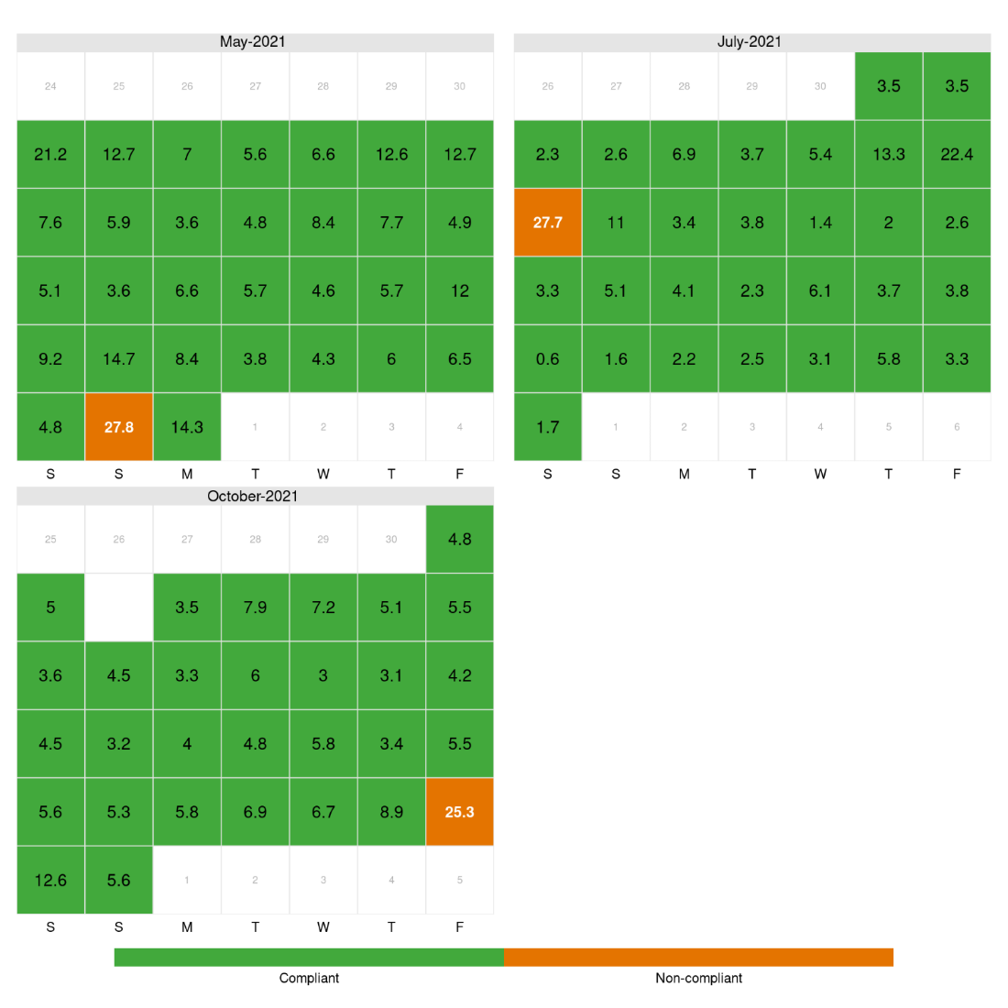
Figure 4: Melbourne PM_{2.5} calendar plots showing days where exceedances of the average daily PM_{2.5} standard of 25 µg/m³ occurred.
Figure 5: Traralgon PM_{2.5} calendar plots showing days where exceedances of the average daily PM_{2.5} standard of 25 µg/m³ occurred.

3.2 - Particles (PM₁₀)
In 2021 the peak 24-hour PM₁₀ measurement at a NEPM station was 61.43 µg/m³ at Geelong South on 9 September 2021. This event was likely to be associated with strong wind gusts during a change.
Bushfires and continental scale dust storms are classified as exceptional events as per the definition in the Measure. In 2021 no exceedances were attributed to continental-scale dust storms.

Table 19: 24hr PM₁₀ percentiles for 2021
Monitoring Station | Data availability (% days) | Max (ug/m3) | 99th percentile | 98th percentile | 95th percentile | 90th percentile | 75th percentile | 50th percentile
Alphington | 70.41 | 42.07 | 35.49 | 32.92 | 30.22 | 26.88 | 21.52 | 17.24
Dandenong | 96.71 | 45.73 | 35.6 | 31.63 | 28.43 | 25.32 | 21.74 | 17.76
Footscray | 65.21 | 58.16 | 39.38 | 36.26 | 32.24 | 26.68 | 21.78 | 17.86
Geelong South | 93.7 | 61.43 | 46.39 | 41.9 | 38.09 | 31.76 | 24.28 | 18.15
Mooroolbark | 95.62 | 45.02 | 31.79 | 29.81 | 26.04 | 23.51 | 19.18 | 15.07
Traralgon | 92.05 | 43.8 | 30.83 | 27.4 | 25.59 | 23.74 | 19.26 | 15.95

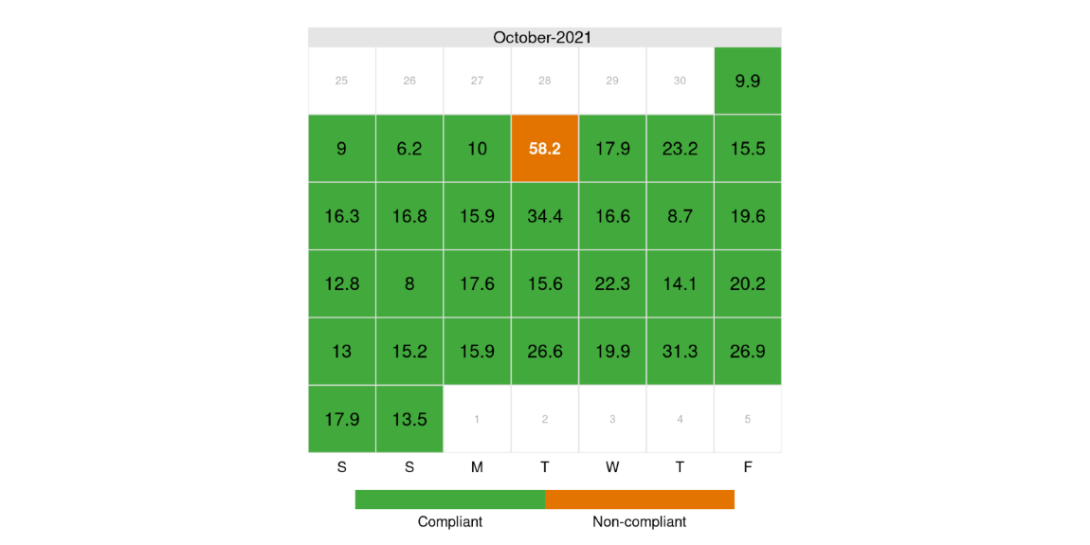
Figure 10: Footscray PM₁₀ calendar plots showing days where exceedances of the average daily PM₁₀ standard of 50 µg/m³ occurred.

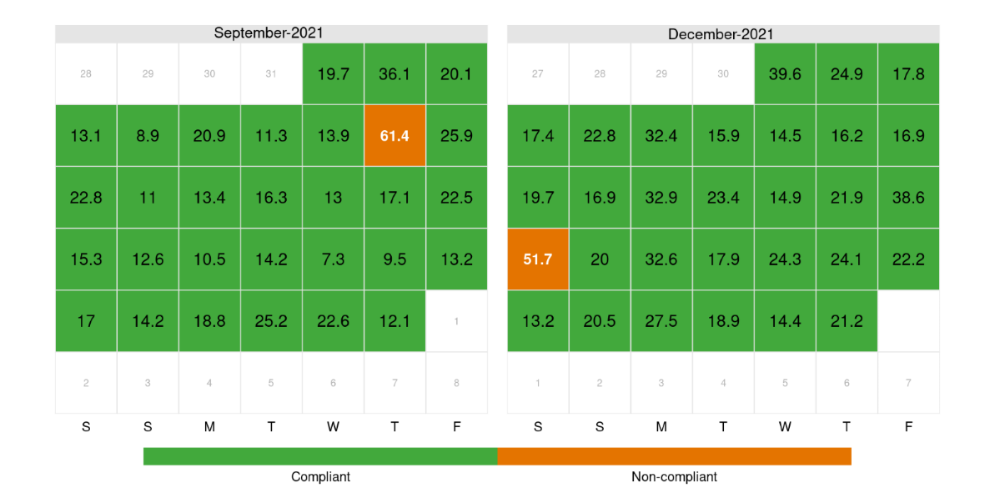
Figure 11: Geelong South PM₁₀ calendar plots showing days where exceedances of the average daily PM₁₀ standard of 50 µg/m³ occurred.

3.3 - Carbon monoxide (CO)
Percentiles of 2021 daily peak concentrations (over an eight-hour averaging period) are provided for carbon monoxide for each station in Table 21. Daily peak values are formed only when at least 75 per cent of the data for the day are valid. The percentiles for eight-hour carbon monoxide is based on rolling averages, including those that overlap from one day to the next.
Higher than usual maximum concentrations of carbon monoxide were recorded in 2021, this is likely to be due to significant bushfires that occurred in January. No exceedances of the standard were recorded in 2021.

Table 20: 8hr CO percentiles
Monitoring Station | Data availability (% days) | Max (ppm) | 99th percentile | 98th percentile | 95th percentile | 90th percentile | 75th percentile | 50th percentile
Alphington | 88.49 | 1.59 | 1.08 | 1.05 | 0.8 | 0.6 | 0.41 | 0.26
Footscray | 87.67 | 0.71 | 0.66 | 0.6 | 0.51 | 0.39 | 0.25 | 0.16
Geelong South | 95.89 | 0.76 | 0.65 | 0.6 | 0.49 | 0.34 | 0.22 | 0.19
Traralgon | 95.62 | 0.83 | 0.75 | 0.74 | 0.64 | 0.56 | 0.33 | 0.2

3.4 - Nitrogen dioxide (NO₂)
Percentiles of 2021 daily peak concentrations (over a one-hour averaging period) are provided for nitrogen dioxide for each station in Table 21. Daily peak values are formed only when at least 75 per cent of the data for the day are valid.
There were no exceedances of the nitrogen dioxide standard recorded in 2021.

Table 21: 1hr NO2 percentiles
Monitoring Station | Data availability (% days) | Max (ppb) | 99th percentile | 98th percentile | 95th percentile | 90th percentile | 75th percentile | 50th percentile
Alphington | 98.36 | 41.4 | 34.21 | 32.27 | 29.64 | 27.2 | 22.6 | 17
Footscray | 93.7 | 50.7 | 40.53 | 36.45 | 32.6 | 29.09 | 24.28 | 18.65
Geelong South | 97.53 | 44 | 34.76 | 33.56 | 29.22 | 25.8 | 19.02 | 12.65
Traralgon | 97.81 | 37.1 | 28.42 | 27.19 | 25.4 | 23.24 | 16.9 | 11.7

3.5 - Ozone (O₃)
Percentiles of 2021 daily peak concentrations, over an eight-hour averaging periods are provided for ozone for each station and standard in Table 22. Daily peak values are formed only when at least 75 per cent of the data for the day are valid. The percentiles for eight-hour ozone are based on rolling averages, including those that overlap from one day to the next.
In 2021 there were not exceedances of the ozone standard recorded across the network.

Table 22: 8hr O₃ percentiles
Monitoring Station | Data availability (% days) | Max (ppb) | 99th percentile | 98th percentile | 95th percentile | 90th percentile | 75th percentile | 50th percentile
Alphington | 95.89 | 52.36 | 46.99 | 42.91 | 37.25 | 32.44 | 27.15 | 22.97
Dandenong | 95.34 | 53.07 | 45.73 | 42.77 | 36.43 | 31.24 | 26.66 | 22.91
Footscray | 70.41 | 49.75 | 43.7 | 40.86 | 34.6 | 30.15 | 25.86 | 21.18
Geelong South | 95.89 | 55.15 | 42.83 | 40.08 | 33.82 | 29.99 | 27.38 | 23.34
Melton | 86.03 | 54.79 | 49.94 | 42.36 | 38.37 | 33.95 | 28.96 | 24.85
Point Cook | 94.79 | 62.36 | 45.75 | 43.11 | 38.59 | 33.76 | 29.33 | 24.95
Traralgon | 87.67 | 41.64 | 37.68 | 34.24 | 31.92 | 28.65 | 25.26 | 20.58

3.6 - Sulfur dioxide (SO₂)
Percentiles of 2021 daily peak concentrations (over an one-hour averaging period) and daily average concentrations are provided for sulfur dioxide for each station in Tables 23 and 24. Daily peak values are formed only when at least 75 per cent of the data for the day are valid.
There were no exceedances of the sulfur dioxide standard recorded in 2021.

Table 23: 1hr SO₂ percentiles
Monitoring Station | Data availability (% days) | Max (ppb) | 99th percentile | 98th percentile | 95th percentile | 90th percentile | 75th percentile | 50th percentile
Alphington | 90.14 | 16.5 | 5.24 | 4.29 | 3.22 | 2.4 | 1.7 | 0.9
Altona North | 77.53 | 41.8 | 30.39 | 28.48 | 19.67 | 11.96 | 4.45 | 1.3
Geelong South | 77.26 | 20.5 | 8.69 | 5.81 | 3.89 | 2.3 | 1.3 | 0.7
Traralgon | 71.78 | 65.9 | 39.67 | 18.42 | 11.3 | 8.79 | 5.2 | 2.3

Table 24: daily SO₂ percentiles
Monitoring Station | Data availability (% days) | Max (ppb) | 99th percentile | 98th percentile | 95th percentile | 90th percentile | 75th percentile | 50th percentile
Alphington | 90.14 | 3.66 | 2.25 | 2.21 | 1.93 | 1.6 | 0.9 | 0.4
Altona North | 77.53 | 15.03 | 7.9 | 7.18 | 3.84 | 2.56 | 1.43 | 0.57
Geelong South | 77.26 | 4 | 3.59 | 2.7 | 1.65 | 1 | 0.58 | 0.18
Traralgon | 71.78 | 10.47 | 4.59 | 4.01 | 2.94 | 2.31 | 1.37 | 0.83

4 - Trend and distribution analysis

4.1 - Particles (PM_{2.5})
Overall trends in PM_{2.5} is generally consistent however there is significant variation in the number of exceedances and higher percentiles depending on events during the year. Overall, there were fewer exceedances in 2021 compared with previous years. For years were there are significant bushfires like 2020, the number of exceedances and higher percentiles is substantially greater. Note the higher number of exceedances and higher percentiles is not recorded for Alphington in 2020 due to lack of data as a result of technical problems with monitor.

Table 25: Alphington PM_{2.5} percentiles
Year | Data availability (% days) | Number of Exceedances | Max (µg/m³) | 99th percentile | 98th percentile | 95th percentile | 90th percentile | 75th percentile | 50th percentile
2021 | 94.25 | 3 | 34.34 | 22.25 | 17.67 | 14.44 | 10.39 | 7.69 | 5.87
2020 | 76.50 | 7 | 35.66 | 27.89 | 25.94 | 19.05 | 13.52 | 9.01 | 6.37
2019 | 67.67 | 2 | 30.65 | 23.71 | 18.90 | 16.23 | 13.34 | 9.27 | 6.58
2018 | 87.40 | 8 | 42.01 | 29.68 | 27.23 | 17.46 | 13.36 | 8.79 | 6.52
2017 | 92.33 | 8 | 35.94 | 27.75 | 26.60 | 20.34 | 15.76 | 10.17 | 7.45

Table 26: Footscray PM_{2.5} percentiles
Year | Data availability (% days) | Number of Exceedances | Max (µg/m³) | 99th percentile | 98th percentile | 95th percentile | 90th percentile | 75th percentile | 50th percentile
2021 | 83.01 | 0 | 21.51 | 16.11 | 13.66 | 11.54 | 9.26 | 6.25 | 4.20
2020 | 95.90 | 8 | 204.50 | 63.05 | 29.86 | 17.59 | 12.92 | 8.34 | 5.79
2019 | 98.08 | 4 | 31.30 | 23.83 | 20.43 | 15.06 | 12.01 | 8.66 | 6.65
2018 | 88.22 | 5 | 31.20 | 28.32 | 20.95 | 15.34 | 12.52 | 8.76 | 6.67
2017 | 96.44 | 4 | 34.77 | 24.51 | 20.72 | 15.53 | 13.06 | 9.25 | 6.75

Table 27: Geelong South PM_{2.5} percentiles
Year | Data availability (% days) | Number of Exceedances | Max (µg/m³) | 99th percentile | 98th percentile | 95th percentile | 90th percentile | 75th percentile | 50th percentile
2021 | 96.71 | 0 | 22.86 | 18.86 | 16.16 | 12.74 | 9.60 | 6.63 | 4.91
2020 | 89.89 | 6 | 155.05 | 60.33 | 23.31 | 14.76 | 11.55 | 7.70 | 5.36
2019 | 95.62 | 1 | 32.68 | 19.28 | 16.97 | 12.85 | 10.48 | 7.51 | 5.53
2018 | 86.58 | 1 | 31.03 | 21.87 | 18.43 | 13.66 | 10.16 | 7.70 | 5.57
2017 | 83.01 | 2 | 26.80 | 22.27 | 18.23 | 13.52 | 10.89 | 8.50 | 6.42

Table 28: Melbourne CBD PM_{2.5} percentiles
Year | Data availability (% days) | Number of Exceedances | Max (µg/m³) | 99th percentile | 98th percentile | 95th percentile | 90th percentile | 75th percentile | 50th percentile
2021 | 95.34 | 3 | 27.78 | 21.82 | 14.93 | 13.08 | 10.20 | 7.33 | 5.52
2020 | 96.99 | 10 | 196.31 | 69.19 | 26.92 | 18.54 | 12.81 | 7.67 | 5.28
2019 | 93.70 | 2 | 27.95 | 21.59 | 19.07 | 14.20 | 12.35 | 8.22 | 5.81
2018 | 94.79 | 7 | 42.14 | 32.43 | 23.97 | 17.07 | 12.79 | 9.07 | 6.81

Table 29: Traralgon PM_{2.5} percentiles
Year | Data availability (% days) | Number of Exceedances | Max (µg/m³) | 99th percentile | 98th percentile | 95th percentile | 90th percentile | 75th percentile | 50th percentile
2021 | 96.71 | 2 | 31.81 | 20.39 | 18.63 | 13.77 | 11.67 | 8.52 | 6.32
2020 | 92.90 | 5 | 236.00 | 30.34 | 22.69 | 18.46 | 14.28 | 9.66 | 6.56
2019 | 95.07 | 8 | 37.40 | 31.42 | 26.15 | 19.23 | 14.87 | 10.73 | 7.48
2018 | 87.12 | 2 | 30.08 | 23.21 | 22.26 | 17.75 | 13.39 | 9.66 | 6.86
2017 | 86.85 | 5 | 32.26 | 27.98 | 21.98 | 18.34 | 14.85 | 9.84 | 7.19

4.2 - Population exposure (PM_{2.5})
In order to estimate concentrations where there are no EPA air monitoring stations, modelled concentrations of PM_{2.5} are used. This has been carried out using the CSIRO Air Quality Forecasting (AQFx) system.
The modelling results with corresponding population data were used to determine the population weighted concentration. A population weighted concentration gives greater weight to modelled concentrations that occur where population centres are. The model was first used by the Bureau of Meteorology in May 2018. 2019 was the first year where a full year was modelled.
The modelled mean PM_{2.5} shows that concentrations of PM_{2.5} were significantly lower in 2021than previous years where bushfires and land burns had a significant impact on annual PM2.5 concentrations. This is shown when comparing the concentration map for 2021 as shown in Figure 12 and those for previous years in Figure 13 and 14.
The lower PM2.5 concentrations in 2021 is also evident from the percentage of the Victorian population estimated to have been exposed to an annual average concentration of 8 µg/m3 or greater. In 2021 this was estimated to be 18.1% of the population, compared with estimates of 79.2% in 2020 and 52.6% in 2019 as shown in Table 30 and Figure 15.

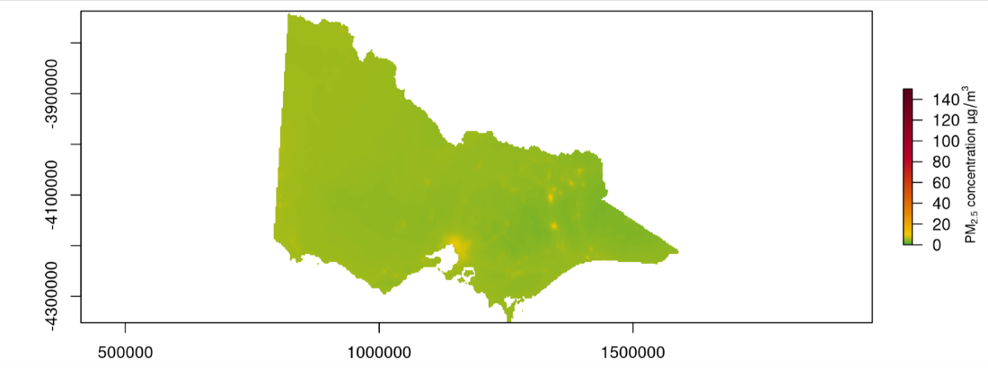
Figure 12: Modelled PM2.5 concentration for 2021

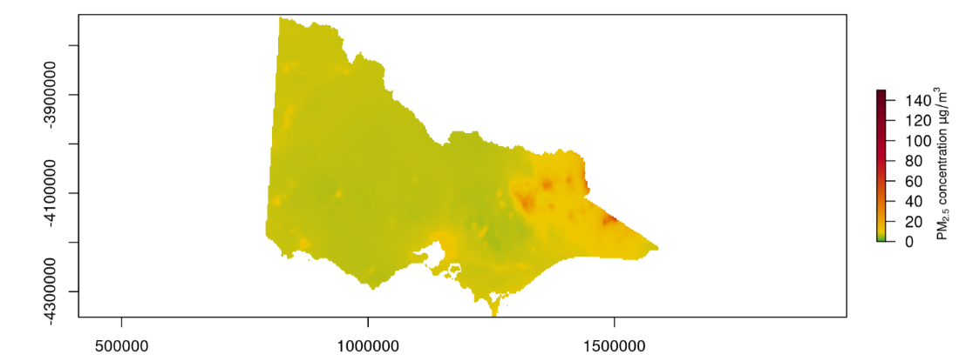
Figure 13: Modelled PM2.5 concentration for 2020

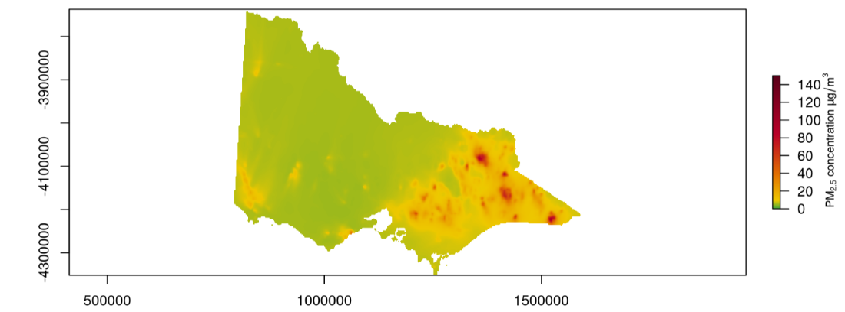
Figure 14: Modelled PM_{2.5} concentration for 2019

Table 30: Percentage of population exposed to PM_{2.5} concentrations
year | 5 | 6 | 7 | 8 | 9 | 10 | 11 | 12 | 13 | 14 | 15 | 20 | 25 | 30 | 35 | 40
2021 | 78.998 | 54.380 | 37.796 | 18.102 | 3.278 | 0.000 | 0.000 | 0.000 | 0.000 | 0.000 | 0.000 | 0.000 | 0.000 | 0.000 | 0.000 | 0.000
2020 | 99.829 | 99.829 | 91.942 | 79.151 | 54.932 | 33.198 | 7.382 | 0.158 | 0.121 | 0.071 | 0.028 | 0.006 | 0.003 | 0.001 | 0.001 | 0.000
2019 | 99.807 | 85.991 | 68.310 | 52.614 | 28.180 | 4.004 | 2.129 | 1.227 | 0.784 | 0.365 | 0.263 | 0.112 | 0.048 | 0.024 | 0.014 | 0.005

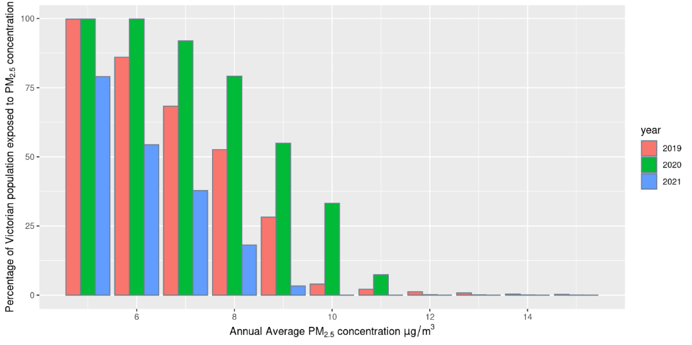
Figure 15: Estimated population exposure to different concentrations of PM_{2.5}

4.3 - Particles (PM₁₀)
Overall trends in PM₁₀ is generally consistent, however there is significant variation in the number of exceedances and higher percentiles depending on events during the year. In 2021 concentrations of PM₁₀ were lower than previous years. For years were there are significant bushfires like 2020, the number of exceedances and higher percentiles can be substantially greater.

Table 31: Alphington PM₁₀ percentiles
Year | Data availability (% days) | Number of Exceedances | Max (µg/m³) | 99th percentile | 98th percentile | 95th percentile | 90th percentile | 75th percentile | 50th percentile
2021 | 70.41 | 0 | 42.07 | 35.49 | 32.92 | 30.22 | 26.88 | 21.52 | 17.24
2020 | 92.35 | 7 | 226.48 | 68.99 | 48.01 | 37.08 | 28.96 | 21.98 | 16.22
2019 | 95.34 | 5 | 69.81 | 55.26 | 45.29 | 37.27 | 31.98 | 23.08 | 16.80
2018 | 90.96 | 3 | 73.99 | 47.44 | 46.25 | 38.33 | 31.07 | 22.56 | 17.34
2017 | 95.89 | 0 | 35.48 | 32.51 | 31.22 | 27.27 | 24.09 | 20.00 | 15.83

Table 32: Dandenong PM₁₀ percentiles
Year | Data availability (% days) | Number of Exceedances | Max (µg/m³) | 99th percentile | 98th percentile | 95th percentile | 90th percentile | 75th percentile | 50th percentile
2021 | 96.71 | 0 | 45.73 | 35.60 | 31.63 | 28.43 | 25.32 | 21.74 | 17.76
2020 | 91.26 | 9 | 259.12 | 87.27 | 62.22 | 37.08 | 29.81 | 23.21 | 17.57
2019 | 94.52 | 9 | 144.03 | 78.72 | 56.55 | 40.81 | 35.45 | 26.27 | 18.24
2018 | 95.89 | 3 | 89.74 | 47.63 | 40.59 | 33.51 | 28.95 | 24.08 | 17.37
2017 | 23.29 | 0 | 37.53 | 35.29 | 34.13 | 29.92 | 28.00 | 22.60 | 16.69

Table 33: Footscray PM₁₀ percentiles
Year | Data availability (% days) | Number of Exceedances | Max (µg/m³) | 99th percentile | 98th percentile | 95th percentile | 90th percentile | 75th percentile | 50th percentile
2021 | 66.85 | 1 | 58.16 | 39.38 | 36.26 | 32.24 | 26.68 | 21.78 | 17.86
2020 | 87.43 | 1 | 50.95 | 36.12 | 35.46 | 31.24 | 25.93 | 20.96 | 15.45
2019 | 79.73 | 7 | 66.92 | 52.89 | 51.18 | 39.85 | 33.19 | 24.30 | 17.38
2018 | 95.89 | 1 | 58.77 | 46.15 | 42.31 | 35.06 | 29.54 | 23.44 | 17.19
2017 | 91.23 | 0 | 49.83 | 39.53 | 36.59 | 30.99 | 28.09 | 23.04 | 17.40

Table 34: Geelong South PM₁₀ percentiles
Year | Data availability (% days) | Number of Exceedances | Max (µg/m³) | 99th percentile | 98th percentile | 95th percentile | 90th percentile | 75th percentile | 50th percentile
2021 | 93.70 | 2 | 61.43 | 46.39 | 41.90 | 38.09 | 31.76 | 24.28 | 18.15
2020 | 73.22 | 6 | 199.41 | 134.25 | 57.05 | 40.05 | 31.48 | 25.13 | 17.39
2019 | 88.49 | 11 | 101.51 | 70.42 | 63.85 | 45.75 | 36.86 | 24.16 | 17.20
2018 | 93.70 | 6 | 97.08 | 70.13 | 46.71 | 41.49 | 33.85 | 25.03 | 17.52
2017 | 81.10 | 3 | 73.73 | 44.33 | 39.57 | 32.41 | 29.61 | 22.82 | 16.43

Table 35: Mooroolbark PM₁₀ percentiles
Year | Data availability (% days) | Number of Exceedances | Max (µg/m³) | 99th percentile | 98th percentile | 95th percentile | 90th percentile | 75th percentile | 50th percentile
2021 | 95.62 | 0 | 45.02 | 31.79 | 29.81 | 26.04 | 23.51 | 19.18 | 15.07
2020 | 89.07 | 4 | 71.37 | 51.00 | 38.43 | 31.01 | 23.41 | 18.40 | 13.91
2019 | 97.53 | 4 | 75.10 | 49.98 | 42.61 | 35.02 | 30.46 | 21.57 | 15.14
2018 | 95.62 | 1 | 105.45 | 34.65 | 33.69 | 29.16 | 25.31 | 20.22 | 15.24
2017 | 96.16 | 2 | 55.45 | 36.35 | 31.25 | 24.49 | 21.60 | 18.54 | 14.39

Table 36: Traralgon PM₁₀ percentiles
Year | Data availability (% days) | Number of Exceedances | Max (µg/m³) | 99th percentile | 98th percentile | 95th percentile | 90th percentile | 75th percentile | 50th percentile
2021 | 92.05 | 0 | 43.40 | 30.83 | 27.40 | 25.59 | 23.74 | 19.26 | 15.95
2020 | 93.99 | 9 | 236.31 | 149.68 | 59.19 | 32.68 | 26.94 | 22.45 | 16.87
2019 | 95.07 | 5 | 77.99 | 52.84 | 46.31 | 35.91 | 29.42 | 22.88 | 16.70
2018 | 95.62 | 0 | 47.38 | 34.09 | 28.49 | 25.91 | 22.87 | 18.85 | 14.82
2017 | 91.78 | 0 | 42.83 | 32.17 | 28.44 | 24.57 | 21.75 | 17.98 | 14.70

4.4 - Carbon monoxide (CO)
Overall trends in CO is generally consistent, however there is significant variation in the number of exceedances and higher percentiles depending on events during the year. For years were there are significant bushfires like 2020, the number of exceedances and higher percentiles is substantially greater.

Table 37: Alphington 8hr CO percentiles
Year | Data availability (% days) | Number of Exceedances | Max (ppm) | 99th percentile | 98th percentile | 95th percentile | 90th percentile | 75th percentile | 50th percentile
2021 | 88.49 | 0 | 1.59 | 1.08 | 1.05 | 0.80 | 0.60 | 0.41 | 0.26
2020 | 88.52 | 0 | 2.25 | 1.35 | 1.21 | 0.99 | 0.74 | 0.41 | 0.22
2019 | 86.03 | 0 | 1.17 | 0.84 | 0.73 | 0.61 | 0.47 | 0.35 | 0.23
2018 | 92.88 | 0 | 1.71 | 1.27 | 1.11 | 0.87 | 0.70 | 0.41 | 0.27
2017 | 93.15 | 0 | 1.49 | 1.37 | 1.24 | 1.12 | 0.88 | 0.43 | 0.31

Table 38: Footscray 8hr CO percentiles
Year | Data availability (% days) | Number of Exceedances | Max (ppm) | 99th percentile | 98th percentile | 95th percentile | 90th percentile | 75th percentile | 50th percentile
2021 | 87.67 | 0 | 0.71 | 0.66 | 0.60 | 0.51 | 0.39 | 0.25 | 0.16
2020 | 92.62 | 0 | 2.84 | 1.30 | 1.19 | 0.68 | 0.49 | 0.29 | 0.20
2019 | 85.21 | 0 | 1.11 | 0.67 | 0.60 | 0.47 | 0.36 | 0.26 | 0.18
2018 | 86.30 | 0 | 0.97 | 0.71 | 0.64 | 0.59 | 0.47 | 0.29 | 0.18
2017 | 91.23 | 0 | 1.11 | 0.91 | 0.81 | 0.60 | 0.47 | 0.30 | 0.19

Table 39: Geelong South 8hr CO percentiles
Year | Data availability (% days) | Number of Exceedances | Max (ppm) | 99th percentile | 98th percentile | 95th percentile | 90th percentile | 75th percentile | 50th percentile
2021 | 95.89 | 0 | 0.76 | 0.65 | 0.60 | 0.49 | 0.34 | 0.22 | 0.19
2020 | 91.53 | 0 | 3.04 | 1.48 | 0.87 | 0.62 | 0.45 | 0.25 | 0.19
2019 | 92.88 | 0 | 1.46 | 0.85 | 0.71 | 0.49 | 0.31 | 0.22 | 0.15
2018 | 81.92 | 0 | 1.07 | 0.81 | 0.73 | 0.58 | 0.44 | 0.26 | 0.18
2017 | 92.33 | 0 | 1.01 | 0.92 | 0.79 | 0.48 | 0.40 | 0.27 | 0.19

Table 40: Traralgon 8hr CO percentiles
Year | Data availability (% days) | Number of Exceedances | Max (ppm) | 99th percentile | 98th percentile | 95th percentile | 90th percentile | 75th percentile | 50th percentile
2021 | 95.62 | 0 | 0.83 | 0.75 | 0.74 | 0.64 | 0.56 | 0.33 | 0.20
2020 | 90.71 | 0 | 4.94 | 2.58 | 1.24 | 0.87 | 0.67 | 0.45 | 0.21
2019 | 90.14 | 0 | 1.19 | 0.96 | 0.87 | 0.62 | 0.54 | 0.35 | 0.21
2018 | 96.16 | 0 | 1.23 | 0.76 | 0.72 | 0.65 | 0.51 | 0.31 | 0.19
2017 | 88.77 | 0 | 1.14 | 0.91 | 0.84 | 0.77 | 0.61 | 0.37 | 0.19

4.5 - Nitrogen dioxide (NO₂)
Overall trends in nitrogen dioxide concentrations are generally consistent.

Table 41: Alphington NO₂ percentiles
Year | Data availability (% days) | Number of Exceedances | Max (ppb) | 99th percentile | 98th percentile | 95th percentile | 90th percentile | 75th percentile | 50th percentile
2021 | 98.36 | 0 | 41.4 | 34.21 | 32.27 | 29.64 | 27.20 | 22.60 | 17.00
2020 | 95.08 | 0 | 51.5 | 34.76 | 32.54 | 31.46 | 29.10 | 23.52 | 17.10
2019 | 94.25 | 0 | 42.4 | 37.30 | 34.67 | 31.88 | 29.71 | 24.80 | 19.05
2018 | 96.71 | 0 | 50.0 | 39.48 | 36.00 | 33.40 | 31.00 | 26.00 | 20.00
2017 | 92.60 | 0 | 57.0 | 38.26 | 36.00 | 33.00 | 31.00 | 27.00 | 20.00

Table 42: Footscray NO₂ percentiles
Year | Data availability (% days) | Number of Exceedances | Max (ppb) | 99th percentile | 98th percentile | 95th percentile | 90th percentile | 75th percentile | 50th percentile
2021 | 93.70 | 0 | 50.7 | 40.53 | 36.45 | 32.60 | 29.09 | 24.28 | 18.65
2020 | 97.81 | 0 | 64.8 | 39.53 | 37.84 | 35.23 | 32.43 | 26.67 | 19.20
2019 | 97.81 | 0 | 49.1 | 43.52 | 41.64 | 36.70 | 32.54 | 27.90 | 21.70
2018 | 98.63 | 0 | 46.0 | 40.64 | 38.00 | 35.05 | 32.00 | 27.00 | 21.00
2017 | 92.88 | 0 | 50.0 | 47.24 | 42.48 | 39.00 | 35.20 | 29.00 | 23.00

Table 43: Geelong South NO₂ percentiles
Year | Data availability (% days) | Number of Exceedances | Max (ppb) | 99th percentile | 98th percentile | 95th percentile | 90th percentile | 75th percentile | 50th percentile
2021 | 97.53 | 0 | 44.0 | 34.76 | 33.56 | 29.22 | 25.8 | 19.02 | 12.65
2020 | 97.27 | 0 | 52.8 | 41.34 | 34.88 | 28.33 | 25.8 | 20.90 | 13.40
2019 | 95.62 | 0 | 38.2 | 34.51 | 31.34 | 29.04 | 25.3 | 21.20 | 13.90
2018 | 88.22 | 0 | 51.0 | 37.58 | 34.00 | 29.95 | 26.0 | 19.00 | 14.00
2017 | 94.79 | 0 | 42.0 | 37.75 | 34.00 | 30.00 | 27.0 | 21.00 | 15.00

Table 44: Traralgon NO₂ percentiles
Year | Data availability (% days) | Number of Exceedances | Max (ppb) | 99th percentile | 98th percentile | 95th percentile | 90th percentile | 75th percentile | 50th percentile
2021 | 97.81 | 0 | 37.1 | 28.42 | 27.19 | 25.40 | 23.24 | 16.90 | 11.70
2020 | 96.72 | 0 | 32.0 | 27.85 | 26.78 | 24.93 | 22.80 | 18.17 | 12.50
2019 | 87.67 | 0 | 34.7 | 33.58 | 31.57 | 28.71 | 24.61 | 19.83 | 14.05
2018 | 96.99 | 0 | 53.0 | 31.00 | 30.00 | 27.00 | 25.00 | 20.00 | 12.00
2017 | 90.68 | 0 | 34.0 | 31.00 | 30.00 | 27.00 | 24.00 | 20.00 | 13.00

4.6 - Ozone (O₃)
Overall trends in ozone concentrations are generally consistent, however there can be significant variation in the number of exceedances and higher percentiles, depending on pollution events during the year. In 2021 concentrations of ozone were lower compared with previous years. However, due to the change in reporting standard from one and four hours to and eight hour standard, there are changes in the number of exceedance days reported for historical data. Based on the eight hour standard, the number of exceedances reported for historical data in this report is higher than those reported based on the one and four hour standards in previous reported. For years were there are significant bushfires, as was the case in 2020, the number of exceedances and higher percentiles is greater than normal. This is due to the emissions of chemicals in smoke which can lead to the formation of ozone. The hotter conditions typically associated with major bushfires are also more conducive to ozone formation.
Table 45: Alphington 8hr O₃ percentiles
Year | Data availability (% days) | Number of Exceedances | Max (ppb) | 99th percentile | 98th percentile | 95th percentile | 90th percentile | 75th percentile | 50th percentile
2021 | 95.89 | 0 | 52.36 | 46.99 | 42.91 | 37.25 | 32.44 | 27.15 | 22.97
2020 | 91.53 | 5 | 103.17 | 67.27 | 51.15 | 39.28 | 33.11 | 27.54 | 22.96
2019 | 91.51 | 1 | 80.57 | 54.11 | 49.80 | 45.35 | 37.94 | 28.29 | 23.89
2018 | 94.25 | 0 | 63.64 | 50.27 | 47.59 | 41.20 | 35.55 | 28.38 | 24.12
2017 | 83.29 | 0 | 61.50 | 51.18 | 48.47 | 42.03 | 34.24 | 26.31 | 22.12

Table 46: Dandenong 8hr O₃ percentiles
Year | Data availability (% days) | Number of Exceedances | Max (ppb) | 99th percentile | 98th percentile | 95th percentile | 90th percentile | 75th percentile | 50th percentile
2021 | 95.34 | 0 | 53.07 | 45.73 | 42.77 | 36.43 | 31.24 | 26.66 | 22.91
2020 | 94.81 | 4 | 90.99 | 64.58 | 43.51 | 36.39 | 32.62 | 28.45 | 23.33
2019 | 91.78 | 1 | 92.06 | 54.68 | 52.56 | 46.34 | 37.82 | 27.64 | 23.56
2018 | 93.97 | 1 | 67.70 | 52.63 | 46.52 | 39.72 | 34.45 | 28.12 | 24.43
2017 | 45.21 | 0 | 57.12 | 55.38 | 52.72 | 49.85 | 45.65 | 36.38 | 28.00

Table 47: Footscray 8hr O₃ percentiles
Year | Data availability (% days) | Number of Exceedances | Max (ppb) | 99th percentile | 98th percentile | 95th percentile | 90th percentile | 75th percentile | 50th percentile
2021 | 70.41 | 0 | 49.75 | 43.70 | 40.86 | 34.60 | 30.15 | 25.86 | 21.18
2020 | 94.26 | 3 | 95.27 | 59.43 | 48.99 | 36.83 | 31.83 | 26.52 | 22.65
2019 | 80.55 | 1 | 65.92 | 52.40 | 47.39 | 44.07 | 35.23 | 27.68 | 22.90
2018 | 49.04 | 2 | 74.67 | 60.41 | 54.96 | 46.70 | 39.23 | 32.86 | 25.62
2017 | 94.79 | 0 | 61.62 | 51.94 | 45.72 | 40.06 | 36.62 | 27.62 | 23.56

Table 48: Geelong South 8hr O₃ percentiles
Year | Data availability (% days) | Number of Exceedances | Max (ppb) | 99th percentile | 98th percentile | 95th percentile | 90th percentile | 75th percentile | 50th percentile
2021 | 95.89 | 0 | 55.15 | 42.83 | 40.08 | 33.82 | 29.99 | 27.38 | 23.34
2020 | 95.08 | 4 | 84.99 | 63.33 | 42.21 | 37.63 | 31.91 | 27.79 | 24.01
2019 | 92.60 | 0 | 63.34 | 52.42 | 48.30 | 42.04 | 34.44 | 28.14 | 24.88
2018 | 83.01 | 0 | 64.38 | 46.07 | 44.32 | 38.83 | 33.23 | 29.35 | 25.38
2017 | 94.25 | 0 | 57.12 | 52.30 | 47.89 | 43.74 | 36.64 | 29.50 | 26.00

Table 49: Melton 8hr O₃ percentiles
Year | Data availability (% days) | Number of Exceedances | Max (ppb) | 99th percentile | 98th percentile | 95th percentile | 90th percentile | 75th percentile | 50th percentile
2021 | 86.03 | 0 | 54.79 | 49.94 | 42.36 | 38.37 | 33.95 | 28.96 | 24.85
2020 | 93.44 | 5 | 104.05 | 65.83 | 54.33 | 40.58 | 34.20 | 30.30 | 26.20
2019 | 94.79 | 0 | 60.67 | 52.69 | 51.11 | 47.50 | 40.44 | 30.99 | 27.28
2018 | 97.53 | 0 | 61.88 | 51.89 | 47.64 | 43.11 | 38.32 | 30.67 | 27.50
2017 | 44.11 | 0 | 60.12 | 56.73 | 53.73 | 50.88 | 48.75 | 40.00 | 29.12

Table 50: Point Cook 8hr O₃ percentiles
Year | Data availability (% days) | Number of Exceedances | Max (ppb) | 99th percentile | 98th percentile | 95th percentile | 90th percentile | 75th percentile | 50th percentile
2021 | 94.79 | 0 | 62.36 | 45.75 | 43.11 | 38.59 | 33.76 | 29.33 | 24.95
2020 | 57.92 | 0 | 42.15 | 45.75 | 40.99 | 35.88 | 32.98 | 30.35 | 27.88
2019 | 73.70 | 0 | 60.58 | 52.43 | 48.39 | 44.31 | 36.78 | 29.46 | 26.76
2018 | 95.89 | 0 | 63.88 | 54.33 | 47.29 | 40.43 | 34.91 | 30.62 | 26.88
2017 | 46.30 | 0 | 64.12 | 56.36 | 52.05 | 49.85 | 42.50 | 35.62 | 26.50

Table 51: Traralgon 8hr O₃ percentiles
Year | Data availability (% days) | Number of Exceedances | Max (ppb) | 99th percentile | 98th percentile | 95th percentile | 90th percentile | 75th percentile | 50th percentile
2021 | 87.67 | 0 | 41.64 | 37.68 | 34.24 | 31.92 | 28.65 | 25.26 | 20.58
2020 | 90.71 | 2 | 98.35 | 58.41 | 45.22 | 35.07 | 30.58 | 26.38 | 22.41
2019 | 93.97 | 1 | 65.20 | 53.93 | 49.89 | 41.32 | 35.57 | 27.00 | 23.01
2018 | 50.96 | 0 | 54.50 | 50.49 | 46.53 | 40.05 | 34.81 | 28.66 | 24.19
2017 | 97.53 | 0 | 50.50 | 44.81 | 41.59 | 36.78 | 31.75 | 27.03 | 22.75

4.7 - Sulfur dioxide (SO₂)
Overall trends in sulfur dioxide is generally consistent, low concentrations, with most NEPM stations recording values close to the instruments’ limit of detection. Stations such as Altona North, Geelong South and Traralgon are situated near major industrial sources, and show that there is consistent variation in sulfur dioxide concentrations between years.

Table 52: Alphington SO₂ percentiles
Year | Data availability (% days) | Number of Exceedances | Max (ppb) | 99th percentile | 98th percentile | 95th percentile | 90th percentile | 75th percentile | 50th percentile
2021 | 90.14 | 0 | 16.5 | 5.24 | 4.29 | 3.22 | 2.40 | 1.7 | 0.9
2020 | 84.70 | 0 | 5.3 | 4.39 | 3.85 | 2.76 | 2.20 | 1.4 | 0.8
2019 | 90.14 | 0 | 10.2 | 6.17 | 5.38 | 3.96 | 3.22 | 2.1 | 1.2
2018 | 96.99 | 0 | 13.0 | 7.19 | 6.94 | 5.00 | 3.00 | 2.0 | 1.0
2017 | 95.62 | 0 | 11.0 | 6.00 | 5.04 | 5.00 | 4.00 | 2.0 | 1.0

Table 53: Altona SO₂ percentiles
Year | Data availability (% days) | Number of Exceedances | Max (ppb) | 99th percentile | 98th percentile | 95th percentile | 90th percentile | 75th percentile | 50th percentile
2021 | 77.53 | 0 | 41.8 | 30.39 | 28.48 | 19.67 | 11.96 | 4.45 | 1.3
2020 | 23.22 | 0 | 43.6 | 41.08 | 32.98 | 26.80 | 19.58 | 8.70 | 3.9
2019 | 47.95 | 0 | 35.1 | 30.14 | 28.30 | 25.23 | 20.84 | 10.65 | 4.3
2018 | 84.93 | 0 | 53.0 | 36.82 | 34.00 | 28.55 | 19.00 | 11.00 | 4.0
2017 | 94.79 | 0 | 49.0 | 37.75 | 34.00 | 25.00 | 18.50 | 10.00 | 4.0

Table 54: Geelong South SO₂ percentiles
Year | Data availability (% days) | Number of Exceedances | Max (ppb) | 99th percentile | 98th percentile | 95th percentile | 90th percentile | 75th percentile | 50th percentile
2021 | 77.26 | 0 | 20.5 | 8.69 | 5.81 | 3.89 | 2.30 | 1.3 | 0.7
2020 | 84.43 | 0 | 27.4 | 13.82 | 8.47 | 4.30 | 3.22 | 1.5 | 0.7
2019 | 94.25 | 0 | 47.1 | 26.54 | 17.80 | 9.85 | 5.54 | 2.2 | 0.7
2018 | 89.86 | 0 | 29.0 | 12.46 | 9.14 | 7.00 | 5.00 | 2.0 | 1.0
2017 | 94.52 | 0 | 17.0 | 10.56 | 8.00 | 5.00 | 3.00 | 2.0 | 1.0

Table 55: Traralgon SO₂ percentiles
Year | Data availability (% days) | Number of Exceedances | Max (ppb) | 99th percentile | 98th percentile | 95th percentile | 90th percentile | 75th percentile | 50th percentile
2021 | 71.78 | 0 | 65.9 | 39.67 | 18.42 | 11.30 | 8.79 | 5.2 | 2.30
2020 | 95.08 | 0 | 68.0 | 22.63 | 15.32 | 9.60 | 7.02 | 3.6 | 1.85
2019 | 93.15 | 0 | 49.9 | 30.47 | 26.32 | 15.24 | 8.71 | 5.2 | 2.80
2018 | 89.59 | 0 | 79.0 | 38.74 | 21.86 | 14.00 | 10.00 | 4.0 | 2.00
2017 | 94.79 | 0 | 63.0 | 35.60 | 22.20 | 11.75 | 9.00 | 6.0 | 3.00

Table 56: Alphington daily SO₂ percentiles
Year | Data availability (% days) | Number of Exceedances | Max (ppb) | 99th percentile | 98th percentile | 95th percentile | 90th percentile | 75th percentile | 50th percentile
2021 | 90.14 | 0 | 3.66 | 2.25 | 2.21 | 1.93 | 1.60 | 0.90 | 0.40
2020 | 84.70 | 0 | 2.45 | 2.01 | 1.51 | 1.13 | 0.86 | 0.57 | 0.33
2019 | 90.14 | 0 | 2.10 | 1.79 | 1.46 | 1.21 | 0.99 | 0.64 | 0.37
2018 | 96.99 | 0 | 3.74 | 1.90 | 1.52 | 1.23 | 1.00 | 0.57 | 0.30
2017 | 95.62 | 0 | 2.57 | 1.79 | 1.52 | 1.22 | 1.00 | 0.57 | 0.30

Table 57: Altona daily SO₂ percentiles
Year | Data availability (% days) | Number of Exceedances | Max (ppb) | 99th percentile | 98th percentile | 95th percentile | 90th percentile | 75th percentile | 50th percentile
2021 | 77.53 | 0 | 15.03 | 7.90 | 7.18 | 3.84 | 2.56 | 1.43 | 0.57
2020 | 23.22 | 0 | 9.61 | 9.40 | 8.02 | 6.48 | 4.56 | 2.43 | 1.25
2019 | 47.95 | 0 | 7.76 | 7.09 | 6.31 | 4.55 | 3.01 | 1.88 | 1.10
2018 | 84.93 | 0 | 14.91 | 9.39 | 8.76 | 5.42 | 3.17 | 1.86 | 1.02
2017 | 94.79 | 0 | 13.65 | 8.24 | 7.10 | 4.51 | 3.41 | 1.91 | 1.00

Table 58: Geelong South daily SO₂ percentiles
Year | Data availability (% days) | Number of Exceedances | Max (ppb) | 99th percentile | 98th percentile | 95th percentile | 90th percentile | 75th percentile | 50th percentile
2021 | 77.26 | 0 | 4.00 | 3.59 | 2.70 | 1.65 | 1.00 | 0.58 | 0.18
2020 | 84.43 | 0 | 2.64 | 2.28 | 1.86 | 1.22 | 0.94 | 0.50 | 0.28
2019 | 94.25 | 0 | 5.09 | 3.00 | 2.36 | 1.58 | 1.02 | 0.57 | 0.21
2018 | 89.86 | 0 | 3.48 | 2.27 | 2.04 | 1.55 | 1.11 | 0.69 | 0.27
2017 | 94.52 | 0 | 2.30 | 1.81 | 1.57 | 1.17 | 0.91 | 0.61 | 0.17
Table 59: Traralgon daily SO₂ percentiles
Year | Data availability (% days) | Number of Exceedances | Max (ppb) | 99th percentile | 98th percentile | 95th percentile | 90th percentile | 75th percentile | 50th percentile
2021 | 71.78 | 0 | 10.47 | 4.59 | 4.01 | 2.94 | 2.31 | 1.37 | 0.83
2020 | 95.08 | 0 | 7.81 | 3.50 | 2.40 | 2.05 | 1.49 | 0.94 | 0.56
2019 | 93.15 | 0 | 8.44 | 4.25 | 3.19 | 2.59 | 1.85 | 1.20 | 0.64
2018 | 89.59 | 0 | 9.57 | 4.66 | 3.02 | 2.12 | 1.61 | 0.98 | 0.48
2017 | 94.79 | 0 | 15.09 | 6.05 | 3.63 | 2.47 | 2.04 | 1.35 | 0.65

Accessibility
Contact us if you need this information in an accessible format such as large print or audio.
Please telephone 1300 372 842 or email contact@epa.vic.gov.au

Interpreter assistance
If you need interpreter assistance or want this document translated, please call 131 450 and advise your preferred language. If you are deaf, or have a hearing or speech impairment, contact us through the National Relay Service.
epa.vic.gov.au
Environment Protection Authority Victoria
GPO BOX 4395 Melbourne VIC 3001
1300 372 842

