

Publication 1799.3 | January 2025

|  |
| --- |
| Permissions scheme policy |



Authorised and published by the Victorian Government, 1 Treasury Place, Melbourne

epa.vic.gov.au

Environment Protection Authority Victoria

GPO BOX 4395 Melbourne VIC 3001

1300 372 84

This content is for general information only. Obtain professional advice if you have any specific concern. EPA Victoria has made reasonable effort to ensure accuracy at the time of publication. Except where noted at [epa.vic.gov.au/copyright](https://www.epa.vic.gov.au/copyright), all content in this work* is licensed under the Creative Commons Attribution 4.0 Licence. To view a copy of this licence, visit [creativecommons.org](https://creativecommons.org/). EPA acknowledges Victoria’s First Nations peoples as the Traditional Owners of the land and water on which we live and work. We pay our respect to their Elders past and present.



Contents

1 Purpose 4

2 Our approach 5

3 An overview of the permissions scheme 7

4 Permissioning tools 8

4.1 Licences 9

4.1.1 Pilot Project Licence 9

4.1.2 Development Licence 9

4.1.3 Operating Licence 9

4.2 Permits 10

4.3 Registrations 10

4.4 Other approval tools 11

4.4.1 Exemptions and determinations 11

4.4.2 Authorisation of discharges or disposal 11

5 Assessment of permission applications 12

6 Accountability in decision-making 14

7 Ensuring compliance with permissions 15

7.1 Permission conditions 15

7.2 Performance statements 16

7.3 Enforcement of permissions 16

# Purpose

Environment Protection Authority (EPA) is Victoria’s environmental regulator.

What are permissions?

Licences, permits and registrations issued by EPA are known collectively as ‘permissions’. They:

* give permission, or allow an entity to undertake a particular activity
* set performance standards under the general environmental duty
* ensure a level playing field between duty holders engaging in similar permissioned activities.

It is a requirement to hold a permission, or permission exemption, before undertaking a prescribed activity. These requirements help to ensure that environment protection standards are met in a cost-effective manner, and that the aspects of the environment that Victorians value are protected.

EPA permissions are supported by guidance and monitoring of compliance by EPA. This is to encourage higher performance and investment in preventative measures.

EPA takes a no tolerance approach to non-compliance. EPA will take proportionate regulatory action against those who fail to meet their obligations.

EPA is an independent statutory authority under the Environment Protection Act 2017 (the Act). Our role is to prevent and reduce harm from pollution and waste.

We administer the Act and Environment Protection Regulations 2021 (the Regulations).

The Act and the Regulations include a range of tools we call permissions. As well as licences, there are two other levels of permissions under the Act, permits and registrations. This approach is risk-based and flexible.

EPA’s Permissions Scheme Policy sets out our approach to implementing the permissions scheme. It aims to provide clarity on how we exercise our regulatory powers and be held to account for our decisions. This includes:

* setting the context for permissions within the legislative framework and the roles of the different permission types
* outlining the factors we will consider in assessing permissions
* highlighting the interactions between the permissions scheme and the regulatory framework for the management of waste.

The Permissions Scheme Policy guides our implementation of the Act, along with the:

* Compliance and Enforcement Policy (publication 1798)
* General Standards Policy (publication 1983)
* Regulatory Communications and Engagement Policy (publication 1929)
* Charter of Consultation (publication 1928).

The Permissions Scheme Policy is also supported by the Fit and Proper Person Policy (publication 1938).

# Our approach

Who is a duty holder?

From government to business to community, all Victorians have duties and obligations under the Act.

Anyone who holds a duty under the Act may be subject to inspections by EPA authorised officers, in accordance with their powers under the Act. EPA may take action even if harm has not yet occurred. Responsibility for preventing harm rests with anyone in management or control of the activity that may give rise to risks of harm.

The Act also includes additional powers that allow EPA to hold individual directors to account for the duties their company holds.

The duties under the Act may apply to:

* employers
* contractors
* company officers
* other persons who manage or control the activity
* persons who manage or control land
* designers, manufactures, suppliers or installers of plant or equipment
* individuals whose activities may give rise to a risk of harm.

The Environment Protection Act 2017 and the Regulations provide a legal framework for the protecting human health and the environment from the harmful effects of pollution and waste.

The general environmental duty (GED) is central to the laws. It requires all Victorians to manage risks to human health and the environment that their activities create. Everyone must take steps to understand their obligations and minimise their risks, so far as reasonably practicable. This includes all businesses, big or small.

Our role is to ensure individuals, business and industry are complying with the laws. We do this through a mix of encouragement and deterrence. We aim to motivate action and deliver improved outcomes for Victorian communities and the environment (see Figure 1). This includes:

* Informing and educating - raising awareness of the impacts of pollution and waste and building a culture of care for the environment.
* Setting standards – providing clear and authoritative standards based on science and community aspirations.
* Supporting to comply – providing practical, constructive and authoritative advice on how to comply with the law.
* Monitoring compliance – assessing compliance with the law and monitoring risks across industries and sectors.
* Enforcing the law – requiring individuals and businesses to take actions to prevent harm, make good any harm caused, and deter non-compliance.
* Encouraging higher performance – recognising good performance, building the case for improved practices and influencing future standards.

When we use our regulatory tools, we focus on the problem and desired outcome. We then apply our tools and powers in a consistent, transparent, and proportionate way.

You can read more about our regulatory approach on the [EPA website](https://www.epa.vic.gov.au/about-epa/what-we-do/epa-regulatory-approach).

Figure 1 EPA’s regulatory activities

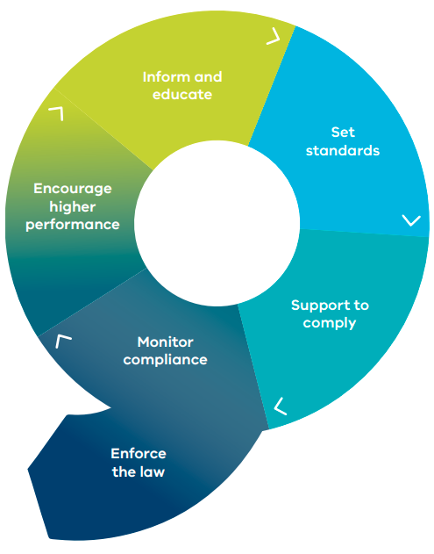

# An overview of the permissions scheme

Industrial activities are a key driver of Victoria’s economic prosperity. But they can pose a significant risk to human health and the environment when they are not effectively managed. A relatively small number of industrial activities make up a considerable amount of Victoria’s emissions to air, land and water. These emissions can also have significant impacts on community health and wellbeing (e.g. from noise and odour).

The Act contains a duties-based framework that targets risks of harm from pollution and waste. The permissions scheme is an important part of EPA’s broader approach to preventing harm. It sets performance standards, in the form of conditions, and supports EPA’s monitoring of compliance.

The permissions scheme in chapter 4 of the Act complements and supports the GED and waste duties. It provides greater assurance that key risks are being effectively managed. It does this by:

* prohibiting persons from engaging in specified activities without the appropriate permission
* requiring some activities to undergo assessment by EPA before commencing
* allowing EPA to set customised conditions on the conduct of prescribed activities.

These restrictions have the potential to cause additional burden on businesses and industry. So permissions are focused on where there is a need for additional control of the risks from an activity. This includes:

* greater certainty for EPA and community in the management and control of risks. This may be necessary where the risks and consequences of harm to human health and the environment are significant and additional confidence in the management of risks is required.
* the need for improved targeting of risks of non-compliance in sectors that attract criminal activity or where there are strong financial drivers to not comply with the law.
* providing increased certainty for business on the standards for compliance.
* enabling the regulatory framework for the management of waste by providing authority to receive industrial waste.

# Permissioning tools

The permissions scheme supports a risk-based and proportionate control of activities that present a significant risk to human health and the environment. The Act creates three broad tiers of permissions, consisting of licences, permits and registrations (see Figure 2).

The Regulations specify the activities which require a permission and which tier of permission is required. The Regulations also set out which activities are required to provide a financial assurance. A financial assurance acts as a security for the potential costs and expenses of remediation or clean-up activities.

Figure 2 Tiers of the Permissions Scheme

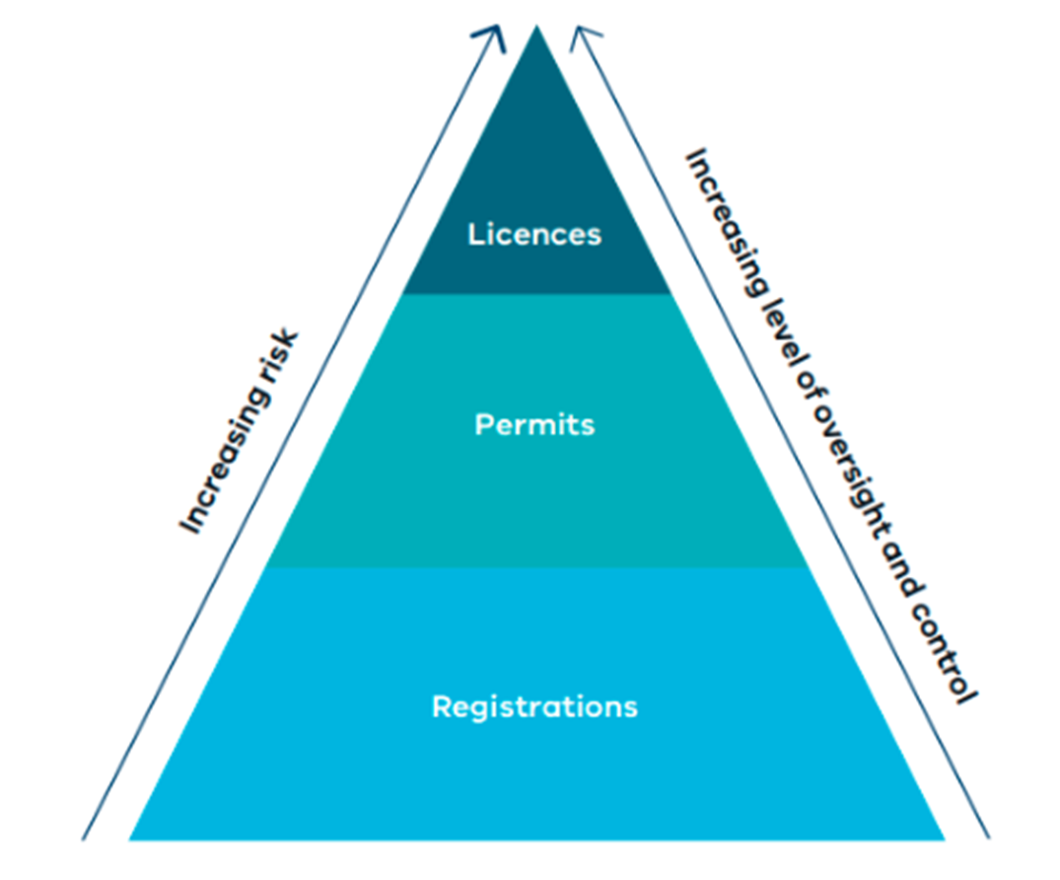

## Licences

Licences are a category of permission that address complex activities that justify the highest level of regulatory control. They are used where:

* there is a significant risk of harm or
* a high potential for mismanagement.

Decisions on licence applications will involve a detailed assessment. A licence that is granted will include customised conditions with ongoing oversight by EPA.

### Pilot Project Licence

A Pilot Project Licence (PPL) is a time-bound approval to support the research, development or demonstration of a novel technology or technique.

An application for a PPL must include a robust assessment and monitoring plan for the proposal. The assessment and monitoring plan should enable:

* the success or otherwise of the novel technology or techniques to be determined and
* monitoring of any potential risks to human health and the environment.

The statutory assessment timeframe of PPL applications is 22 business days. The maximum duration for a PPL is five years.

Following successful demonstration of the pilot, an applicant may seek a Development Licence (or occasionally an Operating Licence or Permit), for the next stage in the lifecycle of the activity.

### Development Licence

A Development Licence (DL) covers the design, construction, modification and commissioning stages of complex, high-risk activities. The process allows EPA to:

* make a science and evidence-based assessment of the design
* seek the views of the community and interested stakeholders
* drive innovation and better practice.

This is an important tool in preventing harm. It supports the duty holder to more effectively seek options to mitigate risks. It also allows EPA to influence the design of works or a facility, including operating and management capability, before it is built.

Once the development activity has been completed, a duty holder will need to apply for an Operating Licence or Permit, where specified in the Regulations. This enables the operational stage of the activity.

The statutory assessment time of DL applications is up to four months. DLs are subject to a public notification and consultation process set out in the Act and the Charter of Consultation.

When issued, these licences can contain a range of conditions to address risks from construction activities and the commissioning of plant or equipment. DLs are subject to expiry dates which will be specified within the licence.

### Operating Licence

An Operating Licence (OL) is required for the operating phase of certain activities. These licences follow directly from a DL where specified in the Regulations and enable the activity to operate. Conditions in an OL can be customised to consider the site-specific risks of the activity and may cover the decommissioning stage of an activity.

If the duty holder has previously completed its works in accordance with a DL, the assessment of an OL application will take up to 15 business days. A new application will take up to 42 business days.

These licences can, with the exception of landfill activities, be issued for up to a maximum of 20 years. After this time a new licence must be sought to lawfully continue the activity. A landfill OL can be granted for up to 99 years.

All OLs will be subject to a mandatory review approximately every five years. The periodic review will assess the performance of the duty holder and identify opportunities for improvement. Following each review, an assessment will be made as to whether a licence should be amended to reflect changes, such as:

* to the Environment Reference Standard
* advances in reasonably practicable risk controls
* performance improvements across the sector.

## Permits

Permits apply to activities that are not adequately addressed through the GED alone and are of:

* moderate risk or
* high risk with low complexity.

Permits may also be required for temporary or time bound activities, such as conducting outdoor concerts or temporary on-site waste treatment. They may also be associated with a fixed site, mobile plant or a vehicle.

The conditions of a permit can also provide additional direction and clarity for duty holders on risk management.

An application for a permit is subject to an assessment process by EPA. Permits will be assessed within 15 or 42 business days, as specified in the Regulations. Most permits can be issued for up to five years, with the option to renew certain types of permits before they expire.

An approved permit will contain conditions that are largely standard across an industry sector. These conditions may be varied where greater risk controls are needed. This includes consideration of the cumulative impact from multiple activities and the sensitivity of the local environment.

## Registrations

Registrations are a simple permission that are automatically granted upon receipt of a suitable application. Registrations may include standard conditions for the relevant activity.

They are suited to activities that pose moderate to low risks. They may also be used in instances where applying standard controls across a sector may raise the standard of compliance and minimise risks to human health and the environment. This includes as a precautionary approach to the management of emerging risks.

Registrations are also an efficient and clear way to provide authorisation to receive industrial waste as required by the Act. A registration can enable others in the chain of custody, such as producers and transporters, to easily discharge their duty to take waste to a place which is authorised to receive it.

By registering to perform an activity, and accepting any conditions attached to the registration, the duty holder agrees to meet the minimum requirements for undertaking that activity. This includes implementing any applicable practices or controls that would also be required under the GED. Conditions of a registration could also include a requirement to notify or report to EPA in certain circumstances. For example, a requirement to notify EPA if approaching a specific threshold.

Registrations can be in force for a maximum of five years. Prior to the expiry of a registration, duty holders have the option to renew the permission. Like any other permission, under certain circumstances, a registration can be suspended or revoked.

## Other approval tools

Designations

The Regulations set out how to classify industrial waste. This determines how the waste is managed and where it may be taken.

A designation can:

* fill gaps in waste classification or
* override the waste classification determined under the Regulations.

It allows EPA to account for novel circumstances and emerging issues around waste. However, it does not allow a waste to be excluded from the industrial waste duties in the Act.

For more information on designations and other rulings and determinations, refer to the General Standards Policy (EPA publication 1983).

### Exemptions and determinations

Despite undertaking a prescribed activity, the Act and Regulations set out the circumstances where EPA may decide that a permission is not required. This includes the power to grant exemptions and make determinations.

These powers enable us to ensure that the requirement to hold a permission is proportionate to the risk of the activity. For example, exemptions and determinations may be granted where:

* an activity in certain contexts poses a low risk to human health and the environment or
* the requirement to hold a permission would be unfairly burdensome.

The granting of an exemption and making of a determination may be subject to conditions or specific requirements. These conditions and requirements must be met by the duty holder. If not complied with, the exemption or determination will not be considered valid or applicable. The duty holder may then face penalties for conducting an activity without the required permission.

### Authorisation of discharges or disposal

EPA has some limited power to authorise a temporary controlled discharge or disposal of waste in circumstances that would otherwise constitute a contravention of the Act. The Act prevents us from authorising a discharge or disposal where it would have significant adverse effects on human health or the environment. Further, we can only issue an authorisation for the purposes of:

* meeting a temporary emergency
* providing for the temporary relief of a public nuisance or community hardship or
* enabling the commissioning, repair, decommissioning or dismantling of any item of plant or equipment.

We anticipate that the use of these powers will be infrequent. Applicants for an authorisation of discharge or disposal must demonstrate that the circumstances meet the above grounds. Otherwise, it may be necessary to consider seeking approval through an alternate or existing permission.

# Assessment of permission applications

Following receipt of an application for a permission, or permission exemption, EPA will undertake an assessment. EPA will either issue or refuse to issue the permission.

Initially, we will determine whether the application has been made correctly and contains all the necessary information. This is to ensure we can make an assessment against the requirements set out in the Act, Regulations and the factors set out in this section.

The amount and type of information required, and the time to assess it, will generally be proportionate to the level of risk and complexity of the activity. To ensure adequate documentation is provided when the application is lodged, businesses are encouraged to engage early with EPA through pre-application meetings. This can also help to avoid unnecessary delays when we must request more information.

Our assessment of an application requires consideration of several factors depending on the type of permission being assessed. A primary consideration is the degree to which the activity may impact environmental values for each segment of the environment as identified in the Environment Reference Standards. We need to ensure that the activity does not pose an unacceptable risk of harm to human health or the environment. This includes the potential contribution of the activity to the cumulative risk of harm to human health and environment.

Additionally, there are a number of other factors that may result in an application being refused or inform the content of any permission conditions. These include:

* Compliance with the Act – how the applicant will comply with the GED, other duties under the Act and regulations, and what measures have been taken, or are proposed, to ensure compliance.
* Principles of environmental protection – In applying these principles, EPA focuses on achieving efficient and practicable outcomes that are in proportion to the risk of harm to human health and the environment. These principles are relevant to some extent to all applications (as per section 11(2) of the Act) and must be considered in our assessment of permissions. The relevance of each principle depends on the issues arising in an application. No principle is treated as absolute or totally dominant in any given situation. The principles are commonly applied in an integrated way and may balance each other in the overall assessment process.
* Best available technology and techniques –whether the best available techniques and technology for a specific risk or activity have been identified, whether they are being proposed to be used, and the relative performance of any other options proposed.
* Stakeholder engagement – the level of stakeholder engagement undertaken by the applicant. EPA will assess whether the views and interests of the community and interested parties potentially affected by the activity have been incorporated into the proposal.
* Fit and proper person – whether the applicant is deemed as a fit and proper person to undertake the activity. EPA has the power to refuse a person or body corporate from holding a permission based on our assessment of whether or not they are fit to hold the permission.
* Prescribed matters – the Act and Regulations also provide ‘prescribed matters’. EPA must take these matters into account when making a decision upon certain permission applications. EPA may request further information in order to assess your application in accordance with these prescribed matters. Permission applications that do not satisfy the prescribed matters may not be issued or approved by EPA.

Working with Traditional Owners

EPA works with Traditional Owners across Victoria to protect and heal Country. We seek to learn from and include Traditional Owner cultural values as part of our work. It helps to strengthen EPA’s role in protecting human health and the environment.

Our engagement and collaboration with Traditional Owners occur across all areas of EPA’s regulatory work and activity. This includes during the assessment of permissions.

EPA expects that permission applications have appropriately identified Traditional owner cultural values and where relevant have taken any risks into account in the permission application.

An area of focus is the application of the Environment Reference Standard for water which recognises Traditional Owner cultural values, as an Environmental Value.

* Consideration of other Acts and legislative frameworks – EPA must consider a number of other legislative frameworks when making permissioning decisions. EPA may require or request further information to assess your application in accordance with these frameworks. Permission applications that do not satisfy the application requirements (published or on request) for such matters may not be accepted by EPA for assessment. The considerations include:
  + Section 38, subsection 1 of the Charter of Human Rights and Responsibilities Act 2006, and any limitations of these rights under section 7 of this Act
  + Section 4B of the Flora and Fauna Guarantee Act 1988 regarding impacts on biodiversity, from the activity
  + Consideration required under section 17 of the Climate Change Act 2017, regarding the impact of greenhouse gas emissions on climate from the activity and impacts of climate change including on the activity’s risk of harm to environment and human health.

# Accountability in decision-making

EPA believes that the public should have access to reliable information that supports a good understanding of:

* the condition of the environment
* risks of harms
* how decisions are made in relation to environmental protection.

This is consistent with the principle of accountability in the Act. This principle also includes providing opportunities for the public to be engaged in decision-making and have their interests taken into consideration.

Enabling consultation is vital. It connects:

* EPA decision making
* permission applications
* environmental protection standards
* the interests and concerns of Victorians.

The engagement pathways for a permission application will depend on the:

* type of permission
* level of public interest
* nature of any risk of harm to human health and the environment.

The Charter of Consultation sets out the commitments EPA makes to engagement during the assessment and administration of permissions.

All permissions granted by EPA will be made available on our website as part of the public register. Most of our permission decisions are also reviewable before the Victorian Civil and Administrative Tribunal (VCAT). This gives the applicant or holder of the permission the opportunity to ask for an independent review of an EPA decision within 15 business days of the decision coming to the applicant’s notice.

The issue of a development licence and the removal of the suspension of an operating licence are also reviewable by third parties whose interests are affected by the decision. This may include community members, under specific grounds set out in section 434(3) of the Act.

# Ensuring compliance with permissions

EPA will monitor the compliance of permissions, permission exemptions and determination through a variety of approaches. Compliance monitoring and site inspections are an important part of our role. It serves to protect the integrity of the environmental protection laws and to lift the performance of businesses and industry sectors over time.

## Permission conditions

EPA has broad powers to set conditions in a permission. We use conditions to establish a framework for risk management, record keeping and reporting.

Most conditions are applied consistently across a type of permission, or to a class of activity. EPA may apply a standard condition where it is necessary to establish a common standard of performance across an industry sector or for a given risk. For example, where there is a history of non-compliances in that industry.

In some circumstances, EPA may raise the performance standards beyond the level of the GED by requiring the use of best available techniques and technology. This may include situations where the combined impact of multiple activities results in risks of a cumulative nature.

Permissions may also include conditions that require administrative and management actions, such as:

* consultation with the local community
* reporting back to EPA on compliance with the conditions of a permission, or provide data on emissions to EPA and the community
* pollution incident planning
* provision of financial assurance to cover the cost of remediating a site.

In addition to standard conditions, EPA may also determine that a permission needs site-specific conditions. Often for complex sites or those with unique features, these can include:

* discharge conditions, such as discharge limits for air emissions or water discharges
* waste acceptance conditions, which set the maximum concentration of contaminants in waste that can be accepted or treated at the activity site
* other conditions that are required to ensure that certain practices are occurring at the activity site.

These conditions complement a permission holder’s compliance with the GED and reinforce the state of knowledge around the management of risks of harm. A permission condition may address a particular risk of harm. If the holder of the permission complies with that condition, they will be taken to have performed a duty or satisfied an obligation.

EPA will apply conditions in a targeted way to ensure they are focused on the key risks of the permissioned activity. This may include the use of conditions that:

* set minimum standards of performance under the GED
* restrict certain actions or activities or
* specify environmental outcomes for an activity to meet.

Permission conditions may not be exhaustive of all measures that a duty holder needs to take to comply with the GED. For example, where a risk is commonplace and an industry’s knowledge is well developed (including general guidance or compliance codes), permission conditions may not be used to address that risk. Therefore, a duty holder may need to manage other risks under the GED, with guidance and good industry practices providing the state of knowledge about how those risks should be managed.

## Performance statements

Permission Information and Performance Statements (PIPS) are a way for permission holders to periodically demonstrate compliance and report their performance to EPA and the community. They support ongoing engagement between permission holders and EPA regarding their performance. This includes actions planned and undertaken to manage risks and keep up to date with industry best practice.

PIPS are a requirement for operating licences and some permitted activities. Throughout the year, EPA will select different sectors to provide a PIPS. The information in performance statements provides EPA with critical data. It helps us to:

* analyse patterns and trends in risk controls and failures
* target future compliance assessments
* design compliance support programs or capacity building initiatives,
* periodically review the effectiveness of the permissions scheme.

Compliance with approvals from other regulators

Your activity may also require approval from other regulators or statutory authorities. A permission, exemption, authorisation or other instrument issued by EPA does not meet your obligations from other laws and regulatory frameworks.

For example, if your activity requires an EPA permission it may also require you to hold a permit from your local Council.

If EPA become aware of non-compliance with obligations under other laws, we may also share this information with other relevant regulators.

Performance statements, record keeping and other reporting requirements that may be specified in a permission are in addition to duties under the Act to notify EPA of pollution incidents and significant contamination issues.

## Enforcement of permissions

EPA expects all permission holders to:

* know their legal obligations
* identify operational risks
* have the appropriate risk management controls in place.

Non-compliance with the Act, a condition of a permission, or the failure to hold the correct permission for your activity will be enforced in line with EPA’s Compliance and Enforcement Policy (publication 1798).

The Act provides for a range of enforcement measures including the power to suspend or revoke a permission. This has the effect of temporarily or permanently removing the right of the duty holder to operate that activity.

A permission may be suspended on the basis of non-compliance with the Act or Regulations, in addition to a breach of permission conditions.

Accessibility

Contact us if you need this information in an accessible format such as large print or audio.   
Please telephone 1300 372 842 or email [contact@epa.vic.gov.au](mailto:contact@epa.vic.gov.au)

Interpreter assistance



If you need interpreter assistance or want this document translated, please call 131 450 and advise your preferred language. If you are deaf, or have a hearing or speech impairment, contact us through the National Relay Service.



[](https://twitter.com/EPA_Victoria) [](https://www.facebook.com/EPAVictoria) [](https://www.linkedin.com/company/epa---victoria/) [](http://www.youtube.com/channel/UCTH9sYvphkFxGlAsIyTecJQ)

[epa.vic.gov.au](https://www.epa.vic.gov.au/)

Environment Protection Authority Victoria

GPO BOX 4395 Melbourne VIC 3001

1300 372 842



Authorised and published by the Victorian Government, 1 Treasury Place, Melbourne