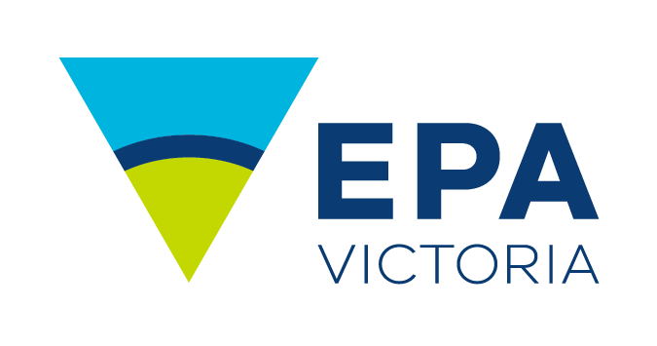Guidance for environmental and human health risk assessment of wastewater discharges to surface waters

Risk assessment of wastewater

discharges to surface waters

Publication 1287 | May 2023

Water Sciences and Environmental Public Health Branch, Science Division

[epa.vic.gov.au](https://www.epa.vic.gov.au/)

Environment Protection Authority Victoria

GPO BOX 4395 Melbourne VIC 3001

1300 372 842

This publication is for general guidance only. You should obtain professional advice if you   
have any specific concern. EPA Victoria has made every reasonable effort to ensure accuracy   
at the time of publication.

Give feedback about this publication online: [epa.vic.gov.au/publication-feedback](http://www.epa.vic.gov.au/publication-feedback)

EPA acknowledges Aboriginal people as the first peoples and Traditional custodians of the land   
and water on which we live, work and depend. We pay respect to Aboriginal Elders past and present   
and recognise the continuing connection to, and aspirations for Country.

Executive summary

The *Guidance for environmental and human health risk assessment of wastewater discharges to surface waters* provides step-by-step guidance to assess the environmental and human health risks associated with point-source wastewater discharges to surface waters. It has been developed to support those responsible for prescribed permission activities with wastewater discharges to surface waters, and the risk assessors/consultants conducting environmental and human health risk assessments on their behalf.

Permission holders or those applying for a permission with wastewater discharges to surface waters are expected to understand the environmental and human health risks associated with their activities and implement controls to avoid or minimise risks, so far as reasonably practicable. Risk assessment is an effective and transparent way of assessing and reporting environmental and human health risks. This guidance provides a framework to support permission holders and the risk assessors appointed on their behalf to assess the environmental and human health risks resulting from the handling and discharge of wastewater.

Environment Protection Authority Victoria (EPA) has developed this *Guidance for environmental and human health risk assessment of wastewater discharges to surface waters* based on current nationally and internationally accepted risk assessment approaches. There are three main phases in the risk assessment process:

1. **Problem formulation** determines the focus and scope of the risk assessment and the management information it needs to provide. This phase identifies which hazards are present and what the resulting risks may be. This phase also includes the development of a monitoring and analysis plan to assess the identified risks.
2. **Risk analysis** determines the probability and magnitude of harm, with specific consequences occurring to the environment and human health. In a human health risk assessment, this phase includes both an exposure assessment and a health effects assessment.
3. **Risk characterisation** is the evaluation and reporting of the problem formulation and risk analysis results for decision-making and risk management purposes.

The complexity of environmental and human health risk assessments can vary, from qualitative to advanced quantitative assessments. The level of complexity will depend on factors such as hazards, impacts, receptor characteristics and the level of knowledge and understanding of these.

This guidance provides a framework for environmental and human health risk assessment. It also includes case studies as examples of how environmental and human health risk assessments can be conducted.

For more information, please contact EPA at [1300 372 842](tel:1300372842) or 1300 EPA VIC or [contact@epa.vic.gov.au](mailto:contact@epa.vic.gov.au)

Contents

1. Introduction 11

1.1. Objective and users 11

1.2. Scope 11

1.3. How to use this guidance 13

1.4. Status 14

2. Risk assessment 15

2.1. What is risk assessment? 15

2.2. Types of risk assessment 17

2.3. Prioritising discharges for risk assessment 21

3. Conducting an environmental and human health risk assessment of wastewater discharges 22

3.1. Problem formulation 23

3.1.1. Management goals and management objectives 23

3.1.2. Collation of available data and information 24

3.1.3. Identifying environmental values and potential risks 24

3.1.4. Identification of endpoints 27

3.1.5. Conceptual models 28

3.1.6. Risk analysis plan 30

3.2. Risk analysis 33

3.2.1. Risk likelihood 34

3.2.2. Risk consequence 34

3.2.3. Types of risk analysis 34

3.2.4. Use of standards and risk analysis methodologies 35

3.2.5. Special considerations for human health risk analysis 36

3.2.6. Uncertainty analysis 38

3.3. Risk characterisation 39

4. Risk management 40

4.1. Implement controls 40

4.2. Check controls 40

5. Stakeholder participation 41

5.1. Benefits of stakeholder participation 41

5.2. Planning process for stakeholder participation 42

6. Mixing zone and the risk assessment process 45

7. Case studies 45

8. Acknowledgments 45

9. References 45

Appendix A: Examples of conceptual models 48

Appendix B: Case studies 50

B.1. Barwon Water – Black Rock treatment plant 50

B.2. Goulburn Valley Water – Shepparton, Alexandra and Eildon treatment plants 58

B.3. North East Water: Beechworth treatment plant 68

B.4. Risk assessment for a small wastewater treatment plant 75

Appendix C: Guidance for assessing human health risk of wastewater discharges to surface waters 80

C.1. Introduction 80

C.2. When should a health risk assessment be conducted? 80

C.3. What is a human health risk assessment? 80

C.4. Environmental values 82

C.5. The microbial risk assessment framework 85

C.6. Selecting a QMRA approach 87

C.7. Assessing microbial risks of wastewater discharge 89

C.7.1 Problem formulation 89

C.7.2 Exposure assessment 97

C.7.3 Health effects assessment 99

C.7.4 Risk characterisation 100

C.8. Risk management 100

C.9. Variability and uncertainty 102

C.10. Case studies 103

C.10.1 Case study of a metropolitan wastewater treatment plant with receiving waters used for irrigation 104

C.11. References 106

Glossary of terms

|  |  |
| --- | --- |
| Act | The *Environment Protection Act 2017* |
| ANZG | *Australian and New Zealand Guidelines for Fresh and Marine Water Quality*, published by Australian and New Zealand Governments and Australian state and territory governments in 2018 and available online at [www.waterquality.gov.au/anz-guidelines](http://www.waterquality.gov.au/anz-guidelines). |
| Diffuse source | A source of pollutants that is not an identifiable single point of discharge. |
| Environment Reference Standard (ERS) | As defined in the Act. Environment Reference Standard identifies the environmental values of the ambient air, noise, land and water environments that are sought to be achieved or maintained in Victoria, and the standards to support those values. |
| Environmental value | As defined in the Act. Environmental value is a use, an attribute or a function of the environment. Some examples are having safe water to drink, being able to use water for agriculture or industrial activities, being able to breathe clean air, aesthetic enjoyment of land and waterways and being able to sleep without unreasonable noise disturbance. Environmental values are identified in the ERS. |
| General environmental duty (GED) | The duty under section 25(1) in the Act. The GED is the duty for a person engaging in an activity or business that may give rise to risks of harm to human health or the environment from pollution or waste, to minimise those risks, so far as reasonably practicable. |
| Hazards | Any physical (for example, scouring, sediment deposition), chemical (for example, toxicants) or biological entity (for example, pathogens) that can induce a harmful response in an environmental value. |
| Human health | As defined in the Act. Human health in the Act includes psychological health. |
| Indicator | As defined in the ERS. Indicator means a parameter or marker that can be measured and used to do one or more of the following:   * Provide insight into the state of the environment or human health. * Assess and report on whether an environmental value is being achieved or maintained. * Identify and assess risks to the environmental values from pollution and waste.   Examples of water quality indicators are suspended solids, nitrogen, phosphorus and salinity. Examples of biological indicators are macroinvertebrates and fish. |
| Objective (ERS objective) | As defined in the ERS. Objective means the level, load, concentration, amount, benchmark or character of an indicator against which the achievement, maintenance of, or risk to, an environmental value is assessed. |
| Permission | As defined in the Act. A permission means a development licence, an operating licence, a pilot project licence, a permit or a registration. |
| Prescribed permission activity | As defined in the Act. An activity specified in a permission. Prescribed permission activities are listed in the Environment Protection Regulations 2021. |
| Point-source | A single, identifiable, source of pollutants, such as a pipe, drain or ship. |
| Pollutant | A substance associated with pollution or waste that has the potential to cause harm to human health or the environment through physical, chemical, biological or other hazardous properties. |
| Primary contact recreation | As defined in the ERS. Primary contact recreation means an activity in which the whole human body or face and trunk are frequently immersed in water, or the face is frequently wet by spray; and where it is likely that some water will be swallowed or inhaled, or come into contact with ears, nasal passages, mucous membranes or cuts in the skin. |
| Quantitative microbial risk assessment (QMRA) | As defined by the World Health Organization. QMRA is a framework that uses quantitative scientific data, and interprets them in the context of estimated health outcomes to support water management decisions and assist in the prioritisation of remedial or further research efforts. |
| Reasonably practicable | Means putting in controls, to eliminate or minimise risks of harm to human health or the environment, that are proportionate to the risks. |
| Receiving waters | Waters which receive discharges from wastewater or stormwater, including surface waters that receive discharges from groundwater. |
| Reference sites | As defined in the ERS. Reference sites are sites within segments that characterise background water quality levels, desirable conditions, or the best available sites in that segment. |
| Secondary contact recreation | As defined in the ERS. Secondary contact recreation means an activity where the human limbs are regularly wet and in which greater contact (including swallowing water) is unusual (such as boating, fishing, wading), and includes occasional and inadvertent immersion through slipping or being swept into the water by a wave. |
| Segment | As defined in the ERS. Segment means a geographic area or feature of the water environment that has common environmental conditions and natural characteristics, such as levels of total dissolved solids (TDS) for groundwater. |
| State of Knowledge | State of knowledge describes the body of accepted knowledge that is known or ought to be reasonably known about the harm, or risks of harm, to human health and the environment; and the controls for eliminating or reducing those risks. |
| Surface waters | Waters other than groundwater, for example: river, stream, billabong, lake, tidal water, estuary, marine and coastal water. |
| Water dependent ecosystems and species | As defined in the ERS. Water dependent ecosystems and species means any water environment, from small to large, from pond to ocean, in which plants and animals interact with the chemical and physical features of the environment. Water dependent ecosystems and species has the same meaning as aquatic ecosystems in the ANZG. |
| Water quality | The physical, chemical and biological characteristics of water and the measure of its condition, relative to the requirements for one or more biotic species or to any human need or purpose. |
| Wastewater | Wastewater in this guidance means treated waste mainly consisting of water, and includes any of the following:   * Sewage or another human-derived wastewater * Cooling water * Polluted stormwater or groundwater * Water containing any commercial, industrial or trade waste, including animal effluents. |

# Introduction

An environmental and human health risk assessment evaluates the likely or actual harm of one or more hazards – such as pollutants, pathogens or anthropogenic activities – on the environment and human health. The rigour of a risk assessment process produces information that is targeted and transparent. This information is useful to decision makers and managers who must evaluate alternative technologies, compare and prioritise risks and evaluate cost-effective actions to maximise environmental gains.

## Objective and users

This *Guidance for environmental and human health risk assessment of wastewater discharges to surface waters* provides a step-by-step guide to assess the environmental and human health risks associated with point-source wastewater discharges to surface waters. It has been developed to help those responsible for prescribed permission activities (as defined in the Environment Protection Regulations 2021) involving wastewater discharges to surface waters, and the risk assessors/consultants conducting environmental and human health risk assessments on their behalf. This guidance supports minimising the risk of harm ([www.epa.vic.gov.au/for-business/how-to/manage-environmental-risk](https://www.epa.vic.gov.au/for-business/how-to/manage-environmental-risk)) to human health and the environment, and provides information that will help permission holders to comply with their legal obligations and meet community expectations.

## Scope

This guidance has been primarily developed for prescribed permission activities with point-source wastewater discharges to surface waters. However, the information provided can be applied to a range of discharge sources and assessment needs. For example, it can be used to identify and assess risk from diffuse sources of pollution, such as surface run-off associated with construction and agricultural activities. The type and complexity of the risk assessment (see section *Types of risk assessment)* needs to be proportionate to the problem and the harm, or risks of harm, associated with the activity.

This guidance follows the four-step process outlined in *Assessing and controlling risk: a guide for business* (EPA publication 1695.1) with a focus on the identification of hazards and assessment of risks.

Risk assessment and risk management are interlinked. In risk assessment, the risk of a certain situation is determined, then risk management applies solutions to the problem. Risk assessment is not only about identifying whether an activity will pose a risk to human health and the environment. It is also part of planning an effective risk management strategy because assessing and understanding the risk helps to identify appropriate risk management actions. As a result, risk management is introduced in this guidance; however, detailed risk control measures are not presented, as these will depend on the scale and complexity of the activity, and the type and magnitude of the risks identified.

This guidance focuses on, but is not limited to, the assessment of risks to any environmental values identified in the Environment Reference Standard (ERS) (see box: ***Environment Reference Standard and environmental values***).

These environmental values include:

* water dependent ecosystems and species
* human consumption after appropriate treatment
* agriculture and irrigation
* human consumption of aquatic foods
* aquaculture
* industrial and commercial
* water-based recreation (primary contact)
* water-based recreation (secondary contact)
* water-based recreation (aesthetic enjoyment)
* Traditional Owner cultural values (see box: ***Traditional Owner cultural values***)
* navigation and shipping.

**Environment Reference Standard and environmental values**

The ERS is a new legislative instrument made under the *Environment Protection Act 2017*. The ERS brings together environmental values, indicators and objectives that describe environmental and human health outcomes to be achieved or maintained in Victoria. These values, indicators and objectives provide a reference point to consider whether a proposal or activity is consistent with the environmental values identified in the ERS. The ERS also allows the evaluation of potential impacts on human health and the environment that may result from a proposal or activity. More information about the ERS can be found in *Guide to the Environment Reference Standard* (EPA publication 1992).

**Traditional Owner cultural values**

For Traditional Owners, Country is embedded with culture, stories, songlines including ceremonial places and sites of significance. These ‘cultural values’ that are embedded in Country, connect everything and everyone. There are no distinctions between water, land and air.

Assessing risks of harm against this environmental value requires careful consideration of the interconnections of water, land and air – for example, not just considering the direct effect on a target species, but the effects on the wider environment, food sources and predatory species connected to that target species. Developing a conceptual model, which outlines and visualises these interconnections, can be a useful tool in building an understanding of the cultural landscape.

Even in highly disturbed areas, culture, stories and songlines will remain. Efforts to minimise risk of harm and ensure activities don’t maintain existing contamination in such areas can contribute to the healing of Country.

The assessment of Traditional Owner cultural values of surface waters should consider relevant state programs, strategies or national guidance. Reference sources include the Victorian Aboriginal Cultural Heritage Register and Information System (ACHRIS, <https://achris.vic.gov.au>), Cultural water for cultural economies (O’Donnell et al., 2021), Water is Life: Traditional Owner access to water roadmap (DELWP, 2022), Aboriginal Waterway Assessments (available through the DELWP hosted Aboriginal water program website: [www.water.vic.gov.au/aboriginal-values/the-aboriginal-water-program](https://www.water.vic.gov.au/aboriginal-values/the-aboriginal-water-program)) and the Victorian Waterway Management Strategy (DELWP, 2013). Part 2, Division 3 of the Aboriginal Heritage Regulations 2018 outlines areas of cultural heritage sensitivity, including old waterways, ancient lakes and identifiable geological areas and formations. Advice may also be sought from First Peoples - State Relations ([www.firstpeoplesrelations.vic.gov.au](https://www.firstpeoplesrelations.vic.gov.au)), Catchment Management Authorities and/or the Department of Energy, Environment and Climate Action (DEECA) on specific engagement with Registered Aboriginal Parties (RAPs) and/or other Traditional Owner groups (including referencing their Country Plans).

Consideration of the principles and guidelines in the Australian and New Zealand Guidelines for Fresh and Marine Water Quality (ANZG) may also assist in measuring risk of harm against this environmental value ([www.waterquality.gov.au/anz-guidelines/guideline-values/derive/cultural-values](https://www.waterquality.gov.au/anz-guidelines/guideline-values/derive/cultural-values/principles)). As indicated in ANZG, cultural values for any element of the environment cannot be ascertained in the absence of engagement and consultation with Traditional Owners.

It is acknowledged that engagement with the RAPs or other Traditional Owner group is an evolving process. However, it is important to consider that any activity undertaken is on a landscape that has a story and Aboriginal history. As a minimum, assessments should identify whether there are issues, areas or sites of relevance and concern to Traditional Owners, and establish a process to ensure appropriate engagement is undertaken to form indicators and objectives that minimise the risks of harm with respect to this environmental value. If the site under assessment has a Cultural Heritage Management Plan, or is identified on the Aboriginal Cultural Heritage Register and Information System (ACHRIS) as being on or near an area of cultural sensitivity or waterway, then this will indicate that there are matters of cultural concern to consider. However, the primary source of information is the relevant RAPs or other Traditional Owner groups.

It is not appropriate to simply consider Traditional Owner cultural values using the other environmental values as a proxy. ANZG outlines a process to determine whether the existing water quality guidelines can support assessment of risks of harm with respect to this environmental value, but emphasises that the process does not replace the need to consult with Traditional Owners. See: [www.waterquality.gov.au/anz-guidelines/guideline-values/derive/cultural-values](https://www.waterquality.gov.au/anz-guidelines/guideline-values/derive/cultural-values)

## How to use this guidance

You can use this guidance to assess the risks of a wastewater discharge so that risks can be minimised so far as reasonably practicable.

EPA requires an environmental risk assessment as part of an application for a permission, or as part of an existing permission amendment or review, with wastewater discharges to surface waters. EPA will consider the environmental and human health risk assessment reports when assessing the application/review. This enables EPA to set risk-based discharge limits, which consider appropriate spatial and temporal environmental conditions and values to protect the environment and human health.

EPA also requires licence holders to have in place a risk management and monitoring program (RMMP) that enables the licence holder and EPA to determine compliance with the general environmental duty (see box: ***General environmental duty and state of knowledge***). You can use this guidance to collect and analyse the information needed for your RMMP.

This guidance is presented in three parts:

1. The main body of this guidance describes the environmental and human health risk assessment framework. The framework was presented in the first version of this guidance published in 2009. This updated version includes new sections (for example, section 2.3 *Prioritising discharges for risk assessment* and development of a monitoring plan in section 3.1.6 *Risk analysis plan*) and focuses on both environmental and human health risk assessment.
2. Appendices A and B present case studies.
3. Appendix C is a new section introduced in this updated guidance and presents a detailed microbial human health risk assessment framework.

## Status

This guidance contributes to the state of knowledge (see box: ***General environmental duty and state of knowledge***) and supports those who hold a permission or are applying for a permission with EPA to understand their discharges to surface waters, so that risks to the environment and human health can be effectively managed and minimised. EPA has developed a range of guidance for business, much of which is relevant to activities that emit pollutants into the environment. Guidance by topic can be found on EPA's website ([www.epa.vic.gov.au/for-business/find-a-topic](http://www.epa.vic.gov.au/for-business/find-a-topic)).

**General environmental duty and state of knowledge**

The general environmental duty (GED) is introduced in the *Environment Protection Act 2017* and means: ‘A person who is engaging in an activity or business that may give rise to risks of harm to human health or the environment from pollution or waste must minimise those risks, so far as reasonably practicable.’

Measures or controls to eliminate or minimise risks are reasonably practicable when they are proportionate to the risks from the pollution or waste. Further, to determine whether measures or controls are reasonably practicable, consider what a person engaging in an activity knows, or ought reasonably to know, about the harm or risks of harm to human health and the environment and the controls for eliminating or reducing them. This is called ‛state of knowledge’. More information about the general environmental duty and state of knowledge can be found in *Industry guidance: supporting you to comply with the general environmental duty* (EPA publication 1741.1). More information about ‘reasonably practicable’ can be found in *Reasonably practicable* (EPA publication 1856).

# Risk assessment

## What is risk assessment?

Risk assessment is the formal process of evaluating and understanding risk, based on its likelihood and consequences. Likelihood is the probability or chance that the hazard will cause harm (see box: ***Harm***). Consequence is the level of harm or severity of impact that a hazard can cause.

**Harm**

Harm is defined in section 4 of the *Environment Protection Act 2017* as “…an adverse effect to human health or the environment (of whatever degree or duration)…” Section 4 determines that “..harm may arise as a result of the **cumulative effect of harm** arising from an activity combined with harm arising from other activities or factors.” The concept of cumulative effect of harm is important when surface waters have a history of previous impacts and/or the potential for present or future impacts from multiple activities/industries in the catchment.

Environmental and human health risk assessment evaluates the interactions between environmental values (as described in the ERS, but not limited to them) and the hazards that could affect these. This is done in a consistent, clear and structured way using a risk assessment framework (Figure 1). This framework is based on nationally and internationally accepted risk assessment frameworks (US EPA, 1998; US EPA, 2001; Hart et al., 2005; Burgman, 2005; Suter, 2006; Fox and Burgman, 2008; enHealth, 2012; and ANZG, available at [www.waterquality.gov.au/anz-guidelines](https://www.waterquality.gov.au/anz-guidelines)). It ensures all potential risks can be clearly identified and appropriately assessed, and facilitates the required interactions between technical experts, risk managers and interested stakeholders.

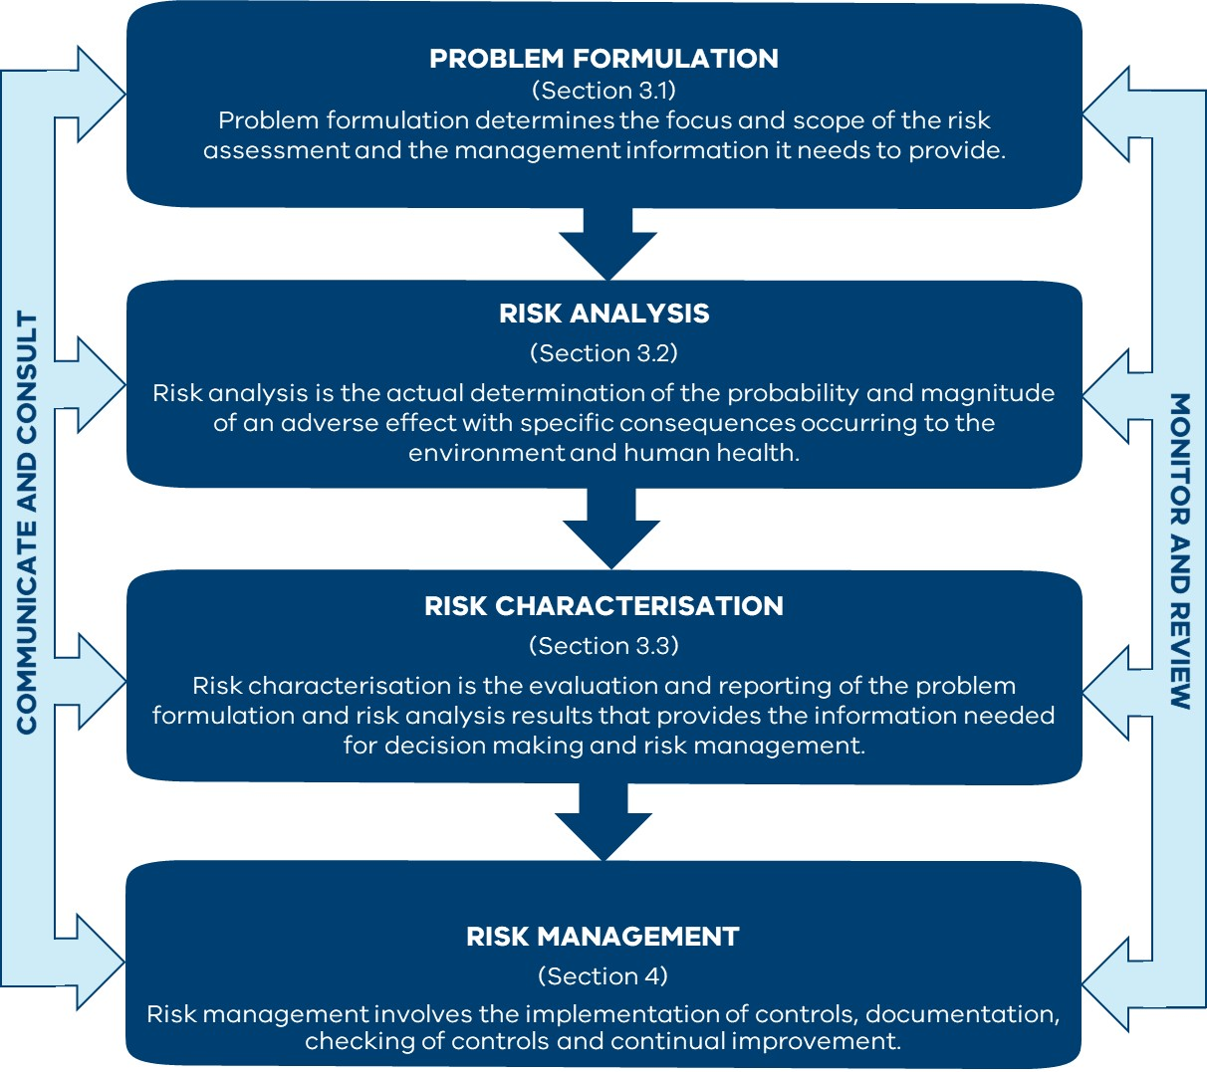

Figure – Environmental and human health risk assessment framework for wastewater discharges to surface waters

The outcomes of an environmental and human health risk assessment are:

* an estimation of the likelihood of environmental values being impacted, the magnitude of the impact, and how the impact changes given alternative scenarios
* the determination of the probability of contracting a specific infection or illness (in the case of a microbial risk assessment) or risk of human exposures exceeding a health-based guideline value (in the case of a chemical risk assessment)
* detailed information and tools that help to better understand how systems work
* targeted management actions and monitoring programs.

EPA has developed comprehensive guidance for microbial human health risk assessment of wastewater discharges. This guidance, available in Appendix C, should be used when developing a risk assessment for wastewater discharges. Where wastewater discharges include chemical contamination (such as industry waste discharge), enHealth (2012) provides guidance on undertaking a human health risk assessment.

## Types of risk assessment

Risk assessments span from qualitative through semi-quantitative to fully quantitative. The appropriateness of a particular risk assessment type depends how well it matches its purpose. While the three types of environmental risk assessment are described as strict categories, any risk assessment might include elements of these approaches:

**Qualitative**: qualitative risk assessments are commonly used for screening risks to determine whether they merit further investigation. It is based on subjectivity and the knowledge of the risk assessor/s.

**Semi-quantitative**: an intermediate level between qualitative and quantitative risk assessments.

**Quantitative**: quantitative risk assessments are based on extensive data, often including mathematical models.

The three types of risk assessment differ in how risk is analysed (the risk analysis phase). See section *3.2.3 Types of risk analysis*.

In making decisions on the type of risk assessment required, consideration should be given to (FAO/WHO, 2009):

* environmental values, local and/or regional values and vulnerability.
* potential impacts to environmental values from the discharge.
* expertise: quantitative risk assessments require mathematical expertise as part of the assessment team. Qualitative risk assessments, on the other hand, may not need much mathematical expertise, but demand considerable judgement to combine evidence in an appropriate and logical manner.
* mathematical models or data limitations: quantitative risk assessments often rely on the availability of mathematical models to describe phenomena and data to estimate the model parameters. If either the theory or data are lacking, then a qualitative or semi-quantitative risk assessment is more appropriate.
* time: qualitative and semi-quantitative risk assessments generally require much less time to generate conclusions compared with quantitative risk assessment.

Figure 2 and Table 1 provide guidance on the type of assessment that may be required under different scenarios. It should be noted that the table and figure do not provide an exhaustive list of scenarios, and other assessment outcomes might also be possible.

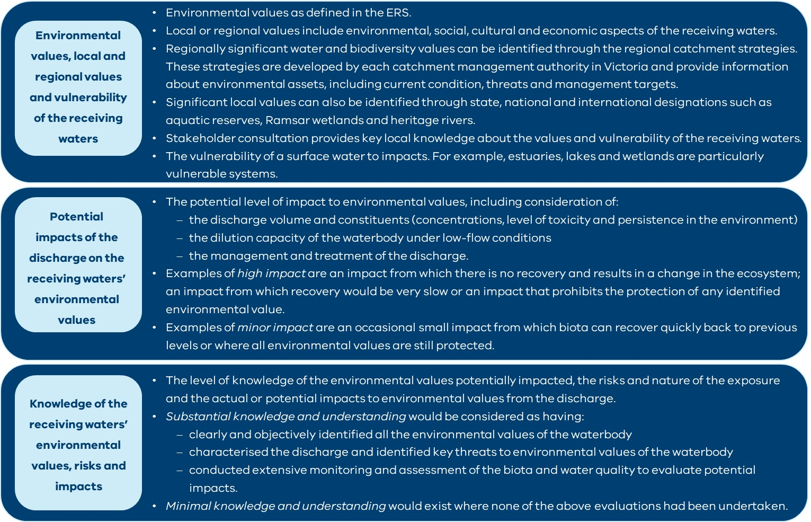

Figure – Considerations when deciding on the type of risk assessment required

Table –Considerations when deciding on the type of risk assessment required

| Environmental values and/or vulnerability of the receiving waters* | Potential impacts of discharge on the receiving waters’ environmental values# | Knowledge and understanding of receiving waters environmental values, risks, and impacts | What type of assessment should be conducted? |
| --- | --- | --- | --- |
| High | Moderate to high | Substantial | A qualitative risk assessment should be conducted initially.  Monitoring should be conducted to assess the effectiveness of management actions and whether the prior assumptions of risk are correct.  If monitoring shows that management actions are not effective, or the prior assumptions of risk are incorrect, then a further semi-quantitative to quantitative risk assessment should be conducted. |
| High | Moderate to high | Minimal | Semi-quantitative or quantitative risk assessment. |
| High | Minor | Substantial | A qualitative risk assessment should be conducted initially.  Monitoring should be conducted to assess whether the prior assumptions of risk are correct.  If monitoring shows that the prior assumption of a minor impact to values is incorrect (that is, there is the potential for a moderate-to-high impact to values), then a further semi-quantitative to quantitative risk assessment should be conducted. |
| High | Minor | Minimal | A qualitative risk assessment should be conducted initially.  If the qualitative risk assessment indicates the prior assumption of minor impact to values is correct, then monitoring should be conducted to assess whether the impact to values remains minor.  If the qualitative risk assessment, or monitoring, indicates the potential for a moderate to high impact, then a further semi-quantitative to quantitative risk assessment should be conducted. |

Table 1 – Continued

| Environmental values and/or vulnerability of the receiving waters* | Potential impacts of discharge on the receiving waters’ environmental values# | Knowledge and understanding of receiving waters environmental values, risks, and impacts | What type of assessment should be conducted? |
| --- | --- | --- | --- |
| Low | Moderate to high | Substantial | A qualitative risk assessment should be conducted initially.  Monitoring should be conducted to assess the effectiveness of management actions and whether the prior assumptions of risk are correct.  If this level of assessment is insufficient to fully understand the risks for management, then a further semi-quantitative to quantitative risk assessment should be conducted. |
| Low | Moderate to high | Minimal | A qualitative risk assessment should be conducted initially.  If this level of assessment is insufficient to fully understand the risks for management, then a further semi-quantitative to quantitative risk assessment should be conducted. |
| Low | Minor | Substantial | A qualitative risk assessment should be conducted initially.  Monitoring should be conducted to assess whether the prior assumptions of risk are correct.  If monitoring shows that the prior assumption of a minor impact to values is incorrect (that is, there is the potential for a moderate-to-high impact to values), then a further semi-quantitative to quantitative risk assessment should be conducted. |

Table 1 – Continued

| Environmental values and/or vulnerability of the receiving waters* | Potential impacts of discharge on the receiving waters’ environmental values# | Knowledge and understanding of receiving waters environmental values, risks, and impacts | What type of assessment should be conducted? |
| --- | --- | --- | --- |
| Low | Minor | Minimal | A qualitative risk assessment should be conducted initially.  If the initial qualitative risk assessment indicates the potential for moderate to high impacts to values, then a further semi-quantitative to quantitative risk assessment should be conducted.  If the initial qualitative risk assessment indicates the prior assumption of minor impact to values is correct, then monitoring should be conducted to assess that the impact to values remains minor.  If monitoring shows that there is potential for moderate to high impact to values in the future, then a semi-quantitative to quantitative risk assessment should be conducted. |

*Three categories (high, medium and low) have been assigned in this table. Please note that these categories are for guidance purposes. Figure 2 provides useful information that can be used to identify significant values and/or vulnerable systems. Key local knowledge about the values and vulnerability of the receiving waters can also be obtained through stakeholder consultation (see section Stakeholder participation in this document).

#Figure 2 provides information and examples about the potential level of impact to environmental values

## Prioritising discharges for risk assessment

Permission holders may be responsible for multiple permissions with wastewater discharges. Wastewater discharges to surface water can have differing risks, which will influence the level of any environmental risk assessment.

When multiple wastewater discharges need to be assessed, EPA recommends a risk-rating approach by which discharges are rated according to the risk posed to the environment and human health (from the highest risk to the lowest risk discharge). The approach involves the development of high-level (low detail) environmental and human health risk assessments for each of the wastewater discharges. Factors such as the type and management of the discharge (such as treatment, volume and constituents) and the characteristics of the receiving waters (such as condition, environmental values at risk and vulnerability) should be considered when rating discharges. The approach enables the identification of high-risk wastewater discharges that must be prioritised and that warrant a full environmental and human health risk assessment (detailed assessment).

# Conducting an environmental and human health risk assessment of wastewater discharges

The environmental and human health risk assessment process systematically organises and evaluates data, information, assumptions and uncertainties to assess risks and inform decision making and management actions.

Environmental and human health risk assessments can be conducted to predict the likelihood of future adverse effects or evaluate the likelihood that effects are caused by current or past events or activities. Where waterbodies have a history of previous impacts and/or the potential for present or future impacts from multiple activities/industries in the catchment, there may be a need to address the **cumulative impacts** on environmental values from multiple pollution sources.

There are three main phases in an environmental and human health risk assessment process (Figure 1):

* problem formulation
* risk analysis
* risk characterisation.

While these phases are shown in a linear fashion in Figure 1, environmental and human health risk assessments are often interactive and iterative processes. As such, the framework should be interpreted in this way. For example, as more is learnt about the potential risks, this may lead to a re-evaluation of previous assumptions and problem formulation, and/or collection of new data and other analyses being conducted.

As more than one risk may be of concern at a site and, in many cases, multiple risks do not operate independently, an integrated assessment approach needs to be taken. This will include all aspects of the discharge that may affect the environmental values being assessed. For example, assessment of water dependent ecosystems and species needs to include factors such as water quality and quantity, physical habitat requirements and seasonal and physical biotic cues (for example, for migration or reproduction).

From a human health perspective, the main purpose of conducting a risk assessment is to identify, analyse and characterise the health risks associated with exposure to the discharge. This may be pathogenic (microbe-related) or chemical exposures. The section *3.2.5* *Special considerations for human health risk analysis* in this guidance introduces the general framework for a health risk assessment. EPA has developed comprehensive guidance for assessing risks to human health from pathogens in wastewater discharges. This guidance is available in Appendix C of this document.

## Problem formulation

The problem formulation phase determines the focus and scope of the environmental and human health risk assessment and the management information it needs to provide.

It is essential that the risk assessors involve all relevant stakeholders in the problem formulation phase. Doing so will ensure that the scope of the investigation is appropriate, all potential risks from the discharge are identified and clearly defined, and the investigation outcomes are practical for risk management. Stakeholders may include Traditional Owners, industry representatives, regulators/decision makers, relevant state agencies and natural resource managers, local government, scientific and technical experts, adjacent landholders, downstream users and local communities. Section *5* *Stakeholder participation* in this document provides more guidance on stakeholder participation.

Problem formulation involves:

* defining management goals
* collating available data and information
* defining the potential risks, including identification of:
  + environmental values requiring protection
  + potential hazards (or threats) to environmental values from the discharge
  + factors influencing the likelihood of the risk occurring and the magnitude of the impacts
  + temporal and spatial scales of the environmental and human health risk assessment
* identifying endpoints that effectively assess the risks from the discharge to environmental values
* developing conceptual models that visually describe the relationships between sources, hazards, environmental values, factors influencing the likelihood of the risk occurring and the magnitude of the impacts on values
* a risk analysis plan.

The steps outlined above may initially be performed sequentially, but the process of problem formulation is often iterative as more information becomes available.

Although this guidance focuses on the risk to surface waters from wastewater discharges, discharges of wastewater to surface waters may have flow on effects on groundwater (refer to *Hydrogeological Assessment Guidelines for Groundwater Quality*, EPA publication 668.1) and land. As part of a holistic risk assessment, the potential interactions between surface waters, groundwater and land should be identified and the risks to the environmental values of each segment of the environment assessed as needed.

### Management goals and management objectives

Management goals provide direction for the focus of the assessment. They are statements that embody broad objectives. For example, management goals could be ensuring that primary recreation in the waterbody (such as swimming) can occur or maintaining a healthy aquatic ecosystem.

Natural resource management goals are often already determined in local strategies (such as regional catchment strategies). A management goal can consist of a series of management objectives that help in interpreting the goal and aid in the selection of appropriate endpoints for assessment (section 3.1.4 in this document).

For example, the management goal ‘maintaining a healthy aquatic ecosystem’ could be defined by these management objectives:

* prevention of algal blooms in waterbodies
* reduction in the concentrations of toxic metals in the water column and sediments to levels that are not harmful to biota
* maintaining healthy fish populations and their habitat
* maintaining healthy macroinvertebrate communities.

### Collation of available data and information

Risk assessors need to gather and integrate all available data and information on the environmental values of the waterbody and the potential hazards to these from the discharge. This may include monitoring data, data and information from models, previous research, literature reviews and local plans and strategies. This information should provide a sound basis on which to identify and define potential risks.

If key information and data are unavailable for assessment of the discharge and its potential impacts on the environmental values, this may need to be identified for collection for the risk analysis phase.

### Identifying environmental values and potential risks

Risk assessors need to identify the environmental values and the potential risks from the wastewater discharges to the environmental values.

Identification of the environmental values to be protected occurs through consultation with all relevant stakeholders (Traditional Owners, industry representatives, regulators/decision makers, resource managers, local government, scientific and technical experts, local communities) and review of local and state resource management and environment protection strategies and policies (ERS, regional waterway strategies, regional catchment strategies). From this process, environmental values are clearly identified, providing a focus for the environmental and human health risk assessment.

Examples of environmental values could be:

* water dependent ecosystem and species
* water-based recreation (secondary contact)
* water-based recreation (aesthetic enjoyment)
* human consumption of aquatic foods.

Hazards are defined as any physical (for example, scouring, sediment deposition), chemical (for example, toxicants) or biological entity (for example, pathogens) that can induce a harmful response in an environmental value. It is important to also consider the possible interactions between multiple hazards.

Factors that influence the likelihood of the risk occurring also need to be identified. For example, if looking at the risk of an algal bloom occurring:

* the hazard is high nutrient concentrations
* factors that may influence a bloom occurring in the presence of high nutrient levels are light levels in the water column, flow velocity and temperature.

***An example of management goals, environmental values, hazards, risks and influential factors for a wastewater discharge*** is shown in the box below.

**An example of management goals, environmental values, hazards, risks and influential factors for a wastewater discharge**

**Situation**: Tertiary treated effluent from a wastewater treatment plant is discharged into a nearby stream.

**Management goals**:

* Maintaining and protecting a healthy aquatic ecosystem.
* Clean water suitable for recreational purposes.

|  |  |  |  |
| --- | --- | --- | --- |
| Environmental values | Hazards | Risk | Other factors influencing the likelihood of the risk occurring |
| Water dependent ecosystem and species | Nutrients | Algal blooms causing low dissolved oxygen | Light, flow and temperature |
| Organic matter | Low dissolved oxygen | Microbial activity |
| Salinity | Direct toxicity | Flow, evaporation |
| pH | Low and high pH can induce toxic effects in a range of substances, as well as being directly harmful to organisms | Buffer capacity, geology |
| Ammonia | Direct toxicity | pH, temperature |
| Metals | Direct toxicity | pH, hardness |
| Recreation (swimming, boating, fishing) | Nutrients | Toxic algal blooms, which may cause skin and eye irritations, or more serious complications if ingested | Light, flow and temperature |
| Disease-causing microorganisms (pathogens) | Ingestion/inhalation by humans causing various illnesses | Age and health of people exposed, time of exposure |
| Metals | Direct toxicity | pH, hardness |

The appropriate spatial scale for the risk assessment is the area in which impacts may occur. The appropriate temporal scale is the period that meets management outcomes and is protective of environmental values. Temporal variability (for example, seasonality and climatic influences) should also be incorporated into the scope of the risk assessment. Impacts due to climate change and stream flow predictions should also be taken into consideration. The ***Example of spatial and temporal scales and variability*** in the box below provides considerations of temporal and spatial scales.

**Example of spatial and temporal scales and variability**

**Potential risk**

The potential risk of algal blooms in a stream from a wastewater treatment plant discharge.

**Spatial considerations**

The area included in the risk assessment could be the point of discharge, upstream of this point (this is, ambient levels in the receiving waters) and downstream to the point where nutrient concentrations have returned to ambient levels or met the relevant ERS objectives. In some cases, a broader spatial scale may be applicable, where the contribution to the catchment load of nutrients is identified as a risk. This is particularly relevant for catchments surrounding surface waters with pollutant load objectives, such as Port Phillip Bay and Western Port.

**Temporal considerations**

This determines the periods of time the risk assessment needs to consider; for example, one year, five or 10 years. The temporal scale may be based on the timing of management plans, the variability of the discharge, the frequency of algal blooms, climatic variability or seasonality.

**Seasonal and climatic variability**

In this example, seasonal influences could be low summer flows. At such a time, nutrients in the discharge will become more concentrated in the receiving waters. In addition, the climatic influence of drought would further exacerbate low flows and nutrient concentrations.

### Identification of endpoints

Endpoints are selected to measure and monitor the environmental values being assessed. **Assessment endpoints** are explicit expressions of the value to be protected. **Measurement endpoints** are the aspect of the assessment endpoint that can be measured.

For example, if risks to water dependent ecosystems and species are being investigated, the endpoints selected may be:

* assessment endpoint: macroinvertebrate community
* measurement endpoint: macroinvertebrate community diversity

and/or

* assessment endpoint: a native fish population (for example, Murray cod)
* measurement endpoint: abundance (for example, Murray cod abundance).

If the risk of an algal bloom occurring in a river is being investigated, the endpoints selected may be:

* assessment endpoint: the river phytoplankton community
* measurement endpoint: chlorophyll a and/or phytoplankton diversity and abundance.

Endpoints are distinguished from management goals by their neutrality and specificity. Endpoints do not represent a desired achievement (or goal). Rather, they are defined by specific measurable components and provide a means of measuring stress-response relationships.

Endpoints need to be:

* susceptible to the wastewater hazard
* predictable and measurable
* relevant to the environmental values.

There is often a trade-off in selecting an endpoint between the costs of ambiguity if endpoints are loosely defined and a loss of generality in endpoints that are very precisely defined. In some cases, more than one endpoint may be required for a risk assessment, to cover the complexity of aquatic systems and the cause-and-effect relationships within these.

The strengths and limitations of potential endpoints should be assessed to select the most appropriate endpoint to analyse the risks. Selection of endpoints requires expert knowledge of aquatic processes and the assessment of these. It also requires local knowledge of the area and management concerns.

### Conceptual models

A conceptual model is a diagram or picture of the relationships between:

* human activities, sources, hazards and the environment
* factors influencing the likelihood of risk occurring
* impacts to the assessment endpoints.

Creating a conceptual model is an important initial step in the analysis of multiple hazards and provides the basis for developing hypotheses on potential cause-effect relationships (Ferenc and Foran, 2000).

The development of a conceptual model has several benefits. Conceptual models:

* aid in simplifying complex processes that may not always be completely understood
* compel risk assessors to think through and clarify their assumptions about cause-effect relationships
* identify knowledge gaps and determine research/data needs
* can easily be updated as information becomes available
* provide an easily understandable communication tool for conveying the risks, assumptions and uncertainties to risk managers and stakeholders.

Development of conceptual models should involve risk managers, technical and scientific experts, Traditional Owners, resource managers and other relevant stakeholders. Hart et al. (2005) outlined the positive outcomes of stakeholder involvement in building conceptual models as:

* providing the stakeholders with some ownership of the process
* bringing out knowledge that is not formally documented
* providing a useful means for increasing participants’ knowledge of the ecosystems being assessed.

Conceptual models are most commonly flow diagrams that use arrows to represent relationships between sources, hazards and assessment endpoints (see Appendix A for examples). They will vary in complexity, depending on the risks and systems being assessed. If there are many complex relationships, it may be more desirable and less confusing to represent the relationships and processes as a set of interrelated models. Such models could progress from a broad scale (such as the catchment level), working towards a finer scale showing more detail (for example, the relationship between wastewater pathogens and toxicants to human health issues).

Depending on the complexity of the conceptual model, supplementary text may be important for providing explanations of the relationships. This helps to prevent confusion. It is also important that the underlying assumptions of the model and key knowledge gaps are identified, reviewed and documented as sources of uncertainty. This avoids the inclusion of incorrect information or misrepresentation of the actual risks. Data and information can be collected to address these knowledge gaps and incorporated into the model as they become available throughout the investigation.

The library of conceptual models developed by the United States Environmental Protection Agency’s Interactive Conceptual Diagram tool ([www.epa.gov/caddis-vol2/simple-and-detailed-conceptual-model-diagram-downloads](http://www.epa.gov/caddis-vol2/simple-and-detailed-conceptual-model-diagram-downloads)) is a useful source of existing models.

### Risk analysis plan

Problem formulation concludes with an analysis plan that summarises the problem formulation phase and delineates the risk analysis phase. The plan is developed based on the conceptual model and information and data collected during problem formulation. It defines the endpoints that will be used to assess risk and how the risk will be quantified and described.

The risk analysis plan also delineates the monitoring program to address data gaps for the risk analysis phase. The aim of a monitoring program is to obtain information to help assess risks of the discharge on the receiving waters. The ANZG provides guidance for developing a monitoring program, including field sampling and laboratory analysis. ANZG is available at [www.waterquality.gov.au/anz-guidelines](http://www.waterquality.gov.au/anz-guidelines) and some important points are summarised below.

The starting point for any monitoring program is to set clear monitoring objectives. Good monitoring objectives should be specific, measurable, meaningful and understandable. One example of a monitoring objective can be ‘to determine if contaminant concentrations being discharged under base flow conditions are exceeding the ANZG [default guideline values](https://www.waterquality.gov.au/anz-guidelines/guideline-values/default) for the protection of aquatic ecosystems in the receiving waters.

Once objectives are defined, an appropriate monitoring plan can be designed. This involves selecting indicators to be monitored, as well as when, where and how they will be sampled. Quality assurance and quality control (QA/QC) for field and laboratory measurements should be considered, together with work health and safety requirements.

Based on the specific monitoring objectives and data requirements, it is important to consider the sample collection methods for water, sediment, biota or any other lines of evidence, including any requirements for analysis-specific sample containers, sample preservation and storage and field measurements.

*Sampling and analysis of waters, wastewaters, soils and wastes* (EPA publication IWRG701) provides detailed direction on appropriate sampling, preservation, storage, analytical and quality assurance procedures.

#### Indicators to be monitored

Indicators of water quality include physical, chemical and biological parameters. When selecting the indicators, it is important to consider the objectives of the monitoring program, the nature of the discharge effluent and the condition of the receiving waters (including sediments), including the following:

* Physical indicators include temperature, turbidity and electrical conductivity.
* Chemical indicators include pH, dissolved oxygen, nutrients, metals, suspended solids, biological oxygen demand, chemical oxygen demand, petroleum hydrocarbons and other natural and manufactured chemicals and contaminants, including contaminants of emerging concern (see box: ***Contaminants of emerging concern***).
* *E. coli* and enterococci are bacterial indicators of faecal contamination used for routine/compliance monitoring. However, it would not be appropriate to use them to assess the microbial risk associated with a discharge. This is because, depending on the treatment, these indicators may be preferentially removed while drivers of risks such as viruses and protozoa may remain. Bacterial indicators remain useful for sanity check and monitoring for plant failures.
* Biological assessment using macroinvertebrates is recommended for a general assessment of rivers and streams. Rapid techniques for macroinvertebrate monitoring are published in *Guideline for environmental management (GEM) – Rapid bioassessment methodology for rivers and streams* (EPA publication 604.2). In estuarine and coastal waters, other biological indicators such as seagrasses can be used to determine the overall health of the system.
* If pollutants of interest indicate potential for accumulation, then biota indicators (such as fish or crustaceans that may be consumed) will be required.
* Indicators for stream flow and discharge volumes or other indicators used to calculate dilution will also be required.

#### Sampling sites

The selection of sampling sites must provide adequate spatial and temporal information to address the monitoring objectives:

* The monitoring plan must include sampling at ‘control sites’ which are sites *not* affected by the discharge; as well as ‘impacted sites’, which *are* affected by the discharge. In a river or stream, control sites are usually sites located upstream of the discharge, while impacted sites are located downstream of the discharge. In lakes or coastal environments, control sites are sites outside the impacted area with similar environmental and biological characteristics to the impacted sites.
* The number of control and impacted sites that are necessary will depend on the spatial scale defined for the risk assessment. The number of sites monitored should be sufficient to assess the environmental conditions and the extent of variation of those conditions.
* The number and location of impacted sites must be sufficient to determine the fate of the pollutants in the receiving waters (such as decaying rates and decomposition) and the spatial extent of any potential impact. For example, in rivers and streams, downstream sites should be sampled at increasing distances from the discharge. The first downstream site should allow mixing of the discharge and the receiving waters. This will depend on the dilution capacity of the receiving waters.
* The discharge must be sampled immediately prior to the discharge point into the receiving waters.
* When selecting sampling sites, seasonal variations should be considered.
* Other potential sources of contamination, such as stormwater drains or confluences/discharges of waterways should also be considered.
* Consider human contact points, for example, recreational water uses points, recreational fishing, etc.

**Contaminants of emerging concern**

Contaminants of emerging concern (CEC) can be defined as natural or manufactured compounds that 1) are newly introduced into the environment or 2) may have been around for longer but have only recently been monitored or detected in the environment, 3) lack standards and guidelines for their monitoring and/or risk assessment and 4) are suspected, or known, to cause adverse ecological and/or human health effects. CEC include a wide array of compounds/chemicals, such as pesticides, pharmaceuticals and personal care products, and microplastics.

There are potentially many thousands of CEC present in discharged wastewaters that may cause adverse effects in receiving aquatic environments. Although it is recognised that CEC present a challenge for risk assessments, the duties under the GED mean that the risks from CEC need to be considered and understood. This involves reviewing and keeping up to date with new and evolving knowledge about the effects of CEC on the environment and human health and the techniques and technologies to treat them. The concept of *reasonably practicable* is particularly relevant when deciding the control measures for CEC. More information about reasonably practicable can be found in *Reasonably practicable* (EPA publication 1856).

Some considerations for CEC risk assessment include:

* the nature of the wastewater influent and population served (for example, municipal and/or trade waste)
* the wastewater treatment technology and final effluent quality
* the nature of the receiving waters (environmental values, vulnerability of the system).

For further information:

EPA’s assessment of emerging contaminants in the environment: [www.epa.vic.gov.au/about-epa/publications/1879](https://www.epa.vic.gov.au/about-epa/publications/1879)

About PFAS: [www.epa.vic.gov.au/for-community/environmental-information/pfas](https://www.epa.vic.gov.au/for-community/environmental-information/pfas) and [www.epa.vic.gov.au/about-epa/publications/2049-report-on-pfas-in-the-environment](https://www.epa.vic.gov.au/about-epa/publications/2049-report-on-pfas-in-the-environment)

#### Sampling frequency

The monitoring objectives and the expected statistical analyses can both influence the sampling frequency. The following points must be considered when deciding the sampling frequency:

* Statistical or other tools that will be used to interpret the data.
* Understanding of the system and/or processes under investigation. For example:
  + Sampling frequency should be increased in cases where a reduced quality of the discharge effluent is expected as a result of decreased treatment performance (such as under big wet loads or shock loads).
  + Weekly measurements might be appropriate for measuring the development of an algal bloom but not for investigating fish.
* For rivers and streams, biological sampling should be done using collection methods described in *Guideline for environmental management (GEM) – Rapid bioassessment methodology for rivers and streams* (EPA publication 604.2) in either spring or autumn and from both riffle and pool habitats if present.

#### Laboratory analysis

Whenselecting the laboratory for analyses, it is important to confirm that the chosen laboratory has the appropriate equipment, expertise and experience to undertake the analyses for the chosen indicators, as well as an adequate quality assurance/quality control (QA/QC) program. The use of laboratories accredited by the National Association of Testing Authorities (NATA), wherever possible, is recommended. Important considerations for the analysis are as follows:

* The analytical methods must detect the minimum concentration of the pollutant/s of interest.
* When the monitoring program aims to ensure that guideline values or standards are not exceeded, the detection limit concentrations for the relevant indicators must be less than the guideline value or standard.
* If the laboratory detection limit commercially available is above the available standard value, the lowest commercially available detection limit concentration should be used.
* When sampling biota for a human health risk assessment, sample and analyse those parts of the species that are consumed.

## Risk analysis

Risk analysis determines the probability and magnitude of an adverse effect with specific consequences to the environmental values within a certain period (Hart et al., 2005). In the risk analysis phase, the endpoints, conceptual model and risk analysis plan developed in problem formulation are used to analyse risk to the environmental values of the waterbody.

In risk analysis, the following steps should be taken for each identified hazard:

1. Determine the likelihood of the hazard causing an adverse effect
2. Assess the consequence (impact) on the environmental value/s identified
3. Calculate the severity of the risk, based on the likelihood and magnitude of the impact.

These three steps should be done for each identified hazard.

### Risk likelihood

Likelihood is based on what is known, or should be known, about the hazard, and the factors influencing the likelihood of risk occurring. Table 2 below from *Assessing and controlling risk: a guide for business* (EPA publication 1695.1) provides key concepts to determine likelihood.

| Table 2 – Key concepts to determine likelihood | |
| --- | --- |
| Concept | Explanation |
| Previous occurrence | Assessing what has happened previously, such as incidents or near misses, gives an indication about likelihood. |
| Controls | Consider what controls are in place and how effective they are. |
| Frequency | A hazard may exist all the time or only sometimes. The more often the hazard is present, the greater the likelihood that it will cause harm. |
| Changes in conditions | Operating or environmental conditions change over time and vary throughout the year. These changes can influence likelihood of a hazard causing harm. |
| Behaviour | The way people act or behave can affect the likelihood of a hazard causing harm. For example, people may make mistakes or misuse items during an incident. |

### Risk consequence

When assessing the magnitude of the impact that each hazard could cause it is important to consider:

* pre-control risk (inherent risk): this is the magnitude or degree of harm if no controls were in place.
* post-control risk (residual risk): this is the magnitude or degree of harm with controls in place. This helps determine the importance of existing or proposed controls and if new or improved controls are required.

More information about risk likelihood and consequence can be found in *Assessing and controlling risk: a guide for business* (EPA publication 1695.1).

### Types of risk analysis

There are three types of risk analysis outlined below. Risk assessors should determine the appropriate type of analysis and the resources needed based on the receiving waters and discharge characteristics, and the level of knowledge and understanding of these (Figure 2 and Table 1).

**Qualitative** **risk analysis** applies a subjective assessment of likelihood against the potential magnitude of an impact to determine the overall severity of the risk. The risk characterisation generated by a qualitative risk assessment will generally be of a descriptive or categorical nature (for example, ‘low’, ‘medium’, ‘high’ or ‘acceptable’ vs ‘unacceptable’) that is not directly tied to a more precisely quantified measure of risk.

A qualitative analysis of risk is based on subjective assessments, where cultural, personal and professional experiences and values all affect the perception of risk, and ultimately, the risk analysis. Consequently, it should be recognised that these estimates of risk represent views or opinions to which there are likely to be many alternatives (Burgman, 1999). Issues of potential bias in qualitative estimates can be mitigated by wide consultation.

A qualitative analysis is commonly used for screening risks and may reveal that further investigations are not required to provide relevant advice to the risk manager. If there are obvious sources of risk that can be eliminated, one does not need to wait for the results of a semi-quantitative or full quantitative risk assessment to implement risk management actions (FAO/WHO, 2009).

**Semi-quantitative** **analysis** provides an intermediary level between the textual evaluation of qualitative risk analysis and the numerical evaluation of quantitative risk analysis, by evaluating risks with a score. In a semi-quantitative analysis pre-defined numerical definition or scoring scales are used to characterise the likelihood of adverse events, their consequences, or both.

A semi-quantitative risk analysis of risk uses clearly defined categories or scaling like A-F. For example, a ‘low’ probability risk category might be defined as having between 5% and 10% probability of occurring in a year. Therefore, a semi-quantitative risk analysis avoids the qualitative judgemental meaning of categories by attaching a specific, quantitative meaning.

**Quantitative** **risk analysis** uses available relevant data to calculate impacts and their probabilities and produces numerical values of the level of risk. It includes data gathering, analysis and modelling techniques such as Monte Carlo and Bayesian analyses.

Semi-quantitative and quantitative risk analyses provide more rigour in the assessment and more detailed information for managing risks. They also provide better internal consistency and better assessment of uncertainties and assumptions.

It should be emphasised that *every* type of risk assessment requires appropriate data to be collected, documented and fully referenced, and synthesized in a logical and transparent manner.

### Use of standards and risk analysis methodologies

Risk analysis often comprises a review of available criteria, standards or guideline values that can be used to assess risk from the wastewater discharge. For example, the ERS provides objectives for key water quality indicators such as nutrients, pH and turbidity. The ANZG provide default guideline values for toxicants for the protection of aquatic species. For human health, where no criteria exist for either the pathway (such as consumption of aquatic foods) or for the specific chemical, guidance on appropriate methodologies are presented in enHealth (2012) and NHMRC (2008).

Examples of the types of risk analysis methods that can be used are given below. In all cases, the guidance in section *3.2.6* *Uncertainty analysis* in this document needs to be incorporated into the analysis for assessing uncertainty.

#### Desktop study

A desktop study involves the compilation of currently available information and data for the discharge and receiving waters. This may involve data trends, patterns and correlations analysis, dilution modelling (including low-flow conditions), decay curves, comparison to available standards (for example, objectives for indicators in the ERS or default guideline values for toxicants in the ANZG), and calculation of hazard quotients or hazard indices. The spatial and temporal variability of the receiving waters and discharge needs to be considered in these analyses.

#### Information from technical experts

Additional information and/or more detailed analyses from specialised technical experts (such as ecologists with expertise in the biota being assessed, hydrologists, ecotoxicologists, microbiologists or other human health experts) can be incorporated into the risk assessment. This may include the analysis and interpretation of biological data, including calculation of standard indices, expert interpretation of family or species data and multivariate analyses.

#### Ecotoxicity testing

This may include whole effluent toxicity (WET) testing, direct toxicity assessment (DTA) of the receiving waters (Chapman and van Dam, 2001) and/or toxicity identification evaluation (TIE).

#### Quantitative predictive modelling, sensitivity analysis and management scenario testing

This can include Bayesian networks, Monte Carlo analyses, regression models, quantitative structure-activity relationships, mathematical dynamic simulation models, and deterministic process models.

If risks and impacts cannot be properly evaluated at the risk analysis phase, it may be necessary to implement a more complex level of assessment. This may include conducting further field investigations to fill knowledge gaps identified in the risk analysis, or further quantification of specific cause-and-effect relationships (see section *3.1.6* *Risk analysis plan* in this document for more information about developing a monitoring program). The new data and information obtained will then need to be incorporated into the conceptual model and an updated analysis plan will usually need to be developed. A risk analysis may be terminated when the risks and management measures are understood.

### Special considerations for human health risk analysis

Health hazards from wastewater discharges are primarily related to waterborne pathogenic microorganisms, but they may also include chemicals that may have an adverse human health impact, particularly where discharges are from industrial facilities. Human health risk assessments require a certain level of quantitative assessment that environmental risk assessments may not need. Therefore, conducting a human health risk assessment needs suitable training in relevant scientific fields (microbial and chemical).

It is important to note that water quality downstream of a discharge may be beyond the water corporation's control. For that reason, levels at the point of discharge (adjusted for dilution) should be considered when assessing the risk. This provides an estimate of excess risks that can be attributed to the discharge.

The procedural steps for assessing microbial risks to human health are described in Appendix C in this document.

There are two distinct phases in human health risk analysis: exposure assessment and health effect/hazard assessment. While chemical risks should be assessed following a similar approach, the scope of the QMRA approach described in Appendix C is to assess microbial risks only.

#### Exposure assessment

Exposure assessment must consider the exposure pathway, which includes:

* the pollutant source or release
* the environmental fate and transport
* the exposure point or area, which are the location(s) where people might come into contact with a pollutant
* the exposure route (inhalation, ingestion or dermal contact)
* the potentially exposed population.

These five points will determine to what extent exposure is occurring. All five points must be present for an exposure pathway to be complete.

Please note that indicative values for calculating risks presented in Appendix C may change as knowledge in the field increases. For that reason, readers should refer to the latest version of the *Australian Guidelines for Water Recycling* (NRMMC et al., 2006, 2008) as the point of truth when calculating risks.

#### Health effect/hazard assessment

Health effect assessments are based on the relationship between the ingested dose of pathogen or chemical and the probability of developing an infection or illness, which are derived from known human feeding studies and scientific investigations. Dose-response assessments can be limited due to dose-response data being unavailable for many pathogens or chemicals. In the absence of dose-response data, assessments can be performed using relevant data from the literature and/or relevant surrogates.

In chemical risk assessment, the hazard assessment stage uses the hazard identified to develop a toxicological profile and toxicity reference values for use in risk assessment. In practice, the hazard assessment stage often comprises a toxicological review of already available toxicity reference numbers that can be used in risk assessment. Further and more general guidance on toxicity assessment is provided in enHealth (2012).

Special considerations to vulnerable populations (such as children, pregnant women, elderly and otherwise immunocompromised individuals) may be required during a health effect assessment.

#### Practical considerations for human health risk analysis

* **Identify potential hazards during problem formulation**. The chemicals/pathogens present in the wastewater will change depending on the source of the waste (human, animal or industrial). As it is not feasible to test for all potential pathogens present, reference pathogens based on local conditions, source characteristics and exposure pathways should be selected for the assessment.
* **Consider how barriers/controls/treatments can reduce risk**. The wastewater treatment plant’s performance in reducing these hazards must be assessed so that the residual levels of pathogens in the discharge can be determined. The plant performance in removing microbial indicators (reported as a log reduction value – LRV) is an important factor to consider when assessing the plant performance. This should include the total LRV for the plant and each individual treatment within the process train.
* **Determine fate of hazard.** When considering the environmental fate and transport of the hazard, the likely fate of pathogens considering dilution factors, die-off and local hydrodynamic conditions should be determined. Similarly for chemicals, dilution, degradation and volatilisation may be considerations.
* **Identify environmental values.** The human health risk assessment must identify the environmental values of the receiving waters, such as water-based recreation (primary and secondary contact), aquaculture (such as shellfish harvesting for human consumption), and agriculture uses. These examples may have potential impacts to human health through direct and indirect exposure to pathogens or chemicals.
* **Quantify risk for exposed population.** In the first instance, a risk assessor should quantify what the risk is for an exposed population using data from the literature, surrogates and conservative assumptions. This may involve using a likely volume of water ingested or inhaled and existing dose-response models or known minimum infectious doses. More complex risk assessment methodology can be used if warranted.

### Uncertainty analysis

The interactions within waterbodies, particularly ecosystem interactions, are not always fully understood. Even when understanding is high, a degree of uncertainty exists with all data and information and their analyses. Furthermore, there is a natural variability in all aquatic system processes.

There are limitations in the type and amount of data that are available or can be collected, and uncertainties associated with the accuracy and/or quality of this data. In addition, there are uncertainties and limitations associated with different methods used for analysing the data and information. For these reasons, uncertainties in the data and information from the problem formulation and risk analysis phases should be identified, estimated and described. This provides transparency and credibility for the assessment and confidence that more informed and appropriate management decisions can be made. The uncertainty analysis should include:

* identification and description of any key knowledge gaps
* identification of assumptions made in the risk analysis and the rationale for these assumptions
* identification and description of data limitations. This includes limitations in both the type and amount of data available and uncertainties in the accuracy and/or quality of the data
* identification and description of the strengths and limitations of the analysis methods and models used
* where possible, quantitative estimates of the uncertainties in the analyses conducted.

More information on assessing uncertainties in risk assessment can be found in Warren-Hicks and Moore (1998), US EPA (1998), Burgman (2005), Hart et al. (2005) and Suter (2006).

## Risk characterisation

Risk characterisation presents the results of the risk analysis and is intended to respond to the risk managers’ needs.

The main outputs from the risk characterisation phase need to be clearly reported to risk managers and decision makers. Therefore, all risk characterisation reports need to contain:

* identification of what the risks are to each of the environmental values of the receiving waters, including cumulative risks from multiple pollution sources
* each risk with an evaluation of the level of change or impact to the environmental value and likelihood of the risk occurring, including the conditions under which the risk is likely to occur
* identification and evaluation of the interactions between the risks identified
* comparison and prioritisation of the risks identified
* reporting of the assumptions, uncertainties (see section *3.2.6* *Uncertainty analysis* in this document) and strengths and limitations of the risk analyses
* a discussion of all information obtained and when the predicted risk is low, advice about the potential for risk to occur under changed conditions
* a summary of the stakeholder and expert participation throughout the risk assessment
* suggested monitoring and assessment program to assess risk assessment predictions and potential effectiveness of management actions.

It is important that risk assessors pass on all advice or opinions that may assist in managing the risk to the receiving waters environmental values, not just the information listed above.

# Risk management

## Implement controls

EPA has developed *Assessing and controlling risk: a guide for business* (EPA publication 1695.1) to provide businesses with a risk management framework. The framework is based on principles that can be applied to any business, irrespective of size or level of risk. EPA publication 1695.1 includes a hierarchy of risk controls that is consistent with the principles of the *Environment Protection Act 2017* (Figure 3).

Figure – Hierarchy of risk controls (EPA publication 1695.1)

The assessment of risk controls is a dynamic process. It should be undertaken regularly to identify whether risk elimination or reduction measures are effective and can be improved, so far as reasonably practicable. To evaluate the effectiveness of risk controls both a formal review of risks and a review of the effectiveness of risk controls and the availability of alternative controls should be conducted and documented.

There should also be mechanisms for managing change to ensure that risks are not increased by changes to process or chemicals used in activities on the site.

## Check controls

The development of risk controls is not intended to be the end of the risk management process. Ongoing evaluation through monitoring and continuous improvement is required under the GED to ensure ongoing compliance.

The effectiveness of controls must be monitored, evaluated and, where necessary, updated. It is important that a monitoring program is developed with appropriate indicators to evaluate controls. These will often include the endpoints selected in the risk assessment. Where appropriate, the collection of new monitoring data can also be used to update the risk assessment, providing increasingly more robust predictions and information for management of risks.

More information about controls, documentation, monitoring and continual improvement and review can be found in *Implementing the general environmental duty: A guide for licence holders* (EPA publication 1851.1).

# Stakeholder participation

A planned approach to stakeholder participation and ongoing dialogue with stakeholders is an important part of any risk assessment. It is beneficial to involve specialist and non-specialist people and organisations in the risk assessment process. Stakeholders may include Traditional Owners, industry representatives, regulators/decision makers, relevant state agencies and natural resource managers, scientific and technical experts, local government, adjacent landholders, downstream users, local communities and non-government organisations.

While key stakeholders should be kept involved throughout the entire risk assessment process, it is particularly important that they are actively involved in the problem formulation step (Hart et al., 2005). If this level of involvement is not achieved, important environmental values, threats and key local knowledge may not be considered in the risk assessment.

## Benefits of stakeholder participation

Stakeholder participation benefits businesses, industry and stakeholders. The benefits of successful participation for businesses include:

* outcomes of the risk assessment being relevant to local management needs
* access to a wider range of information and local knowledge from stakeholders
* obtaining all ideas and new information at the outset of the risk assessment, rather than part way through
* a better understanding of the issues that communities face
* developing good relationships with stakeholders and identifying collaboration possibilities on issues of concern
* increasing the transparency and accountability of businesses and industries
* increasing business and industry’s reputation.

The benefits of successful participation for stakeholders include:

* having the opportunity to provide their expertise and local knowledge
* being aware of and involved in projects being undertaken in their region
* a sense of ownership of solutions to problems and an involvement in decision making processes
* a greater acceptance, respect and recognition of their needs
* an opportunity for a wide range of opinions to be voiced and listened to
* an increase in understanding of the risks being considered, and raising the knowledge base of stakeholders
* being aware of information sources that could be useful to their own organisation
* a sense of empowerment on issues of concern to them.

## Planning process for stakeholder participation

The process outlined below helps risk assessors think through the steps for developing a stakeholder participation plan.

#### Identify the issues/opportunities

Why do you want to involve the public, community, stakeholders and/or technical specialists?

#### Identify the stakeholders

Whose input do you need? Whose interests are affected (positively or negatively) by the wastewater discharge? Who will be outraged later if excluded now? Whose buy-in do you need?

#### Analyse stakeholders’ goals and constraints

What do the stakeholders want from the process? What benefits and costs are posed to them by your activities? What benefits and costs are posed to them by participating in the risk assessment? How much power do they currently have to influence the outcome/decision? How would they like to be involved? What type of involvement might stakeholders be expecting?

#### Analyse your goals and constraints

What are you hoping to get from stakeholders to achieve your goals? What does success look like? What does failure look like? What are you allowed to do or not to do? What is compulsory/non-negotiable? What decisions are predetermined? What is negotiable/open for debate? What are your timelines, budget and mandate/role?

#### Determine your purpose, process and tools

Based on all of the above, what is your overall stakeholder participation purpose with this risk assessment? How might different people/stakeholders be best engaged? What tools are appropriate? The IAP2 model developed by the International Association for Public Participation provides a good approach to working with stakeholders and answering these questions. In using the IAP2 spectrum, a plan for the level of participation required for each stakeholder group can be determined. A summary of the IAP2 approach is provided in Table 3.

#### Outline how participation risks will be managed

Based on the above analysis, what are the risks if you **do not** engage with stakeholders? What are the risks if you do engage with stakeholders? What is the likelihood of these risks occurring? What would be the impact if they did occur? How will risks be managed?

#### Outline how success will be measured/evaluated

What is the purpose of the evaluation? Who wants to know what from the evaluation? What evidence will be collected and how? When will the evaluation occur and what resources are required for it?

#### Write up your plan and implement it

Get buy-in internally and externally when you write up the plan. Evaluate and revise as you go along.

Table – Summary of the IAP2 Public Participation Spectrum developed by the International Association for Public Participation

|  | Inform | Consult | Involve | Collaborate | Empower |
| --- | --- | --- | --- | --- | --- |
| Goal | To provide stakeholders with balanced and objective information to assist them in understanding the problems, alternatives, opportunities and/or solutions. | To obtain feedback from stakeholders on analysis, alternatives and/or decisions. | To work directly with stakeholders throughout the process to ensure that their concerns and aspirations are consistently understood and considered. | To partner with stakeholders in each aspect of the decision including the development of alternatives and the identification of the preferred solution. | To place final decision making in the hands of stakeholders. |
| Promise to the public | We will keep you informed. | We will keep you informed, listen to and acknowledge concerns and aspirations, and provide feedback on how your input influenced the decision. | We will work with you to ensure that your concerns and aspirations are directly reflected in the alternatives developed and provide feedback on how your input influenced the decision. | We will look to you for advice and innovation in formulating solutions and incorporate your advice and recommendations into the decisions to the maximum extent possible. | We will implement what you decide. |
| Example tools | Fact sheets  Newsletters  Field trips/open days  Web sites  Stakeholder information sessions | Surveys  Focus groups  Workshops  Polling | One-on-one discussions  Workshops  Meetings  Development of conceptual models  Feedback tools on how input has been incorporated (for example, documentation sent to stakeholders or verbal feedback sessions) | One-on-one discussions  Workshops  Meetings  Development of conceptual models  Participatory decision-making  Consensus-building  Steering committees  Advisory panels | Delegated decisions  Ballots |

# Mixing zone and the risk assessment process

A mixing zone is an area where discharged wastewater mixes rapidly with receiving waters, before being advected from the site by ambient flow. In a management context, mixing zones are often defined as a bounded area around an effluent discharge where the designated environmental values as outlined in the ERS may not be protected.

The duty holder must eliminate any potential discharges so far as reasonably practicable before a mixing zone is considered. If discharging is then necessary, the duty holder must take a risk mitigation approach consistent with the GED, rather than just accepting an area where pollution occurs.

Under the *Environment Protection Act 1970* State Environment Protection Policy (SEPP) (Waters), mixing zones were recognised as a tool EPA could use to manage risks associated with wastewater discharges from licenced sites (further information on how SEPPs transitioned to the new legislative framework can be found in *Using SEPPs and WMPs in the new environment protection framework* (EPA publication 1994).

Under the *Environment Protection Act 2017* framework, EPA can incorporate the concept of mixing zones, consistent with the GED and the permissioning framework.

Existing guidance on mixing zones is available on the EPA website.

# Case studies

Case studies in Appendix B are risk assessments developed by Barwon Water, Goulburn Valley Water and North East Water. The case studies were included in the first publication of this guidance in 2009. EPA discussed the case studies with Barwon Water, Goulburn Valley Water and North East Water during the review of this guidance and slight modifications were included.

Although the case studies presented in this guidance focus on wastewater discharges from large and small wastewater treatment plants, they can be used as examples for other prescribed permission activities with point-source discharges to surface waters, as well as for other sources or activities. The intent of the case studies is to guide users through the key elements within the risk assessment process. Readers are referred to Appendix C in this document for a comprehensive guide and examples of a human health risk assessment.

# Acknowledgments

EPA thanks Barwon Water, Goulburn Valley Water and North East Water for their participation in the case studies for this guidance.

# References

Australian and New Zealand Guidelines for Fresh and Marine Water Quality (ANZG). Australian and New Zealand Governments and Australian state and territory governments. First published in 2018. Current version available online at [www.waterquality.gov.au/anz-guidelines](https://www.waterquality.gov.au/anz-guidelines)

Burgman MA 1999. Are Australian standards for risk analysis good enough? Australian Biologist 12: 125–137.

Burgman MA 2005. Environmental Risk and Decision Analysis: For Conservation and Natural Resource Management. Cambridge University Press, London.

Chapman J and van Dam RA 2001. Direct toxicity assessment (DTA) for Water Quality Guidelines in Australia and New Zealand. Australasian Journal of Ecotoxicology 7: 175–198.

DELWP (Department of Environment, Land, Water and Planning, State of Victoria) 2013. Victorian Waterway Management Strategy.

DELWP (Department of Environment, Land, Water and Planning, State of Victoria) 2022. Water is Life – Traditional Owner access to water roadmap.

enHealth 2012. Environmental Health Risk Assessment. Guideline for assessing human health risks from environmental hazards.

FAO/WHO [Food and Agriculture Organization of the United Nations/World Health Organization] 2009. *Risk Characterization of Microbiological Hazards in Food: Guidelines.* Microbiological Risk Assessment Series No. 17. Rome. 116 pp.

Ferenc SA and Foran JA 2000. Multiple stressors in ecological risk and impact assessment: approaches to risk estimation. Society of Environmental Toxicology and Chemistry (SETAC) Press.

Fox DR and Burgman M 2008. Ecological Risk Assessment. In: Encyclopedia of Quantitative Risk Analysis and Assessment, John Wiley and Sons.

Hart B, Burgman M, Webb A, Allison G, Chapman M, Duivenvoorden L, Feehan P, Grace M, Lund M, Pollino C, Carey J and McCrea A 2005. Ecological Risk Management Framework for the Irrigation Industry. Report to the National Program for Sustainable Irrigation (NPSI) by Water Studies Centre, Monash University, Clayton, Australia.

NRMMC et al. 2006. Australian Guidelines for Water Recycling: Managing Health and Environmental Risks (Phase 1). Natural Resource Management Ministerial Council, Environment Protection and Heritage Council and Australian Health Ministers Conference.

NRMMC et al. 2008. Australian Guidelines for Water Recycling: Managing Health and Environmental Risks (Phase 2). Augmentation of drinking water supplies. Natural Resource Management Ministerial Council, Environment Protection and Heritage Council and National Health and Medical Research Council.

NHMRC 2008. Guidelines for managing risks in recreational water. National Health and Medical Research Council, Australian Government.

O’Donnell E, Godden L and O’Bryan K 2021. *Cultural Water for Cultural Economies*, Final report of the Accessing water to meet Aboriginal economic development needs project. Published by University of Melbourne.

Suter GW 2006. Ecological Risk Assessment. Second edition, CRC Press, Boca Raton.

US EPA 1998. Guidelines for Ecological Risk Assessment. Report No. EPA/630/R–95/002F, US EPA, Washington, DC.

US EPA 2001. National Research Needs Conference Proceedings: Risk-based Decision-making for Onsite Wastewater Treatment. St. Louis, MO, 5/19 – 20/00.

Warren-Hicks WJ and Moore DR 1998. Uncertainty Analysis in Ecological Risk Assessment. Society of Environmental Toxicology and Chemistry (SETAC), Pensacola, FL, USA.

1. Examples of conceptual models

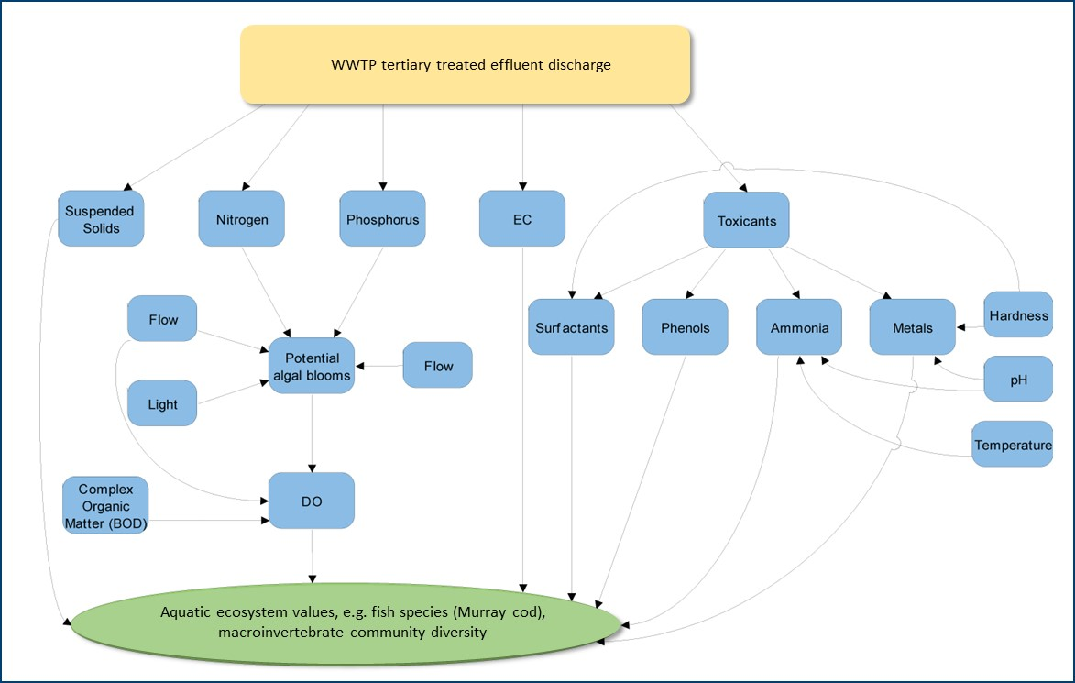

Figure A – Simplified conceptual model of the potential risks to a river aquatic ecosystem from a tertiary treated wastewater treatment plant (WWTP) effluent. Notes: DO = dissolved oxygen, EC = electrical conductivity, BOD = biological oxygen demand

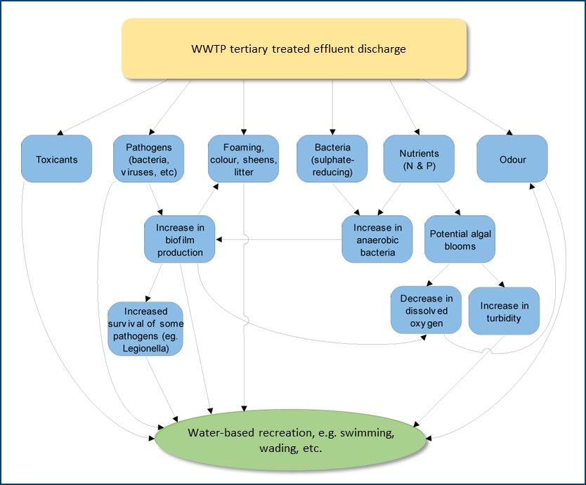

Figure A – Simplified conceptual model of the potential risks to the environmental value of water-based recreation from a tertiary treated wastewater treatment plant (WWTP) effluent. Notes: N = nitrogen, P = phosphorus

1. Case studies

Case studies in this appendix are risk assessments developed by Barwon Water, Goulburn Valley Water and North East Water. This guidance has used a modified version of these risk assessments with a focus on ecological risk assessment. Appendix C should be consulted for a comprehensive microbial human health risk assessment.

* 1. Barwon Water – Black Rock treatment plant

The Black Rock wastewater treatment plant (WWTP) is near Thirteenth Beach, south of Geelong. It treats domestic and industrial wastewater from Geelong and surrounding towns. The plant has a strict trade waste policy and a natural biological treatment process (intermittently decanted extended aeration (IDEA)) that produces water suitable for reuse. Recycled water from the Black Rock WWTP is used on golf courses and recreation reserves, and for turf and flower production. The remaining treated volume (about 25,000 ML per year) is discharged to the ocean between Barwon Heads and Torquay. The ocean outfall is about 1.1 km offshore and 16 m below the ocean surface. The outfall has a diffuser that was designed to direct the discharge away from the high value shoreline and produce a high initial dilution. The EPA licence for Black Rock WWTP defines the discharge mixing zone as a 424 m x 200 m area surrounding the diffuser.

#### Problem formulation

The focus of the risk assessment was to investigate the potential risks posed by the Black Rock WWTP discharge to the environmental values of the receiving marine waters, both in and out of the mixing zone area. The problem formulation included the following:

1. Identification of Barwon Water’s key management goals to be informed by the risk assessment. These goals were to:

* ensure the discharge complies with the EPA licence requirements in the mixing zone and outside the mixing zone. Barwon Water also defined specific management objectives under these broader goals for each of the environmental values (Table B1)
* identification of the receiving waters’ environmental values (Table B2 and Figure B1)
* collation of information and monitoring data on the discharge and receiving waters
* identification of the potential hazards from the discharge and the pathways for risks occurring
* development of a conceptual model showing the key interactions between hazards and environmental values (Figure B2).

1. In identifying the potential hazards from the discharge and pathways for risks to be investigated, the risk assessors considered the:

* source of the original wastewater
* composition of the treated discharge water, that is, the potential hazards and their concentrations and loads
* volume of discharge water
* nature of the environmental values.

Table B –Barwon Water management objectives

|  |  |
| --- | --- |
| Environmental value | Management objectives |
| Water dependent ecosystems and species | Comply with EPA requirements within the mixing zone  Outside the mixing zone:   * Maintain biodiversity and ecosystem processes * No acute or chronic toxicity * No assemblage impact due to salinity effects * No suspended solids effects above ambient levels – smothering and turbidity * No dissolved oxygen depletion * No bioaccumulation/concentration/magnification of toxic substances * No primary or secondary enrichment * No synergistic effects due to combinations of discharge effects |
| Traditional Owner cultural values | Comply with EPA requirements within the mixing zone  Outside the mixing zone:   * No loss of biodiversity – particularly species of cultural or spiritual significance * No loss of amenity * No loss of primary or secondary contact opportunities |
| Water-based recreation (aesthetic enjoyment) | Comply with EPA requirements within the mixing zone  Outside the mixing zone:   * No oils, slicks, scums or films * No impact on ambient levels of turbidity * No odour * No algal blooms |
| Water-based recreation (primary and secondary contact), human consumption of aquatic foods (natural populations – commercial and recreational catch) | Would require an independent human health risk assessment (see Appendix C) |

Table B – Environmental values identified for the Black Rock discharge receiving waters

|  |  |
| --- | --- |
| Environmental value | Values |
| Water dependent ecosystems and species | The marine ecosystem in the region of the outfall comprises a range of habitats and associated biota. |
| Traditional Owner cultural values | Indigenous and non-indigenous cultural values may be associated with the dunes and land behind the dunes. |
| Water-based recreation (aesthetic enjoyment) | The beaches, dunes and elevated vantage points are valued for their aesthetic qualities. |

See Appendix C for a human health risk assessment.

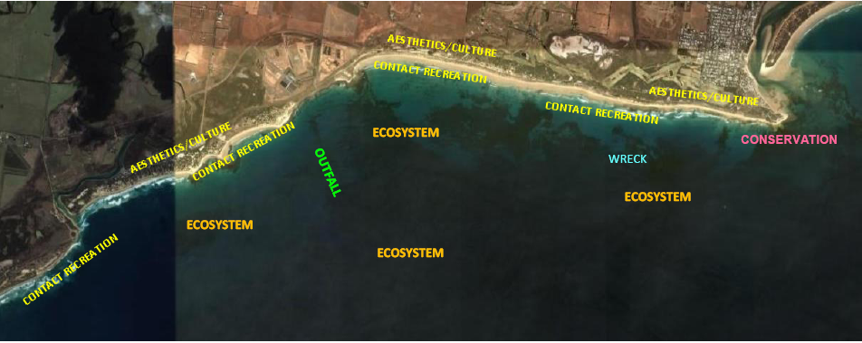

Figure B – Location of environmental values at Black Rock

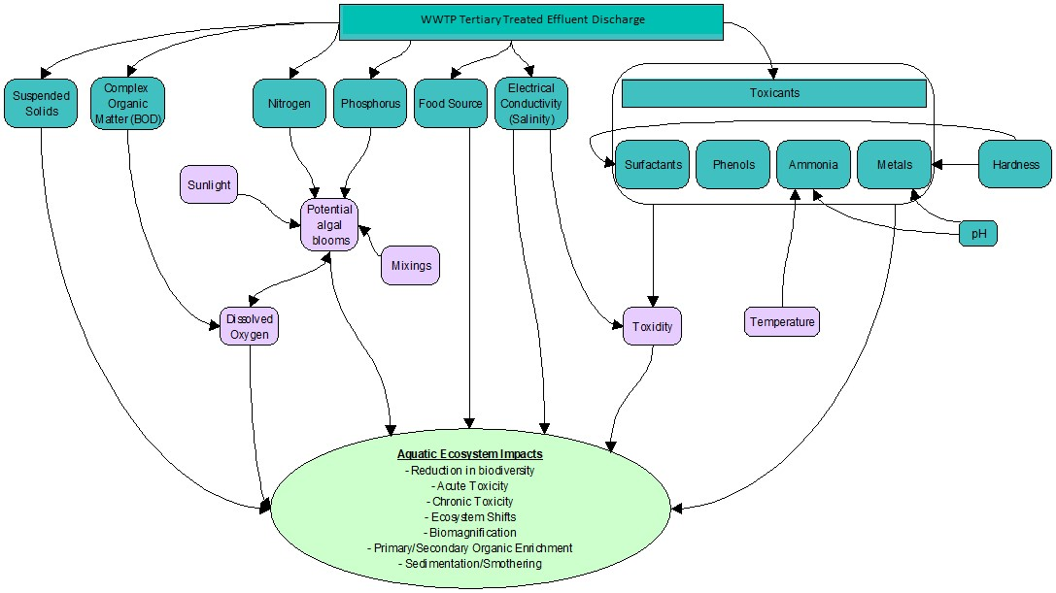

Figure B – Conceptual model of the direct interactions of a wastewater treatment plant (WWTP) discharge with a marine aquatic ecosystem

#### Risk analysis

The risk analysis was conducted using the semi-quantitative approach in the Australian/New Zealand Standards AS/NZS 4360 (2004). The likelihood and consequence definitions for the risk analysis were clearly defined (Table B3 and Table B4). To increase the robustness and transparency of the analysis, the consequence ratings were defined in very specific terms for each of the different marine environmental uses (Table B4). Evaluation of risk to the environmental values was determined from the consequence and likelihood levels using a risk matrix (Table B5).

Table B – Likelihood definitions

|  |  |
| --- | --- |
| Descriptor | Likelihood |
| Almost certain | The event is expected to occur in most circumstances |
| Likely | The event will probably occur in most circumstances |
| Possible | The event should occur at some time |
| Unlikely | The event could occur at some time |
| Rare | The event may occur only in exceptional circumstances |

A group of three scientific and technical experts determined the risk likelihood and consequence levels for each of the environmental values being investigated. Enough monitoring data and information was available on the discharge and marine receiving waters to determine these levels, without the need for further monitoring or modelling as part of the analysis. The information and data used included:

* mixing and transport: tidal data, temperature, salinity, stratification, currents, dispersion and dilution characteristics
* ecotoxicity testing: acute toxicity testing (*Allorchestes compressa* LC50, 96 hr), chronic toxicity testing (*Hormosira* germination test, Doughboy scallop larval development, *Nizschia* cell division)
* marine ecology: species present/abundance and multivariate analysis of infauna sampling data from around the discharge and reef sampling data
* effluent water quality and toxicants: for example, nutrients, ammonia, salinity, pH, biological oxygen demand, suspended solids, metals.

|  |  |  |  |
| --- | --- | --- | --- |
| Table B4 – Environmental consequence descriptions | | | |
| Environmental value | Consequence | Descriptor | Level |
| Water dependent ecosystems and species | Highly modified ecological assemblage dominated by a few low salinity and stress-tolerant species.  Deformities or reduced metabolic function in species over a wide area.  High levels of cumulative contaminants in biological tissues over a wide spatial area.  Acute toxicity no observed effect concentration (NOEC) <10%, unknown cause. | Severe | 5 |
| Highly modified ecological assemblage dominated by filter and deposit feeders, grazers and blue-green and green algae.  Deformities or reduced metabolic function in species in identifiable area.  Elevated contaminants in some species.  Acute toxicity NOEC <100%, unknown cause, chronic toxicity NOEC <5% cause due to non-persistent substances, unlikely to satisfy ERS objectives. | Major | 4 |
| Modified ecological assemblage dominated by certain rapid growing algae, grazers and lacking sensitive species.  Acute toxicity NOEC >100%, chronic toxicity NOEC >5% cause due to non-persistent substances, may meet ERS objectives with mixing zone and outfall diffuser. | Moderate | 3 |
| Modified ecological assemblage with detectable difference in species proportions and lacking some sensitive species,  No acute toxicity, chronic toxicity NOEC >25%cause due to non-persistent substances, likely to meet ERS objectives with mixing zone and outfall diffuser. | Minor | 2 |
| Minor change in species composition with difference in species proportions and sensitive species present.  No acute toxicity, chronic toxicity NOEC >50% cause due to non-persistent substances, likely to meet ERS objectives with mixing zone. | Insignificant | 1 |
| Water-based recreation (aesthetic enjoyment) | Offensive suspended solids, discolouration, odour, foams and slicks. | Severe | 5 |
| Obvious suspended solids, discolouration, odour, foams and slicks. | Major | 4 |
| Frequent detectable discolouration, odour and slicks. | Moderate | 3 |
| Occasional detectable discolouration, odour and slicks. | Minor | 2 |
| No detectable discolouration, odour and slicks. | Insignificant | 1 |

|  |  |  |  |  |  |
| --- | --- | --- | --- | --- | --- |
| Table B – Environmental risk matrix | | | | | |
| Likelihood | Consequence | | | | |
| Insignificant  1 | Minor  2 | Moderate  3 | Major  4 | Severe  5 |
| Almost certain | Negligible | Moderate | High | Extreme | Extreme |
| Likely | Negligible | Moderate | Moderate | High | High |
| Possible | Negligible | Low | Moderate | High | High |
| Unlikely | Negligible | Low | Low | Moderate | Moderate |
| Rare | Negligible | Negligible | Negligible | Low | Moderate |

A summary of the above data analysis to determine the consequence, likelihood and risk levels is given below for each environmental value.

***Water dependent ecosystems and species*:** The aquatic ecosystem in the mixing zone discharge region comprises a rocky reef kelp dominated community, a sparse soft seabed infauna community and pelagic and planktonic water column communities. Exposure to the discharge water is greatest for the fixed benthic communities on the seabed close to the outfall diffuser (rocky reef kelp and soft seabed infauna) and lowest on the other communities (pelagic and planktonic). Exposure of wastewater to benthic communities will decrease with distance from the outfall. Analysis of the biological monitoring data found minor differences between reef benthic communities immediately at the outfall compared to communities occurring within five meters of the outfall. In addition, wide natural variability in infauna communities was observed and no obvious differences were observed between the infauna community at the outfall and those distant from the outfall. No state-listed species (*Flora and Fauna Guarantee Act* *1988*) were found to likely occur in the discharge region. It was noted that several nationally listed species (*Environment Protection and Biodiversity Conservation Act* *1999*) may occur in the region at times. However, the area of concern is not a known significant breeding, feeding, calving or aggregation area for any of these listed species, and the discharge is not a threatening process for any of the species defined under the *Environment Protection and Biodiversity Conservation Act* (1999).

When examining ecotoxicological endpoints, test results revealed that the discharge water was not acutely toxic to test-organisms and has no- to very-mild chronic effects. Where a chronic response was detected, it was deemed to be very low and varied between test organisms and between the years tested.

***Water-based recreation (aesthetic enjoyment) and Traditional Owner cultural values*:** The Black Rock treatment outfall is situated about 1.1 km offshore and has a diffuser that was designed to direct the discharge away from the shoreline and produce a high initial dilution. Source control and high treatment levels have reduced the nuisance constituents of the discharge to very low levels, and monitoring at Bancoora beach has reported no foams or slicks.

#### Risk characterisation and management

The risk characterisation involved:

* clearly defining the level of risk posed to the different environmental values
* identifying management responses for addressing the above risks
* documentation of the risk assessment
* Barwon Water defined the management actions they would implement for different levels of risk (Table B6). This provided a consistent and transparent approach for dealing with the risks identified in the assessment.

|  |  |
| --- | --- |
| Table B – Management response to risk levels | |
| Risk level | Management response |
| Extreme risk | Immediate action required |
| High risk | Senior management attention needed |
| Moderate risk | Investigate cause, mitigation measures and mixing zone considerations |
| Low risk | Monitor and report |
| Negligible risk | Short justification only |

The final risk characterisation and management actions are summarised below.

*Water dependent ecosystems and species:*

* Risk: low.
* Management action: continue monitoring the marine ecosystem and effluent toxicity testing.

*Water-based recreation (aesthetic enjoyment):*

* Risk: negligible.
* Management action: continue monitoring aesthetic indicators at high value beaches.

A further management action being implemented by Barwon Water for all environmental values is an investigation of the mixing zone using water quality or dye indicators to confirm dilution gradients and dispersion pathways. Barwon Water has previously conducted a number of dilution/dispersion investigations in the mixing zone

The risk assessment was extensively documented in a risk characterisation report. This report includes a detailed presentation of background material, information and monitoring data, analysis methods and results, the assumptions made throughout the risk assessment, the results of the risk posed to the environmental values and management actions for these.

* 1. Goulburn Valley Water – Shepparton, Alexandra and Eildon treatment plants

Goulburn Valley Water (GV Water) manage three wastewater treatment plants (WWTPs) in north-eastern Victoria. The WWTPs are at Shepparton, Alexandra and Eildon.

The Shepparton WWTP treats domestic and trade waste from Shepparton. The trade waste is from food processing industries, with no heavy industrial inputs. About 60% of the treated water is recycled and used for irrigated agricultural production. The remaining treated water, about 3,000 ML per year, is discharged to the Goulburn River downstream of Shepparton between late autumn and early spring. The plant treatment process includes pre-treatment that involves screening and then a High Rate Anaerobic Lagoon process, followed by tertiary treatment involving phosphorus removal.

The Alexandra WWTP mainly treats domestic waste and has minor trade waste inputs from retail enterprises. About 50% of the treated water is recycled and used for irrigated agricultural production. The remaining treated water, about 180 ML per year, is discharged to the Goulburn River downstream of Alexandra between late autumn and early spring. The plant treatment process includes coarse manual screening, aerated lagoons, winter storage, chemically assisted clarification and rapid sand filtration plant.

The Eildon WWTP mainly treats domestic waste and has minor trade waste inputs from retail enterprises. It discharges about 116 ML per year to the Goulburn River downstream of Eildon. The discharge is continual throughout the year. The plant treatment process includes screening and grit removal, primary sedimentation, trickling filter, humus tank, lagoon detention, and Dissolved Air Flotation and Filtration (DAFF) tertiary treatment.

#### Problem formulation

The focus of the risk assessment was to investigate the potential risks posed by the Shepparton, Alexandra and Eildon discharges to the environmental values of the Goulburn River. This also included assessing the extent of

the mixing zones for all three WWTP discharges. GV Water’s key management goals in conducting the risk assessment were to:

* determine the mixing zones and level of impact to environmental values for each of the WWTPs
* protect the environmental values outside the mixing zones
* develop appropriate monitoring programs
* support decision-making on where to invest resources for the most desirable environmental, economic and social outcomes
* ensure continuous improvement in management of WWTP facilities.

GV Water held a problem formulation stakeholder workshop in August 2008. The workshop involved a wide range of stakeholders including representatives from GV Water, the appointed consulting firm, EPA Victoria, Department of Sustainability and Environment (Water and Sustainability group), Goulburn Broken Catchment Management Authority (CMA) and the Shepparton and Murrindindi Councils. Prior to the workshop, GV Water and their consultant compiled and summarised all available information and data on the discharge effluents and receiving waters. This was made available to participants at the workshop.

At the problem formulation workshop, stakeholders and experts:

* identified the environmental values to be protected for each site based on existing regional strategies and local/expert knowledge (Table B7)
* identified the potential hazards from the discharges and potential environmental effects from these (Table B8 and Table B9)
* developed conceptual models showing the key interactions between the environmental values and hazards to be investigated in the risk analysis. Conceptual models are presented in this guidance for biodiversity (Figure B3), recreational values (Figure B4), heritage values (Figure B5) and economic values (Figure B6).
* determined the mixing zone for the Shepparton wastewater discharge using available data on the Goulburn River receiving waters.

|  |  |  |  |
| --- | --- | --- | --- |
| Table B – Environmental values of the Goulburn River identified by stakeholders | | | |
| Environmental value | Shepparton | Alexandra | Eildon |
| Biodiversity values | | | |
| Macroinvertebrates | P | P | P |
| Native fish (including rare and threatened) | P | x | x |
| Introduced fish (target recreational species) | P | P | P |
| Amphibians | P | P | P |
| Other aquatic fauna (turtles, birds, platypus) | P | P | P |
| Algae (phytoplankton) | P | P | P |
| Aquatic macrophytes | P | P | P |
| Riparian vegetation (river red gums) | P | P | P |
| Recreational values | | | |
| Boating/canoeing | P | P | P |
| Camping | P | P | P |
| Recreational fishing | P | P | P |
| Swimming | P | P | P |
| Heritage values | | | |
| Landscape and aesthetics | P | P | P |
| Indigenous values | P | P | P |
| Icon species | P | P | P |
| Trout fishery | x | P | P |
| Aquaculture | x | P | P |
| Economic values | | | |
| Aquaculture | x | P | P |
| Irrigation | P | P | P |
| Caravan parks | x | P | P |
| Tourism | x | P | P |
| Turf farms | x | P | x |
| Domestic consumption (indirect) | P | P | P |
| Shading indicates that stakeholders considered the value as particularly significant at the location. | | | |
|  | | | |

|  |  |  |  |  |  |  |
| --- | --- | --- | --- | --- | --- | --- |
| Table B – Potential hazards identified for GV Water WWTP discharges | | | | | | |
| Stressors | Shepparton | | Alexandra | | Eildon | |
| Nutrients | P | | P | | P | |
| Toxicants | P | | P | | P | |
| Electrical conductivity | P | | x | | x | |
| Endocrine disruptors (EDCs) | P | | P | | P | |
| Nuisance organisms (algae) | P | | P | | P | |
| Pathogens | P | | P | | P | |
| Whirling disease* | P | | P | | P | |
| Discharge volume | P | | P | | P | |
| Total suspended solids | P | | P | | P | |
| pH | P | | P | | P | |
| *Literature reviewed after the workshop suggested that whirling disease is not known to occur in Australia. It was therefore not considered further in the risk assessment. | | | | | | |
| Table B – Potential environmental effects of GV Water WWTP discharges | | | | | | |
| Effects | | Shepparton | | Alexandra | | Eildon |
| Increased macrophyte growth | | P | | P | | P |
| Algal blooms | | P | | P | | P |
| Loss of species | | P | | P | | P |
| Reduced health of individual organisms (condition) | | P | | P | | P |
| Water quality as a barrier to fish movement | | P | | P | | P |
| Community composition changes | | P | | P | | P |
| Human health impacts* | | P | | P | | P |
| Reduced recreational potential | | P | | P | | P |
| Livestock health (agriculture) | | P | | P | | P |
| Fish health (aquaculture) | | x | | P | | P |
| Altered hydrological regime | | P | | x | | x |

*Would require an independent human health risk assessment (see Appendix C).

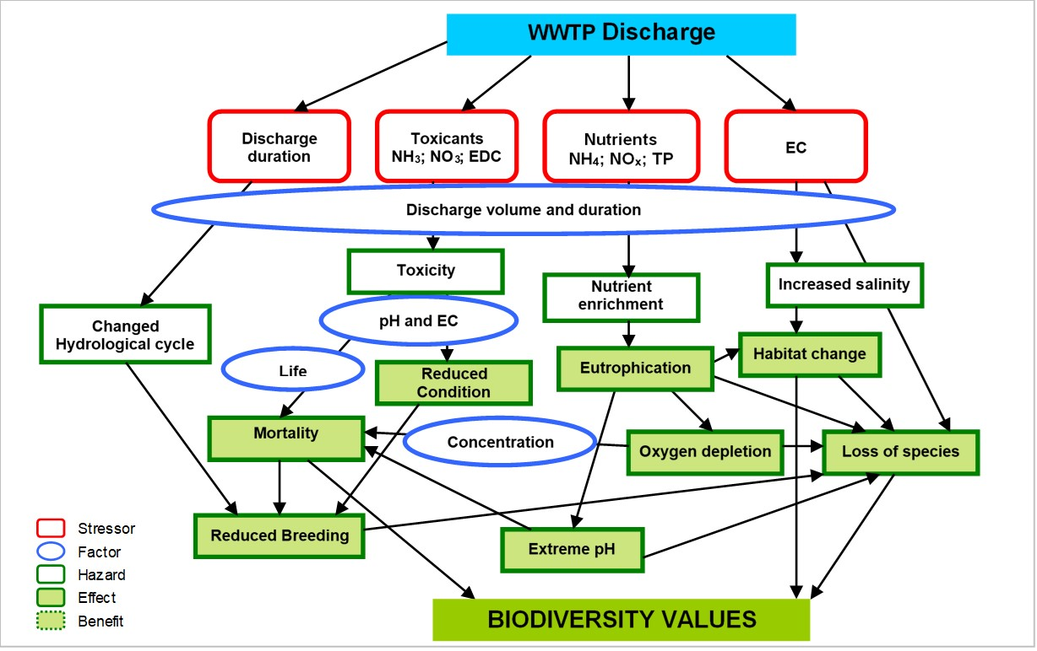

Figure B – Conceptual model of the relationship between a wastewater treatment plant (WWTP) discharge and the biodiversity values of the Goulburn River. Notes: EC = electrical conductivity, EDC = endocrine disruptive chemicals, NH3 = ammonia, NH4 = ammonium, NO3 = nitrate, NOx = nitrogen oxide, TP = total phosphorus

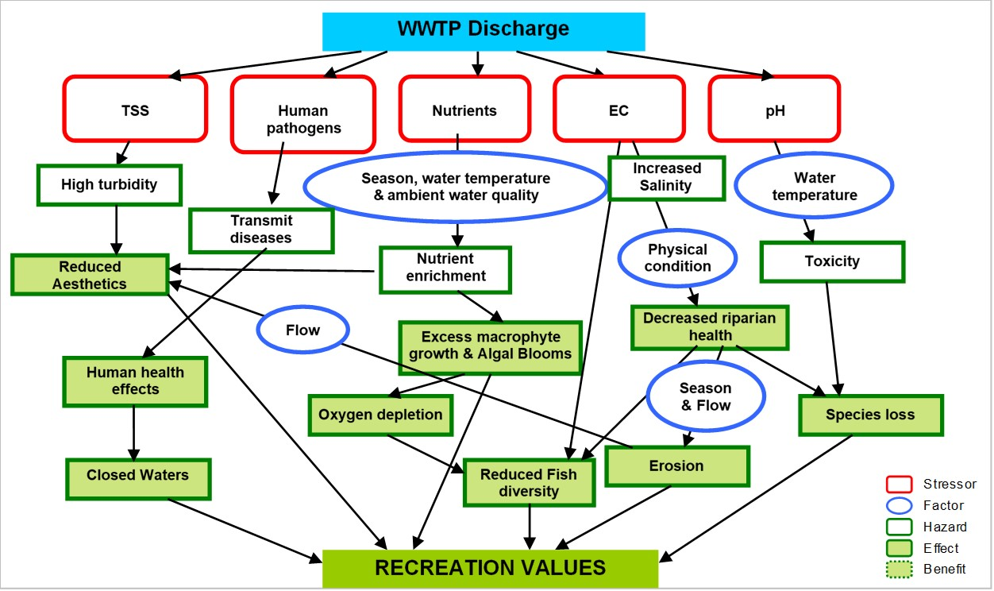

Figure B – Conceptual model of the relationship between a wastewater treatment plant (WWTP) discharge and the recreational values of the Goulburn River. Notes: EC = electrical conductivity, TSS = total suspended solids

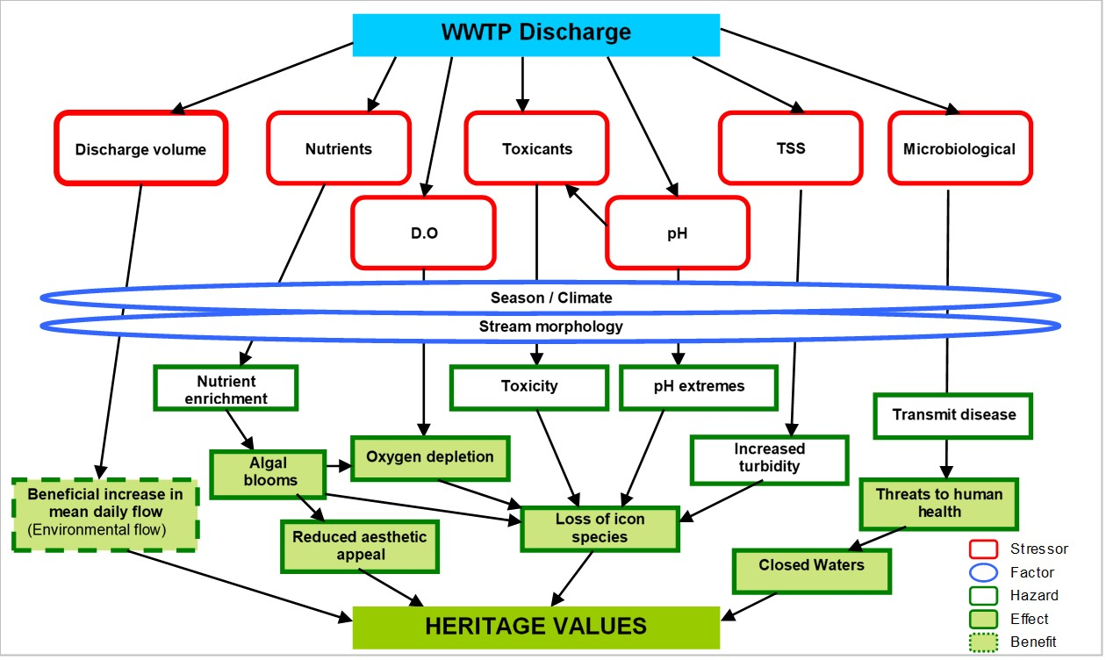

Figure B – Conceptual model of the relationship between a wastewater treatment plant (WWTP) discharge and the heritage values of the Goulburn River. Notes: D.O = dissolved oxygen, TSS = total suspended solids

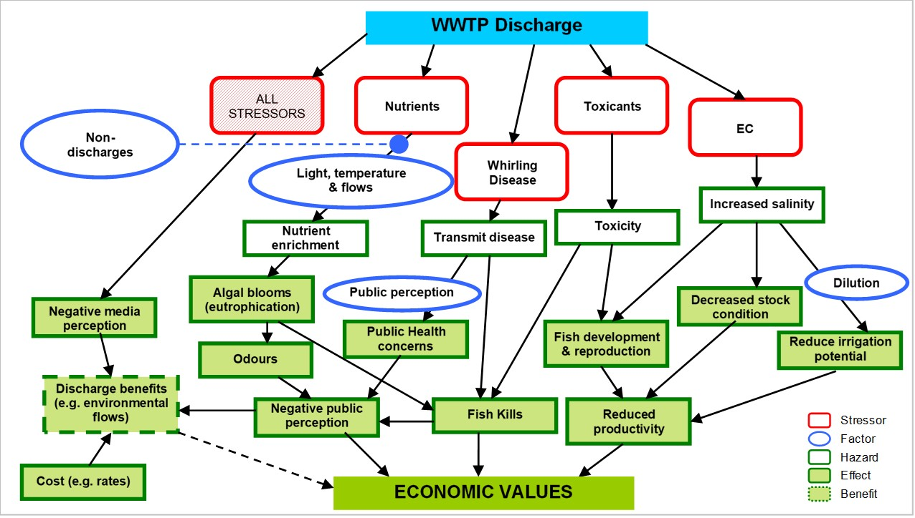

Figure B –Conceptual model of the relationship between a wastewater treatment plant (WWTP) discharge and the economic values of the Goulburn River. Notes: EC = electrical conductivity

#### Risk analysis

A semi-quantitative approach was used to conduct the risk analysis for the Shepparton WWTP. This was done using a risk matrix adapted from GV Water’s existing management systems (Table B10).

A group of scientific experts determined the risk likelihood and consequence levels for each of the environmental values being investigated. Enough monitoring data was available on the discharge and Goulburn River receiving waters to determine these levels, without the need for further monitoring as part of the analysis. Five years of monitoring data (2001 to 2005) was available for the receiving waters upstream and downstream of the discharge and included:

* physicochemical water quality data (for example, nutrients, dissolved oxygen, turbidity, temperature, pH, salinity)
* ammonia toxicity data
* macroinvertebrate community diversity data.

There was insufficient data available for the receiving waters of the Alexandra and Eildon discharge to conduct a thorough risk analysis. Therefore, a preliminary risk analysis was conducted for these discharges using the effluent water quality data and receiving waters flow gauge data from 2003 to 2006. The daily discharge volume and mean daily flow of the receiving waters were used to calculate the minimum dilution capacity of the receiving waters for this period. This was used along with water quality data of the effluent to estimate the potential concentrations of hazards in the receiving waters from the discharge. These estimates were then used to conduct a preliminary risk analysis using the matrix in Table B10. The purpose of this preliminary analysis was to provide information to assist in prioritising the receiving waters monitoring needed to conduct a more thorough risk analysis.

#### Risk characterisation and management

The risk characterisation involved:

* clearly defining the level of risk posed to the different environmental values
* identifying management responses for addressing the above risks
* documentation of the risk assessment.

|  |  |  |  |  |  |  |  |  |  |
| --- | --- | --- | --- | --- | --- | --- | --- | --- | --- |
| Table B – Environmental risk matrix | | | | | | | | | |
|  | | | | **Consequence (with criteria)** | | | | | |
| 1 | 2 | 3 | 4 | 5 | |
| Small | Minor | Moderate | Major | Catastrophic | |
| Minimal on-site impact | Moderate on-site impacts | High level on-site impact | Catastrophic on-site short-term uncontrolled impact | Catastrophic on-site irreversible impact | |
| No local impact | Minimal local impact | Moderate local impact | High local impact | Catastrophic local impact | |
| No external area impact | No external area impact | Minimal external area impact | Moderate external area impact | High external area impact | |
| No long-term cumulative effects | No long-term cumulative effects | No long-term cumulative effects | May cause long-term cumulative effects | Known to cause long-term cumulative effects | |
| Likelihood of effect | 5 | Certain | Weekly-Monthly | High | Very high | Extreme | Extreme | Extreme |
| 4 | Likely | Monthly-Yearly | Medium | High | Very high | Extreme | Extreme |
| 3 | Possible | Yearly–10 yrs | Low | Medium | High | Very high | Extreme |
| 2 | Unlikely | 10yrs–100 yrs | Negligible | Low | Medium | High | Extreme |
| 1 | Rare | 100 yrs+ | Negligible | Negligible | Low | Medium | Extreme |

***Shepparton WWTP***

The risk analysis of the Shepparton WWTP showed:

* Risk – a negligible to low risk from all potential hazards to all the environmental values
* Management plan – GW Water’s management plan in response to the level of risk identified for the Shepparton WWTP to environmental values is to:
  + develop and implement an appropriate monitoring plan that can assess if risk levels change in the Goulburn River from the discharge (including biological, water quality and human health indicators)
  + continually assess the above monitoring data as it becomes available and implement management actions if the risk levels change.

***Alexandra and Eildon WWTPs***

A preliminary risk analysis was conducted for Alexandra and Eildon on the effluent data and dilution capacity of the receiving waters. This preliminary analysis indicated:

* Risk – a low risk to environmental values from all potential hazards for both discharges.
* Management plan – GV Water’s management plan in response to the risks indicated for the Alexandra and Eildon WWTPs environmental values is to:
  + monitor the receiving waters to assess if the risk assessment assumptions of risks being low are correct
  + monitor all key indicators to determine the extent of the mixing zone
  + develop a long-term monitoring plan for continual assessment of risk levels.

The risk assessment for all three WWTPs was extensively documented in a risk characterisation report. This report includes: a detailed presentation of background material, information and monitoring data, analysis, methods and results, the key knowledge gaps and assumptions made throughout the risk assessment, the results of the risk posed to the environmental values, and management actions for these. This report can be obtained from GV Water.

* 1. North East Water: Beechworth treatment plant

North East Water (NE Water) manage Beechworth wastewater treatment plant (WWTP), which is situated in north-east Victoria, approximately 3 km downstream of the town of Beechworth in the Upper Ovens Catchment. The WWTP has secondary treatment in lagoons with a chemically assisted sedimentation plant to remove algae and phosphorus prior to discharge. In the warmer months, secondary treated water from the WWTP is used for irrigation. During winter, an average of 150 ML of tertiary treated effluent is discharged to Spring Creek over a four-month period. Spring Creek is a tributary of Reedy Creek, which flows into the Ovens River about 14 km north-west of Wangaratta.

#### Problem formulation

The focus of the risk assessment was to investigate the potential risks posed by the Beechworth WWTP winter discharge to the environmental values of Spring and Reedy creeks. This also included assessing the extent of the mixing zone for the discharge. NE Water’s management goal for the risk assessment was to obtain information to assist management decisions on the future upgrade of the WWTP. In particular, the goal was to provide:

* a greater understanding of the current impact of the discharge to the creeks
* information to help assess how effective different WWTP upgrade scenarios would be in improving the health of the creeks downstream of the discharge.

NE Water had a problem formulation stakeholder workshop in February 2008. The workshop was attended by: a risk assessment consultant, NE Water, North East Catchment Management Authority, Indigo Shire, Wooragee Landcare Group, and an ecological expert from La Trobe University. Prior to the workshop, NE Water and their risk assessment consultant compiled and summarised all available information and data on the discharge effluent and receiving waters. Consultation with key stakeholders and experts delivered the following outcomes:

* identification of clear management goals
* identification of seven environmental values as being potentially at risk from discharge hazards of Spring and Reedy creeks (Table B11)
* determination of the environmental effects that may be caused by hazards (Table B12)
* development of a conceptual model illustrating the relationships between hazards and environmental values (Figure B7)
* identification of data gaps and the development of monitoring programs to resolve them
* development of a risk analysis plan and submission to EPA.

The findings from the workshop and available data were used to identify the key issues for investigation and development of the risk analysis plan.

The risk analysis plan provided:

* background information on the WWTP discharge and receiving waters
* documentation of the problem formulation phase
* detail on how the key risks identified in the problem formulation would be further assessed through a two-year monitoring program and subsequent data analysis (Table B13).

|  |  |  |
| --- | --- | --- |
| Table B – Environmental values identified for Spring and Reedy creeks | | |
| Environmental value | Local value | Hazard |
| Water dependent ecosystems  and species | Ephemeral stream habitat | Discharge volume and timing |
| Nutrients (nitrogen, phosphorus) |
| Ephemeral flow regime | Discharge volume and timing |
| Macroinvertebrate communities and native fish populations | Discharge volume and timing |
| Suspended solids |
| Colour, foam, slick |
| Electrical conductivity |
| pH |
| Nutrients (nitrogen, phosphorus) |
| Ammonia |
| Other toxicants (NO2, NO3, metals) |
| Organic matter |
| Water-based recreation  (aesthetic enjoyment) | Appearance of plant and algae communities | Nutrients (nitrogen, phosphorus) |
| Water-based recreation (secondary contact)* | Bush walking | Pathogens |
| Agriculture and Irrigation* | Stock and domestic water supply | Electrical conductivity |
| Other toxicants (NO2, NO3) |
| *Would require an independent human health risk assessment (see Appendix C). | | |

|  |  |
| --- | --- |
| Table B – Potential hazards and issues from the Beechworth discharge to be addressed by the risk assessment | |
| Environmental issue | Environmental indicator and effect |
| Physical | |
| Smother habitat | Fine solids and sediment accumulate on bed and smother habitat |
| Scour or remove habitat | Scouring following dredging or very high discharge rate |
| Light attenuation | Significant change in colour, particulates or turbidity |
| Flow patterns | Changes in currents and flow patterns |
| Colour, foam, slick | Visible colour, odour, slick or litter arising from discharge |
| Odour | Odour apparent or reported |
| Ecosystem | |
| Primary modification  (dissolved oxygen, light, pH, salinity) | Change in species composition – modified ecological assemblage, with detectable changes in species composition and lacking sensitive species from reference sites |
| Primary enrichment (ammonia, nitrogen, phosphorus, micro-nutrients, organic carbon) | Stimulatory effect of discharge – modified ecological assemblage dominated by filter and deposit feeders, grazers and increased green and blue-green algae |
| Secondary enrichment  (nitrogen, phosphorus) | Stimulatory effect of discharge – modified ecological assemblage, with detectable changes in species composition and lacking sensitive species from reference sites |
| Secondary modification  (ecological interactions) | Minor changes in species composition, with sensitive species present but some differences in species proportions from reference sites |
| Biochemical | |
| Toxicity | Detectable acute and chronic toxicity in bioassay |
| Bioaccumulation | Metals and pesticides accumulate in biota |
| Dissolved oxygen depletion | Lower dissolved oxygen due to high biological oxygen demand or low mixing |
| Public health issues* | |
| Microbiological – pathogens | Elevated levels of pathogens and indicator microorganisms in waters used for water supplies, bathing or secondary recreation |
| Fish – contamination | Elevated levels of metals, pesticides or pathogens in fish and other aquatic organisms |
| Sediments – contamination | Elevated levels of metals, pesticides or pathogens in sediments |
| *Would require an independent human health risk assessment (see Appendix C). | |



Figure B –Conceptual model of the relationships between the discharge and potential issues influencing water quality and ecological conditions in the Spring and Reedy creek systems

Table B – Summary of the key risks to be investigated and the monitoring/studies to be conducted

|  |  |
| --- | --- |
| Key risks for analysis | Monitoring/studies |
| Reduced light attenuation | Turbidity and diatom growth monitoring |
| Nutrient enrichment and primary modification of the ecosystem through effects from increased nutrients and dissolved oxygen depletion. | Nutrient, dissolved oxygen, attached algae, artificial substrate (diatom chlorophyll a and phytoplankton), macroinvertebrate and groundwater monitoring. |
| Ammonia toxicity | Ammonia and macroinvertebrate monitoring, desktop investigation of local fish communities and their tolerances. |
| Change in flow patterns | Hydrological study to determine daily flows in Spring and Reedy creeks with and without the input of the discharge. |

More-detailed information on the problem formulation phase and risk analysis plan can be found in *The* *Beechworth Wastewater Treatment Plant Wastewater Discharge to Waterways Risk Analysis Plan*, which can be obtained from NE Water (Ph 1300 361 622).

#### Risk analysis

The outcomes of problem formulation guided the risk analysis stage, which included extensive collection and analysis of data from a wide range of sources including:

* Spring and Reedy creeks water quality data
* wastewater discharge quality data
* modelled flow volume data from Spring and Reedy creeks
* biological assessment data from Spring, Reedy and other ephemeral creeks
* groundwater monitoring bore data
* attached algae chlorophylla data
* literature review
* expert advice.

The risk analysis identified four environmental values that were at risk from the wastewater discharge (Table B14).

|  |  |  |  |
| --- | --- | --- | --- |
| Table B - Environmental risk matrix | | | |
| Environmental value | Likelihood | Consequence | Risk |
| Ephemeral stream habitat | Likely | Moderate | High |
| Appearance of plant and algae communities | Possible | Minor | Medium |
| Macroinvertebrate communities | Possible | Minor | Medium |
| Native fish populations | Possible | Negligible | Low |

#### Risk characterisation and management

The risk ratings assigned to each of the environmental values (Table B14) were used to assign priority for risk investigation and management.

The key risks to environmental values are outlined below:

* Elevated nitrogen and phosphorus concentrations in the discharge are likely to increase changes to ephemeral stream habitat, which could possibly impact aquatic organisms.
* Elevated nitrogen and phosphorus concentrations in the discharge could possibly contribute to algal blooms and impact the appearance of plant and algae communities.
* A direct impact to macroinvertebrate communities was determined to be unlikely, but it is recognised that the discharge could possibly stimulate changes to macroinvertebrate habitat through nutrient enrichment.
* Ammonia concentrations meet ANZG protection levels for ammonia toxicity in Reedy Creek where fish might be present. However, it is recognised that under exceptional conditions, native fish populations could be impacted by ammonia toxicity.

An uncertainty analysis was conducted to recognise the limitations of data collection and assessment endpoints. These limitations included: insufficient nutrient data, unsuitable monitoring sites and unsuitability of ERS objective application to the study area. Monitoring and assessment programs were developed to address these uncertainties. The broad objective of the programs was to eliminate uncertainties prior to risk management. The monitoring and assessment programs were implemented to specifically target at-risk environmental values and conducted in parallel with continued effluent management options analysis at the Beechworth WWTP. The programs were assessed against measurable endpoints prior to NE Water commitment to management decisions.

A risk management plan was developed for Beechworth WWTP. The plan included:

* risk assessment outcome
* management targets and objectives
* effluent management and plant upgrade options for risk mitigation
* risk mitigation timeframe.

The risk management plan was submitted to EPA after the completion of monitoring programs. The plan provided NE Water and EPA with a robust risk assessment and the required mechanisms to manage risks to environmental values through effluent management and plant upgrade options.

Since the first publication of this guidance in 2009, the Beechworth WWTP risk assessment delivered key outcomes, including, an informed process improvement (fixed media nitrogen reduction) and an informed licence amendment. NE Water has reviewed the risk assessment to determine any changes in the risk profile and undertaken ongoing waterway monitoring programs. The Beechworth WWTP (and collection system) is currently being upgraded to support growth and to ensure risks are managed.

* 1. Risk assessment for a small wastewater treatment plant

A small caravan park is applying for a discharge-to-water permission to EPA. The wastewater is from the on-site cabins and shower block facility and contains treated human effluent. Some of the treated water is recycled and used for irrigating the gardens on site, but a small quantity (0.3 ML year) is discharged to a local stream. The treatment process is an aerated lagoon system and chlorine dosing.

#### Problem formulation

The focus of the risk assessment was to investigate the potential risks posed by the discharge from the caravan park to the environmental values of the receiving waters. The problem formulation included the identification of the caravan parks’ key management goals. These goals were to protect the environmental values from discharge impacts through:

* identifying the environmental values of the receiving waters
* collating information on the discharge and receiving waters
* identifying the potential hazards from the discharge and the pathways for risks occurring
* developing an appropriate monitoring program.

#### Identification of the receiving waters’ environmental values

The caravan park owner engaged a suitably qualified consultant to assist with the development of their environmental risk assessment. Based on information in the local catchment management authority’s regional strategy and local knowledge, the consultant and the park owner identified that the discharge site is a degraded ecosystem. Identified environmental values and management objectives are shown in Table B15.

|  |  |  |
| --- | --- | --- |
| Table B – Small wastewater treatment plant values and management objectives | | |
| Environmental value | Values | Management objectives |
| Water dependent ecosystems and species | Macroinvertebrate communities, native fish populations, natural in-stream habitat, natural flow regime, natural plant and algae community composition and distribution, water quality | Maintain biodiversity and ecosystem processes  No increase suspended solids above ambient levels  No deplete dissolved oxygen levels  No occurrence of bioaccumulation, concentration or magnification of toxic substances  No nutrient enrichment |
| Water-based recreation (aesthetic enjoyment) | Natural plant and algae community composition and distribution | No oils, slicks, scums or films  No impact on ambient levels of turbidity  No odour  No occurrence of algal blooms |

#### Collation of information on the discharge and receiving waters

The park owner and consultant compiled and summarised all available information and data on the discharge effluent and receiving waters. This was done by laboratory testing of the effluent quality. The flow rates of the stream were obtained from Melbourne Water. The volume of discharge water was calculated from a water balance of the site, which considered historical information of the number of visitors, number of cabins, and the volume of water that is recycled for garden irrigation.

#### Identification of the potential hazards from the discharge and the pathways for risks occurring

The consultant considered the:

* composition of the treated discharge water, that is, the potential hazards and their concentrations and loads
* volume of discharge water
* nature of the environmental values
* nature of exposure and proximity of environmental values to the discharge water.

Figure B8 is a conceptual model showing the key interactions between hazards and environmental values.

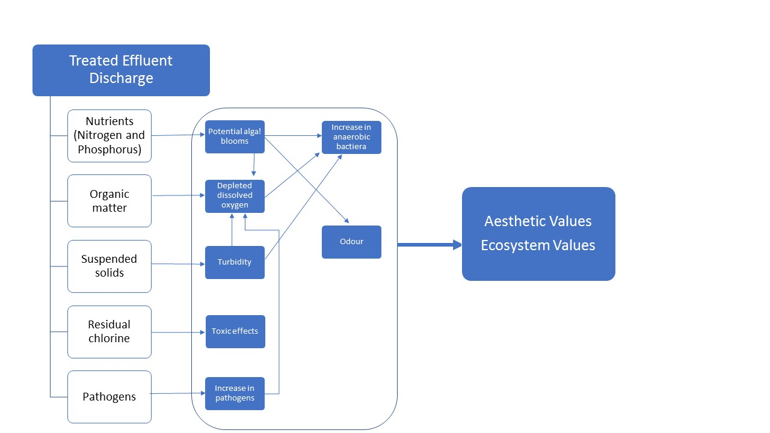

Figure B – Conceptual model of the interactions of ecosystem and aesthetic values with a small wastewater treatment plant discharge

#### Risk analysis

The risk analysis was conducted using a qualitative approach. The likelihood and consequence definitions were defined as shown in Tables B16 and B17. Evaluation of risk to the environmental values was determined from the consequence and likelihood levels using a risk matrix (Table B18).

|  |  |
| --- | --- |
| Table B – Likelihood definitions | |
| Descriptor | Likelihood |
| Likely | The event will probably occur in most circumstances |
| Possible | The event should occur at some time |
| Unlikely | The event could occur at some time |

|  |  |  |  |  |  |
| --- | --- | --- | --- | --- | --- |
| Table B17 – Environmental consequence descriptions | | | | | |
| Environmental value | Consequence | | | | Descriptor |
| Water dependent ecosystems and species | Absence of ecological assemblage present. Toxic impacts from chlorine overdosing. | | | | Major |
| Highly modified ecological assemblage dominated by blue-green and green algae. Some toxic impacts from chlorine residue. | | | | Moderate |
| Modified ecological assemblage with detectable difference in species proportions. | | | | Minor |
| Water-based recreation (aesthetic enjoyment) | Obvious suspended solids, discolouration, odour, foams and slicks. | | | | Major |
| Frequent detectable discolouration, odour and slicks. | | | | Moderate |
| Occasional detectable discolouration, odour and slicks. | | | | Minor |
|  |  | | | |  |
| Table B – Environmental risk matrix | | | | | |
| Likelihood | | Consequence | | | |
| Minor | Moderate | Major | |
| Likely | | Moderate | Moderate | High | |
| Possible | | Low | Moderate | High | |
| Unlikely | | Low | Low | Moderate | |

Monitoring data for the receiving waters was available from Melbourne Water, without the need for further monitoring or modelling as part of the analysis. These data included:

* freshwater ecology: species presence and abundance
* water quality and toxicants of the receiving waters, such as nutrients, ammonia, salinity, pH, biological oxygen demand, suspended solids and metals.

A summary of the above data analysis to determine the consequence, likelihood and risk levels is given below for each environmental value.

#### Water dependent ecosystems and species

There were only a few stress-tolerant macroinvertebrate species identified downstream of the designated discharge point. There are no state-listed species (*Flora and Fauna Guarantee Act* *1988*) likely to occur in the discharge region or nationally listed species (*Environment Protection and Biodiversity Conservation Act* *1999*).

#### Water-based recreation (aesthetic enjoyment)

The discharge location has a very high level of dilution and dispersion. Source control and high treatment levels have reduced the nuisance constituents of the discharge to very low levels (data presented as an appendix in the final report). Monitoring at the discharge point has reported no foams or slicks.

As the caravan park was a relatively new park, the effluent quality was unknown. Therefore, monitoring of the effluent quality was required, including physicochemical water quality data (such as nutrients, dissolved oxygen, turbidity, pH, temperature, salinity) and microbial data.

A risk analysis was conducted for the discharge using the effluent water quality data and receiving waters flow gauge data from Melbourne Water. The daily discharge volume and mean daily flow of the receiving waters were used to calculate the minimum dilution capacity of the receiving waters for this period. This was used along with water quality data of the effluent to estimate the potential concentrations of hazards in the receiving waters from the discharge. These estimates were then used to conduct a preliminary risk analysis using the matrix in Table B18.

#### Risk characterisation and management

The risk characterisation involved defining the level of risk posed to the environmental values, identifying management responses for addressing the risks and documenting the risk assessment. The management actions implemented for the different levels of risk are provided in Table B19.

|  |  |
| --- | --- |
| Table B – Management response to risk levels | |
| Risk level | Management response |
| High | Immediate action required |
| Moderate | Investigate cause and mitigation measures |
| Low | Monitor and report |

The final risk characterisation (that is, the assessed level of risk posed to the environmental values) and management actions for addressing these risks are summarised below.

***Water dependent ecosystems and species***

* Risk: low
* Management actions:
  + Develop and implement an appropriate monitoring plan to assess if the risk levels change in the receiving waters from the discharge including biological, water quality and human health indicators and continue monitoring the freshwater ecosystem to comply with EPA licence.
  + Monitor the receiving waters to assess if the risk assessment assumptions of risks being low are correct.

***Water-based recreation (aesthetic enjoyment)***

* Risk: low
* Management action: continue monitoring aesthetic indicators downstream of the discharge point.

1. Guidance for assessing human health risk of wastewater discharges to surface waters
   1. Introduction

The guidance in this appendix provides a framework to assess the microbial risk resulting from the handling and discharge of wastewater. The guidance is not a compliance tool. It helps users understand the risks to human health from wastewater discharge, so that risks can be minimised so far as reasonably practicable. It provides information that will help permission holders comply with their legal obligations and meet community expectations.

The complexity of human health risk assessmentscan vary, from semi-quantitative to advanced quantitative assessments. The level of complexity will depend on factors such as hazards, impacts and receptor characteristics, which are case-specific. This appendix focusses on treated domestic and animal effluent wastewater discharges. The main body of the environmental guidance can be used for chemical risk assessment.

Note: indicative values for calculating risks presented in this appendix may change as knowledge in the field increases. For that reason, users should refer to the latest version of the Australian Guidelines for Water Recycling (NRMMC et al., 2006, 2008) as the point of truth when calculating risks.

For more information, please contact EPA at [1300 372 842](tel:1300372842) or 1300 EPA VIC or [contact@epa.vic.gov.au](mailto:contact@epa.vic.gov.au)

* 1. When should a health risk assessment be conducted?

When wastewater is released into surface waters, a risk assessment is used to identify possible exposure pathways and evaluate the health risks associated with ingestion, inhalation and/or dermal exposure. Hazards likely to have adverse health outcomes in wastewater are primarily pathogenic microorganisms but they can also include chemicals. This guidance will focus on the risks associated with pathogens introduced into surface waters through the discharge of wastewaters.

The risk assessment approach presented in this guidance is particularly useful during planning stages, when infrastructure upgrades are being considered. It will assist the planning process as scenarios involving different treatment options can be assessed in terms of performance for reducing health risks.

This document is a risk assessment tool. It does not intend to address risk management issues, even if it can be used to assess the impact of mitigation measures (additional treatment, etc.) when developing risk management strategies.

* 1. What is a human health risk assessment?

A health risk assessment is a preventive approach that involves identifying and managing human health risks in a proactive way, rather than simply reacting when problems arise. A human health risk assessment evaluates the risk to the environment or human health. Specifically, it evaluates the potential impact of a particular hazard on a specific environmental value, for example, recreational use of a water body. Understanding the risk also enables the identification of appropriate management actions for that specific environmental value. The endpoint of a risk assessment can be compared with an environmental objective specific to an environmental value. In a human health risk assessment of wastewater discharges to surface waters, the endpoint of a risk assessment is usually the probability of contracting gastrointestinal illness.

The World Health Organization (WHO) first adopted a risk-based approach in 1999, via the Stockholm Framework. The aim of this framework is to provide an evidence-based guide for risk management decisions. This framework has been developed for the control of waterborne infectious diseases, toxic chemicals and other health hazards. This framework involves a systematic assessment of risks as well as a definition of health-based risk management objectives and the planning for an appropriate risk management response (Fewtrell and Bartram, 2001).

Health risk assessments involve four groups of activities: problem formulation, exposure assessment, health effect assessment and risk characterisation (enHealth, 2012; WHO, 2016) (Figure C1).

1. **Problem formulation**

* **Hazards**: Look systematically at all the hazards to identify those which could potentially affect human health (what might happen and how). This guidance focuses on pathogens that may have an adverse impact on the health of people exposed to recreational waters or other environmental values. It is important to note that the ERS relies on bacterial indicators whose levels may not represent accurately potential adverse health outcomes. However, because of the costs of monitoring pathogens, bacterial indicators remain the metric of choice for routine monitoring and compliance purposes. Bacterial indicators are compliance indicators of plant performance (mostly performance in removing bacterial pathogens). They also indicate the presence of faecal contamination in the environment. Estimating health risk based on bacterial indicators only may not fully encompass all potential risks of harm.
* **Hazardous events:** 
  + look systematically at all the hazardous events to identify those which could potentially affect human health (what might happen and how). Here we focus on events that may introduce pathogens into water or fail to remove them. These events may occur at every step of the wastewater treatment process.
  + assess the risk from each hazard by estimating the likelihood of the event happening.
  + assess the adequacy of controls to prevent contamination: control measures that are (or could) be put in place to: prevent hazards from occurring; remove them; or reduce them to acceptable levels. These can be engineered controls (such as wastewater treatment or disposal processes) or non-engineered measures (for example, more stringent acceptance criteria for trade waste in a wastewater treatment plant).

1. **Exposure assessment**

* Look systematically at the exposure due to the environmental values by defining all potential uses of the surface waters.

1. **Health effect assessment**

* Identify the dose-response relationships and the probability of illness or infection for the defined hazards to determine the potential health effects.

1. **Risk characterisation**

* Quantify the risk and ascertain the variability and uncertainty of the results. Risk characterisation should include consideration of the cumulative impacts on environmental values from multiple pollution sources.
* Identify preventive measures to eliminate, reduce, mitigate or control the hazards identified and to establish monitoring programs to ensure that the preventive measures operate effectively.
* Verify that the management system consistently provides water quality that is fit for the identified intended (or unintended) existing uses.

By following these steps, a prioritisation of the hazards can be established, based on the risks for the end user. The approach described above ensures that the risk assessment asks and answers the following questions:

* How likely is it that something will happen?
* What are the likely consequences should the event occur?

The outcomes of a human health risk assessment are:

* an estimation of the likelihood of environmental values impacted, the magnitude of the impact and how the impact changes given alternative scenarios
* the probability of contracting a specific infection or illness
* detailed information and tools that help to better understand how systems work
* targeted management actions and monitoring programs.
  1. Environmental values

To assess health risks of wastewater discharges into waterways, the assessment must:

* assess discharges as treated water (re)used to increase environmental flow in waterways
* identify and consider potential uses and values of the impacted waterways.

Consequently, the assessment should be conducted in the context of the relevant policies and guidelines, depending on the existing environmental values identified (Table C1).

**1. Problem formulation = Scope & purpose of assessment**

Which hazards?

Choose reference pathogens (according to local conditions, exposure pathways, source water characteristics and incidence and severity of waterborne diseases).

Which exposure pathways (including hazardous events)?

Identify exposure pathway(s) (scope the risk assessment and determine what will be included/excluded), time scale (single exposure, independent exposures or a year) and population exposed (total population or specific fractions).

Which health outcomes?

Health outcomes may include infection, illness and sequelae or a measure of disease burden that includes all of these outcomes (e.g. disability adjusted life years or DALYs, see Box 1).

What level of certainty needed for risk management?

**2. Exposure assessment = Dose of pathogens for defined exposure pathway(s)**

* source concentration
* pathogen reduction achieved by barriers/control/transport
* magnitude and frequency of exposure.

**3. Health effects assessment = Expected health effects of defined hazards**

* dose-response
* illness & sequelae
* secondary transmission & immunity
* impact on burden of disease.

Estimates size/frequency of exposure to pathogens via identified exposure pathways during hazardous events defined in problem formulation by:

* defining exposure pathways
* quantifying each component of exposure pathway
* quantifying magnitude/frequency of exposure for range of scenarios to be considered.

Assesses dose-response, probability of illness or sequelae that may occur following initial infection/contact, and burden of disease.

Special consideration to vulnerable populations (e.g. children, pregnant women, elderly and otherwise immunocompromised individuals) may be required.

**4. Risk characterisation = Expected health effects of the estimated dose**

Quantification of risk

Determine the probability of infection, probability of illness, expected number of illness cases and DALYs.

Variability and uncertainty analyses

Identify and quantify the variability and uncertainty influencing risk output. Variables may include pathogen densities, efficacy of intervention measures, dose-response parameters and morbidity ratio.

Sensitivity analysis

Investigate how variability and uncertainty of input parameters can be used to explore the difference in outcomes of the quantitative microbial risk assessment (QMRA) model (described in Section C4).

Figure C – Harmonised framework for water-related risk assessments (Source: WHO, 2016)

Table C – Environmental values of discharged wastewater and applicable policies and/or guidelines for assessing risks

|  |  |
| --- | --- |
| Environmental values | Applicable policy/guidelines |
| Urban (non-potable) with uncontrolled public access including:   * residential and commercial garden watering, car washing, toilet flushing, water features * municipal uses such irrigation for urban recreation, open space and sporting facilities, road making and dust control and street cleaning * fire control | * Environment Protection Act 2017 * DHHS 2013 * EPA Victoria 2021a * EPA Victoria 2021b * NRMMC et al., 2006, 2008 * Environment Protection Regulations, permissions and licences |
| Agricultural including:   * irrigation of human food crops consumed raw * irrigation of human food crops cooked/processed * irrigation of non-food crops such as instant turf, woodlots and flowers * grazing/fodder for livestock * stock watering | * Environment Protection Act 2017 * Livestock Disease Control Act 1994 * NRMMC et al., 2006, 2008 |
| Industrial including:   * open systems with worker exposure potential * wash-down water * cooling/process water | * Environment Protection Act 2017 * Occupational Health and Safety Act 2004 * Public Health and Wellbeing Act 2008 * Regulations for cooling towers |
| Primary and secondary contact recreation | * ERS * NHMRC 2008 |
| Recreational fishing and shellfish harvesting | * ERS |

* 1. The microbial risk assessment framework

The microbial risk assessment framework uses the quantitative microbial risk assessment (QMRA) approach, which is a holistic, quantitative approach combining scientific data and information. It follows the steps described in Figure C1 to describe:

* the pathogen loading to the environment
* the transport and fate of pathogen in the environment, including any removal by treatment or inactivation in the environment
* the exposure of the relevant population
* the dose-response (health effect given the pathogen dose).

Quantitative microbial risk assessment can include fate and transport models for various media, including the source zone (initial release of faecal contamination), air, soil/land surface, surface water, vadose zone and aquifer (Whelan et al., 2014). The analysis step of a QMRA integrates these various interdisciplinary exposure and effect models and databases.

In the context of a wastewater treatment plant, the following approach is generally taken to assess compliance to a health target through QMRA (WHO, 2016):

1. Characterisation of the microbial contamination in the source water.
2. Characterisation of removal and inactivation of microbial contamination by treatment and environmental processes (log reduction values or ‘LRVs’), based on literature, process models or by monitoring the removal of process indicator organisms.
3. Calculation of risk of infection, and in some cases of illness, in the exposed population, based on pathogen dose-response and routes of exposure.
4. In some cases, disability adjusted life years (DALYs) (see box: ***Disability adjusted life years (DALYs) calculation***) are estimated from the risk of infection and illness by including the likelihood of symptoms with particular estimated impact on quality of life from its severity and possible sequelae or death. In Victoria, the acceptable outcome to human health from recycled water uses is less than 10-6 DALY (NRMMC et al., 2006).
5. The calculated risk is evaluated against the health target set by EPA or other normative body. Calculations can be made with a simple deterministic approach (point estimate, also called deterministic QMRA) (WHO, 2016) or by more complex stochastic calculations (often using Monte Carlo simulations, also referred to as probabilistic QMRA) (Haas et al., 1999, 2014).

**Disability adjusted life years (DALYs) calculation**

**This explanation of the calculation of DALYs is extracted from the *Australian Guidelines for Water Recycling: Managing Health and Environmental Risks* (Phase 1) (NRMMC et al., 2006). The calculation of DALYs per case is based on Havelaar and Melse (2003), with a modification using Australian data for rotavirus, as described in WSAA (2004).**

Pathogens found in sources of contamination can have very different health outcomes. Some outcomes are mild (for example diarrhoea) while others can be severe (for example, haemolytic uraemic syndrome associated with *Escherichia coli* O157:H7). Disability adjusted life years (DALYs) provides a mechanism for assessing these outcomes and allocating resources based on the severity of impact. Standard risk assessments determine the likelihood of infection or illness. DALYs convert these likelihoods into burdens of disease.

The basic principle of DALY is to provide a weight of severity for each health impact, within the range of zero (good health) to one (death). The weighting is then multiplied by the duration of the effect and the number of people affected. In the case of death, duration is regarded as the years lost compared to normal life expectancy (estimated at 81 years).

**DALYs = YLL (years of life lost) + YLD (years lived with a disability or illness)**.

Disability refers to conditions that detract from good health. In this guidance, disability generally relates to illness. Using this approach, a mild diarrhoea with a severity weighting of 0.1, lasting seven days results in a DALY of 0.002 (0.1 x 7/365), whereas the death of a 1-year-old (resulting in a loss of 80 years of life) equates to a DALY of 80 (1x 80).

Using an Australian example of rotavirus infection:

* mild diarrhoea (severity rating of 0.1), lasting three days in 97.5% of cases
* severe diarrhoea (severity rating of 0.23), lasting seven days in 2.5% of cases
* rare deaths of very young children in 0.015% of cases.

The DALY per case = (0.1 x 3/365 x 0.975) + (0.23 x 7/365 x 0.025) + (1 x 80 x 0.00015) = 0.0008 + 0.0001 + 0.012 = 0.013

Infection with *Cryptosporidium* can cause watery diarrhoea (severity weighting of 0.067) lasting for seven days with extremely rare deaths in 0.0001% of cases. This equates to a DALY per case of 0.0015.

*Campylobacter* can cause diarrhoea of varying severity, including Guillain–Barré syndrome of varying severity, reactive arthritis and occasional deaths. The calculated DALY per case is 0.0046.

Based on DALY per case, the impacts of the three pathogens, by decreasing order of importance, is rotavirus > *Campylobacter* > *Cryptosporidium*.

* 1. Selecting a QMRA approach

Quantitative microbial risk assessment is suited to a tiered approach, starting with a relatively simple but conservative screening-level QMRA to prioritise risks of different exposures or scenarios. A screening QMRA approach will be sufficient in most cases. It will also assist in determining whether a detailed QMRA is warranted. The selection of a more advanced QMRA approach should be based on Table C2 (which provides pros and cons of various approaches) and Figure C2.

Table C – Different QMRA approaches

|  |  |  |
| --- | --- | --- |
|  | Pros | Cons |
| Screening QMRA  Mostly desk-based, relies on data from the literature.  Provides worst-case estimate. | Broad overview of risk to highlight significant issues or to eliminate insignificant concerns.  Collection and analysis of readily available information using sanitary surveys.  Rapid and low cost. | Worst-case estimates on pathogen occurrence and barrier efficacy.  Highly dependent on assumptions. |
| Advanced QMRA  Uses data from the literature and from monitoring.  Provides best- and worst-case estimates. | More detailed information on possible health risks.  Additional collection of more specific data and information (such as data on microbial contamination using reference pathogens monitoring and their variation).  More objective and reliable due to using more specific information. | Medium cost and time.  Best (point) estimates. |
| In-depth QMRA  Involves an extensive monitoring program.  Uses Monte Carlo simulation for risk calculation. | Comprehensive understanding/robust definition of health risks.  Additional collection of more specific data and information (such as data on pathogen occurrence, their fate and variation in the environment).  Most objective and reliable due to use of more specific information and probabilistic approach to incorporate variability and uncertainty. | Highest cost and longest time.  Probabilistic estimates. |

Screening-level QMRAs may use average, worst and best-case scenarios to illustrate a range of risks that can be deduced from available information with a level of uncertainty but are usually used to provide a worst-case estimate. Screening QMRAs are not a pass/fail test but they provide a conservative estimate of the risk. If the risk is not acceptable, then a more advanced approach may be warranted to eliminate conservative assumptions.

As it is difficult to quantitatively account for all sources of variability and uncertainty in QMRA, it may be important to consider factors such as pathogen densities, populations, dose-response models, which may be relevant to the study’s objective. Therefore, different levels of complexity may be needed to support the intended risk management outcome (WHO, 2016) and an iterative approach could be used (Figure C2). If the QMRA approach does not provide enough knowledge to understand and mitigate the risk, another level of complexity can be added. By reducing conservative assumptions made for less complex approaches, the calculated risk may then become acceptable.

For example, a simple QMRA approach may assume that:

* *Salmonella* concentrations always remain the same (assumed to be the highest known levels)
* all *Salmonella* detected are infectious for humans
* all people exposed to the lowest known infectious dose will get sick.

It means that the risk may be conservatively assessed well above the health target. By using a probabilistic approach involving a Monte Carlo simulation, the QMRA will, for example, randomly assign to a sample of thousands of individuals:

* different volumes ingested
* various concentrations of *Salmonella* at the time of exposure
* different probabilities of getting sick.

By considering the variability in exposures and consequences, the more complex QMRA will most likely provide a lower risk estimate that is more reflective of the true risk.

Risk assessors might choose not to conduct more complex QMRA modelling when quick action is needed due to immediate concern and the cost of assessment is more than the cost of remediation. Similarly, a screening-level might indicate that the risk is insignificant. It might also be impossible to conduct further QMRA modelling as the assumptions are very uncertain and further analyses based on these assumptions would not provide more certainty.

On the other hand, further QMRA modelling might be required to increase objectivity and reduce reliance on assumptions, to ensure that remedial actions are well targeted by comparing alternatives. A more complex QMRA would provide a more systematic consideration of uncertainties and would provide insight into the validity of the results using sensitivity analysis.

Pathogen risks can be weighed with other economic, social and cultural factors for an overall cost-benefit analysis to select the best option. For example, a waterbody might be closed for recreational activities after a screening QMRA has indicated a significant risk. The small number of recreational users does not warrant further investigation and the potentially prohibitive costs involved in additional treatment and/or remediation.

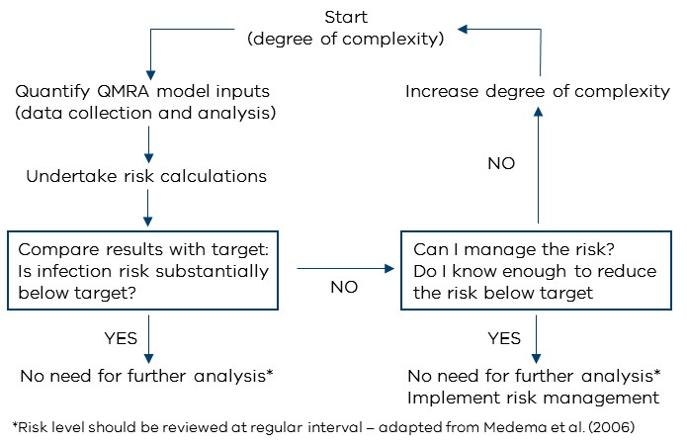

Figure C – Iterative approach for implementing QMRA

* 1. Assessing microbial risks of wastewater discharge
     1. Problem formulation

To define the scope of the risk assessment and be able to formulate the problem appropriately, it is useful to draw a schematic diagram, such as the one illustrated in Figure C3. The intention is to identify all the sources-pathways-receptors and to determine what the hazards are and what environmental values are likely to be impacted. It means the sources of contamination (hazards) and exposure pathways will dictate the assumptions made during the risk assessment.

Figure C3 is an example of a schematic diagram of a point-source model. However, the information provided in this guidance can be applied to a range of sources and assessment needs. For example, it can be used to identify and assess risk from diffuse sources of pollution, such as surface run-off associated with some industrial and agricultural activities.

#### Hazards in the raw wastewater

Wastewater may refer to sewage, stormwater, animal effluents or trade wastes with various degrees of treatment. In addition to the faecal matter from toilets, sewage contains material collected from all internal household drains and all the contaminants of greywater and urine. Sewage can therefore contain a range of enteric pathogens infectious to humans. Sewage also contains high levels of nutrients, particularly nitrates, which have been identified as key health hazards when they contaminate aquifers used as a source of drinking water. Discharge of trade wastes to sewers can also introduce a range of pathogens and other contaminants, particularly chemicals.

Stormwater refers to the water resulting from rain draining into the stormwater system from roofs, roads, footpaths and other ground surfaces. It is usually channelled into local waterways but may also discharge into a sewerage system. Stormwater may carry rubbish, animal faeces, motor oil, petrol, tyre rubber, soil and debris. Initial run-off associated with heavy rainfall can contain very high concentrations of enteric pathogens (disease-causing organisms) and contaminants (both chemical and physical).

Animal effluents refer to point-source discharge of effluents from processing plants such as food processing plants, abattoirs, sale yards, intensive farming facilities such as feedlots or dairy. Animal effluents usually contain a range of enteric pathogens infectious to humans and high levels of nutrients. Animal effluents are usually either discharged after on-site treatment or treated as trade waste in a wastewater treatment plant operated by a water corporation.

All discharges from wastewater treatment plants represent a likely source of contaminants to surface waters due to their pathogen and chemical loading. Discharges could also come from any sewerage asset, including pumping stations, outfalls, bypasses, overflows, chokes and leakage, on-site sewage disposal systems and water reuse systems. Table C3 provides the typical concentration of indicators and pathogens in raw sewage and stormwater. Pathogen loading from animal effluents will be highly variable, depending on the activity and animal involved. Microbial risk assessors should be able to account for uncertainties due to analytical methods. When monitoring is required, culture methods are preferred for pathogen analysis, although they may not always be possible.

Historical data is useful in understanding the raw wastewater characteristics. Data needs to be reviewed over time and after specific events, such as heavy rainfall, particularly for sewerage systems that receive stormwater discharges. However, substantial gaps in datasets are likely, as source water surveillance and monitoring programs are generally not designed to detect any changes in a system that are usually outside the knowledge and control of the wastewater treatment plant operator. These gaps need to be identified. In some cases, generic data (such as data from other wastewater treatment plants) can be useful, but such data should be used with care. In many cases, it may be necessary to undertake targeted sampling programs to underpin further assessment of source water quality.

These sampling programs need to consider catchment inputs and potential hazards and hazardous events, as described in Table C4. The type and nature of industries and trade-waste discharges need to be considered for sewage and stormwater systems.

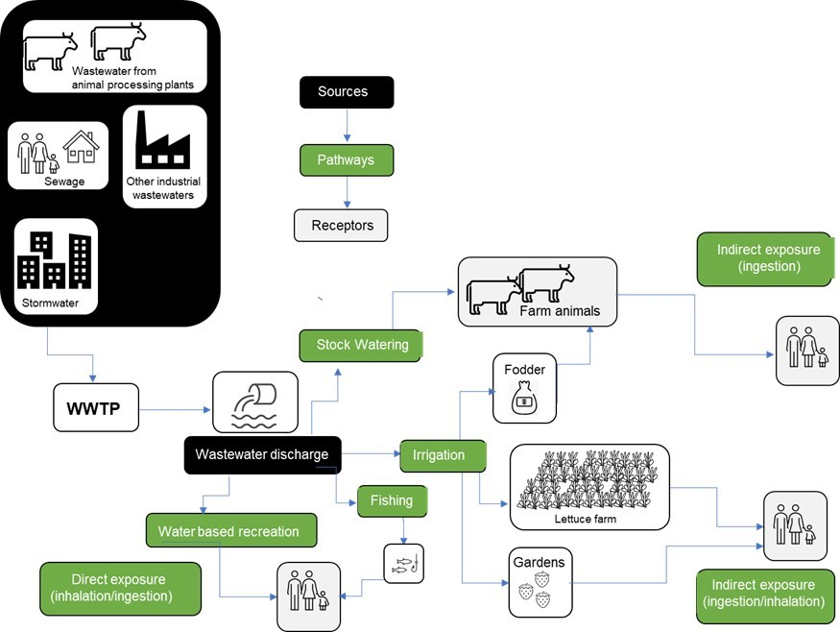

Figure C – Schematic diagram of the exposure pathways for a wastewater treatment plant

Table C – Typical log-normal concentrations of pathogens and indicators in raw sewage and stormwater

|  |  |  |
| --- | --- | --- |
| Microorganism | Raw sewage  (org/100 ml) | Raw stormwater  (urban catchment)  (org/100 ml) |
| Bacteria |  |  |
| *Salmonella*  *Clostridium perfringens*  *Campylobacter*  *Shigella*  *E. coli* (indicator*)  Enterococci (indicator) | <1–104  103–105  <1–104  <1–103  104–109  105-106 | 102–103.3  100–100.7  103.6–105.2  103.2–104.5 |
| Viruses |  |  |
| Enteroviruses  Adenoviruses  Noroviruses  Rotaviruses  Somatic coliphages (indicator)  F-RNA coliphages (indicator) | <1–105  <1–103  <1–105  <1–104  <1–108  <1–106 | 103.1–104.7 |
| Protozoa and helminths |  |  |
| *Cryptosporidium*  *Giardia* | <1–104  <1–104 | 10-0.9–100.7  10-2.9–10-2.2 |
| Helminth ova | 0–10 |  |

*Most *E. coli* are not pathogenic. Nonetheless, attention should be paid to the presence of pathogenic *E. coli* when wastewater contains animal effluents.

Sources: Bitton (1999); Faechem et al. (1983); Geldreich (1990); NRC (1996); Navarro and Jiménez (2011); Soller et al. (2016); Deere and Khan (2016).

Table C4 – Examples of potential hazardous events

|  |  |
| --- | --- |
| Stormwater | Sewerage systems |
| Sewage overflows and septic system discharges.  Entry of livestock waste.  Climatic and seasonal variations (such as heavy rainfall, drought).  Industrial discharges.  Major fires, flooding, natural disasters, sabotage.  Accidental spills or discharge.  Leaching from existing or historical waste disposal (such as landfill) or mining sites; or from contaminated sites or hazardous wastes.  Road washing.  Densification of residential areas. | Infiltration of stormwater.  Increased pathogen loads (outside outbreak event).  Change in community disease profile.  Pandemic events.  Infiltration of saline groundwater into sewer.  Trade-waste discharges including accidental and illegal discharges.  Infiltration of waste from contaminated sites or waste disposal sites (for example, landfill). |

Adapted from NRMMC et al. (2008)

Uncertainties and variability when characterising hazards may include:

* **Spatial variation:** Pathogen concentrations in raw wastewater will vary between and within sites, depending on catchment size, its topography and geohydrological conditions, local weather patterns, as well as upstream land uses determining faecal sources and loadings and the possible presence of barriers to reduce discharge of pathogens to surface water.
* **Temporal variation:** Pathogen concentrations in raw wastewater will vary depending on the seasonal health of the human and animal population and the occurrence of outbreaks, environmental conditions and hydrograph events. Pathogen concentrations in the effluent will also vary over time, depending on fluctuations in water loading, treatment performance and difference in pathogen survival depending on the season.
* **Demographic variation:** Pathogen concentrations in the raw wastewater will also depend on the size, age and health of the human and animal population in the catchment and prevalence of infections.
* **Source variation:** Pathogen types and concentrations in the raw wastewater will vary depending on the source of the wastewater. Information on concentrations and prevalence of pathogens in wastewaters from animal processing plants can be found in the literature. When a wastewater treatment plant receives significant volumes of trade waste and/or where environmental values are likely to include agriculture and irrigation, different pathogens may be identified: pathogens that i) can impact human health directly, or ii) can impact animal health, or iii) can impact human health indirectly, though the consumption of contaminated agriculture produce (Figure C3).
* **Dilution variation:** Pathogen concentrations in the treated wastewater will also depend on the volume of effluent discharged compared to the flow of receiving waters determining the dilution factor.

Therefore, it is important that the inventory of hazards likely to adversely affect environmental values include:

* nature of inputs (types and range of industry, pharmaceuticals and agricultural chemical manufacturers, hospitals and veterinary clinics, abattoirs, food processing, dairy processing, industrial, domestic wastes, etc.)
* trade waste programs and controls (including assessment of risks of accidental or illegal discharges)
* volumes of domestic and industrial waste and discharge patterns (such as contaminant loads, diurnal and seasonal variations)
* future developments
* stormwater discharges (for example, agricultural and mining activities, residential and industrial developments, septic waste inputs, weather patterns, etc.)
* existing discharges to marine and freshwater water
* flow conditions of surface waters to estimate dilution factors at various times of the year.

The application of a dilution factor, which may vary throughout the year according to rainfall, needs to consider the dilution of the total pathogen loading into the receiving waters. Alternatively, a monitoring program of reference pathogens and indicators should be developed to determine the concentrations of pathogens present after dilution. Ideally, monitoring should occur at the point of discharge and at the end of the dilution zone (if applicable) during various flow conditions representative of the variations of flows in the waterway impacted by the discharge. Impact on weather patterns due to climate change and stream flow predictions should also be taken into consideration when developing a monitoring program.

#### Antimicrobial resistance: an emerging threat to public health

Antimicrobial resistance (AMR), also known as antibiotic resistant bacteria and genes (ARB&G) are recognised worldwide as environmental contaminants of emerging concern. Wastewater treatment plants are a reservoir of AMR due to the large numbers of bacteria and antibiotics present and the opportunity for antibiotic resistant genes (ARG) to be easily spread amongst bacteria. Current research shows that technologies that are most effective at reducing AMR in wastewater effluent are those that significantly reduce bacterial numbers prior to a disinfection step. However, treatment processes are not effective at removing antibiotics or ARG and if insufficient disinfection occurs, antibiotic resistant bacteria may be selected throughout the treatment process.

The draft United Nations Resolution on Environment and Health (6 December 2017) recognised that AMR is a current and increasing threat to global health, food security and sustainable development of all countries. The resolution underlined the need to further understand the role of environmental pollution in the development of AMR. The resolution also highlighted the limited availability of tools for environmental surveillance of anthropogenic sourced antimicrobials and the limited understanding of the long-term effects of antimicrobials in the environment on the health of humans, animals, plants and ecosystems. However, the inherent complexity of this issue, coupled with limited knowledge transfer to government authorities, has led to a situation where environmental regulators lack the information needed to assess and manage ARB&G related risks.

#### Fate of pathogens before discharge: performance of the plant in reducing hazards

The characterisation of hazards in wastewater and their mitigation may be captured through the plant performance validation program, the continued monitoring program of the plant performance and the trade waste monitoring program. As bacterial indicators such as *E. coli* alone do not provide information regarding the nature of faecal contaminant, it is important that the inventory of potential pathogen inputs be established and critical control points derived using the Hazard Analysis Critical Control Points (HACCP) approach implemented along the wastewater treatment process.

Treatment performance should be ascertained, validated and monitored using a performance monitoring program. The program should be based on a well-designed site-specific HACCP system to:

* ensure specified LRVs are achieved during routine operations
* identify when and how a wastewater treatment process might fail so that risk mitigation measures can be implemented (DHHS, 2013).

Table 5C provides indicative LRVs of various enteric pathogens and indicator organisms for different treatments. Higher LRVs are achievable but should only be claimed if they can be validated.

Monitoring programs will need to consider a range of seasonal variations and impacts of specific events, as wastewater treatment processes generally function best under steady-state conditions and performance can seriously deteriorate when there are major fluctuations in quality and flow. Events to consider include:

* influx of stormwater into sewerage systems following heavy rain or floods resulting in elevated turbidity
* influx of sewage into stormwater systems
* influx of trade waste into sewerage systems or stormwater catchments
* influence of heavy rain, flooding or external contamination on receiving waters
* large variations in population densities in holiday destinations.

Table C – Indicative log reductions values (LRV) of enteric pathogens

|  |  |  |  |  |
| --- | --- | --- | --- | --- |
|  | Bacteria | Viruses | Protozoa | Helminths |
| Primary treatment | 0 | 0 | 0 | 0 |
| Secondary treatment | 1-2 | 0.5-1 | 0.5-1 | 0 |
| Dual media filtration with coagulation and flocculation | 2.5-4 | 1-2 | 2.5-4 | 2 |
| Membrane bioreactor (MBR) | 2-4 | 1.5-4 | 2-4 | 0 |
| Membrane filtration | 4 | 0 | 4 | 4 |
| Reverse osmosis | 1.5-4 | 1.5-4 | 1.5-4 | 4 |
| Lagoon storage* | 1.0-5.0 | 1.0-4.0 | 3.0-4.0 | 1.5-3.0 |
| Chlorination | 4 | 4 | 0 | 0 |
| Ozonation | 4 | 4 | 0 | 0 |
| UV light# | 4 | 4 | 4 | 0 |

*System specific as log reductions are largely dependant on lagoon design and retention times.

#Log reductions are largely dependant on the UV dose achieved, with viruses required much higher doses than protozoa and bacteria.

Sources: Hijnen et al. (2005); US EPA (2005); WHO (2011); DHHS (2013); Pype et al. (2015); WaterSecure (2017a,b,c,d).

#### Fate of pathogens after discharge

The likelihood of wastewater assets impacting recreational waters and other environmental values is primarily determined by whether a direct discharge is possible. The likelihood of impacts also depends on whether other means of mitigating the impacts are possible. Mitigation could also be due to environmental factors, such as predation, competition and die-off; the removal of pathogens during the transport of discharges from source to the receiving waters; or dilution of chemicals in the receiving waters (Baker et al., 2016). However, for the purpose of assessing human health risks, pathogens from a wastewater treatment plant effluent are often assumed to occur in the receiving waters in the same proportion as they occur in disinfected secondary effluent (Fong et al., 2010; Katayama et al., 2008; Soller et al., 2010). This assumption is reasonable if the travel time from the effluent discharge(s) to the receiving waterbodies is relatively short compared to the time required for a substantial inactivation of the reference pathogens (Soller et al., 2010). Another reason for this approach is that wastewater treatment plant operators often do not have control over the water quality once discharged.

Discharges of wastewater may cause pathogens to re-suspend in the sediments of watercourses. For that reason, monitoring must also include water sampling in the receiving waters, downstream of the wastewater discharge outlet.

* + 1. Exposure assessment

Any exposure assessment must consider the exposure pathway, which relates to five elements:

1. the contaminant source or release
2. the environmental fate and transport
3. the exposure point or area, this is, the location(s) where people might come into contact with a contaminant
4. the exposure route (inhalation, ingestion or dermal contact)
5. the potentially exposed population.

The schematic diagram (Figure C3) prepared during the problem formulation phase must be used to determine what exposure pathways are likely.

These five elements will determine to what extent exposure is occurring. All five elements must be present for the exposure pathway to be complete (enHealth, 2012).

Examples of intake volumes for a range of possible uses, based on a combination of scientific data and order of magnitude reference values, are provided in Table C6. These values are recommended as the conservative default values when specific or local information is not available.

For exposure not listed in Table C6, risks assessors should refer to enHealth (2012) or data reported in the scientific literature.

Table C – Examples of exposures for various activities

|  |  |  |  |  |
| --- | --- | --- | --- | --- |
| Activity | Route of exposure | Volume (ml) | Frequency/  person/year | Comments |
| Garden irrigation | Ingestion of sprays | 0.1 | 90 | Garden watering estimated to typically occur every second day during dry months. Exposure to aerosols occurs during watering. |
| Garden irrigation | Routine ingestion  Accidental ingestion | 1  100 | 90  1 | Routine exposure results from indirect ingestion via contact with plants, lawns, etc.  Infrequent event. |
| Municipal irrigation | Ingestion | 1 | 50 | Moderate frequencies as most people use municipal areas sparingly (estimate once every 1 to 3 weeks).  People are unlikely to be directly exposed to large amounts of spray and therefore exposure is from indirect ingestion via contact with lawns, etc. Likely to be higher when used to irrigate facilities such as sports grounds and golf courses (estimate 1/week). |
| Food crop consumption (commercial) | Ingestion | 5 (lettuce)  1 (other raw produce) | 70  140 | At most, 100 g of lettuce leaves hold 10.8 mL of water and cucumbers 0.4 mL (immediately post watering). A serve of lettuce (40 g) might hold 5 mL of water and other produce might hold up to 1 mL per serve.  Calculated frequencies are based on ABS* data. |
| Toilet flushing# | Ingestion of sprays | 0.01 | 1100 | Frequency based on 3 uses of home toilet per day.  Aerosol volumes are less than those produced by garden irrigation. |
| Fire fighting# | Ingestion of water and sprays | 20 | 50 | Median ingestion for firefighters: 20 mL per fire with a maximum number of fires fought of 50 per year. |
| Water-based recreational activities | Ingestion (primary contact)  Ingestion (secondary contact) | 108  10.8 | Variable | Exposure volume per day defined using data on accidental ingestion of water during swimming from Dufour et al. (2006) as presented in WHO (2016). A reduction factor of 10 is assumed for the ingested volume during secondary contact recreation. Local demographic data must be applied to determine the frequency/person/year. |

*ABS: Australian Bureau of Statistics - Adapted from NRMMC et al. (2006) and NHMRC (2008) for water-based recreational activities.

#These activities were included to cover rural/remote areas that may rely on water extracted from a creek for residential and firefighting uses.

* + 1. Health effects assessment

Information on the relationship between the ingested dose of pathogens and the probability of developing infection and illness is usually derived from human feeding studies and investigations of outbreaks (Haas et al., 1999, 2014; Messner et al., 2014; Rose and Gerba, 1991; Teunis et al., 2004, 2008; WHO, 2011). The doses associated with infection are typically 10-100 times lower for viruses and protozoa than for bacteria. *Shigella*, typhoid *Salmonella* and haemorrhagic *E. coli* are notable exceptions. For example, investigation of one outbreak found that average doses of *E. coli* O157:H7 associated with infection were 30–35 organisms (Teunis et al., 2004).

Factors such as immune status, pre-existing health conditions and diet will affect the dose-response, with immuno-compromised populations most at risk. As the influence of these multiple factors is not well characterised, the general approach taken is usually to assess the health risk of the general population. In some circumstances, it can be appropriate to use dose-responses associated with vulnerable groups for the risk assessments associated with specific environmental values. Dose-response models for children are likely to be different than those of adults and will usually provide very different outcomes. Attention should be paid to the population targeted by the epidemiological studies from which models and infectious doses were derived.

Dose-response correlations are expressed mathematically. Examples of mathematical models used to describe doses responses for pathogens of relevance (‘reference pathogens’) are provided in Table C7. Please note that the use of dose-response models for *E. coli* O157:H7 may be warranted if animal effluents are present.

The most commonly applied models are based on a ‘single’ hit theory, which means each ingested pathogen is assumed to act independently and has an individual probability of causing infection (WHO, 2016). As individuals are exposed to all pathogens present, this limitation may be partially overcome by using QMRA-Monte Carlo risk simulations for pathogens likely to be present (and for those which dose-response data are available (Mara, 2011).

Table C – Dose-response relationships for reference pathogens

|  |  |  |  |  |
| --- | --- | --- | --- | --- |
| Organism type | Distribution | Model | Parameters | Probability of illness per infection |
| Bacteria  (*Campylobacter)* | Approximate beta-Poisson | Pinf = |   0.145    7.58 | 0.3 |
| Virus (norovirus) | Exact beta-Poisson | Pinf = |   0.0044    0.002 | 0.7 |
| Protozoa  (*Cryptosporidium*) | Exponential | Pinf = r.d | r = 2 | 0.7 |

 and r are parameters describing the probability of infection; d = dose;  = median infective dose (N50)/(21/-1); Pinf = probability of infection.

Sources: Medema et al. (1996, 2009); Teunis et al. (2004) ; Messner et al*.* (2014); Van Abel et al. (2016).

The main challenges in assessing health effects remain the variability and uncertainty in dose-response data used to calculate the risk of infection and the lack of dose-response models for most pathogens. When dose-response models do not exist, it is possible to conservatively assume that the minimum infectious dose will result in an infection.

* + 1. Risk characterisation

This final step in any human health risk assessment process using the QMRA approach is to integrate the information collected on hazard identification, exposure assessment and health effects assessment to produce an estimate of the magnitude of risk for each reference pathogen.

This information is vital for the prioritisation of mitigation measures. It is also possible to use this information to calculate the degree of pathogen reduction that is required to produce a wastewater quality that meets specific health-based target values (NRMMC et al., 2006) when discharged into surface waters.

In managing risks to human health, it is necessary to determine acceptable or tolerable risk, set health-based targets and assess risks. Following the ‘Stockholm framework’, whereby the tolerable risk resulting from any water exposure should be the same for any type of environmental value (Fewtrell and Bartram, 2001), the maximum tolerable addition burden of disease adopted in this document **is 10–6 DALYs per person per year**. This tolerable risk is consistent with the WHO’s recommendation (WHO, 2011) and is approximately equivalent to a lifetime additional risk of cancer of 10–5 (one case per 100,000 people) or an annual diarrhoeal risk of illness of 10–3 (one case of illness per 1,000 people). The reported rate of diarrhoeal illness in Australia is 0.8–0.92 cases per person per year (NRMMC et al., 2006).

DALYs provide a means of quantifying the burden of public health impacts arising from disease caused by microbiological, chemical and physical hazards. They can be used to:

* define tolerable risk in terms of public health outcomes
* compare impacts from different hazards; for example, in the normal population, *Cryptosporidium* causes a short-lived and self-limiting diarrhoeal illness with only rare severe impacts, whereas *Campylobacter* can have both acute and chronic impacts (Havelaar and Melse, 2003)
* prioritise resources toward controlling hazards with the greatest potential impact.

More information regarding the definition and calculation of DALYs is provided in box: ***Disability adjusted life years (DALYs) calculation***.

The calculation of the DALY will take into account the ingested volume. The use of this health-based target is therefore applicable to all types of exposure. The only difference is that the assumed ingested volume is adjusted according to the environmental value.

* 1. Risk management

#### Performance targets

Safety in the present context is defined as ‘*ensuring that microbial health risk complies with the definition of tolerable risk*’ (NRMMC et al., 2006). This is achieved by meeting performance targets. For wastewater discharges, these targets are set at levels whereby concentrations of pathogens in waters receiving wastewater discharges are at concentrations below those that would impact environmental values. However, after wastewater is discharged to a waterway, the subsequent quality of that water is often out of the control of the wastewater treatment plant operator. Therefore, LRVs need to be applied at a point in the system (before discharge) where wastewater is not re-contaminated. A natural waterway is subject to contamination from many sources of unknown quality. DALY values and QMRA results cannot be used to set treatment targets for the waterway, unless the treatment or controls are applied to water abstracted from the waterway directly prior to use.

Furthermore, knowledge on the likelihood of developing an illness from exposure to pathogens in wastewater discharges is still limited, as is the potential severity of illness and any possible sequelae. Likelihood and severity of infection largely depends on the health status of the exposed person and on the health care received during illness, with factors varying across regions and population groups. Australia’s ongoing efforts to advancing the DALY pathogen relationship data are reflected in the *Australian* *Guidelines for Water Recycling* (NRMMC et al., 2006, 2008).

It is also important to note that it is the risk of illness, rather than infection, that has traditionally been the selected outcome when determining health targets. DALYs are population-weighted disease burden outcomes for whole populations, including vulnerable groups. There might be some cases when it can be useful in some circumstances to consider an illness endpoint rather than a DALY or infection endpoint. For example, people who engage in a voluntary activity such as outdoor recreational activities are less likely to belong to highly vulnerable groups, and it is usually expected that a self-limiting illness such as a gastrointestinal illness is the principal point of concern. This approach requires an acceptable illness rate target to be defined. Refer to the relevant guidelines for the respective acceptable illness rate targets. For example, in recreational waters, illness rate up to 1% are considered acceptable (NHMRC, 2008).

#### Required level of treatment to meet health targets

Water guidelines generally specify a combination of treatment process and controls. Table C8 provides the level of treatment required for various environmental values of surface waters impacted by treated wastewater to meet the health-based target. Please note that the appropriate dilution factor will need to be applied when wastewater is discharged into surface waters.

The information from the exposure assessment and health effects assessment is combined to:

* determine the magnitude of risk
* quantify the required level of treatment required expressed as LRV (log reduction value)
* obtain a residual risk after preventive measures lower than 10-6 DALYs per person per year.

Table C8 – Indicative log reduction values recommended to maintain environmental values

|  |  |  |  |  |  |
| --- | --- | --- | --- | --- | --- |
| Activity | Route of exposure | Exposure (L) x frequency  (per year) | LRV | | |
| Protozoa | Virus | Bacteria |
| Garden irrigation | Ingestion of sprays  Ingestion – low  Ingestion – high | 0.001 x 90  0.001 x 90  0.1 x 1 |  |  |  |
| Total | 0.2 | 5.0 | 5.6 | 5.3 |
| Municipal irrigation | Ingestion of spray | 0.001 x 50 | 4.4 | 5.0 | 4.7 |
| Food crop consumption (commercial) | Ingestion lettuce  Ingestion – other produce | 0.005 x 70  0.001 x 140 |  |  |  |
| Total | 0.49 | 5.4 | 6.0 | 5.7 |
| Toilet flushing | Ingestion of sprays | 0.00001 x 1100 | 3.7 | 4.3 | 4.0 |
| Fire fighting | Ingestion of water and sprays | 0.02 x 50 | 4.0 | 4.6 | 4.3 |

Source: NRMMC et al. (2006)

Viruses usually require the highest LRV, reflecting the high infectivity of viruses compared with bacteria and the higher disease burden of viruses compared with protozoa. The LRV is calculated using the equation:

Where Crw is the pathogen concentration in the raw wastewater (before treatment); N is the frequency of exposure per year; DF is the expected dilution factor when discharging into the waterway; and DALYd is the dose equivalent to a DALY of 10-6 (1.6 x 10-2 *Cryptosporidium*; 2.5 x 10-3 rotavirus; 3.8 x 10-2 *Campylobacter*) and includes the dose-response and ratio of infection to illness.

To maintain adequate level of treatment, it is important that a process for the management of failure be developed. Actions to mitigate risks of failure will be triggered by non-compliance with critical limits detected upstream of, or within, the wastewater treatment plant. These critical limits will be determined during the development of the HACCP plan and the treatment performance validation. Actions may include an automatic interruption of the discharge to the waterway until remedial action is implemented. Non-compliance with other limits may result in corrective action being taken while the system remains operational.

* 1. Variability and uncertainty

Exposure volumes and frequencies will vary between and within individuals, depending on climate, age, lifestyle, and cultural factors. Changes to sites over time due to seasonal changes and participation in exposure activities also affect exposure volumes and frequencies.

Dose-response will vary between and within individuals, depending on immune status, age and health factors. Dose-response will also depend on differences between pathogenic strains, due to different strain virulence and exposure pathways, and to the physiological state of the pathogen. These variabilities lead to variability in health risk.

Other common uncertainty considerations arising in QMRA studies include:

#### Absence of specific information

Information extracted from the literature or data from similar systems may be used to fill this gap. However, there will often be uncertainties about the validity and representativeness of the information for the specific system being studied. For that reason, data used for the purpose of assessing risk must be conservative.

#### Uncertainty about local studies

When using local data sets, discrepancies with literature findings must be considered. Data from the peer-reviewed literature might be more reliable rather than data from local, unreliable studies.

#### Uncertainty regarding the selection of a statistical distribution

The distribution may be skewed, leading to over or under-estimation of risk.

#### Uncertainty about the model assumptions

A model may rely on assumptions not entirely valid in the context of a specific study. For example, pathogen loadings may be different if the model was developed in another country, or the model may focus on a specific portion of the population.

#### Statistical uncertainty and representativeness

The measurement uncertainty and data representativeness will depend on the sample size. The sample size must be representative of seasonal variations and rainfall events. For a probabilistic QMRA, the number of samples must be large enough for the Monte Carlo simulation. If the focus is the impact on a specific environmental value, the sampling monitoring must address that particular use of the water. For example, sampling must focus on the summer season when most people swim if the focus is on water-based recreation and no less than 20 samples should be collected.

* 1. Case studies

Several case studies, including cases involving secondary and primary recreational uses of waterways, are available in Annexe A of the WHO’s publication on QMRA and its application for water safety management (WHO, 2016). ‘Case study No 5’ looks at setting health-based performance targets and safe use of wastewater in Australia (NRMMC, 2006) and is therefore relevant to the risks to human health from wastewater discharge into surface waters covered by this guidance.

A case study is provided below.

* + 1. Case study of a metropolitan wastewater treatment plant with receiving waters used for irrigation

The source is treated sewage from a major metropolitan wastewater treatment plant, receiving domestic and industrial sewage. Water extracted from the waterway receiving the wastewater discharge is used for spray irrigation of commercial crops, including salad and vegetables. The wastewater treatment plant flow is 120 ML/day. The plant provides secondary treatment, followed by about 25 days of lagoon storage and polishing, before discharge of most of its treated sewage to the waterway. The flow of the waterway can be very low during periods of drought, greatly affecting the waterway’s dilution capacity.

#### Problem formulation

**Hazards** – Human microbial hazards in this type of wastewater discharge include enteric viruses, protozoa and bacteria. Helminths represent a potential hazard for stock and human health. Three reference pathogens are selected to represent the major risks identified: *Campylobacter* for bacteria, adenovirus for viruses and *Cryptosporidium* for protozoa.

A catchment survey is used to identify industrial inputs into the sewage system. The survey does not identify major concerns with discharges in the area served by the wastewater treatment plant, subject to a trade-waste control program. There are no animal processing plants (such as abattoirs) in the catchment. The dilution and mixing impact provided by the lagoons and the waterway are assessed. Dilution and flow are calculated for the period of time the water is likely to be used (for example, no park irrigation is likely to occur during wet periods; park irrigation is more likely to occur in periods of low flow and dilution factor). Several scenarios are explored, including scenarios with average dilution and no dilution.

**Plant performance in reducing hazards –** A trade-waste control program is used to minimise the release of pathogens from high-risk industries (food processing plants and slaughterhouses) to the wastewater treatment plant. Only high-risk trade waste is monitored for quality, but a source water monitoring program exists to assess quality of incoming sewage.

The treatment system includes secondary treatment followed by lagoon detention (>25 days). The advantage of lagoons is that they are robust and easy to maintain. They provide an early warning of problems detected in secondary treatment and can dilute any transient peaks in microbial hazards. They also provide reductions in concentrations of helminths.

Operational procedures are identified for all processes and activities associated with the system.

Documented procedures are available to all operations personnel and available for inspection at any time.

There is evidence that water quality requirements and performance targets had been achieved and validated before the wastewater treatment scheme was approved. Before commissioning, the system was validated by testing for the removal of *Cryptosporidium, Giardia*, adenoviruses, noroviruses, rotavirus, enteroviruses, hepatitis A and helminths and by checking appropriate critical control points and critical limits were in place to ensure the treatment system was working properly. The removal of bacterial pathogens is demonstrated by removal of *Escherichia coli*.

Actions to mitigate risks of failure include the following:

* Non-compliance with critical limits results in flow to the waterway being stopped automatically until remedial action is implemented. In this case, the flow is stopped if the flow rates stop the minimum lagoon-detention times being met.
* Non-compliance with other limits can result in corrective action being taken while the system remains operational.

#### Exposure assessment

The use of water extracted from the waterway includes the irrigation of salad vegetables, lucerne for stock feed and recreational areas. The irrigators use drip and overhead spray irrigation systems.

The upper 95th percentile of the pathogen concentration in the wastewater was selected as a default point value for the QMRA study, after application of the estimated dilution factor.

The intake volume for the identified use of irrigation of food crops were 5 mL for lettuce and 1 mL for other raw produce, with a frequency of 70 and 140 per person per year respectively (Table C6). The intake volume for the identified use of irrigation of recreational areas was estimated as 1 mL, with a frequency of 50 per person per year (Table C6).

#### Health effects assessment

The dose-response models described in Table C7 were applied.

#### Risk characterisation

Microbial quality is identified as essential. The calculated DALY is higher than 10-6 during periods of low flow in the waterway, indicating that secondary treated sewage does not comply with the health target and represents an unacceptable risk. Consequently, the outcome of the risk assessment is to set log-reduction requirements that are consistent with those shown in Table C8. Additional treatment is required to meet the adequate log reduction. Because of low flow of the receiving waters, the pathogen load already in the waterway, or recontamination prior to abstraction were assumed to be non-significant. However, existing pathogen loads and likely recontamination prior to abstraction should be taken into consideration so that a validated and reliable water quality is provided to end-users.

#### Risk management

The treatment should be expanded to include coagulation, dual media filtration and disinfection, with critical control points for human health, identified as:

* lagoon storage (minimum 25 days)
* dual media filtration (turbidity limits)
* disinfection (UV treatment and chlorine residual limits).

The QMRA study confirms that the expansion of the treatment process will achieve a DALY<10‑6, which is an adequate LRV for this type of treatment process.

After validation of the treatment process expansion, the following ongoing monitoring is recommended to ensure treatment is adequate and environmental values are maintained: *E. coli*, pH and turbidity (weekly) and *Cryptosporidium* and adenoviruses (quarterly).

* 1. References

Baker DL, Ferguson CM, Chier P, Warnecke M and Watkinson A 2016. Standardised survey method for identifying catchment risks to water quality. Journal of Water & Health 14 (3): 349–368.

Bitton G 1999. Wastewater Microbiology. Second edition, Wiley–Liss Inc., New York.

Deere D and Khan S 2016. Collation and analysis of pathogen monitoring data from Australian sewage samples. Water Research Australia Research Report 2018-12.

DHHS 2013. Guidelines for validating treatment processes for pathogen reduction. State of Victoria, Department of Health.

Dufour AP, Evans O, Behymer TD and Cantu R 2006. Water ingestion during swimming activities in a pool: a pilot study. Journal of Water & Health 4(4): 425-430.

enHealth 2012. Environmental health risk assessment – Guidelines for assessing human health risks from environmental hazards. Commonwealth of Australia.

EPA Victoria 2021a. Victorian Guideline for Water Recycling. EPA Publication 1910.1.

EPA Victoria 2021b. Technical information for the Victorian guideline for water recycling. EPA Publication 1911.1.

Feachem RG, Bradley DJ, Garelick H and Mara DD 1983. Sanitation and disease: health aspects of excreta and wastewater management. John Wiley and Sons, Chichester, UK.

Fewtrell L and Bartram J 2001. Water quality: guidelines, standards and health: assessment of risk and risk management for water-related infectious diseases. Fewtrell L and Bartram J (eds), World Health Organization.

Fong TT, Phanikumar MS, Xagoraraki I and Rose JB 2010. Quantitative detection of human adenoviruses in wastewater and combined sewer overflows influencing a Michigan river. Applied and Environmental Microbiology 76(3): 715-723.

Geldreich EE 1990. Microbiological quality of source waters for water supply. In: McFeters GA (eds) Drinking Water Microbiology. Brock/Springer series in contemporary bioscience. Springer, New York, NY.

Haas CN, Rose JB and Gerba CP 1999. Quantitative Microbial Risk Assessment. John Wiley and Sons, New York, NY.

Haas CN, Rose JB and Gerba CP 2014. Quantitative Microbial Risk Assessment. Second edition, John Wiley and Sons, Chichester, UK.

Havelaar A and Melse JM 2003. Quantifying public health risk in the WHO guidelines for drinking water quality: a burden of disease approach. RIVM report 734301022, Bilthoven, The Netherlands.

Hijnen WAM, Beerendonk EF and Medema GJ 2006. Inactivation credit of UV radiation for viruses, bacteria and protozoan (oo)cysts in water: A review. Water Research 40: 3–22.

Katayama H, Haramoto E, Oguma K, Yamashita H, Tajima A, Nakajima H and Ohgaki S 2008. One-year monthly quantitative survey of noroviruses, enteroviruses, and adenoviruses in wastewater collected from six plants in Japan. Water Research 42(6-7): 1441–1448.

Mara D 2011. ‘Water- and wastewater-related disease and infection risks: what is an appropriate value for the maximum tolerable additional burden of disease?’, Journal of Water & Health 9(2): 217–224.

Medema G, Teunis P, Blokker M, Deere D, Davison A, Charles P and Loret J-F 2009. Risk assessment of *Cryptosporidium in drinking water*. World Health Organisation, Geneva.

Medema GJ, Teunis PF, Havelaar AH and Haas CN 1996. Assessment of the dose-response relationship of *Campylobacter jejuni.* International Journal of Food Microbiology 30(1-2): 101–111.

Messner MJ, Berger P and Nappier SP 2014. Fractional Poisson – A single dose-response model for human norovirus. Risk Analysis 34(10): 1820–1829.

Navarro I and Jiménez B 2011. Evaluation of the WHO helminth eggs criteria using a QMRA approach for the safe reuse of wastewater and sludge in developing countries. Water Science and Technology Journal International Association for Water Pollution Research 63: 1499–1505.

NHMRC 2008. Guidelines for managing risks in recreational water. National Health and Medical Research Council, Australian Government.

NRC 1996. Use of Reclaimed Water and Sludge in Food Crop Production.National Research Council, National Academy Press, Washington DC.

NRMMC et al. 2006. Australian Guidelines for water recycling: Managing health and environmental risks (Phase 1). Natural Resource Management Ministerial Council, Environment Protection and Heritage Council and Australian Health Ministers Conference.

NRMMC et al. 2008. Australian Guidelines for Water Recycling: Managing Health and Environmental Risks (Phase 2). Augmentation of drinking water supplies. Natural Resource Management Ministerial Council, Environment Protection and Heritage Council and National Health and Medical Research Council.

Pype M-L, Alvarez de Eulate A, Arrigan D, Busetti F, Le-Clech P and Gernjak W 2015. Development of validation protocols for reverse osmosis membranes in water recycling. Brisbane, Australia: Australian Water Recycling Centre of Excellence.

Rose JB and Gerba CP 1991. Use of risk assessment for development of microbial standards. Water Science & Technology 24(2): 29–34.

Soller JA, Schoen ME, Bartrand T, Ravenscroft JE and Ashbolt NJ 2010. Estimated human health risks from exposure to recreational waters impacted by human and non-human sources of faecal contamination. Water Research 44(16): 4674–4691.

Soller JA, Eftim SE, Warren I and Nappier SP 2016. Evaluation of microbiological risks associated with direct potable reuse. Microbial Risk Analysis. http://dx.doi.org/10.1016/j.mran.2016.08.003.

Teunis PFM, Ogden ID and Strachan NJC 2008. Hierarchical dose-response of *E. coli* O157:H7 from human outbreaks incorporating heterogeneity in exposure. Epidemiology and Infection 136(6): 761–770.

Teunis P, Takumi K and Shinagawa K 2004. Dose-response for infection by *Escherichia coli* O157:H7 from outbreak data. Risk Analysis 24(2): 401–407.

US EPA (United States Environmental Protection Agency) 2005. Membrane filtration guidance manual. EPA 815-R-06-009. Washington (DC): United States Environmental Protection Agency.

Van Abel N, Schoen ME, Kissel JC and Meschke JS 2016. Comparison of risk predicted by multiple norovirus dose-response models and implications for quantitative microbial risk assessment. Risk Analysis 37(2): 245–264.

WaterSecure (2017a). Membrane Bioreactor, WaterVal validation protocol, Australian WaterSecure Innovations Ltd, Brisbane. <https://www.waterra.com.au/research/waterval/>

WaterSecure (2017b). Ozone disinfection, WaterVal validation protocol, Australian WaterSecure Innovations Ltd, Brisbane. <https://www.waterra.com.au/research/waterval/>

WaterSecure (2017c). UV disinfection, WaterVal validation protocol, Australian WaterSecure Innovations Ltd, Brisbane. <https://www.waterra.com.au/research/waterval/>

WaterSecure (2017d). Chlorine disinfection, WaterVal validation protocol, Australian WaterSecure Innovations Ltd, Brisbane. <https://www.waterra.com.au/research/waterval/>

Whelan G, Kim K, Pelton MA, Soller JA, Castleton KJ, Molina M, Pachepsky Y and Zepp R 2014. An integrated environmental modelling framework for performing Quantitative Microbial Risk Assessments. Environmental Modelling and Software 55: 77–91.

WHO 2011. Guidelines for Drinking Water Quality. Fourth edition, World Health Organization, Geneva, Switzerland.

WHO 2016. Quantitative Microbial Risk Assessment: Application for Water Safety Management. World Health Organization, Geneva, Switzerland.

WSAA 2004. Health risk assessment of firefighting from recycled water mains. Occasional paper no. 11, WSAA, Melbourne.