Illegal Waste Dumping

The real cost of illegal dumping
Some people dump waste in our environment to avoid the costs of lawful disposal. Others simply cut corners to save time. Whatever the perceived benefit, the cost to the community is always higher.

Financial costs
Once alerted, EPA Officers assess the situation and investigations start. Each case is different, but can involve:
- Securing the site
- Scientific sampling and testing
- Gathering evidence from local witnesses
- Assessing the evidence against known matters.
Fines or charges can be laid when the evidence is clear.
Where possible, we make the dumper clear the waste. If they can’t do so to the necessary standard, we can clear the waste with the dumper covering the cost.
Here’s where things can escalate.
Some dumpers challenge the actions EPA has taken, either in court or at VCAT. This is their right.
Other dumpers structure their businesses so that they are unable to pay. Transferring assets and choosing bankruptcy in an attempt to avoid paying for their actions.
In either case, EPA uses every legal means necessary to hold polluters to account. Unfortunately, the cost of doing so is higher the longer these cases run.
In the end, EPA ensures illegally dumped waste is cleared. We do everything possible to make dumpers pay, but if it is impossible or impractical to do so, all Victorians pay the cost.

Intangible costs
Even when the financial cost of illegal dumping is covered, intangible costs remain. In many cases, the cost of investigating and clearing dumped waste is just the beginning. The loss of amenity impact on our community can be ongoing in many forms.
- Contamination from dumping can devastate local ecosystems and take years to remediate.
- Dumped tyres are a fire hazard that put whole communities at risk.
- Dumped asbestos is a health risk to anyone exposed to the dust, long after it is cleared.
Dumped waste can impact our community long after the waste is gone.
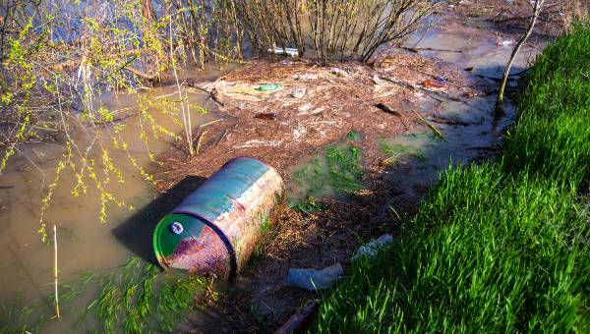

Market costs
When shonky operators dump waste, they pocket the fees intended to cover safe processing. This undermines legitimate businesses that manage waste legally.
In this way, each load of dumped waste makes safe disposal harder.
In Victoria, waste operators collect data on the hazardous waste they receive. This impacts future planning decisions and reveals trends in Victoria’s waste needs.
This data matters. When it is incomplete we are less able to plan and reduce our future environmental impact.

So what can we do?
Every illegal waste report we receive supports our ability to combat dumping.
For more information, learn what happens when you report.

