Waste designation
Environment Protection Act 2017

Designation number
- Not priority waste (transactions)
- Not priority waste (transport)
24 August 2022

24 August 2027

CPB Contractors Pty Limited 000893667
Level 18, 177 Pacific Highway, North Sydney NSW 2060

West Gate Tunnel Project (WGTP) – Zone 302 (refer to Appendix 1 –
activity site plan)

WD000300231

Issue date Expiry date
Designation holder ACN/ABN
Registered address Activity site

Waste classification

Issued under regulation 86(1) of the Environment Protection Regulations 2021 (the Regulations).

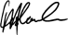
Motla Leshoele Manager, Permissioning
Delegate of Environment Protection Authority Victoria (EPA)

Environment Protection Authority Victoria
GPO BOX 4395 Melbourne VIC 3001
1300 372 842 (1300 EPA VIC) www.epa.vic.gov.au

Context
The Environment Protection Authority Victoria (EPA) is Victoria’s environmental regulator acting in accordance with the Environment Protection Act 2017 (the Act). Our regulatory role is to work with community, industry and business to prevent and reduce the harmful effects of pollution and waste on Victoria’s environment and people.

About issuing waste designations
Waste holders have legal obligations to classify their waste under Parts 6.4 and 6.5 of the Act. This involves understanding the waste, its nature, source, composition and how to identify the most appropriate waste code or codes and waste classification under Schedule 5 to the Regulations and the incorporated documents (EPA Publication 1827.2: Waste classification assessment protocol and EPA Publication 1828.2: Waste disposal categories – characteristics and thresholds). If the waste cannot be classified in accordance with the Regulations and incorporated documents, the person who has the management or control of the waste must apply to EPA for a designation.
EPA can issue a designation, setting out the waste classification for a waste, under regulation 86 of the Regulations. Designations may be made to classify new or unusual waste types that are not adequately classified under the Regulations or if a classification would impose an undue burden on persons in management or control of the waste.
All designation details are publicly accessible via the EPA Public Register.

Key information and obligations Interpretation
For the purposes of this designation, “You” means the “designation holder” identified on the first page. Unless a contrary intention appears, words or terms used in this designation have the same meaning as in the Act and in any regulations made pursuant to the Act.

Compliance
Your designation is subject to conditions. It is important to note that this designation has no effect if you fail to comply with any condition specified.
This designation does not satisfy, alter or remove any requirement under the Act, except to the extent the designation expressly states otherwise or as otherwise provided by the Regulations.

Amendment or revocation
Under regulation 86(14) of the Regulations, the Authority may amend or revoke this designation by way of written notice to the designation holder. If you need an amendment to your designation, please contact EPA.

Designation number: 2022/WD000300231

Duration of designation
This designation is subject to the expiry date identified on the first page of this designation. It will remain in force until that time unless it is first revoked by EPA.

Designation structure
Your designation has multiple parts:
- Definitions
- Waste to which this designation applies
- Designation
- Standard conditions
- Specific conditions
- Notes
- Schedule 1 - Waste Sampling and method of analysis
- Schedule 2 – Vehicle standard for transport of waste
- Schedule 3 - Record keeping and reporting requirements
- Appendix 1 – Activity Site Plan

Definitions
In this designation, words or phrases have the same meaning as in the Act or the Regulations unless otherwise specified, and-
Designation holder means the person specified on Page 1 of this designation as the designation holder
Activity site means a site defined in Appendix 1 – activity site
SAQP means the sampling analysis quality plan for waste categorisation of tunnel spoil for reuse or containment at or disposal by EPA approved premises

Waste to which this designation applies
This designation applies to the following waste generated at the “activity site” identified on
page 1 and Appendix 1:
  - Tunnel boring machine spoil (“the waste”) that is generated during works within the West Gate Tunnel Project – Zone 302 area [attached here as Appendix 1, Activity Site Plan], with a volume not exceeding 1,500,000 m3 at a maximum rate of 8,000 m3.day.

Designation number: 2022/WD000300231

Designation
For the purposes of regulation 86 of the Regulations, waste to which this designation applies is classified by the Authority as follows –
- the waste is not priority waste - transactions; and
- the waste is not priority waste – transport.

Conditions
Standard conditions
The designation holder must, so far as reasonably practicable, take all reasonable steps to ensure that any activity under this designation does not cause contamination of land or water so that the condition of

5.1

5.2

5.3

5.4
the land or water is so changed as to make, or reasonably be expected to make, the land or water detrimental to any relevant environmental value of the land or water identified in any relevant environment reference standard.
Any laboratory analysis required for the purposes of this designation must be undertaken by a National Association of Testing Authorities accredited laboratory.
The designation holder must, so far as reasonably practicable, provide information regarding any risks of harm to human health or the environment that exist in relation to the waste to the person in management or control of the receiving site to ensure the waste can be managed in a manner that complies with section 25 of the Act.
Prior to removal from the Activity site, a visual assessment of the condition of the Waste must be undertaken to determine any odour or discolouration, as documented in the Project’s Sampling and Analysis Quality Plan (SAQP).

The assessment in 5.4 must be retained by the designation holder and kept for a period of at least two years.
5.5
5.7

5.6 The waste must be transported to an EPA approved premises.

A copy of this designation must be present at all times at the Activity site as well as at the EPA approved premises.

5.8
Waste sampling, method of analysis and decision-making framework for waste categorization must be as per Schedule 1. In the event of any inconsistency arising between the SAQP and the conditions of this designation, the conditions of this designation shall apply.

Storage of the waste must prevent liquid and mud from leaving the premises or entering waterways, stormwater systems or groundwater.
5.9

When loading waste into the load compartment of a vehicle, a sufficient

5.10

5.11
freeboard must be maintained to prevent the waste from dislodging from the vehicle during transport.
The designation holder must immediately notify EPA of any diversion of waste consignments from the preferred truck route or the receiving site by calling 1300 EPA VIC (1300 372 842), sending an email to contact@epa.vic.gov.au, or using the EPA Interaction Portal.

The designation holder must develop a Spill Management Plan (“SMP”)
5.12
for transportation of the Waste to avoid and safely manage spills.
5.13

The SMP for the transportation of the waste is kept at all times in each vehicle used to transport the Waste.

All transporters of the Waste are familiar with the relevant SMP held in

5.14

5.15
the vehicle prior to collection and transport of the waste and are competent in the implementation of any measures required by that SMP.
The designation holder must ensure that waste is only transported in vehicles that have been assessed and approved by the designation holder as complying with the standards referred to in Schedule 2.

The designation holder must ensure that all drivers are inducted as per
5.16
the requirements detailed in the Project’s SAQP

The designation holder must record the volume of the Waste and number of consignments transported to the EPA approved premises,

5.17
and analytical details of the representative soil samples (as per Schedule 3 below), and the records must be retained for five years from the date of transport and be able to be immediately produced upon request by an officer of the EPA.

Wastes to which this designation applies must not be diluted or mixed with other wastes.
5.18

5.19 Any assessment of background levels must be made in accordance with section 36 of the Act.

By the 21st day of each month, following the commencement of waste

5.20
generation, the designation holder must submit to EPA a summary report for the previous month showing the information set out in Schedule 3 below.

Notes
- For the purpose of compliance with this designation the following publications are relevant guidance ─
  - Industrial waste resource guidelines – Sampling and analysis of waters, wastewaters, soils and wastes, published by the Authority in June 2009 (as amended from time to time) and available on its website (publication IWRG701); and
  - Industrial waste resource guidelines – Soil Sampling, published by the Authority in June 2009 (as amended from time to time) and available on its website (publication IWRG702).
- Freeboard means the height between the upper most level of the waste and the lowest point on the side of the vehicle body where waste may spill over.

Abbreviation | Compound name
PFAS PFOS PFOA PFHxS | Per-and poly-fluorinated alkyl substances Perfluorooctane sulfonate Perfluorooctanoic acid  Perfluorohexane sulfonate

Designation number: 2022/WD000300231

Schedule 1: Waste Sampling and method of analysis
Spoil and spoil water sampling, method of analysis and decision-making framework for waste categorisation must be undertaken in accordance with the Project’s Sampling and Analysis Quality Plan (SAQP) which include, but is not limited to the following requirements:
- Soil sampling method:
  - Sampling and analysis of the spoil may only be undertaken on soil from TBM 1. Classification of the waste from TBM 1 spoil may be applied to TBM 2 waste.
  - For the first bay of spoil from each geological domain, initial primary samples must be taken at a rate per bay of between 1:250 m3 and 1:350 m3.
  - If the results of the testing of spoil sent to first bay of each domain satisfy the pre- requisites set out in the SAQP’s Table 10 for the “minimum testing regime”, then the “minimum testing regime” specified in Table 10 of the SAQP (two primary samples plus two duplicate and triplicate samples per bay) may be applied to the subsequent spoil that is sent from that domain to each successive holding bay.
  - If the maximum data values from each of the primary, duplicate and triplicate from the subsequent bays indicate that results are trending, or may trend towards >75% of the containment cell acceptance criteria, then testing of all samples taken at a rate of between 1:250 m3 and 1:350 m3 must be reinstated until 10 day tracking of maximum data values re-establishes results are trending <75% of the reuse criteria.
  - Waste must be sampled in accordance with the SAQP prior to being deposited in a containment cell within an EPA approved premises or disposed of at a licensed facility.
  - Sampling must be undertaken by a suitably qualified person appointed by the designation holder. Sample submission sheet must consist of a chain of custody (CoC) which demonstrates the integrity of samples from the site of sample collection, and receipt of samples at testing laboratory.
  - The ‘21 Day Turnaround Rule’ as described in the SAQP may be applied and EPA is
notified within 24 hours of the decision.

Designation number: 2022/WD000300231

Analysis:

  - Samples collected from the first bay of each domain must be analysed for the standard IWRG 621 suite and PFAS compounds.
  - Waste from areas where potential acid sulfate soils may be present must be tested and
assessed against the criteria listed in EPA Publication 655.1 “Acid Sulfate Soil and Rock”.
  - Tested samples from all domains must be analysed for total and leachable concentrations of all PFAS analytes referred to as PFOS, PFHxS and PFOA using commercial laboratory standard methods complying with the analysis procedure for PFAS of AS 4439.3 – 1997, with US EPA Method EPA- 821-R-11-007 for the solid component and US EPA 537 for the liquid component
  - For analytical methods, quality assurance procedure, sample integrity reference must be made to:
    - IWRG 701; Sampling and analysis of wastewaters, soils and wastes
    - IWRG 621; Soil hazard categorisation and management
    - AS 4439.3; Wastes, sediments and contaminated soils – Preparation of leachates
– Bottle leaching procedure
    - AS 4482.1: Guide to the sampling and investigation of potentially contaminated soil and sites
  - Chain of Custody documentation must be used, and must include but not be limited to the following information:
    - Name of the sampler
    - Description of the sample (example – Domain 2)
    - Collection date and time
    - Departure date from the site of origin
    - Receipt of sample at testing laboratory.

Designation number: 2022/WD000300231

Schedule 2: Vehicle standard for transport of waste

- To safely transport the waste, there must be no gaps between the tailgate and the tipping body.
- The tipping body and the load area must be leak proof with no holes or gaps.
- A leak-free compression seal is required between the body and the tailgate when closed.
- The tipping body of the vehicle must be fitted with a waterproof PVC tarpaulin cover to protect the waste from adverse weather conditions.
- The tarpaulin cover must be put in place before transporting the waste.
- A fire extinguisher, suitable spill kit and safety equipment must be carried and located in an accessible position of the vehicle.

Notes:
Retractable tarpaulin, roll-on roll-off type tarpaulin cover or manual tarpaulin covers with enveloped sides and tie-downs are all appropriate for PFAS impacted waste.
Any incident or spill of wastes must immediately be notified to EPA by calling 1300 EPA VIC (1300 372 842), sending an email to contact@epa.vic.gov.au, or using the EPA Interaction Portal.
The spill kit must comprise containment tubes or absorbents, broom and a shovel.
The safety of driver is the responsibility of the company or the individual (in the case of owner driver). Safety equipment include full-length overalls, abrasion or chemical-resistant gloves, dust masks, respirators or breathing apparatus, safety footwear or chemical-resistant boots, goggles or face shields, eye rinse bottle.

Designation number: 2022/WD000300231

Schedule 3: Record keeping and reporting requirements
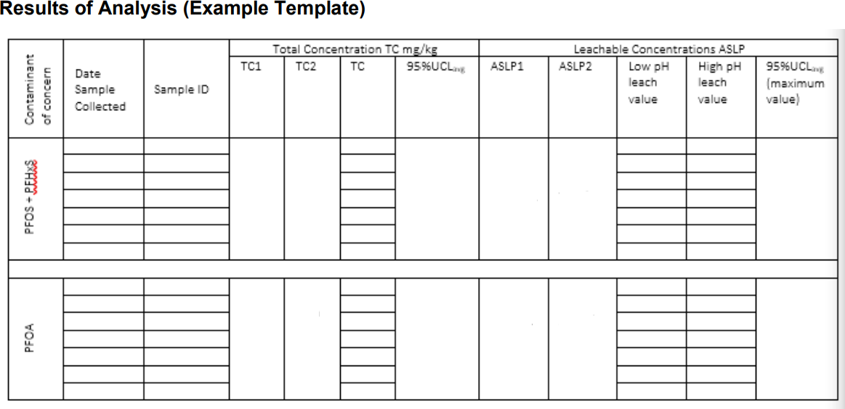
Monthly Summary Report Must include, but is not limited to:
- Reporting Period:
- Number of consignments:
- The volume of waste that was:
  - Sent to a premises for which the occupier holds either an approved Environment Management Plan in accordance with Environment Protection (Management of Tunnel Boring Machine Spoil) Regulations 2020 or an L09 permit in accordance with the Environment Protection Regulations (2021) during the reporting period and specifying which premises.
  - Sent to an EPA licensed facility during the reporting period
  - Approved for deposition in a containment cell at an EPA approved premises during the reporting period
- The total number of kilolitres of wastewater that was generated at the premises during the reporting period that was:
  - Treated during the reporting period
  - Reused during the reporting period
  - Discharged into the sewerage system of a water corporation in accordance with a trade waste agreement during the reporting period.

Designation number: 2022/WD000300231

OFFICIAL

Waste designation
Environment Protection Act 2017

Appendix 1 – Activity Site Plan
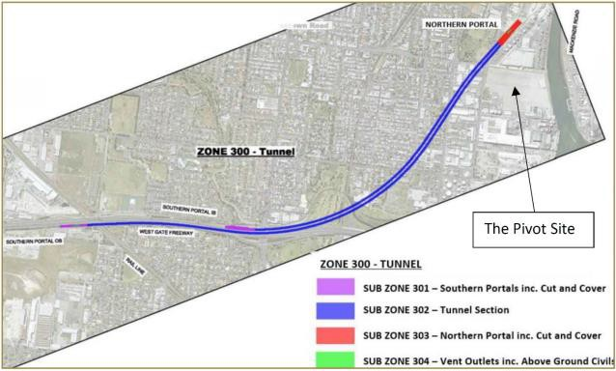

Environment Protection Authority Victoria
GPO BOX 4395 Melbourne VIC 3001
1300 372 842 (1300 EPA VIC) www.epa.vic.gov.au

