Flow chart: Overview of permit requirements for outdoor entertainment venues and events
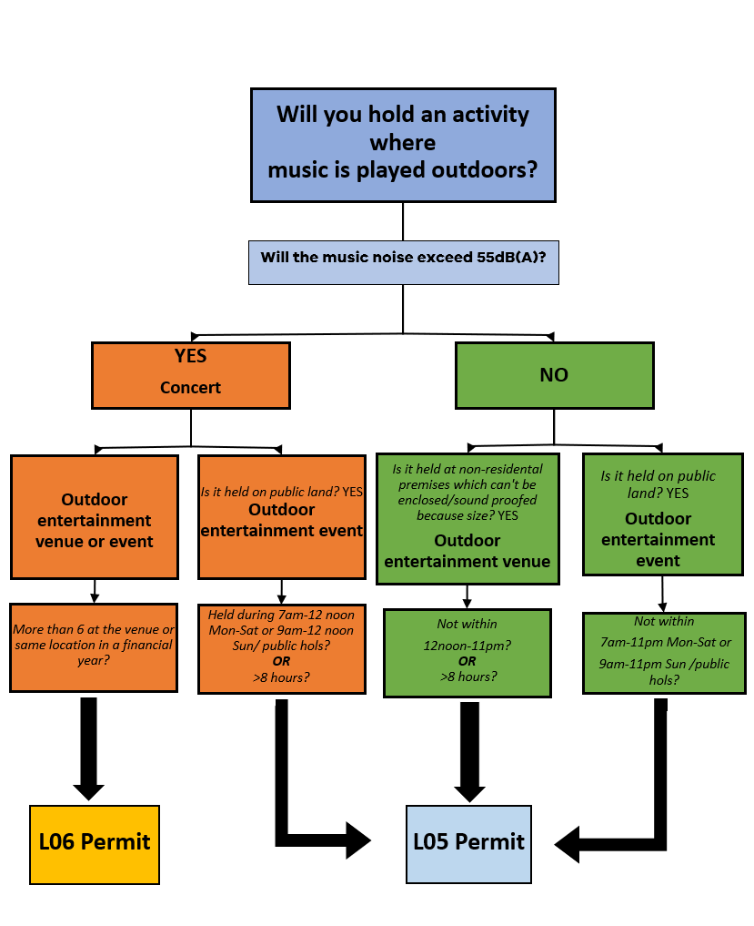
A permit can cover multiple operations or concerts (see Part 3.2 of this guideline).

