PLANT AND PROCESS DESCRIPTION: WESP AND HEAT PLANT

- Proposal for Development Licence
The proposal is to divert air emissions from existing emission points Jet Dryer stack (DP4) and Drum Dryer stack (DP17) to a Wet Electrostatic Precipitator (WESP) which will remove contaminants from the gas stream by a combination of water scrubbing and electrostatic absorption.
The WESP will produce solid waste, consisting of the particulate material it removes from the gas stream from the dryers. This solid waste will be transferred to a 4 MW heat plant where it will be burnt as fuel, providing hot air to help heat the dryers. The use of the solid waste for fuel is an efficient re-use of material that is consistent with the waste hierarchy and circular economy principles.

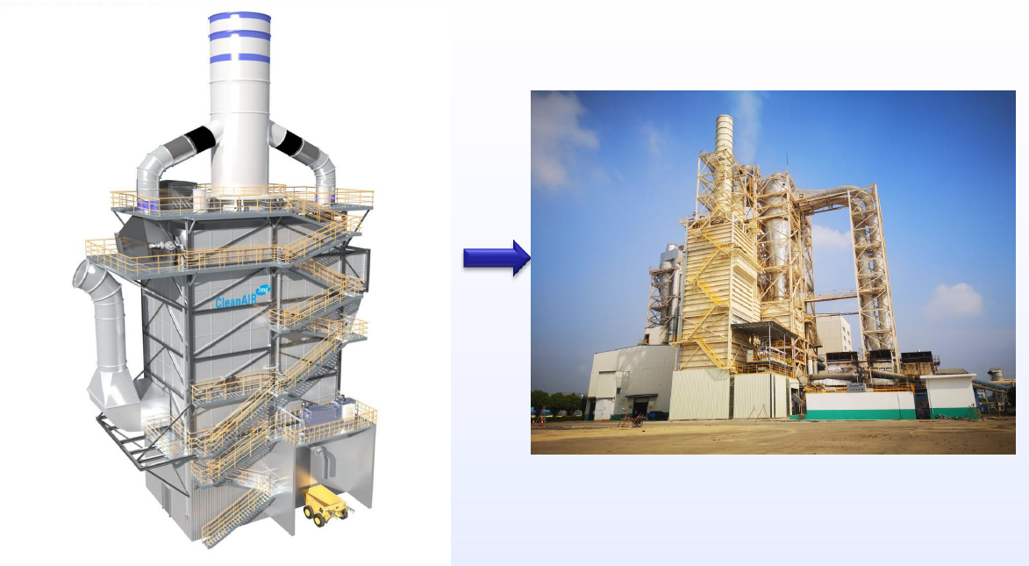

- Process Flow

- Untreated flue gas from the dryers (crude gas) is drawn by existing dryer fans into the crude gas ducting which connects the dryers and the main body of the WESP.
- The gas is treated in the WESP by water scrubbing absorption and electrostatic removal of contaminants.
- Treated (cleaned) flue gas exits the WESP stack to atmosphere.
- Waste water from the WESP can be used in the Presslines, or returned to the dryers to be evaporated.
- Solid waste is transferred to the heat plant to be burnt as fuel. Gases and particulate from the heat plant is directed into the WESP for treatment.

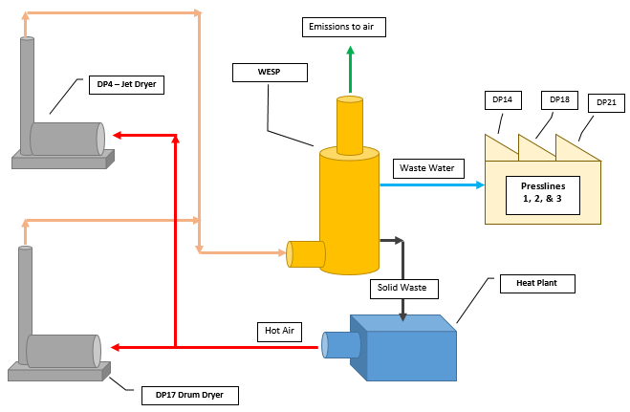
WESP & Heat Plant process flow diagram

- WESP Process Description
A WESP consists of a number of process operations contained within an outer casing, that treat flue gas from the dryers which eventually exits from the WESP stack.
- Quench
- Scrubber
- Wet electrostatic precipitator
- Water recycling system
- Defogging system
- Firefighting system
- Operator interface and control system
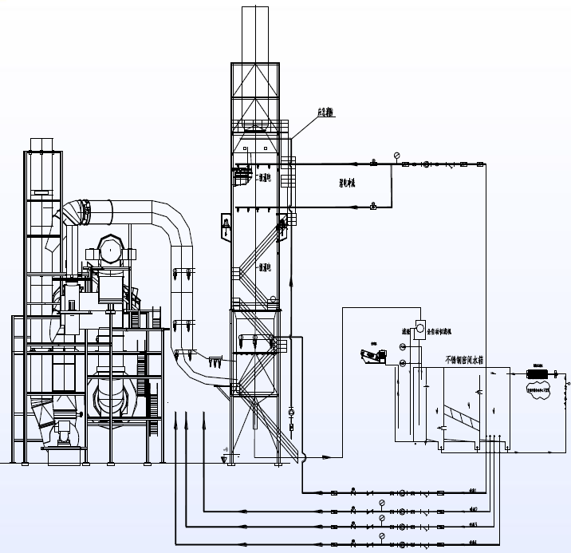

  - Quench
Crude gas exiting the dryers is cooled by an initial quench located in the crude gas ducting between the dryers and the WESP.
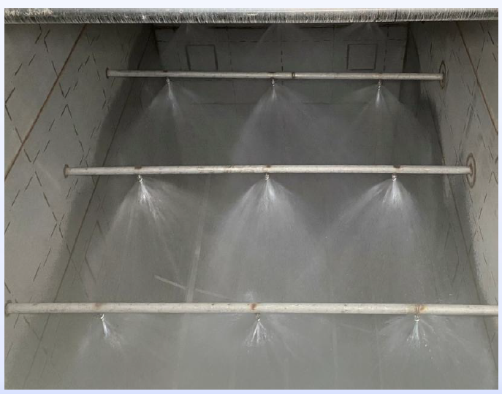

  - Scrubber
A water scrubber located within the main body of the WESP separates out larger particulates and ensures a uniform flow of gas over the entire cross section of the WESP.
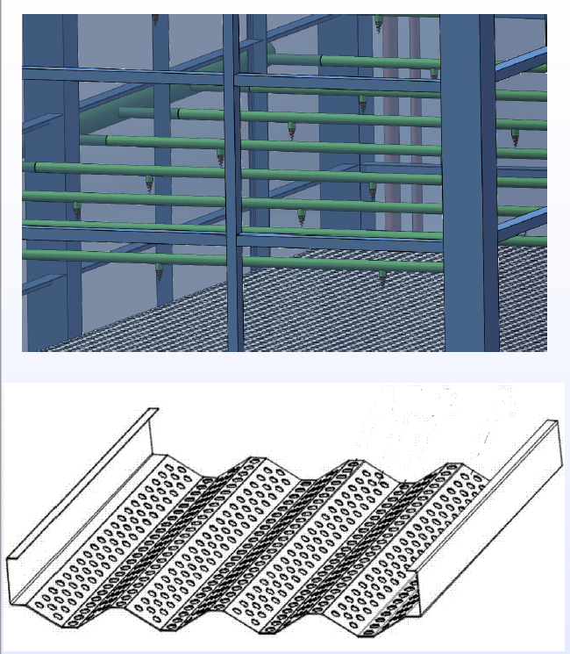

  - Wet electrostatic precipitator
Plate-type electrodes are maintained at high voltage which generates an electrical field which causes particulates to become charged and attracted to the collectors. The collectors are intermittently washed by water to remove build-up.
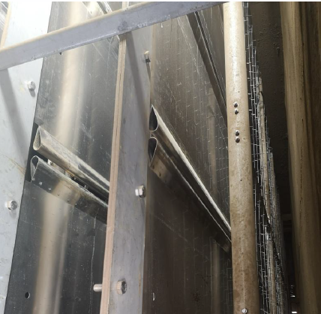
  - Water recycling system
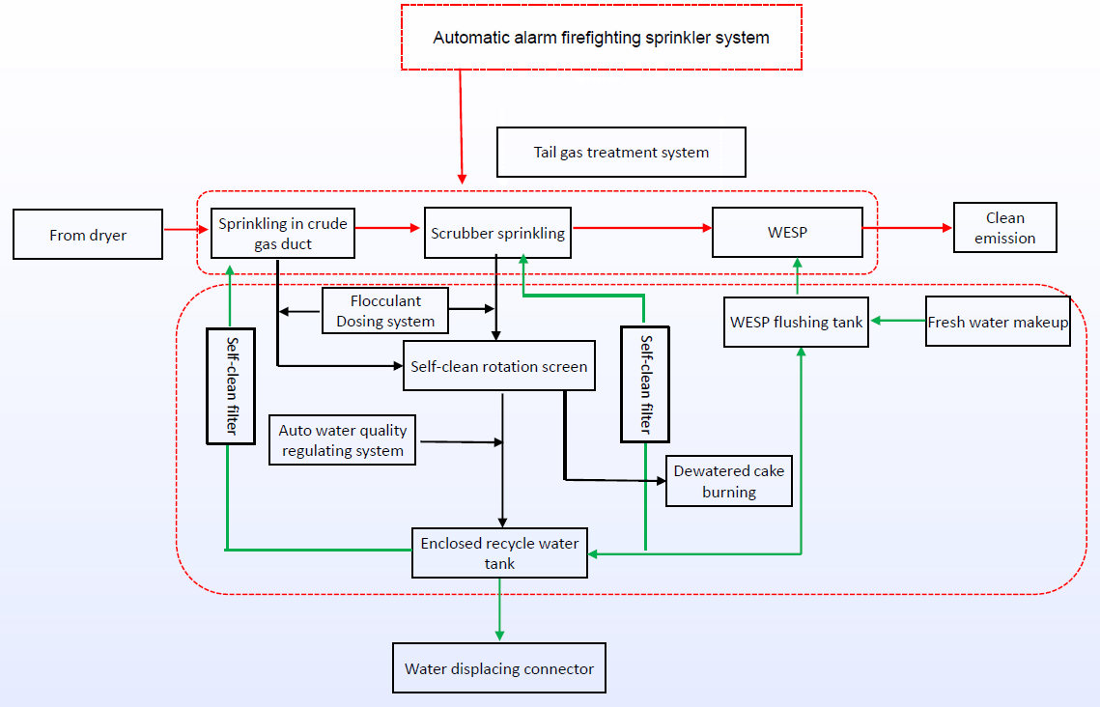

Water from the crude gas scrubbing, main scrubbing and WESP flushing operations is collected, filtered and screened to remove solid material in the form of a ‘wet cake’.
Fresh water is added and dirty water bled off as required to ensure optimum operation and the WESP and removal of contaminants from the dryer flue gas.
The wet cake is transferred to the heat plant where it is burnt as fuel.
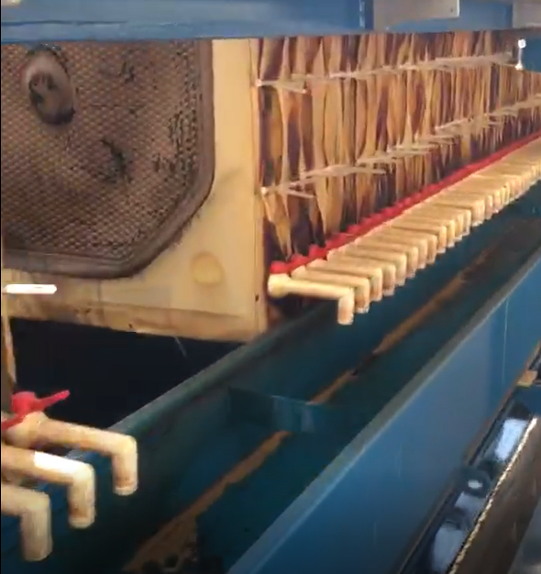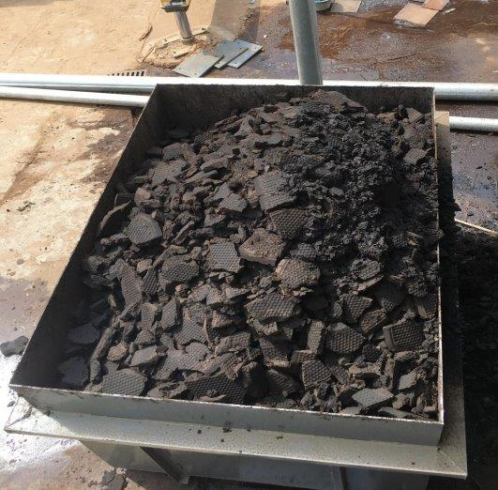

  - Defogging System
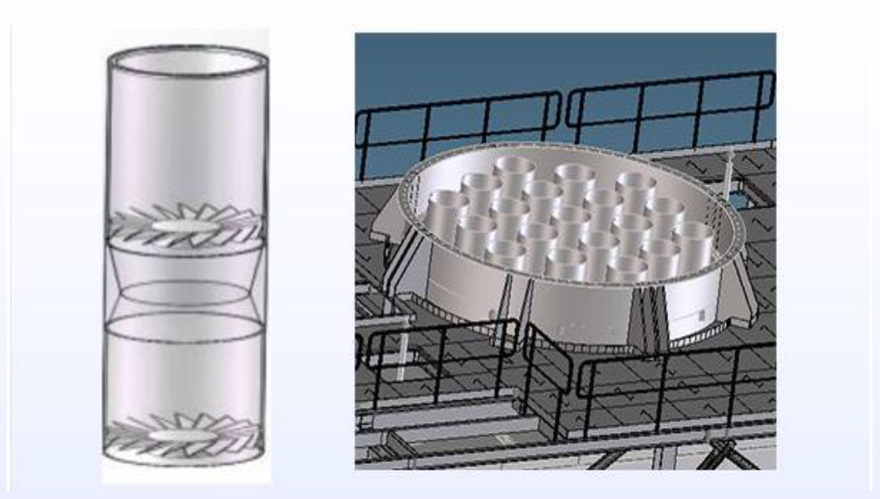
The stack outlet is fitted with ~ 20 miniature cyclones which further remove condensables in the flue gas and minimise the visibility of the plume. They increase the overall efficiency of the WESP and are self-cleaning.

  - Firefighting System
The WESP has provision for emergency water supply in case of fire, connected to the internal water spraying system.

  - Operator interface and control system
The WESP is a mostly automatic system, controlled by a PLC , with the following features:
- Remote and local monitoring & control;
- HV monitoring & safety interlock;
- Flow rate monitoring alarm & firefighting interlock;
- Recycle water treatment remote & local control;
- Gas temperature monitoring & switch air flap interlock;
- Water quality automatic detecting & regulating;
- Water level monitoring & interlock;
- Historical data and curve collection and analysis.
Monsbent is also proposing that dryer operation be interlocked to the WESP to prevent the dryers running without emissions control (except for commissioning, trouble-shooting and emergency situations).

An operator computer interface for the WESP will be located in the Pressline control rooms and monitored by the Pressline Supervisor and Operators.
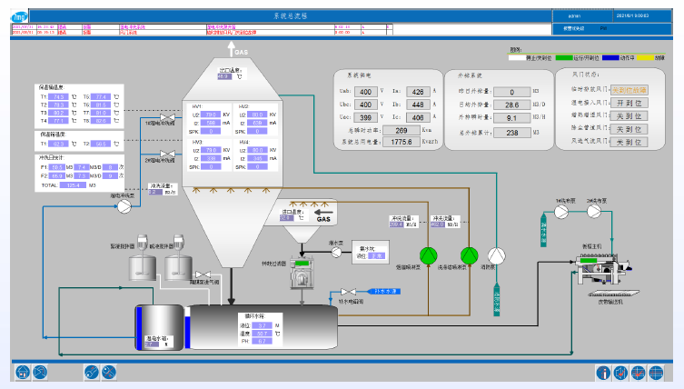

  - Stack Test Sampling Point
Stack tests will be conducted from the top level access platform, as shown on the schematic below.
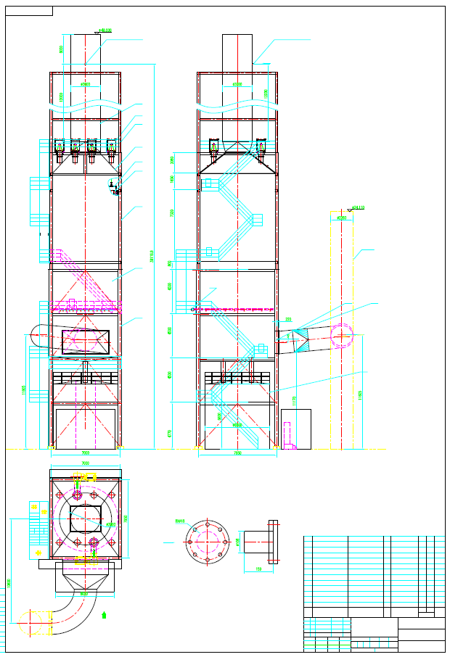
WESP Schematic
  - Location
Proposed location of the WESP and heat plant are shown below.
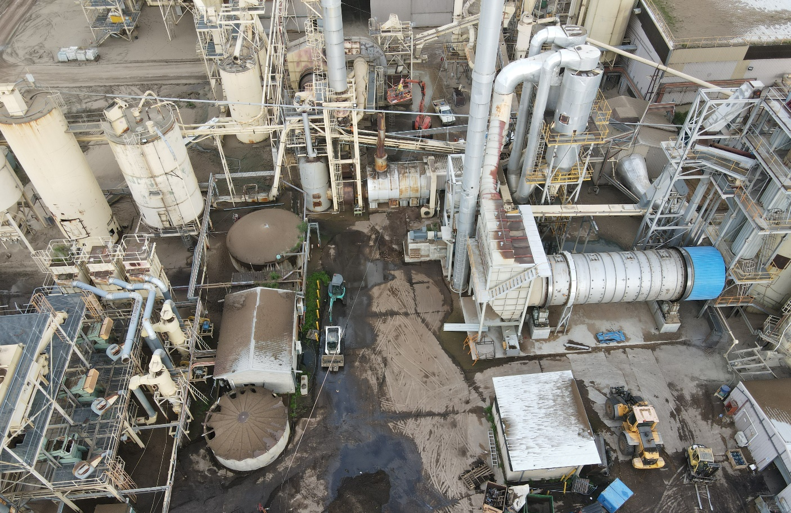
Heat Plant
WESP
WESP and Heat Plant proposed location
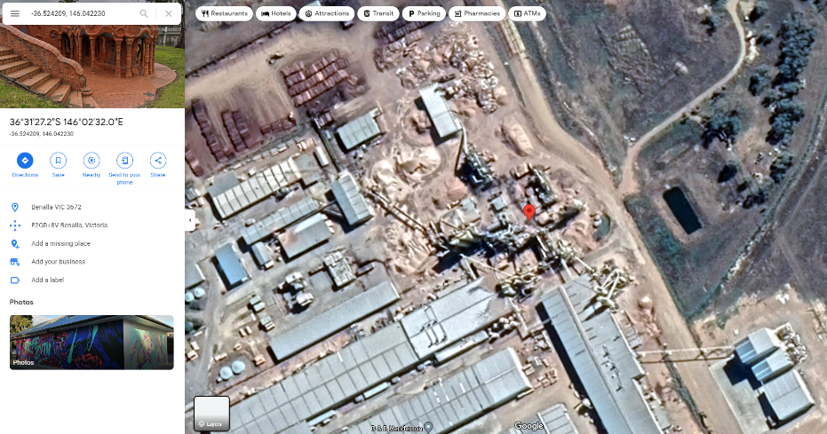
Aerial view of site showing proposed location

  - Chemical amounts and storage
Chemicals used in the WESP will be a flocculant or coagulant, to assist with recovering solids from the reticulation water, and an alkali solution to adjust pH, most likely sodium hydroxide which is already handled on site. Usage will depend on operational status of the WESP. Estimates are given below:
- Sodium hydroxide 50% solution: 50-100 l/h.
- Flocculant/coagulant: 1-3 l/h.
Chemicals are proposed to be stored in 1000 L intermediate bulk containers (IBCs) in an impervious, bunded area within the WESP compound.
  - Procedural controls

- Operation of the dryers is covered by a work instruction, which will be updated to reference a new work instruction which will include operation of the WESP. The new work instruction will include:
- Required competencies to operate equipment
- Normal and abnormal operating conditions
- Monitoring requirements
- Response to alarms
- Response to emergency, including fire
- Hazards and precautions
- Environmental requirements
- Quality requirements
As part of the commissioning process, training will be rolled out to production personnel to ensure competency of personnel responsible for operating the WESP and Heat Plant. Pressline Supervisors will provide supervision for the area.

  - Monitoring, testing, maintenance, inspections, etc.
The WESP will be added to the site’s preventative maintenance schedule, which is managed through the ‘Mainpac’ software application. Specific maintenance and inspection requirements will be determined in conjunction with the supplier, and confirmed as part of commissioning and post-commissioning works.
Emissions testing will consist of a stack test.

- Heat Plant Process Description
The Heat Plant will have a capacity of 4.0 MW and will be used to provide energy by the combustion of waste wood - bark, sander dust, recycled wood, etc. - to produce heat. The hot flue gas from the Heat Plant will be directly supplied to the wood chip drying system at a nominal 650°C. Fuel consumption will depend on the wood mix, moisture content, and heating demand. Capacities for the fuel feed system are given in the technical proposal from Quingshan Energy.
There will be two methods of delivering fuel to the Heat plant:
- Sanding dust combustion system.
- Solid wood waste combustion system.
Sanding dust combustion system
Dust recovered from the line 1 and line 3 sanders is currently burnt directly in the combustion chambers of the Drum and Jet dryers. This dust will be diverted to the Heat Plant via a blow line and fed into the combustion chamber by a dosing screw and an injection nozzle.
The dust combustion system has a maximum capacity of 500 kg/hr, so the total amount of sander dust generated on site will be burnt using a combination of the Heat Plant’s combustion chamber and one or both of the existing dryers’ combustion chambers.
Further details of the dust combustion system are given in the proposal from Quingshan Energy, section 7160.
Solid wood waste combustion system
Recycled wood waste and wet cake from the WESP will be delivered to the Heat Plant by site front-end loaders or forklifts using skips or other appropriate containers, and loaded into the fuel bin. The fuel belt conveyor then delivers the fuel from the bin to the fuel feeder and from there into the combustion chamber.
The combustion chamber uses an air-cooled, hydraulically-driven reciprocating grate, which will allow it to use both wet and dry fuels, improve fuel mixing and thereby ensure optimised combustion. (Refer to proposal from Quingshan Energy section 7211 for further details).
A schematic of the Heat Plant is shown over leaf. Detailed plant drawings are expected to be developed as part of the design and construction process.

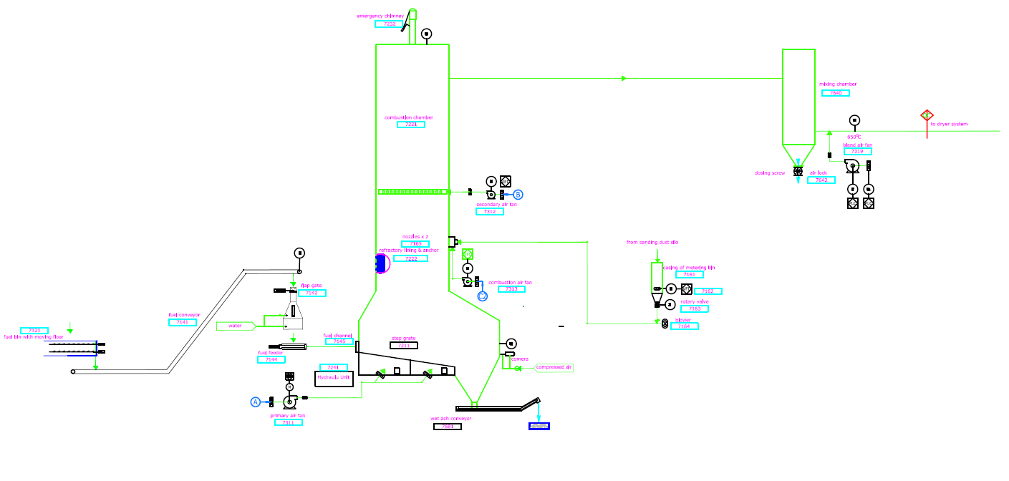
Heat Plant Schematic
  - Operator interface and control system
The Heat Plant will be controlled by a PLC with a computer interface located at the Pressline control rooms. The PLC will be fitted with a UPS in case of power loss.
The following factors will be automatically controlled by the PLC:
- Rate of fuel delivery.
- Combustion.
- Internal temperatures and pressures.
- Thermal output.

  - Firefighting and Emergency Vent System
The Heat Plant has provision for emergency water supply in case of fire, as well as cooling water to the fuel metering bin, to prevent over-heating of the bin and a potential backfire situation.
The Heat Plant is also fitted with an emergency stack. If triggered, this would represent an emergency release (as defined in Section 354 of the Act) and result in emergency shut down procedures being activated and EPA notification. The emergency vent is available to mitigate impact of a pressure build up in the combustion chamber and is expected to occur rarely. In practice the objective is for it not to be used at all.
  - Stack Test Sampling Point
The Heat Plant will not be fitted with a stack test sampling point as all emissions will go to the WESP, which will have its own stack test sampling point.
  - Location
Refer to section 3.9.
  - Chemical amounts and storage
Nil, except as used during maintenance and repairs, under existing site permit to work procedures.
  - Procedural controls
Operation of the Heat Plant will be developed in conjunction with the WESP operating instructions.
- Required competencies to operate equipment.
- Normal and abnormal operating conditions.
- Monitoring requirements.
- Response to alarms.
- Response to emergency, including fire.
- Hazards and precautions.
- Environmental requirements.
- Quality requirements.
As part of the commissioning process, training will be rolled out to production personnel to ensure competency of personnel responsible for operating the Heat Plant. Pressline Supervisors will provide supervision for the area.

  - Monitoring, testing, maintenance, inspections, etc.
The Heat Plant will be added to the site’s preventative maintenance schedule, which is managed through the ‘Mainpac’ software application. Specific maintenance and inspection requirements will be determined in conjunction with the supplier, and confirmed as part of commissioning and post-commissioning works.
The Heat Plant includes a ‘de-ash’ system which burns out the combustion chamber and drops out residual fly ash, which will be collected by the slag/ash conveyor and disposed of as per waste management regulations. As part of the commissioning process the ash will be tested to ensure it does not contain any hazardous chemicals or metals that could contaminate ground water (as per US Energy Information Administration (EIA) recommendations, (https://www.eia.gov/energyexplained/biomass/biomass-and-the-environment.php).

